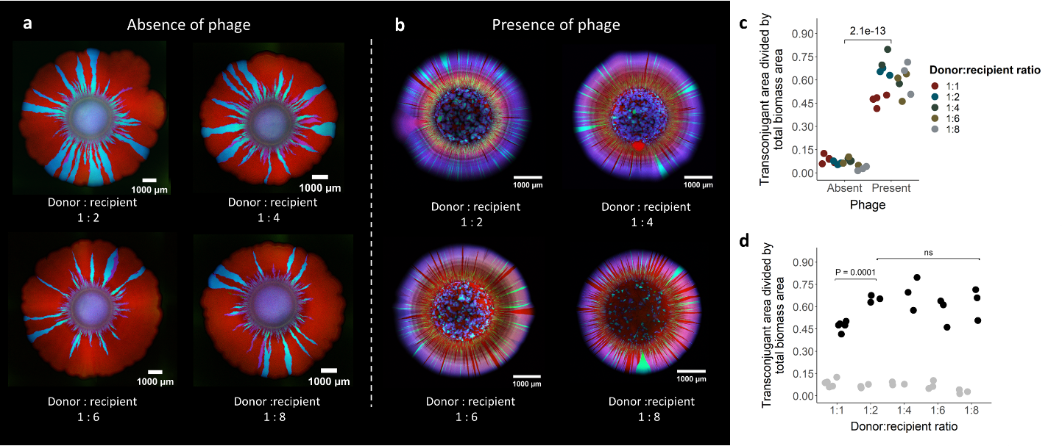

Extended Data Fig. 1: Surface-associated growth experiments with different initial ratios of the R388 donor to potential recipient. a,b, Representative CLSM images of the R388 donor and potential recipient after ten days of growth in anoxic conditions in the (a) absence or (b) presence of phage, where we added the phage directly to the growing biomass. The R388 donor expresses GFP and CFP and appears cyan, the potential recipient expresses RFP and appears red, and transconjugants express RFP and CFP and appear magenta. c, The total transconjugant area divided by the total biomass area for different initial ratios of the R388 donor to potential recipient. d, The total transconjugant area divided by the total biomass area plotted as a function of the initial ratio of the R388 donor to the potential recipient. For c and d, each datapoint is a measurement for one of three independent experimental replicates and the P values are for two-sample two-sided Welch tests.

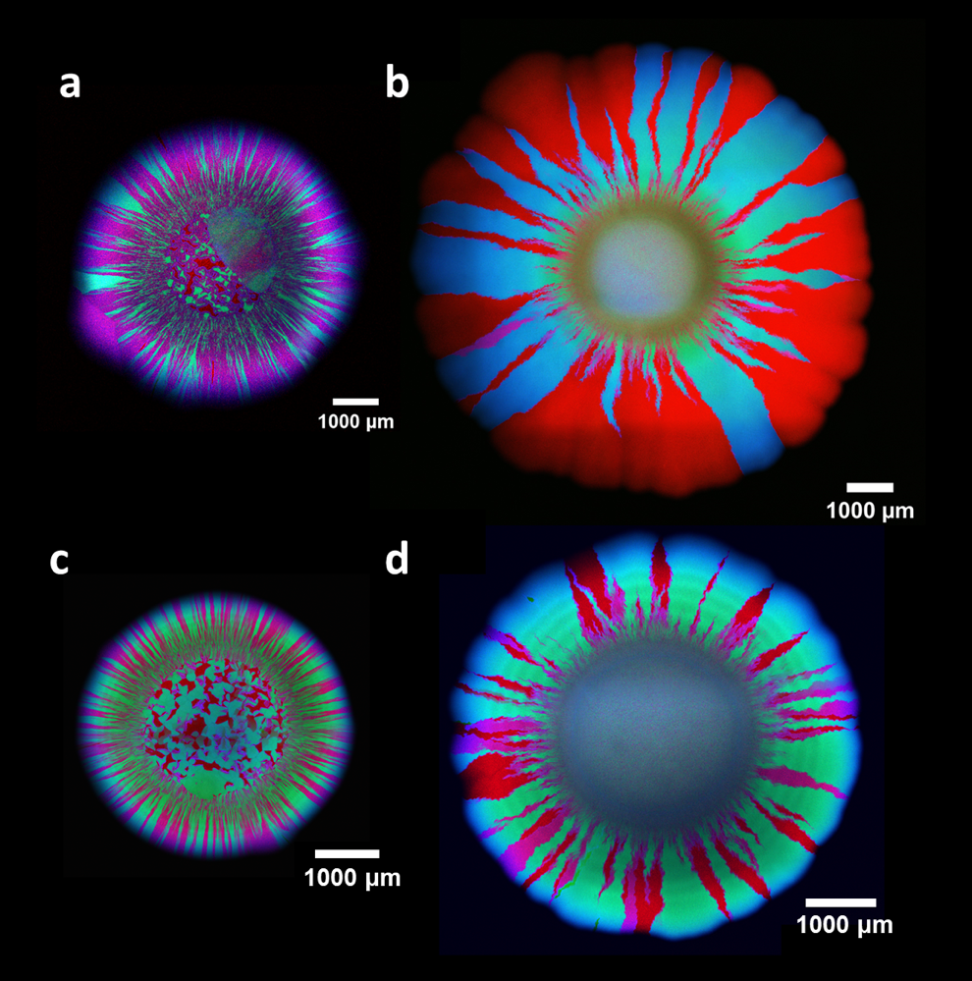

Extended Data Fig. 2: Surface-associated growth experiments in oxic and low nutrient conditions. a,b, Representative CLSM images of the R388 donor and potential recipient after six days of growth in the (a) presence or (b) absence of phage in oxic conditions, where we added the phage directly to the growing biomass. c,d, Representative CLSM images of the R388 donor and potential recipient in the (c) presence or (d) absence of phage after six days of growth on 10% LB agar plates, where we added the phage directly to the growing biomass. The R388 donor expresses GFP and CFP and appears cyan, the potential recipient expresses RFP and appears red, and transconjugants express RFP and CFP and appear magenta recipient expresses RFP and appears red, and transconjugants express RFP and CFP and appear magenta.

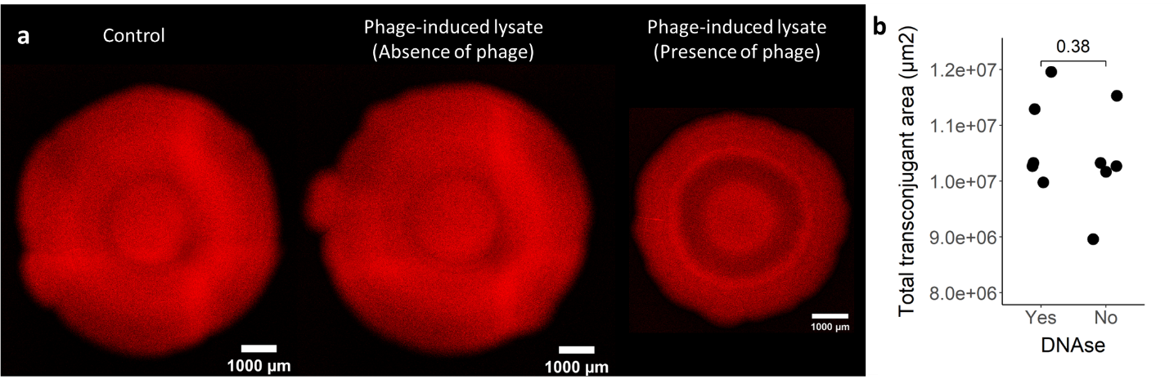 Extended Data Fig. 3: Experimental tests of whether R388 or its associated genes are transferred via natural transformation or transduction. a, Representative CLSM images of the potential recipient grown alone for ten days in anoxic conditions. Control; the potential recipient grown without phage or phage-induced lysate. Phage-induced lysate (Absence of phage); the potential recipient grown with phage-induced lysate of the R388 donor and with heat-inactivated phage. Phage-induced lysate (Presence of phage); the potential recipient grown with phage-induced lysate of the R388 donor and with viable phage. b, Total number of transconjugants that emerge with or without DNase I digestion of free DNA. Each datapoint is a measurement for one of five independent experimental replicates and the P value is for a two-sample two-sided Welch test.

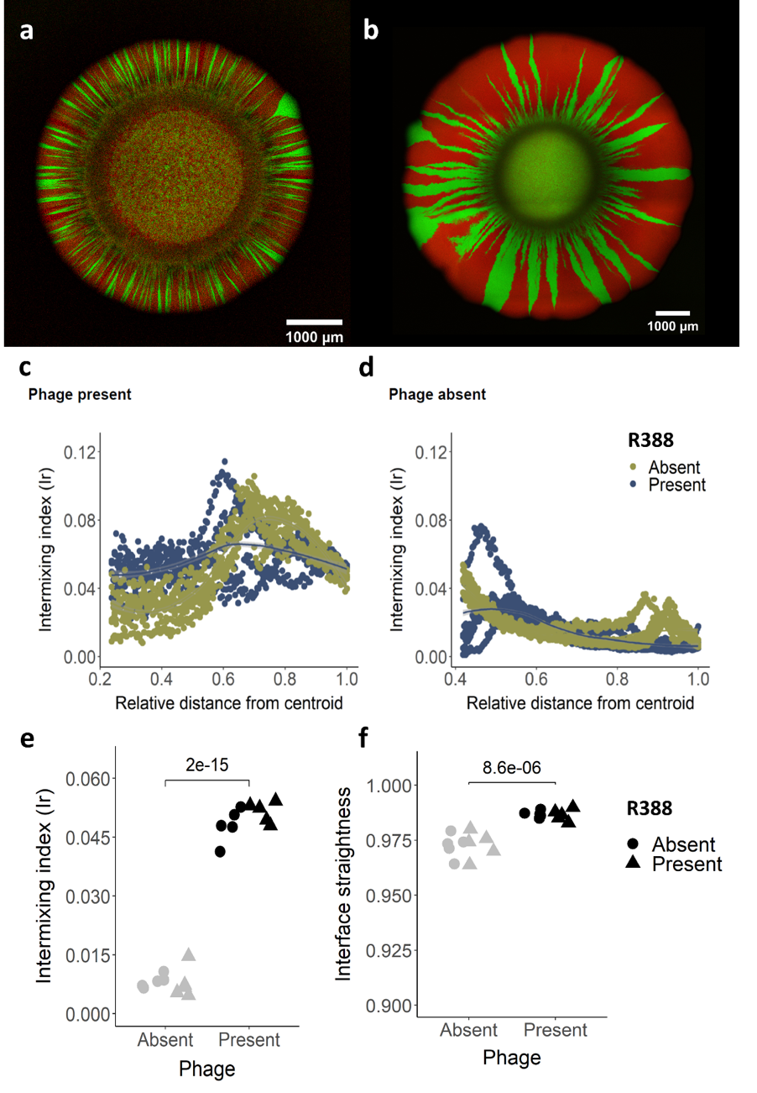

Extended Data Fig. 4: Effect of phage on spatial intermixing and interface straightness in the absence or presence of R388. a,b, Representative CLSM images of two E. coli strains lacking R388 after ten days of growth in anoxic condition in the (a) presence or (b) absence of phage, where we added the phage directly to the growing biomass. c,d, The intermixing index as a function of the radial distance from the centroid of the inoculation area to the final biomass periphery in the (c) presence or (d) absence of phage. e, The intermixing index quantified across a 30 µm thick band positioned at the final biomass periphery. f, The mean interface straightness. For e and f, each data point is a measurement for one of five independent experimental replicates and the P values are for two-sample two-sided Welch tests.

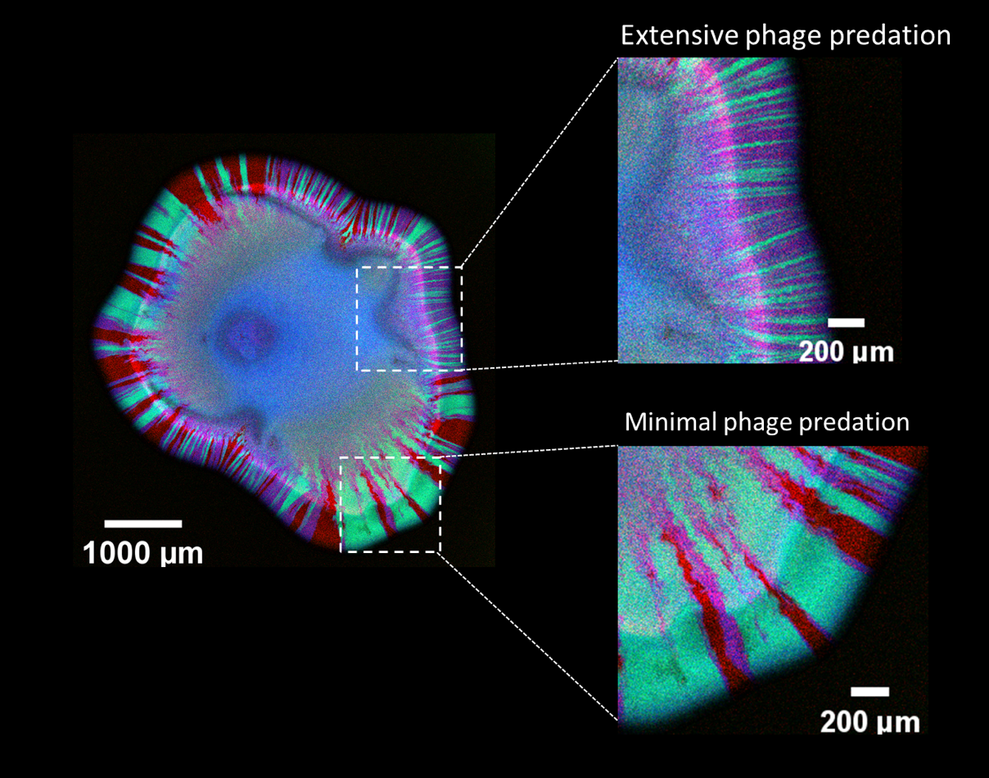

Extended Data Fig. 5: Surface-associated growth experiments with the direct amendment of a low dosage of phage. Representative CLSM image of the R388 donor and potential recipient after ten days of growth in anoxic conditions where we added the phage directly to the growing biomass at a low dosage of 6 × 10⁴ PFU/mL. The R388 donor expresses GFP and CFP and appears cyan, the potential recipient expresses RFP and appears red, and transconjugants express RFP and CFP and appear magenta. The images on the right are magnifications of the regions in the white dashed boxes in the image on the left. The upper right box is a representative region with extensive phage predation and extensive R388 transfer while the lower right box is a representative region with minimal phage predation and minimal R388 transfer.

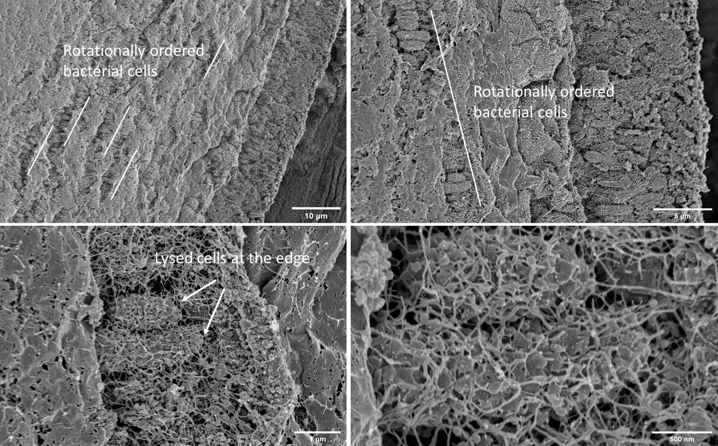

Extended Data Fig. 6: Scanning electron microscopy images during surface-associated growth in the presence of phage. The experimental setup is identical to that used for the data presented in Fig. 2. Briefly, we inoculated the R388 donor and potential recipient onto the center of a nutrient-amended agar surface. After allowing the bacteria to grow for six hours, we deposited a 1 µl droplet of the phage solution directly to the growing biomass. After ten days of incubation in anoxic conditions, we then analyzed the biomass with scanning electron microscopy.

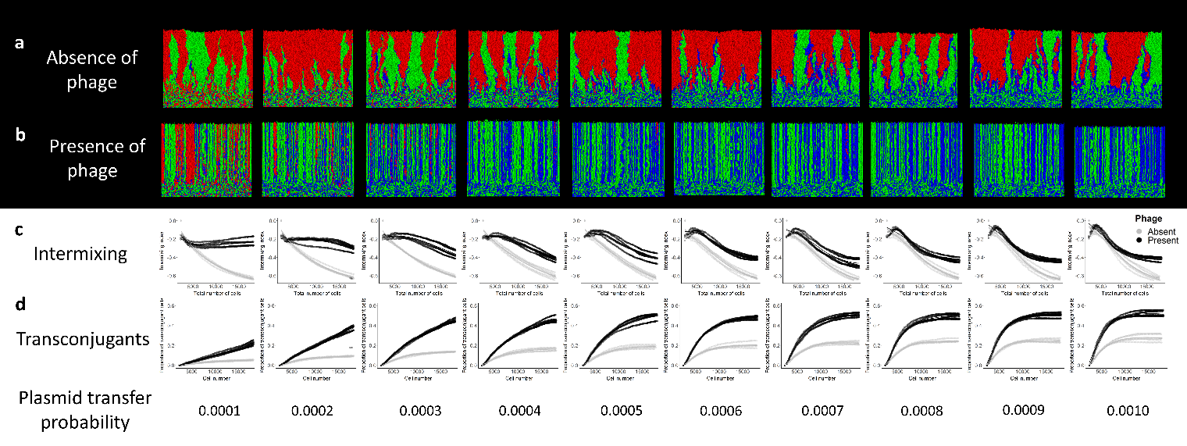

Extended Data Fig. 7: Surface-associated growth simulations in the presence of a plasmid as a function of the plasmid transfer probability. a,b, Representative simulations of two competing strains where the red cells are potential recipients and the green cells carry a plasmid that reduces the growth rate by 5%. If a red cell receives the plasmid from a green cell, its growth rate is reduced accordingly and appears blue. We simulated biomass growth as a function of the plasmid transfer probability in the (a) absence or (b) presence of phage until reaching a population size of 18,000 cells. c, The intermixing index as a function of the radial distance from the centroid of the inoculation area to the final biomass periphery. d, The frequency of transconjugants as a function of the radial distance from the centroid of the inoculation area to the final biomass periphery. For c and d, data are plotted in the presence (black lines) or absence (grey lines) of phage. Each line is for one of five independent simulations.

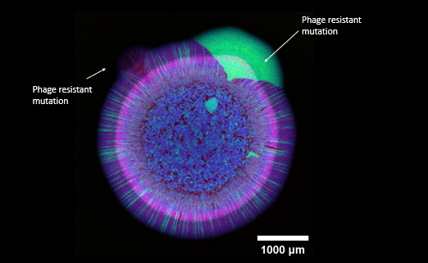

Extended Data Fig. 8: Representative CLSM image of a phage-resistant mutant emerging during surface-associated growth. The R388 donor and potential recipient after six days of growth in anoxic conditions in the presence of phage, where we directly added the phage to the growing biomass. The R388 donor expresses GFP and CFP and appears cyan, the potential recipient expresses RFP and appears red, and transconjugants express RFP and CFP and appear magenta.

Parameter | Description | Value | Unit
$${\text{g}}_{\text{n}}$$ | Specific growth rate when not carrying the plasmid | 1 | -
$${\text{g}}_{\text{plasmid}}$$ | Specific growth rate when carrying the plasmid | 0.95 | -
$${\text{L}}_{\text{0}}$$ | Mean initial cell length | 2 | µm
$${\text{L}}_{\text{d}}$$ | Cell length at division | 3.5-4 | µm
w_{infection} | Width of the peripheral cell layer affected by phage | 4 | µm
$${\text{d}}_{\text{cell}}$$ | Mean diameter of the cells | 0.5 | µm
N | Initial cell number | 1200 | cell
$$\text{P}$$ | Probability of horizontal gene transfer | 0.0001-0.001 | -

Extended Data Table 1: Model parameters used for individual-based computational simulations of surface-associated microbial growth in the presence of a plasmid.

