SUPPLEMENTAL MATERIAL
Antioxidant and In-vitro cytotoxic potential of Hydro-alcoholic seed extract of Ingudi (Balanites aegyptiaca Linn. Delile)

Sanjeev Kumar^{1#*}, Amit Ranjan^{1#}, Manoj Kumar Das², Neelu Singh³, Poonam Pal¹, Nancy Tripathi⁴, Rajesh Kumar Singh¹, , Kamal Nayan Dwivedi¹, Rajesh Sharma⁵, Shreyans K. Jain⁴

¹Department of Dravyaguna, Faculty of Ayurveda, Institute of Medical Sciences, Banaras Hindu University, Varanasi-221005, India
² Department of MBBT, Tezpur University, Assam, India
³School of Environmental Science, Jawaharlal Nehru University, New Delhi, 110067, India
⁴Department of Pharmaceutical Engineering & Technology, Indian Institute of Technology BHU, Varanasi-221005, India
⁵Department of Dravyaguna, Government Ayurvedic College & Hospital, Akhnoor, Jammu-181201, India
First Author: #

*Correspondence author: Dr. Sanjeev Kumar
Department of Dravyaguna
Faculty of Ayurveda
Institute of Medical Sciences
Banaras Hindu University, Varanasi-221005, India
Contact No.: + 91-7398098351
Email Id: kumarsanjeevdg@bhu.ac.in

E-mail addresses of the first author1: kumarsanjeevdg@bhu.ac.in
E-mail addresses of co-authors 9: amitranjan1111@gmail.com
E-mail addresses of co-authors2: mgsmonoj@gmail.com
E-mail addresses of co-authors3: nsneelusingh@gmail.com
E-mail addresses of co-authors 4: zoo.s.p.9095@gmail.com
E-mail addresses of co-authors 5: nancytripathi.rs.phe19@itbhu.ac.in
E-mail addresses of co-authors 6: rkszoology@gmail.com
E-mail addresses of co-authors 7: kndbhu@gmail.com
E-mail addresses of co-authors 8: dr.rajeshsh@gmail.com
E-mail addresses of co-authors 10: sjain.phe@iitbhu.ac.in

Abstract:
The well-known medicinal herb Balanites aegyptiaca has long been utilized by local people to treat a variety of human illnesses, particularly Krimighna (antibacterial), Kusthagna (skin disease), Vrana-Ropaka (wound healer), and Vishaghna (antioxidant). In this study, the phytochemical, and cell toxicity were evaluated using previously reported standard methodology. Briefly, the crude extract of seeds was prepared by hydro-alcoholic (4:6) solvent, concentrated in the rotatory evaporator, and finally lyophilized until completely dry. Utilizing the DPPH method allows for the evaluation of the radical scavenging capacity. The cytotoxicity was evaluated by cell proliferation assay (MTT) against MCF-7, MDA-MB-231, FaDu, and human PBMCs cells 2×10³ cells. The results showed that the hydro-alcoholic extract of the seeds of Balanites aegyptiaca has significant antioxidant and anti-cancer properties. The combined result explored its possibility to serve as a raw drug for candidate pharmaceutical drug molecule isolation and use in chronic wound treatment.
Keywords: Balanetes aegyptiaca; Ingudi; Hingot; DPPH free radical; Anticancerous.

Contents

Fig S1. Structure of Balanitin 6
Fig S2. ¹H NMR spectrum of Balanitin 6.
Fig S3. ¹³C NMR spectrum of Balanitin 6.
Fig S4. Mass spectrum of Balanitin 6.

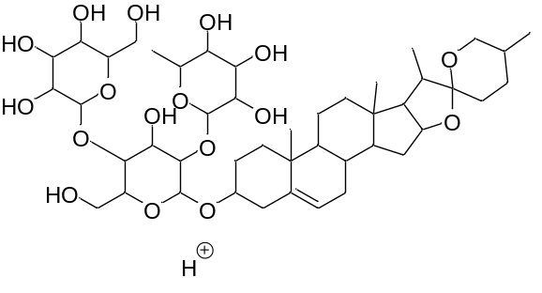
Fig S1. Structure of Balanitin 6

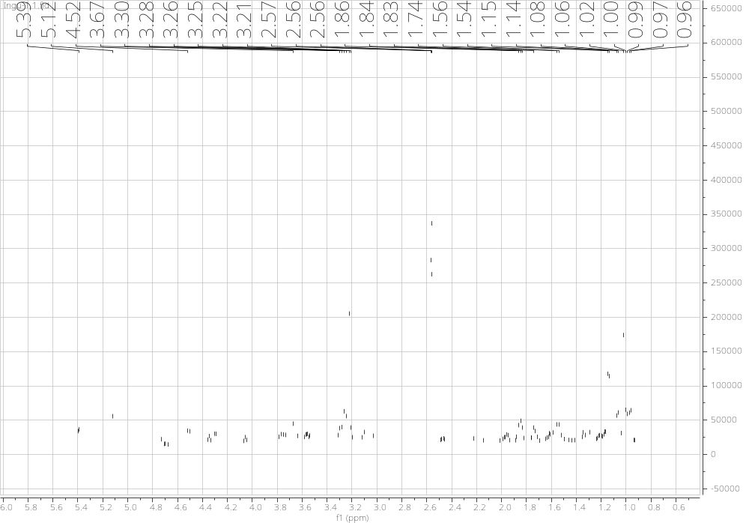
Fig S2. ¹H NMR spectrum of Balanitin 6.

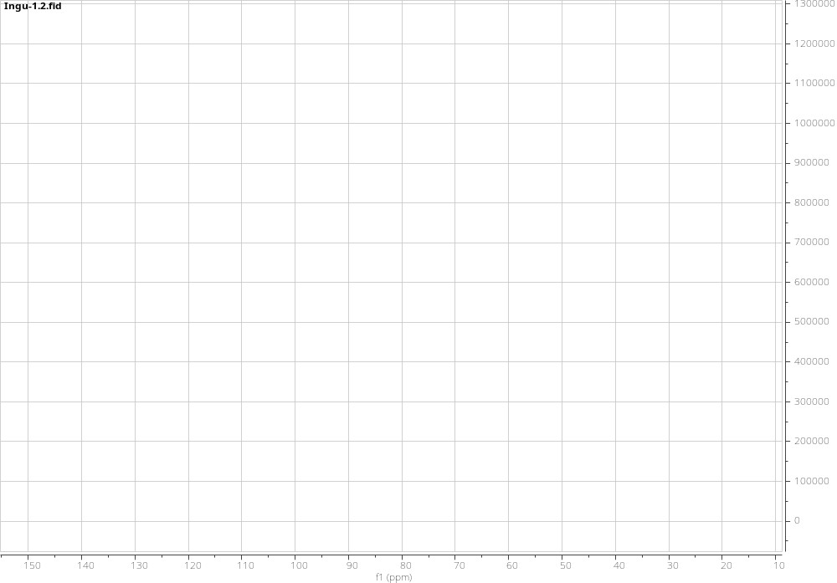
Fig S3. ¹³C NMR spectrum of Balanitin 6.

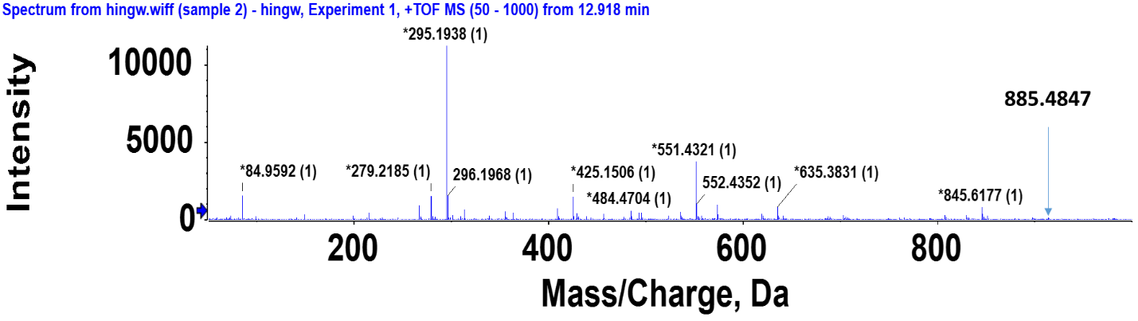

Fig. S4. Mass spectrum of Balanitin 6.

