Supporting Information for
Strain engineering the spin-valley coupling of the R-stacking sliding ferroelectric bilayer R stacking VX₂ (X = S, Se, Te)
Jiayu ma, Xin Luo*, Yue Zheng*
Guangdong Provincial Key Laboratory of Magnetoelectric Physics and Devices, School of Physics, Sun Yat-sen University, Guangzhou 510275, China
State Key Laboratory of Optoelectronic Materials and Technologies, School of Physics, Sun Yat-sen University, 510275, Guangzhou, China
Centre for Physical Mechanics and Biophysics, Sun Yat-Sen University, Guangzhou 510275, China

*Email: luox77@mail.sysu.edu.cn; zhengy35@mail.sysu.edu.cn

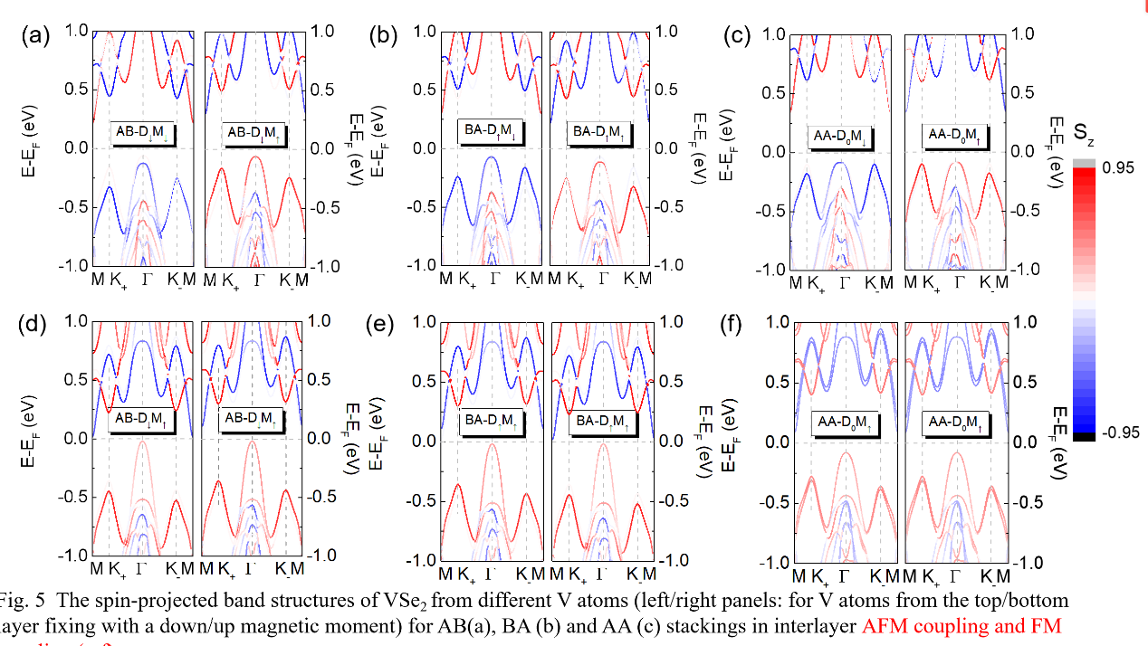
Fig. S1 The spin-projected band structures of VSe₂ from different V atoms for AB, BA and AA stackings in interlayer AFM coupling (a-c) and FM coupling (e-f). The left and right panels of each graph represent V atoms from the top and bottom layers, respectively.

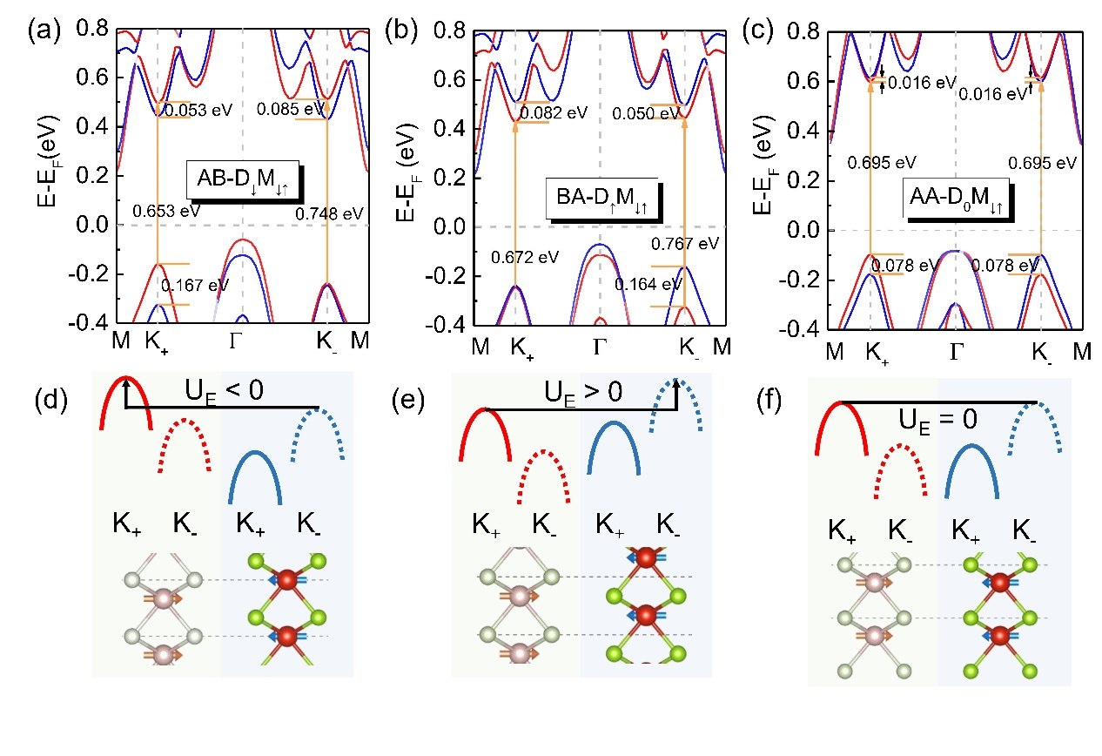
Fig. S2 The enlarged spin-projected band structures for bilayer AFM VSe₂ in AB (a), BA (b) and AA (c) stackings respectively. The black shadowed labels denote the polarizations and magnetic moment correspondingly. (d-f) respectively demonstrate the band alignments of valence band in (a-c). The left and right VSe₂ layers represents the upper and bottom layers, respectively.
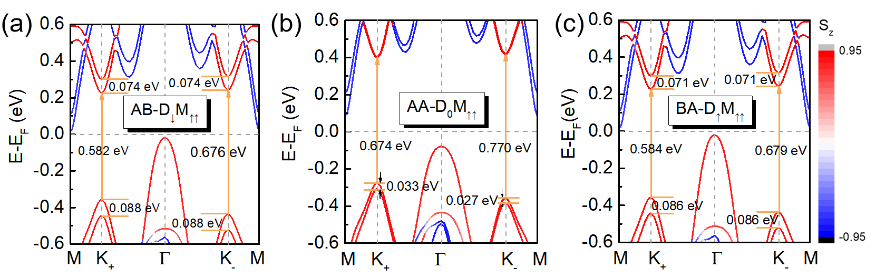
Fig. S3 The enlarged spin-projected band structures for bilayer FM VSe₂ in(a) AB, (b) AA and (c)BA stackings, respectively.

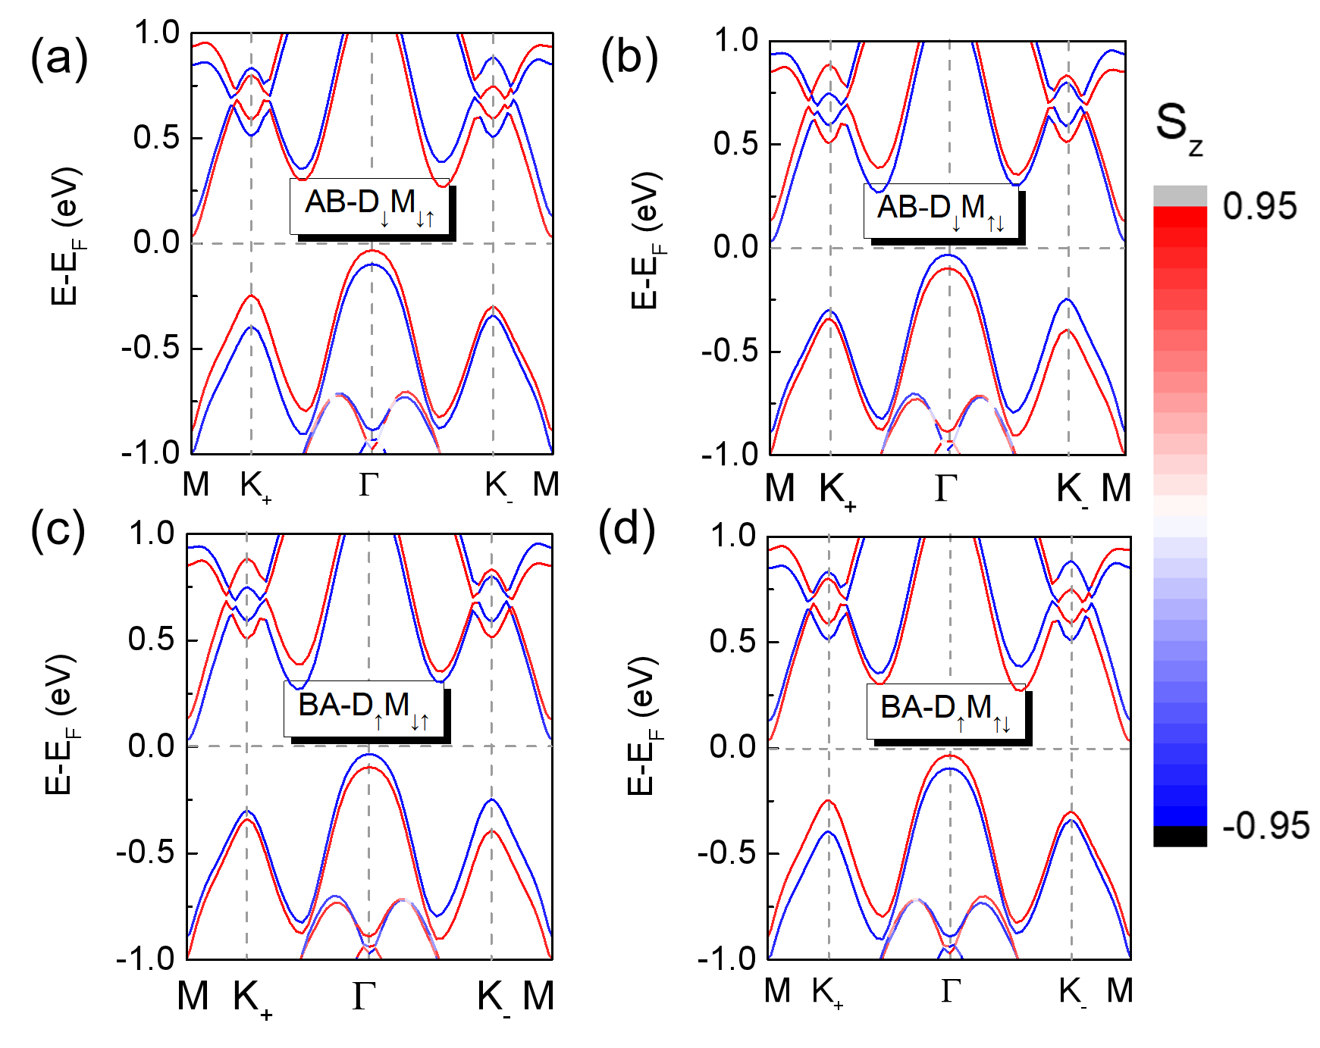
Fig. S4 The spin-projected band structures of VS₂ in AB stacking with (a) head-to-head and (b) tail-to-tail interlayer magnetic moment. Similarly, (c) and (d) represent BA stacking under the same conditions.

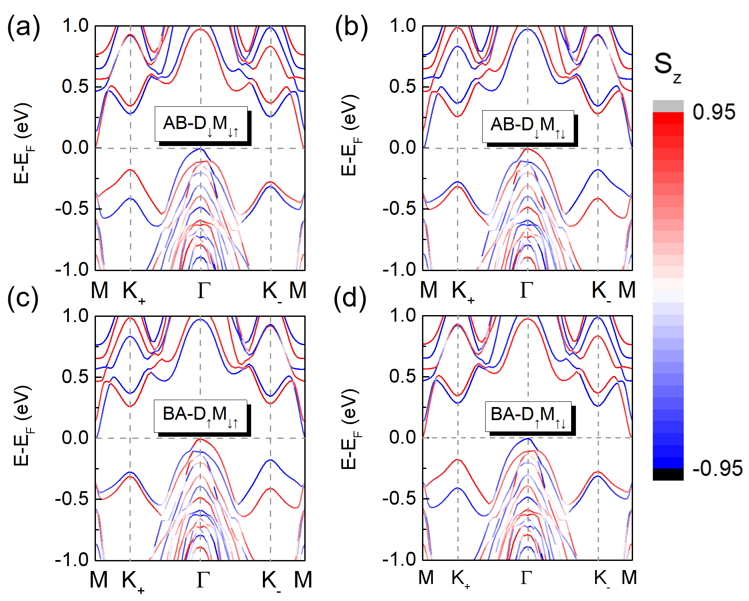
Fig. S5 The spin-projected band structures of VTe₂ in AB stacking with (a) head-to-head and (b) tail-to-tail interlayer magnetic moment. Similarly, (c) and (d) represent BA stacking under the same conditions.

