Figure 1
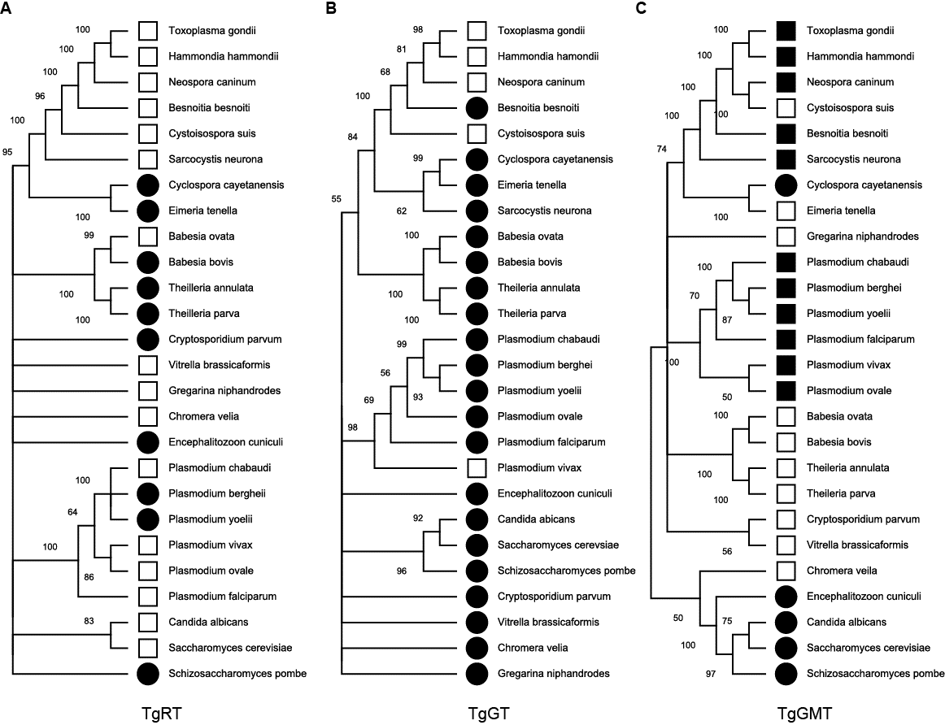

Fig. 1: Phylogenetic tree of capping proteins using MEGA analysis of TgRT (A), TgGT (B), and TgGMT (C) after alignment of full-length protein sequences in 100 bootstrap replicates. The nodes supported >50% are denoted. The open circle represents <200 aa, solid circle 200-600 aa, empty square 601-700 aa, and solid square >1000 aa.

Figure 2

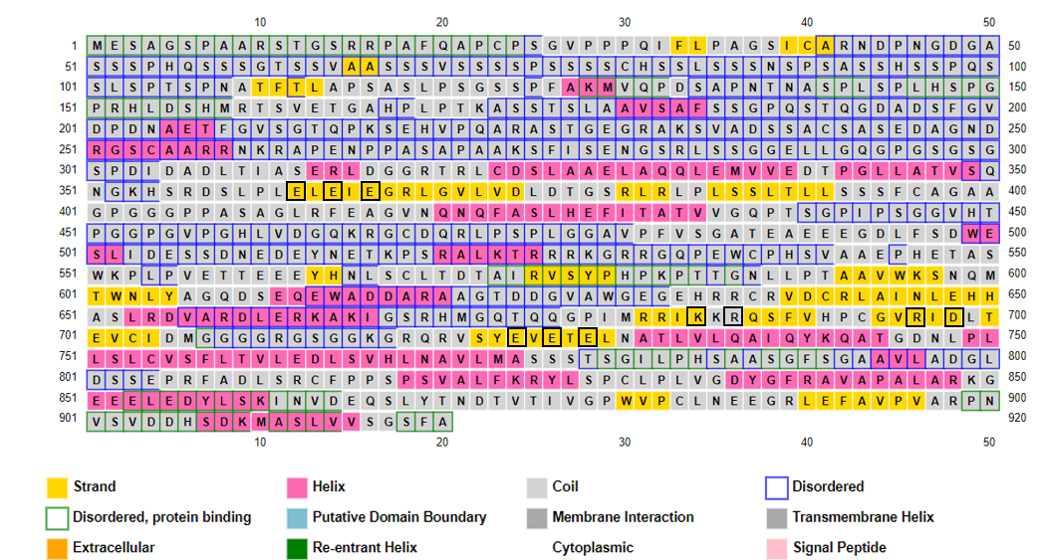

Fig 2. Secondary structure prediction of TgRT (920 aa) using PsiPred. The α helices (pink) and β sheets (yellow) are depicted as per prediction. The 10 conserved hydrophilic amino acid residues are enclosed in a black box. The colour scheme for the other identified secondary structures is depicted below.

Figure 3
ScCeg1 -----------------------------------------------------------M 1
Pcg -----------------------------------------------------------M 1
TgGT MNALHSEAIPPPPEDGRRTAHGEKLRSSSSSSPSSSPSSSSPSSSSSSSSSSSPSSSSSS 60
Pgt ------------------------------------------------------------ 0

ScCeg1 VLAMESRVAPEIPGLIQ-------PGNVTQDLKMMVCKLLNSPKPTKTFPGSQPVSFQHS 54
Pcg APSEKDIEEVSVPGVLA-------PRDDVRVLKTRIAKLLGT--SPDTFPGSQPVSFSKK 52
TgGT PVHSLAVSPAELPGILEGDASGLLPPEQAQRVRERVRKMCGW--SRDSFPGGQPVSLSKS 118
Pgt -----MITSTYHPG------EKIENEFLKEKIRSKINEMLKW--KRRGFPGCNPVSLTNH 47
** . :: : :: *** :***: :

ScCeg1 DVEEKLLAHDYYVCEKTDGLRVLMFIVINPVTG-EQGCFMIDRENNYYLVNGFRFPRLPQ 113
Pcg HLQ-ALKEKNYFVCEKSDGIRCLLYMTEHPRYENRPSVYLFDRKMNFYHVEKIFYPVEND 111
TgGT NLT-ELFRNPYVACEKTDGIRFLLLAASG-------CIFLIGRKEEVRMIPDKFLPRKGR 170
Pgt NIK-NLFTKEYLICEKTDGVRYFLFIASN-------TTFLIDRNYEIF-KNDMHIPTIED 98
.: * : * ***:**:* :: . :::.*: : *

ScCeg1 KKKEELLETLQDGTLLDGELVIQTNPMTK----LQELRYLMFDCLAINGRCL-TQSPTSS 168
Pcg KSG----KKYHVDTLLDGELVLDIYPGGK-----KQLRYLVFDCLACDGIVY-MSRLLDK 161
TgGT LH------EPQQLTLLDGELVMDRLPNG-----ESVARYLIYDAICIERDESIKELNLMG 219
Pgt LS------KKQQLTLLDGELVEDIIYNEKTGVEEKKIVYLIYDGLYIQRKD-ITNLSYFE 151
: ******** : . **::* : : .

ScCeg1 RLAHLGKEFFKPYFDLRAAYP--------------------------------------- 189
Pcg RLGIFAKSIQKPLDEYTKTHM--------------------------------------- 182
TgGT RLAAVAERVVAPLRELEEEERMQSERNEAA--------------------R--------- 250
Pgt RLTNVYNYVITPLKKYKKSQKNKKNKNNLQTNHENESLYIELDEKDNIKKRKSNLNNMLT 211
** . : . * .

ScCeg1 ------------------------------------------------------------ 189
Pcg ------------------------------------------------------------ 182
TgGT -------------ESH-------------------------------------------- 253
Pgt EEENVLISHKKNDHPHINNKNMNAVNVNGVDVNGVNINQDFNNHNENNNLLMNQGILIDE 271

ScCeg1 -----------------------------------------------------NRCTTFP 196
Pcg -----------------------------------------------------RETAIFP 189
TgGT ANDG-----TG------------------------------E----AQLAKTGRTKGKNS 274
Pgt NNNGIQNIGTNDNINSLNNCNLLLYKREEHREEKEYEEEEDERSYSSDDTASTIHEEEIP 331

ScCeg1 FKISMKHMDFSYQLVKVA-KSLDKLPHLSDGLIFTPVKAPYTAGGKDSLLLKWKPEQENT 255
Pcg FLTSLKKMELGHGILKLFNEVIPRLRHGNDGLIFTCTETPYVSGT-DQSLLKWKPKEMNT 248
TgGT LEIYLKDFFEIFDLLHI-QRMALRLPHESDGIIFTPVNLPYATGT-CRQLLKWKPPHLNT 332
Pgt FEIYLKDFYPIEKICEL-IKIMKKLPHYSDGIIFTPLHSPYITGN-FYQLLKWKPLNLNT 389
: :*.: : .: . :* * .**:*** . ** :* ****** . **

ScCeg1 VDFKLILDIPMVEDPSLPKDDRNRWYYNYDVKPVFSLYVWQGGADVNSRLKHFDQPFDRK 315
Pcg IDFMLKLEFAQPEEG----------DIDYSAMPEFQLGVWEGRN---------------- 282
TgGT VDFSADAL-----------------YDEQGVPRLFQLYIADHGVRVF--KGEFLAPYGKL 373
Pgt VDFGIETI-----------------YDEYNIPSKFELFISINGVRTS--YKCYLAEYGDV 430
:** : . *.* :

ScCeg1 EFEILERTYRKFAELSVSDEEWQNLKNLEQPLNGRIVECA-------------------- 355
Pcg -------MYSFFAFMYVDEKEWEKLKSFNVPLSERIVECY-------------------- 315
TgGT YKELLQ--------MA-----------SSTRLSGTIVECFWFASPPVYTFVPSLRSAEDS 414
Pgt YKELLQ--------LA-----------ISNKISHYIIECYYVSKNI-FSI---------- 460
: . :. *:**

ScCeg1 -----------------------KNQETGAWEMLRFRDDKLNGNHTSVVQKVLESINDSV 392
Pcg -----------------------LDD-ENRWRFLRFRDDKRDANHISTVKSVLQSIEDGV 351
TgGT RSDKEVCRWRAWNAAKPLYDVENGTWKEGGWVAERIRTDKSLPNSFQVMKKVQQSIDDSI 474
Pgt ------CKG----------ENGREQKVEGGWIAQKIRFDKNIPNDISTLNKVIQSILDNI 504
. * ::* ** * ..::.* :** *.:

ScCeg1 SLEDLEEIVGDIKRCWDERRANMAGGSGRPLPSQSQNATLSTSKPVHSQPPSNDKEPKYV 452
Pcg SKEDLLKEMPIIREAYYNRKKPSVTK--RKLDETSNDDAP-AIKKV---AKESEKEI--- 402
TgGT TFRTLLREAERYRIHGK-----KTVGEGCTLPPDHKKKAS-------------------- 509
Pgt TIDSLIKEISRNRKAK-------------------------------------------- 520
: * . :

ScCeg1 DEDDWSD 459
Pcg ------- 402
TgGT ------- 509
Pgt ------- 520

Fig. 3 TgGT (509 aa) motif analysis. An alignment of the complete amino acid sequence of TgGT and guanylyltransferase from S. cerevisiae (ScCeg1), S.pombe (Pcg), and P. falciparum (Pgt) revealed the presence of conserved catalytic motifs I to VIa shaded in yellow. The conserved amino acid residues within the catalytic motifs are marked under by an asterisk *

Figure 4
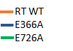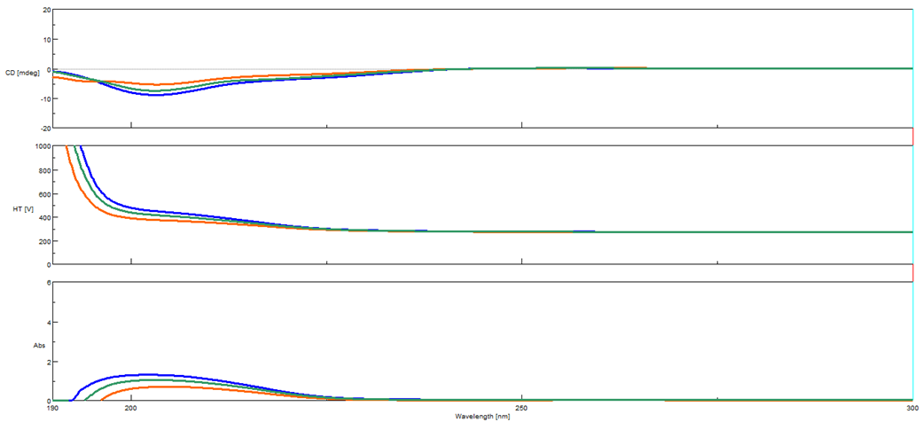
No. | Protein | α helix | β strand
1. | TgRT1 WT | 17.94 | 26.38
2. | E366A | 18.08 | 26.57
3. | E726A | 18.08 | 26.57

Fig. 4 Circular Dichroism (CD) for TgRT WT and E366A, E726A Proteins (Analysis using BeStSel). The proteins were diluted to 0.2 mg/ml, and far-UV spectra were measured three times between 195 and 300 nm at 4 °C using a CD spectrophotometer (Jasco). Data was analyzed for secondary structure using the BeStSel online tool.

Figure 5
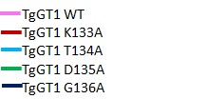
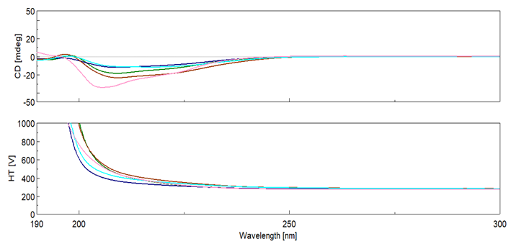
No. | Protein | α Helix | β strand1
1 | WT | 8.42 | 26.36
2 | K133A | 8.42 | 29.09
3 | T134A | 10.45 | 29.09
4 | D135A | 10.45 | 29.09
5 | G136A | 10.45 | 29.09

Fig. 5. Circular Dichroism (CD) for TgGT WT and K133A, T134A, D135A, G136A Proteins (Analysis using BeStSel). The proteins were diluted to 0.2 mg/ml, and far-UV spectra were measured three times between 195 and 300 nm at 4 °C using a CD spectrophotometer (Jasco). Data was analyzed for secondary structure using the BeStSel online tool.
Figure 6
PF3D7_0315100 --MKYLTFNKNNRDAIDLSEKLEATKIDLSNPLLLQYNWVIWEQVSDNKIKQSNNYKDYT 58
TGME49_223410 MAAKFLSFNQELNEAVDLKDWVKEEP-VPDEPLPLRYVWHVWEQVQQDD--RSKEYSDNT 57
*:*:**:: .:*:**.: :: .:** *:* * :****.::. :*::*.* *

PF3D7_0315100 RPLAKFNSVQKFWQLWNRLPQPSDLLAQRSMTRFSEDGIFRIVDALMIFRDNIQPMWEDP 118
TGME49_223410 RDLAAFDTVQKFWQLWSFIPQPSELLDHKRMVRQDKNGRSHVVDAVMIFKEGIKPMWEDP 117
* ** *::********. :****:** :: *.* .::* ::***:***::.*:******

PF3D7_0315100 ANSGGGHFEYKILPKDYPYSQIDEFWNNLVLAIIGCSLKHYDLITGIRLVDKLSTTRYGY 178
TGME49_223410 RNATGGHFEYRLSFPQMSAGQIDEYWNNLVLGLIGSTVEGSDHITGVRLVDKLSQGRHSC 177
*: ******:: : .****:******.:**.::: * ***:******* *:.

PF3D7_0315100 IRIEIWYTTITDESVKNYLRKDLEEHMCNRIDGSTIFPPRVKSLSHIHR 227
TGME49_223410 IRIEVWYSKLPSREVQDALLKEINKCMATKIDGSVGTLPRADVKSHGK- 225
****:**:.: ...*:: * *:::: *..:****. **.. ** :

Fig. 6: Pairwise alignment of TgeIF4E and PfeIF4E1 showing conserved amino acid residues interacting with m7G binding residues (marked in yellow). Amino acid residues involved in eIF4G binding are marked in purple. Numbers to the right of the sequences indicate the positions of residues.

Figure 7
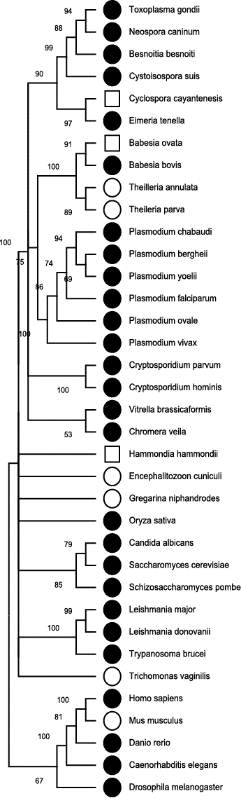
Fig. 7 A Dendrogram of eIF4e proteins from 36 different species. The open circle represents <200 aa, the solid circle is 200-600 aa, and the open square 601-1000 aa. Branches with bootstrap support less than 50% are collapsed.
Figure 8
A

1 mesagspaar stgsrrpafq apcpsgvppp qiflpagsic arndpngdga sssphqsssg
61 tssvaasssv sssspssssc hsslsssnsp sasshsspqs slsptspnat ftlapsaslp
121 sgsspfakmv qpdsapntna splsplhspg prhldshmrt svetgahplp tkasstslaa
181 vsafssgpqs tqgdadsfgv dpdnaetfgv sgtqpksehv pqarastgeg raksvadssa
241 csasedagnd rgscaarrnk rapenppasa paaksfisen gsrlssggel lgqgpgsgsg
301 spdidadlti aserldggrt rlcdslaael aqqlemvved tpgllatvsq ngkhsrdslp
361 leleiegrlg vlvdldtgsr lrlplssltl lsssfcagaa gpgggppasa glrfeagvnq
421 nqfaslhefi tatvvgqpts gpipsggvht pggpgvpghl vdgqkrgcdq rlpsplggav
481 pfvsgateae eegdlfsdwe slidessdne deynetkpsr alktrrrkgr rgqpewcphs
541 vaaephetas wkplpvette eeyhnlsclt dtairvsyph pkpttgnllp taavwksnqm
601 twnlyagqds eqewaddara agtddgvawg egehrrcrvd crlainlehh aslrdvardl
661 erkakigsrh mgqtqqgpim rrikkrqsfv hpcgvridlt evcidmgggg rgsggkgrqr
721 vsyeveteln atlvlqaiqy kqatgdnlpl lslcvsfltv ledlsvhlna vlmassstsg
781 ilphsaasgf sgaavladgl dsseprfadl srcfppspsv alfkrylspc lplvgdygfr
841 avapalarkg eeeledylsk invdeqslyt ndtvtivgpw vpclneegrl efavpvarpn

B

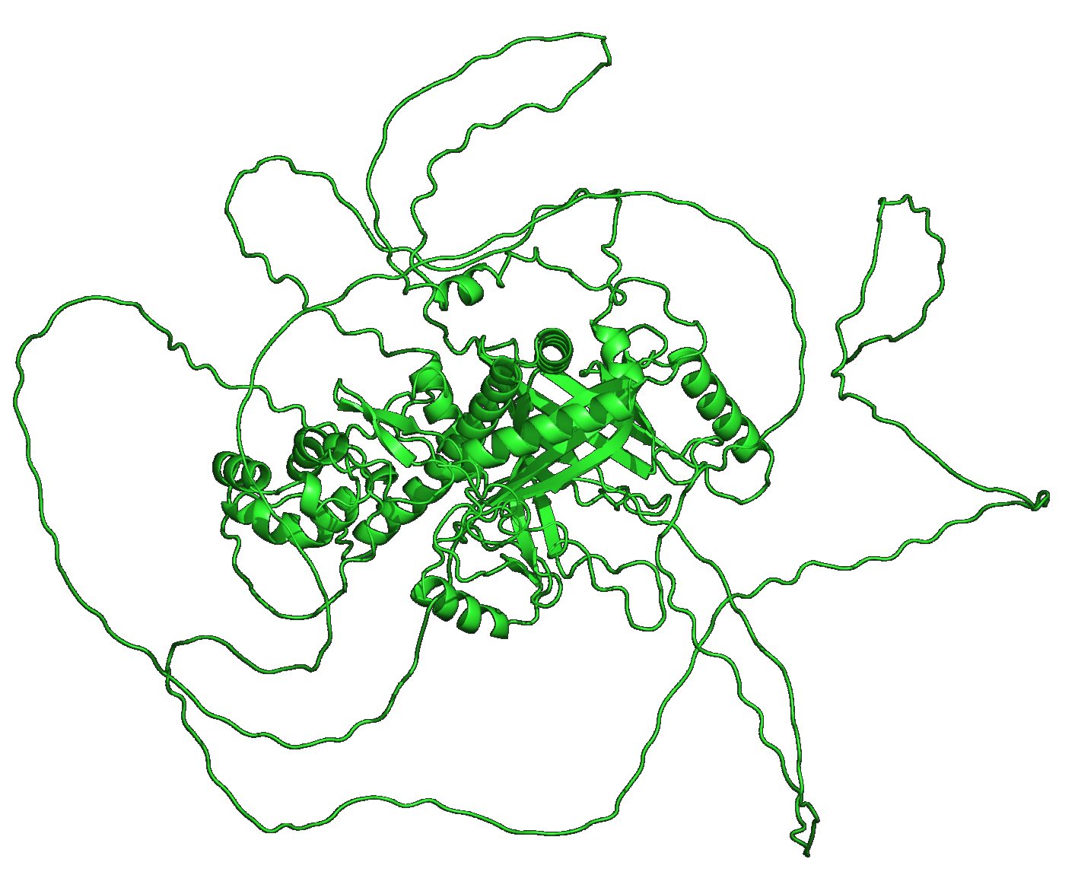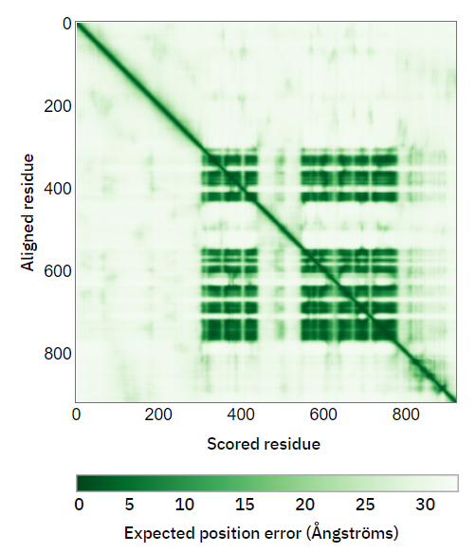

C

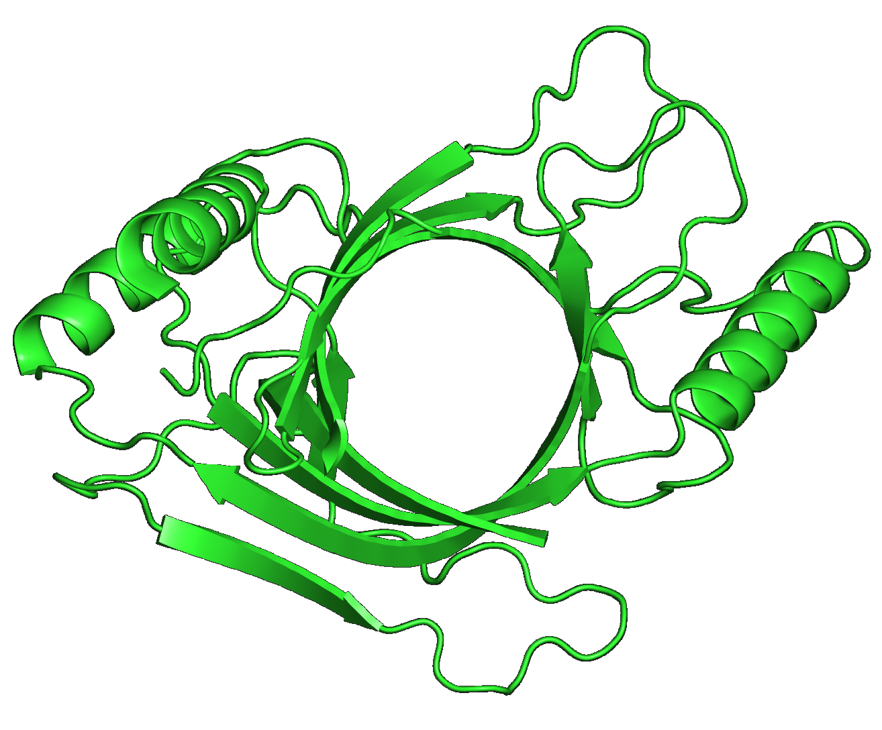

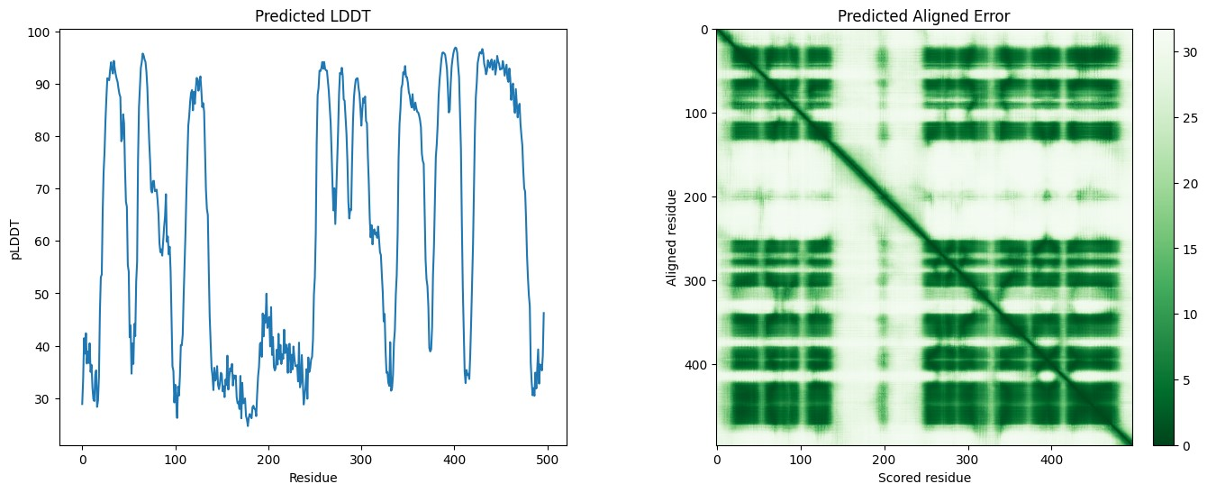

Fig 8. TgRT (S8F0G9) structure prediction using Collabfold.
Fig. A Total amino acid sequence of full-length TgRT (920aa)
Fig. B Structure prediction for TgRT triphosphate tunnel. The PAE score for full-length TgRT is found to be poor. Unstructured part (indicated by the low local PAE score).
Fig. C The amino acid (361-729) marked in yellow (Fig A) was selected for structure prediction using Collabfold. Sequence alignment indicates the number of sequences that could be aligned to each position. Note the overall change in PAE score compared to full-length TgRT.

