Online Supplementary Resource for Journal of Affective Science

To accompany

Peer Threat Evaluations Shape One’s Own
Threat Perceptions and Feelings of Distress
Lisa Espinosa¹*, Erik C. Nook²*, Martin Asperholm¹, Therese Collins^{1,3}, Juliet Y. Davidow⁴, & Andreas Olsson¹
*equal contribution
1 – Karolinska Institutet., 2 – Princeton University, 3 – Monash University, 4 – Northeastern University

Address correspondence to:
Lisa Espinosa
Division of Psychology, Department of Clinical Neuroscience
Karolinska Institutet
Nobels väg 9
171 77 Solna, Sweden
lisaespinosaa@gmail.com

Table of Contents
I. Table ESM_1: OASIS image normed valence ratings and examples of images
II. Computational approach
II.1 Study 1 Computational Results
II.2 Study 2 Computational Results
II.3 Discussion of the Computational Approach
III. Correlation between θ and φ for study 1 and 2
IV. Computational model parameter recovery statistics
I. Table ESM_1. Valance Mean and Standard Deviation for OASIS Images for Studies 1 & 2
Image Nbr | Theme | Category | M | SD | Study
I14 | Angry face 3 | Person | 2.5 | 1.06 | 2
I21 | Angry pose 2 | Person | 2.81 | 1.00 | 1 & 2
I26 | Animal carcass 5 | Animal | 1.62 | 1.04 | 1 & 2
I27 | Animal carcass 6 | Animal | 2.40 | 1.47 | 1 & 2
I82 | Bloody knife 1 | Object | 1.84 | 1.06 | 1 & 2
I89 | Bored pose 4 | Person | 3.13 | 1.02 | 1
I117 | Car accident 2 | Object | 1.97 | 1.01 | 1 & 2
I122 | Car crash 3 | Scene | 2.03 | 0.83 | 1 & 2
I136 | Cat 7 | Animal | 3.32 | 1.26 | 1 & 2
I166 | Cockroach 1 | Animal | 2.06 | 1.18 | 1 & 2
I208 | Dead bodies 1 | Person | 1.20 | 0.74 | 1 & 2
I209 | Dead bodies 2 | Person | 1.25 | 0.70 | 1 & 2
I215 | Depressed pose 3 | Person | 2.66 | 0.96 | 1 & 2
I233 | Destruction 10 | Scene | 2.10 | 1.04 | 1 & 2
I235 | Destruction 2 | Scene | 2.18 | 1.02 | 2
I276 | Dog 26 | Animal | 1.30 | 0.69 | 1 & 2
I282 | Dog attack 1 | Animal | 2.85 | 1.45 | 1 & 2
I284 | Dog Attack 3 | Animal | 2.65 | 1.28 | 1 & 2
I287 | Dummy | Object | 1.16 | 0.55 | 1 & 2
I306 | Explosion 5 | Scene | 1.82 | 1.30 | 1 & 2
I310 | Feces 2 | Object | 2.01 | 1.03 | 1 & 2
I314 | Fence 4 | Object | 2.88 | 1.10 | 2
I316 | Fence 6 | Object | 4.31 | 1.02 | 1 & 2
I317 | Ferret 1 | Animal | 2.80 | 1.19 | 1
I324 | Fire 7 | Scene | 1.74 | 0.90 | 2
I325 | Fire 8 | Scene | 4.20 | 1.70 | 1
I326 | Fire 9 | Scene | 1.47 | 0.74 | 1 & 2
I343 | Flood 3 | Scene | 2.29 | 1.16 | 1 & 2
I380 | Garbage dump 2 | Scene | 1.60 | 0.78 | 1 & 2
I383 | Garbage dump 5 | Scene | 2.14 | 1.01 | 1 & 2
I387 | Gargoyle 1 | Object | 3.90 | 1.37 | 1
I398 | Gorilla 1 | Animal | 3.90 | 1.35 | 1 & 2
I408 | Graveyard 3 | Scene | 3.58 | 1.23 | 1 & 2
I411 | Gun 1 | Object | 2.73 | 1.47 | 2
I421 | Hallway 1 | Scene | 2.61 | 1.13 | 1
I438 | Injury 2 | Person | 2.09 | 0.76 | 1 & 2
I440 | Injury 4 | Person | 1.39 | 0.93 | 1 & 2
I441 | Intensity 1 | Person | 2.81 | 1.14 | 1 & 2
I444 | Jail 3 | Scene | 2.52 | 1.19 | 1 & 2
I446 | Jail 5 | Scene | 3.07 | 1.35 | 1 & 2
I496 | Miserable pose 3 | Person | 1.10 | 0.41 | 1 & 2
I503 | Monkey 4 | Animal | 2.86 | 1.10 | 1 & 2
I591 | Opossum 1 | Animal | 3.28 | 1.28 | 1 & 2
I638 | Plane crash 3 | Scene | 2.23 | 1.04 | 1 & 2
I639 | Plane crash 4 | Scene | 2.04 | 1.04 | 2
I641 | Police 2 | Person | 2.39 | 1.26 | 1 & 2
I644 | Police 5 | Person | 2.43 | 1.24 | 1 & 2
I649 | Prison 1 | Scene | 4.03 | 1.23 | 1 & 2
I683 | Rooster 1 | Animal | 4.32 | 1.17 | 1
I714 | Scary face 1 | Person | 1.77 | 0.98 | 1 & 2
I725 | Severed finger 1 | Person | 1.67 | 0.90 | 1 & 2
I729 | Shark 4 | Animal | 3.08 | 1.12 | 1 & 2
I740 | Shot 3 | Object | 1.91 | 0.97 | 1 & 2
I770 | Snake 4 | Animal | 2.37 | 1.26 | 2
I771 | Snake 5 | Animal | 2.90 | 1.35 | 1 & 2
I794 | Spider 2 | Animal | 2.90 | 1.42 | 1 & 2
I802 | Storage 3 | Object | 3.70 | 1.14 | 1
I816 | Surgery 1 | Person | 2.91 | 1.14 | 1 & 2
I824 | Swingset 1 | Object | 4.31 | 0.73 | 1
I825 | Thuderstorm 1 | Scene | 3.17 | 1.36 | 1 & 2
I848 | Tornado 1 | Scene | 2.09 | 1.11 | 1 & 2
I853 | Torture chamber 1 | Object | 3.36 | 1.30 | 1 & 2
I855 | Tumor 1 | Person | 1.40 | 0.72 | 1 & 2
I864 | War 1 | Person | 1.75 | 1.28 | 1 & 2
I867 | War 4 | Person | 2.97 | 1.38 | 1 & 2
I869 | War 6 | Person | 1.39 | 0.88 | 1 & 2
I873 | Weapon 1 | Object | 2.84 | 1.38 | 1 & 2
Practice trials
I274 | Dog 24 | Animal | 1.89 | 1.08 | 1
I316 | Fence 6 | Object | 4.31 | 1.02 | 1 & 2
I325 | Fire 8 | Scene | 4.20 | 1.70 | 2
Note. OASIS images from: Kurdi, B., Lozano, S., & Banaji, M. R. (2017). Introducing the Open Affective Standardized Image Set (OASIS). Behavior Research Methods, 49(2), 457–470. doi: 10.3758/s13428-016-0715-3

Examples of OASIS images used in Study 1 and 2:
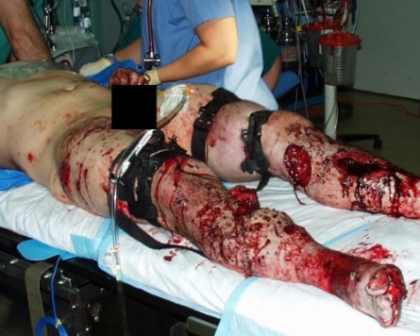  Injury 4.jpg | 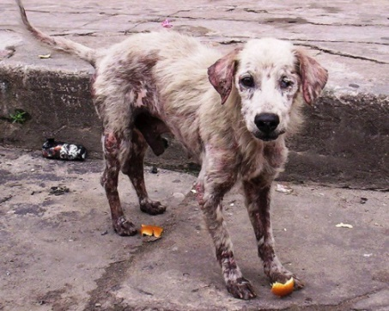  Dog 24.jpg
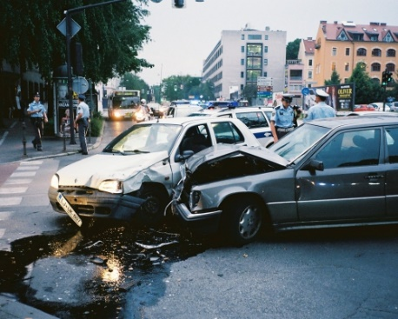  Car crash 3.jpg | 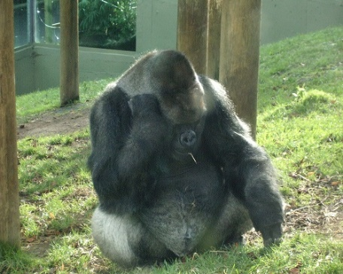  Gorrila 1.jpg
II. Computational Approach
We developed a novel decision-making computational model to predict participants’ decisions to categorize images as either threatening or safe. Like other choice models, participants’ decisions on each trial are modeled as a combination of item-level information moderated by person-level parameters. Similar to (Goldenberg et al., 2019; Mavrodiev et al., 2013), we fit computational models to estimate individual-level sensitivity to social influence. Specifically, we built models testing whether just peer threat ratings, peer safety ratings, both, and other free parameters could estimate participant behavior. More specifically, our hypothesized model estimates participants’ decision to categorize the picture as threatening or safe in the following way:
C = D₁ + θT + φS
where C is the participant’s categorization of the image (1 = threatening, 0 = safe), D1 is the participant’s initial distress rating in response to the image, T is the number of previous participants who have categorized the image as threatening, S is the number of previous participants who have categorized the image as safe, θ (Theta) is a free parameter measuring how strongly participants incorporate peers’ threat categorizations into their own categorizations, and φ (Phi) is a free parameter measuring how strongly participants incorporate peers’ safety categorizations into their own categorizations.
Models were fit to estimate θ and φ for each participant, bounded between -1 and 1. A standard softmax function with a free temperature parameter was used in this model (Daw et al., 2006; Schulz & Gershman, 2019; Wilson & Collins, 2019; Zhang et al., 2020). In our preregistrations, we planned to compare the model above to three alternative models to find the best fitting model of participants’ decisions to categorize images as threatening or safe: (i) a model that only includes initial distress ratings and peers’ threat categorizations without including peers’ safe categorizations (i.e., C = D₁ + θT), (ii) a model that only includes initial distress ratings and peers’ safety categorizations without including peers’ threat categorizations (i.e., C = D₁ + φS), and (iii) a model in which a third free parameter δ (Delta) weights the influence of initial distress ratings (i.e., C = δD₁ + θT + φS). Following preregistration, we also devised two additional models that we believed were important to test: (iv) a model that treated participants’ sensitivity to peers’ safety categorizations as merely the opposite of their sensitivity to peers’ threat categorizations [i.e., C = D₁ + θT + (-θ)S] and (v) a model that treated participants’ sensitivity to peers’ threat categorizations as merely the opposite of their sensitivity to peers’ safety categorizations [i.e., C = D₁ + (-φ)T + φS]. These last two models are important for testing whether After penalization for models with higher parameter complexity, the best-fitting model (i.e., the model with the lowest average AIC (Akaike Information Criterion) and BIC (Bayesian information criterion) across participants) was selected and interpreted.
Model Comparisons for Studies 1 and 2
We tested four competing computational models of participants’ data to find the best fitting model of participants’ decisions to categorize images as threatening or safe (Table ESM_2). Using average AIC and BIC, we found that the best fitting model, after penalization for models with higher parameter complexity, included participants’ initial distress ratings for each image, peer threat categorizations for each image (scaled by the free parameter θ that captured how sensitive participants were to peer threat categorizations), and peer safety categorizations for each image (scaled by the free parameter φ that captured how sensitive participants were to peer threat categorizations). Parameter recovery statistics were acceptable (see Table ESM_3). Consequently, θ and φ were extracted for further analyses in both studies.
Table ESM_2. Model comparison statistics.
Model | Study 1 AIC | Study 1 BIC | Study 2 AIC | Study 2 BIC
C = D₁ + θT + φS | 51.33 | 57.61 | 54.54 | 60.82
C = D₁ + θT | 57.51 | 61.70 | 58.42 | 62.61
C = D₁ + φS | 56.71 | 60.89 | 58.94 | 63.13
C = δD₁+ θT + φS | 52.87 | 61.24 | 56.01 | 64.38
C = D₁ + θT + (-θ)S | 59.43 | 63.62 | 59.09 | 64.10
C = D₁ + (-φ)T + φS | 59.43 | 63.62 | 59.09 | 64.10
Notes: Bold indicates best fitting model (as determined by lowest average AIC and BIC). AIC = Akaike Information Criterion, BIC = Bayes Information Criterion, C = participant's evaluation of the image as threatening (1) or safe (0), D₁ = participant’s initial distress rating of the image, T = number of peers who categorized the image as threatening, S = number of peers who categorized the image as safe.

II.2 Study 1 Computational Results
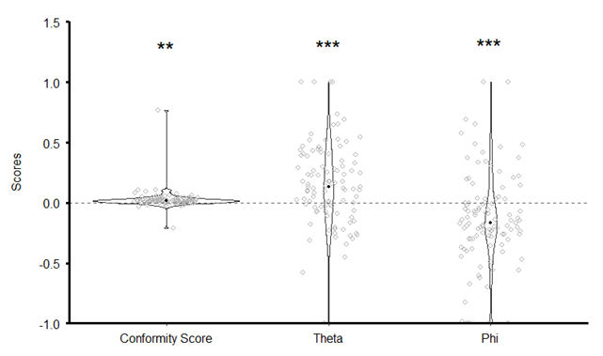
Figure S1. Study 1 Results Showing Individual Score Distributions for Conformity Scores, θ (Theta) and φ (Phi). Black dots indicate the mean for each dependent variable. All three means are significantly different than 0, **p <.01, *** p <.001

Computational Parameters
Computational approaches corroborated the result presented in the main text. As illustrated in Figure S1, θ (i.e., a computational estimate of the influence of the number of peers who categorized an image as threatening on participants’ decision to categorize an image as threatening) was significantly greater than 0 (M = .15, SD = .33, t(102) = 4.58, p < .001, d = .45), and φ (i.e., a computational estimate of the influence of the number of peers who categorized an image as safe on participants’ decision to categorize an image as threatening) was significantly less than 0 (M = -.13, SD = .38, t(102) = -3.45, p < .001, d = -.34). This means that our results show again that participants incorporated both peers’ threat and safety evaluations. We hypothesized that, compared to the evaluation of something being safe to share, the evaluation of something being threatening would be less dependent to how many others evaluated this image as threatening. A paired-samples t-test indicated that the absolute value of θs in the sample was not significantly greater than the absolute values of φs (t(102) = 1.11, p = .26). This means that, contrary to prediction, peers’ threat categorizations did not influence participants’ decision to categorize images as threatening more strongly than peers’ safety categorizations, and suggests that when exposed to other people’s evaluation of a negative content (such as the pictures used in this study), individuals equally integrate safety and threat online information.
Relations between computational and regression approaches
Finally, a Pearson correlation test showed that conformity scores presented in the main text were significantly correlated with both θ (r(103) = .28, p = .009) and φ (r(103) = -.40, p < .001) suggesting a convergence between the computational and regression approaches. Testing our predefined formal model, comparing it to a regression approach and showing their convergence demonstrates that computational models can help developing transparent explanatory psychological theories (Guest & Martin, 2021).
In our study design, threat/safety evaluations were perfectly anticorrelated (i.e. all participant evaluations summed to 100 so if 70 provided threat evaluations then 30 provided safe evaluations and vice versa). To mitigate the concern that this design feature led threat and safety inputs to “trade off” in our model, we verified that (i) as described above, model fit significantly improved when both peer threat and safety evaluations were included in the model rather than only one of them even when using AIC and BIC which penalize for more complex models; (ii) model fit also significantly improved when the parameter that scaled peer threat categorizations was not treated merely as the inverse of the parameter that scaled peer safety categorizations (suggesting that these two parameters are computationally distinct); (iii) θ and φ were only weakly correlated across participants (r(103) = .20, p = .04, see Figure ESM_4a ), and (iv) parameter recovery in simulated data showed high recoverability of θ and φ (rs = .98) and that there was low bleed over across these parameters (i.e., varying the “ground truth” of θ did not lead to variations in recovered φ (rs = .09, Table ESM_3 and Figure ESM_5).

II.2 Study 2 Computational Results
Replicating Study 1. As in Study 1, we ran a one-way t-tests to assess whether the mean of θs was significantly greater than 0, and whether the mean of φs was significantly less than 0. We also used a paired-samples t-test to assess if the absolute value of θs in the sample was significantly greater than the absolute values of φs, and we assessed the relationship between conformity scores, θ, and φ using Pearson correlations.
Testing Influence of Peer Categorization on Follow-up Distress Ratings. we computed a Pearson correlation coefficient to assess the relationship between emotional influence scores and both θ and φ. We hypothesized that the degree to which participants incorporate peers’ information in the categorization of images relates to how strongly peers’ information influences their emotional responses to the images. Third, we used mixed-effects models to try to predict participants’ follow-up distress ratings at the trial level based on their computationally derived free parameters. We produced three different mixed-effect models, which we applied to participants’ data at the trial level. These regressions modeled participants’ follow-up distress ratings as the outcome variable and included different combinations of predictors to test whether computationally derived free parameters enhanced the ability of the model to predict follow-up ratings. We tested three models of how participants’ follow-up distress ratings could be predicted from combinations of participants’ initial ratings and computational parameters: (1) a model including initial distress ratings alone, (2) a model including initial distress ratings and peers’ categorizations (note that only trial-level threat categorizations were included in the model given that safety and threat categorizations were perfectly anticorrelated), and (3) a full model including initial distress ratings and peers’ categorizations multiplied by each participant’s φ and θ parameters. We hypothesized that the third model would have the best fit (i.e., the lowest AIC). If so, this would provide additional evidence that peers’ categorizations influenced participants’ emotional responses to images and that the computational model provided a meaningful advance in predicting participants’ actual emotional experiences following exposure to peer behavior. We also used chi-squared tests to statistically compare the fit of each model and demonstrate that the winning model was a significantly better fit than the others.
Results
Replicating Study 1
Computational approaches corroborated the result presented in the main text: θ (M = .17, SD = .33) was significantly greater than 0 (t(114) = 5.43, p < .001, d = .50), and φ (M = -.14, SD = .36) was significantly less than 0 (t(114) = -4.15 p < .001, d = -.38), see Figure ESM_2. However, a paired-samples t-test indicated that the absolute value of θs in the sample was not significantly greater than the absolute values of φs (t(114) = .29, p = .77), suggesting that, contrary to prediction but in line with results from Study 1, peers’ threat categorizations did not influence participants’ decision to categorize an image as threatening more strongly than peers’ safe categorizations. Finally, a Pearson correlation test showed that conformity scores were significantly correlated with both θ (r(115) = .57, p < .001) and φ (r(115) = -.54, p < .001). This suggests convergence between the computational and regression approaches. In this study, θ and φ were not correlated (r(115) = .11, p = .24, see Figure ESM_4b).

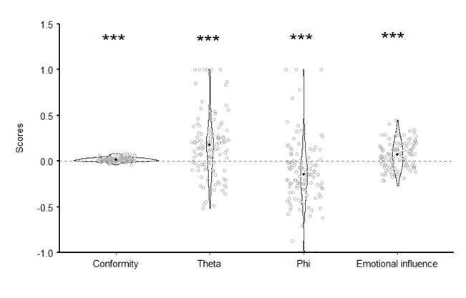
Figure ESM 2. Study 2 Results Showing Individual Score Distributions for Conformity Scores, θ (Theta), φ (Phi) and Emotional Influence Scores. The black dots indicate the mean for each depend variable. All four means are significantly different than 0, ***p <.001

Testing Influence of Peer Categorization on Distress Ratings
Pearson correlation tests showed that emotional influence scores were significantly correlated with φ (r(114) = -.22, p < .05, Figure ESM_3), but not with θ (r(114) = .15, p = .22). Though not a preregistered analysis, we compared these correlations using a Steiger test. We found that these correlations did not differ significantly from each other (z = -.57, p = .56). Consequently, we have evidence from the computational approach that emotional influence is potentially more strongly related to safety peer signals, but it is possible that in a larger sample, both would contribute to distress ratings.
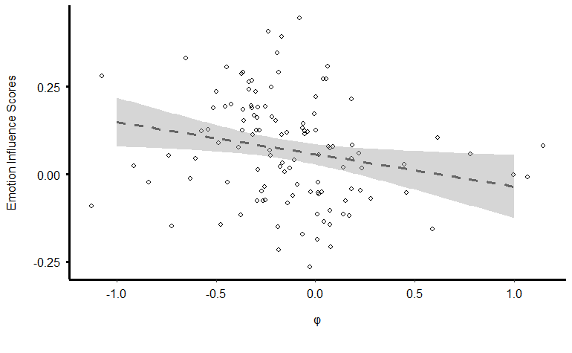
Figure ESM_3. Correlation Between Emotion Influence Scores and φ. Figure showing a significant correlation between emotion influence scores and φ (Phi) in Study 2. Negative φ scores indicate that participants were more likely to categorize the image as “safe” when more peers rated it “safe”. Positive φ score indicate that participants were more likely to categorize the image as “threatening” when more peers rated it “safe”. Our results indicate that individuals who more strongly incorporate peers’ safety evaluations into their own categorizations tend to be more emotionally influenced.

Finally, we used mixed-effects models to test whether computational estimates of participants’ sensitivity to peer threat/safety categorizations (i.e., θ and φ) improved predictions of participants’ trial-level follow-up distress ratings. We tested three models. An initial model (1) that predicted trial-level follow-up distress ratings from only participants’ initial distress ratings fit with an AIC of 59925. A second model (2) that added trial-level peer threat categorizations provided a significantly better fit (AIC = 59887, model comparison chi-square (χ²) = 39.82, degrees of freedom (DF) = 1, p < .001). Finally, a third model (3) that included initial distress ratings, peer threat categorizations multiplied by the participants’ θ, and peer safe categorizations multiplied by the participants φ provided the best fit of all (AIC = 59872, χ² = 16.88, DF = 1, p < .001). As such, the most precise predictions of participants’ follow-up distress ratings were provided by a model that included trial-level initial distress ratings as well as peer categorizations modified by computationally-derived θ and φ parameters, supporting our proposed model of social influence.
II.3 Discussion of the Computational Approach
We used a novel computational modeling approach to show that (i) the decision to categorize images as threatening emerges from integrating both one’s own distress ratings and peers’ evaluations, (ii) participants did not integrate peer threat evaluations into their own evaluations more strongly than peer safety evaluations, and (iii) how strongly one incorporates peer safety information into their own evaluations is correlated with how strongly their emotional responses are influenced by peer information. Although we see the promise of such an approach (Goldenberg et al., 2014, 2020; Lindström et al., 2021; Yu et al., 2021) we are concerned that the application of computational approaches to the current paradigm is limited by the fact that peer threat and safety categorizations are perfectly anticorrelated. We provided several checks that our model provided a better fit than alternative models, that θ and φ were not redundant, and that our parameters were recoverable. However, the fact that our design included perfectly anticorrelated peer threat and safety categorizations nonetheless adds a limit on the generalizability of the model. Because we preregistered these analyses and believe they may inspire further research, we transparently we present these analyses in the Online Resource for interested readers and hope that they may support future research on this topic.

III. Correlation between θ and φ
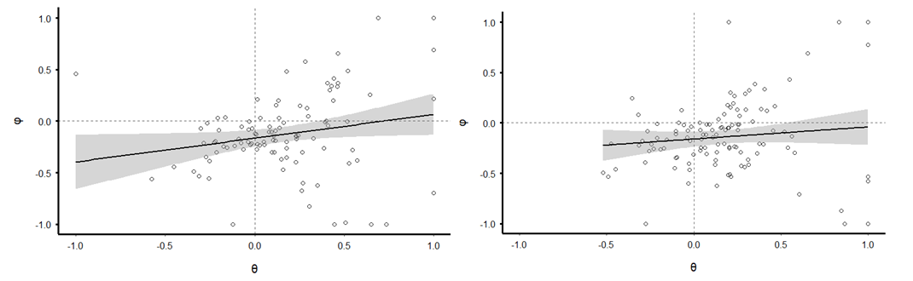
(b)
(a)

Figure ESM_4 a & b. Plots of correlation between θ and φ. a) illustrates a weak correlation in study 1 (r(103) = .20, p = .04). b) illustrates a non-significant correlation in study 2 (r(115) = .11 p = .22).

IV. Computational Model Parameter Recovery Statistics
We performed parameter recovery procedures to ensure that the computational model used in this study could identify participants who had been intentionally constructed with a certain θ and φ. We first defined our target parameter space as 9 levels of θ (-1 to 1 in increments of .25), 9 levels of φ (-1 to 1 in increments of .25) and 4 levels of β (1 to 8.5 in increments of 2.5). We simulated data for 30 participants in each of these 324 parameter combinations, resulting in a total of 9,720 simulated participants. Each simulated subject’s data resembled data from Study 1, with 60 trials of images that were assigned a random number of previous threat/safety categorizations (which summed to 100). We randomized initial distress ratings for these simulated participants from a uniform distribution ranging from 0 to 100. The “value” of participants categorizing an image as threatening was computed following our computational model (C = D₁ + θT + φS) and the participant’s actual decision was then assigned using the standard softmax function with the simulated participant’s assigned β.
We then modeled these simulated participants using the computational model to verify that we could recover participants’ target parameters. As can be seen in Figure ESM_5 and Table ESM_3, we observed high parameter recovery, with extremely strong correlations between “target” and “recovered” θ and φ. We also observed only a small correlation between recovered θ and recovered φ suggesting that there was not strong confusion of these parameters in the modeling process.

Table ESM_3. Parameter recovery correlation coefficients.
 | Target θ | Target φ | Recovered θ
Target θ | -
Target φ | .00 | -
Recovered θ | .98 | .09 | -
Recovered φ | .09 | .98 | .19

Figure ESM_5. Plots of parameter recovery statistics for (A) θ and (B) φ. Bar graphs show the average “recovered” parameters on the y-axis for each level of the “target” parameters on the x-axis along with 95% confidence intervals. Each bar represents scores for 1,080 participants.

