Supplementary Fig.1 Gene ontology analysis showing clusters of genes in a functionally grouped network. Top 10 GO biological category annotations for the differentially expressed genes (DEGs) identified based on the RNA-seq data for control vs electrically stimulated retinal organoid samples (a. BP-1 vs. control, b. BP-2 vs control). A term with P < 0.05 that is considered to be significantly overexpressed is included in this cluster.
Supplementary Fig.2 Ingenuity Pathway Analysis (IPA) data. IPA of differentially expressed genes in retinal organoids showed as a graphical summary representing networks of the major pathways identified as the most significant in the differential transcriptomics data (P < 0.05). The degree of gene downregulation (green) and upregulation (red) are denoted by color codes and the total number of genes belonging to each category is given in the right panel.

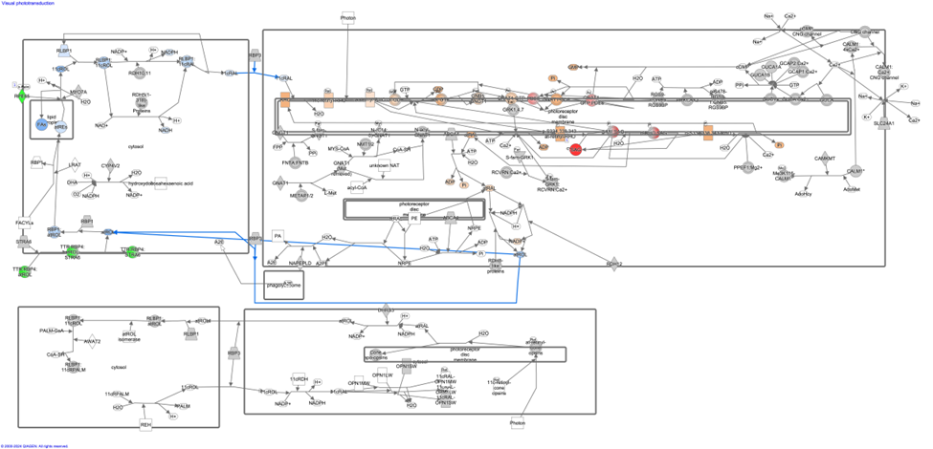
Supplementary Fig.3 Ingenuity Pathway Analysis (IPA) of Visual Phototransduction Pathway in BP-1 Group. IPA data of differentially expressed genes is presented as a graphical summary representing networks of various genes involved. The visual phototransduction pathway was identified as one of the highly differentially expressed pathways in the BP-1 group (P < 0.05). The degree of gene expressions is denoted by different color codes.

Supplementary Fig.4 Number of upregulated and downregulated genes belonging to the key retinal developmental pathways. The bar diagram shows the percentage of differentially expressed genes in BP-1 and BP-2 retinal organoid groups.

Table 1. List of the genes with its corresponding catalog numbers

Probe List | Gene Alias | Cat#(Thermo Fisher)
Recoverin | Rcvrn | Hs00610056_m1
Rhodopsin | Rho | Hs00892431_m1
BRN3A | POU4F1 | Hs00366711_m1
Beta 3 Tubulin | TUBB3 | Hs00964963_g1
Red Green Opsin | OPN1LW | Hs00241039_m1
Cone arrestin | ARR3 | Hs01020134_m1
Red blue Opsin | OPN1SW | Hs00181790_m1
CRALBP | RLBP1 | Hs00165632_m1
Ki 67 | MKI67 | Hs04260396_g1
CRX | CRX | Hs00230899_m1
synaptophysin | SYP | Hs00300531_m1
vGLUT1 | SLC17A7 | Hs00220404_m1
GAPDH | GAPDH | Hs00266705_g1
SAG | S-antigen visual arrestin | Hs01027187_m1

Table 2. List of Antibodies Used
Primary antibodies
Antigen | Species | Specific for | Dilution | Supplier | Catalog #
CRALBP | Rabbit | RPE and Muller cells | 1:1K | Abcam | ab243664
Brn3A | Rabbit | RGC | 1:100 | Thermo fisher scientific | BS-3669R
Recoverin | Rabbit | Photoreceptors, cone bipolar cells | 1:2K | Millipore | AB5585-I
Rhodopsin  (rho1D4) | Mouse | Rods | 1:100 | Invitrogen | MA5-45247
Vimentin | Rabbit | Muller cells | 1:300 | Abcam | ab1373
Synaptophysin | Goat | Membrane protein of synaptic vesicles | 1:100 | Novus Biologicals (Littleton, CO) | AF5555

Secondary antibodies
Conjugate | Species | Specific for | Dilution | Supplier | Catalog # | RRID
Alexa Fluor 488 | Donkey | Rabbit IgG (H + L) | 1:400 | Jackson ImmunoResearch (West Grove, PA, United States) | 711-545-152 | AB_2313584
Rhodamine Red-X | Donkey | Rabbit IgG (H + L) | 1:400 | Jackson ImmunoResearch | 711-295-152 | AB_2340613
Alexa Fluor 488 | Donkey | Mouse IgG (H + L) | 1:400 | Jackson ImmunoResearch | 715-545-150 | AB_2340846
Rhodamine Red-X | Donkey | Mouse IgG (H + L) | 1:400 | Jackson ImmunoResearch | 715-295-151 | AB_2340832

Table 3. List of Differentially Expressed Genes that were Upregulated and Downregulated

- Neuronal Maintenance and Functionality BP-1
BP-1
b. Neuronal Maintenance and Functionality BP-2

BP-2
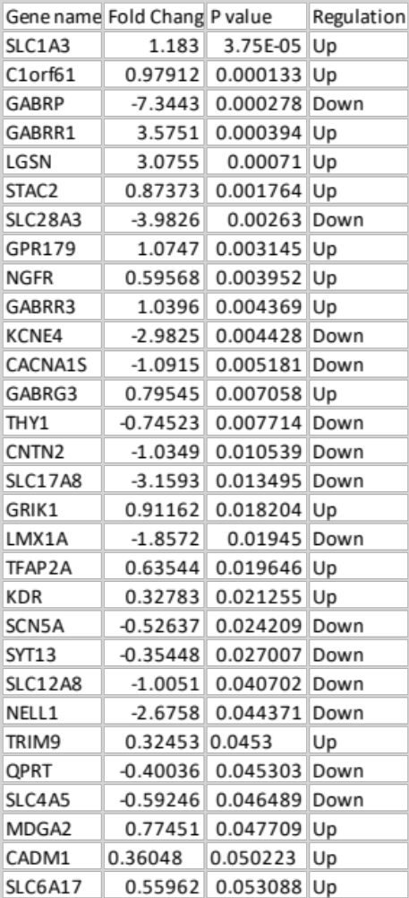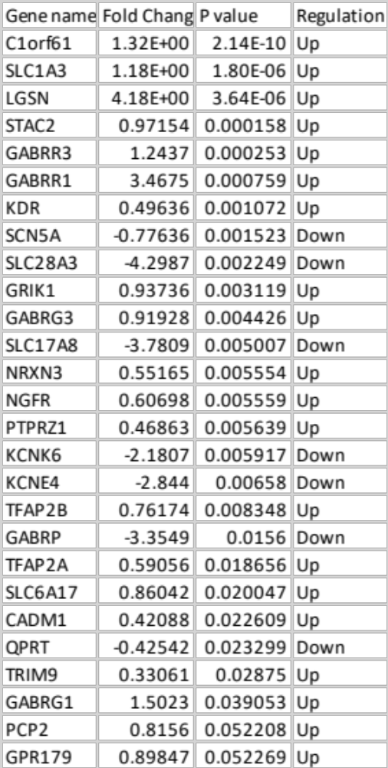

c. Neuronal Development and Maturation BP-1

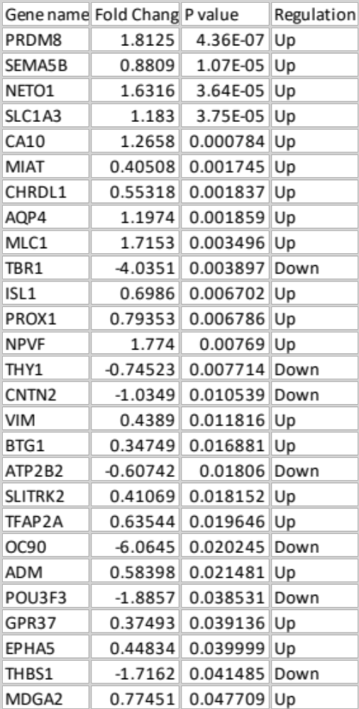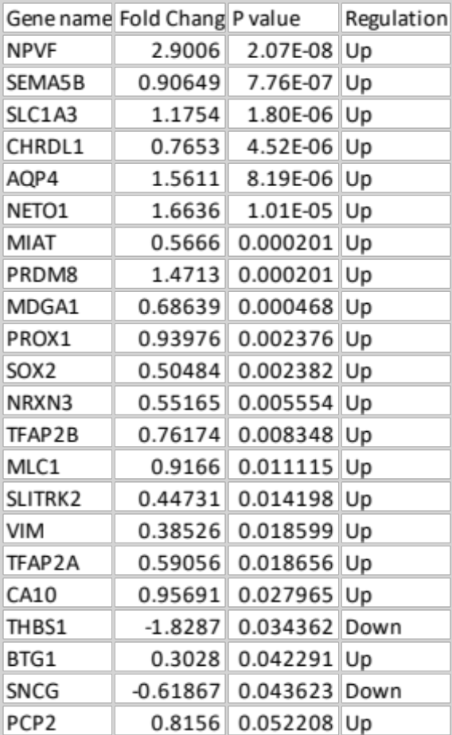
d. Neuronal Developemnent and Maturation BP-2

BP-2

f. Photoreceptor Development and Function BP-2

BP-2
e. Photoreceptor Development and Function BP-1

BP-1

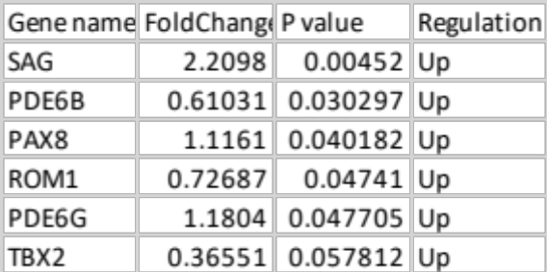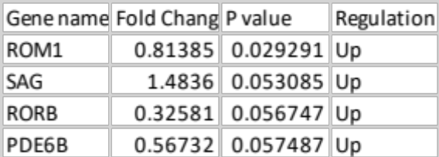

h. Retinal Development and Function BP-2
g. Retinal Development and Function BP-1

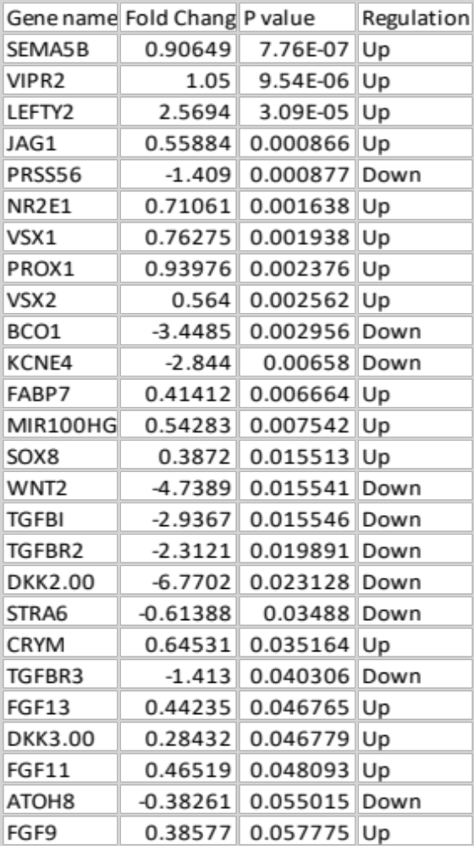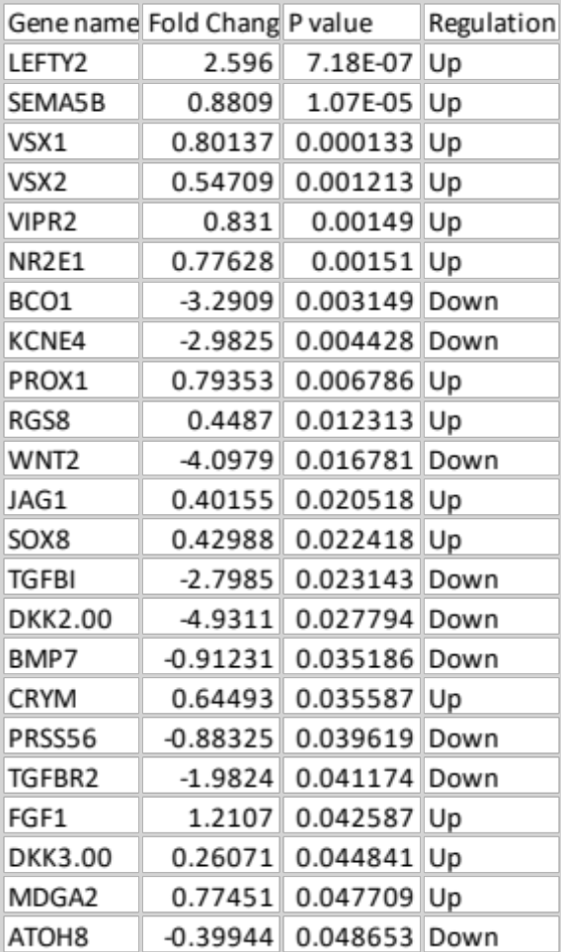

i. Retinal Disease condition BP-1
j. Retinal Diseases Condition BP-2
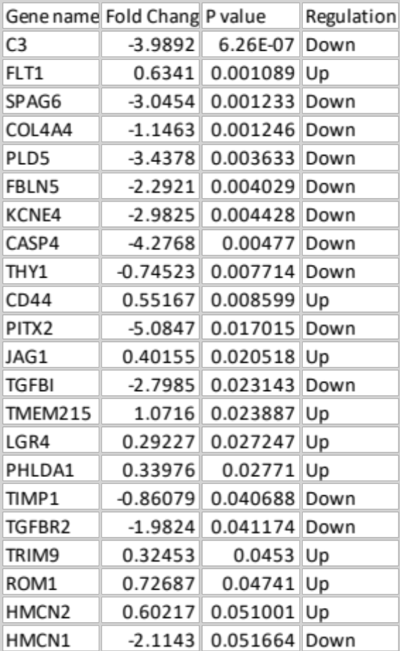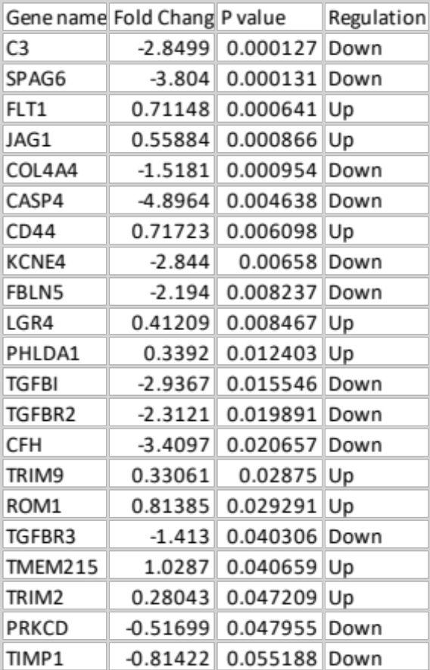

k. Retinal Homeostasis BP-1
l. Retinal Homeostasis BP-2
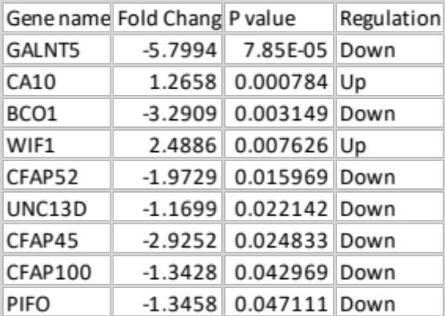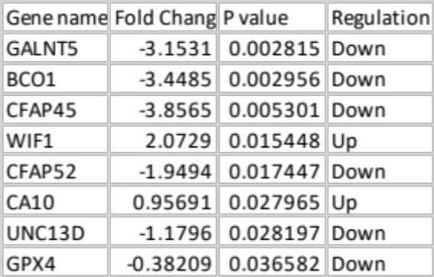

n. RPE Development and Function BP-2
m. RPE Development and Function BP-1
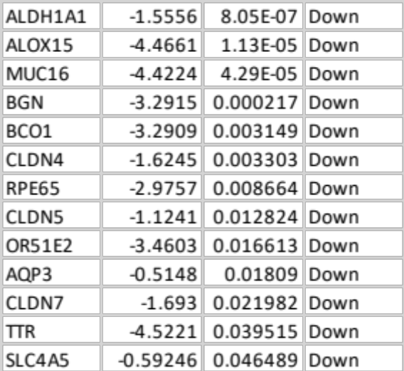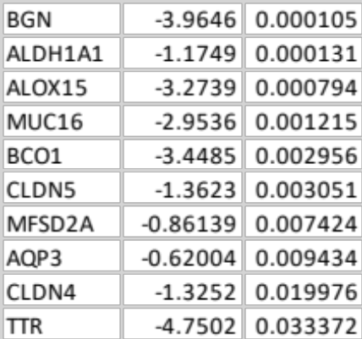

p. Retinal Layer Formation BP-2
o. Retinal Layer Formation BP-1
