Supplementary information for
Seasonal Diversity of Indo-Pacific Warm Pool Volume Expansion: The Role of Climatological Subsurface Temperature Patterns
Qiuying Gan^{1,2,3}, Jeremy Cheuk-Hin Leung²*, Wenjie Dong^{1,3}*, Lei Wang⁴, Weijing Li², Weihong Qian^{2,5}, Banglin Zhang^{2,6}

¹ School of Atmospheric Sciences, Key Laboratory of Tropical Atmosphere-Ocean System, Ministry of Education, Sun Yat-sen University, Zhuhai, China
² Guangzhou Institute of Tropical and Marine Meteorology/Guangdong Provincial Key Laboratory of Regional Numerical Weather Prediction, CMA, Guangzhou, China
³ Key Laboratory of Tropical Atmosphere-Ocean System, Ministry of Education, Zhuhai, China
⁴Laboratory for Coastal Ocean Variation and Disaster Prediction, College of Ocean and Meteorology, Guangdong Ocean University, Zhanjiang, China
⁵Department of Atmospheric and Oceanic Sciences, Peking University, Beijing, China
⁶College of Atmospheric Science, Lanzhou University, Lanzhou, China

Contents of this file
This supporting information provides supplementary figures cited in the main text, Figures S1 to S10.

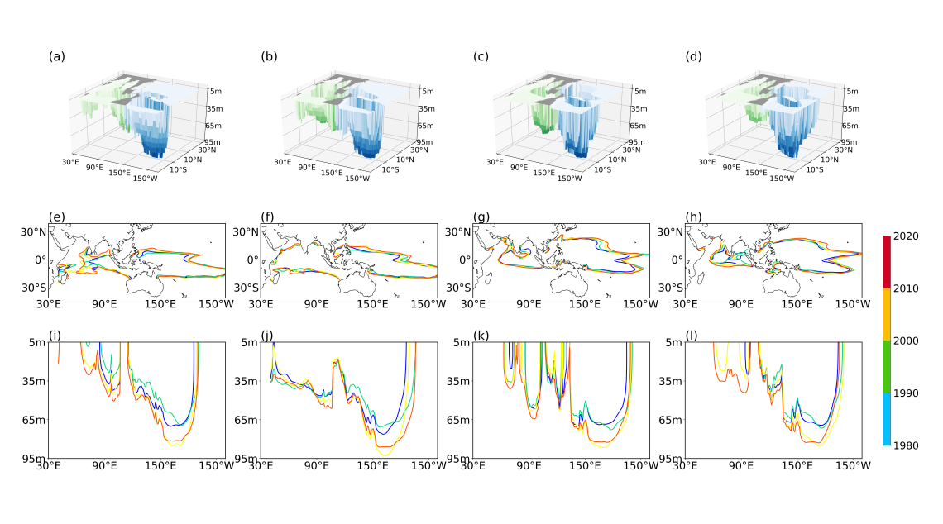
Figure S1. Climatology IPWP shape (a-d). Change of surface IPWP shape (e-h) and IPWP depth (i-l) from 1980 to 2020. a,e,i are the IPWP properties in winter (DJF), b,f,j are the IPWP properties in spring (MAM), c,g,k are the IPWP properties in summer (JJA), and d,h,l are the IPWP properties in autumn (SON). Contour lines are plotted every decade, where warmer colored lines represent the IPWP in more recent periods. Results are based on the NCEP GODAS potential temperature dataset.
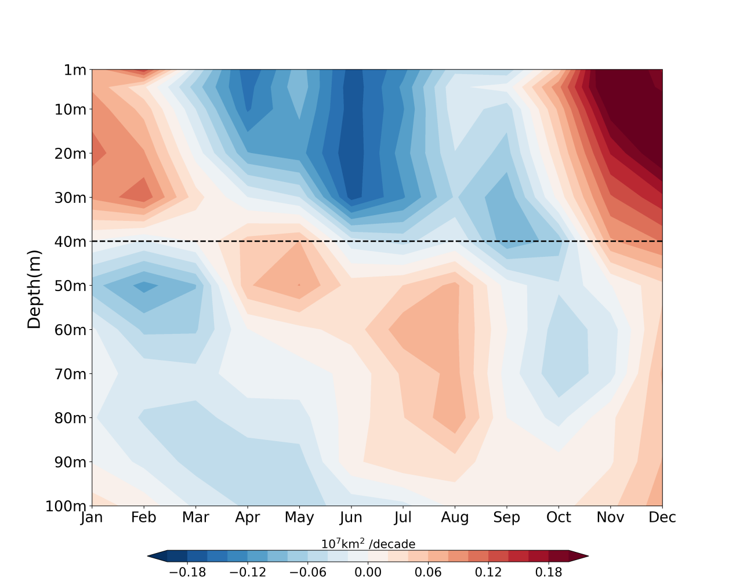
Figure S2. Difference of IPWP area in two period (pre-1950 period and post-1950 period) varied with depths and seasons (unit: 10⁷km²/decade). The dotted line denotes the boundary of shallow and deep IPWP. Results are based on the IAP ocean temperature dataset.

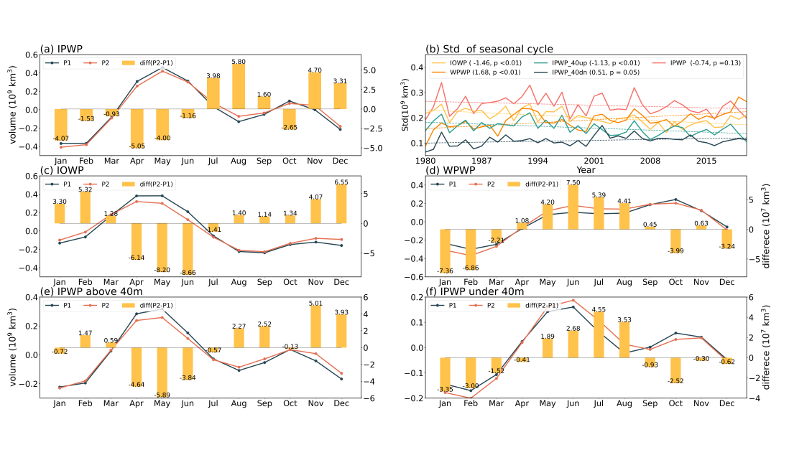
Figure S3. Departure values relative to the mean of annual cycle of (a) IPWP volume (unit: 10⁹ km³), (c) IOWP volume (unit: 10⁹ km³), (d) WPWP volume (unit: 10⁹ km³), (e) IPWP volume above 40m (unit: 10⁹ km³) and (f) IPWP volume under 40m (unit: 10⁹ km³). The dark green and red lines indicate the annual cycle in period P1(1980-1999) and P2 (2000-2020), respectively. The yellow bars denote the differences (P2 minus P1) (unit:10⁷ km³). (b) The standard deviation of the annual cycle of IPWP volume (red solid line, unit:10⁹ km³), IOWP volume (yellow solid line, unit:10⁹ km³), WPWP volume (orange solid line, unit:10⁹ km³), IPWP volume above 40m (lake green solid line, unit:10⁹ km³), and IPWP volume under 40m (dark green solid line, unit:10⁹ km³). Their linear trends were denoted by dotted lines (unit:10⁷ km²/decade). Results are based on the NCEP GODAS potential temperature dataset.

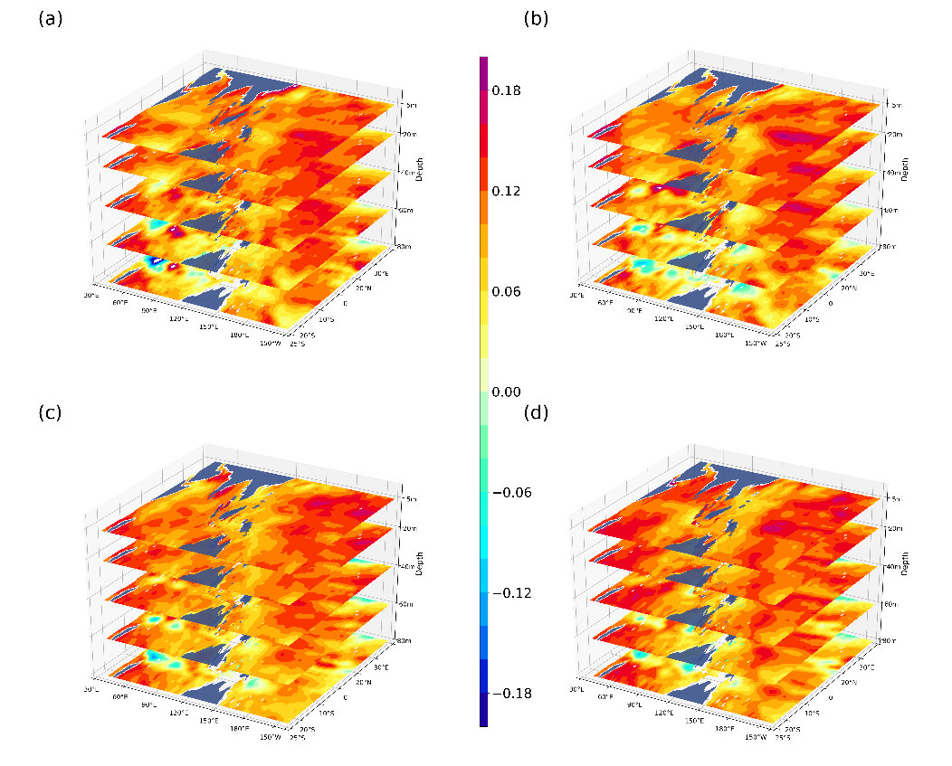
Figure S4. Trend of tropical Indo-Pacific Ocean temperature in 5m, 20m, 40m, 60m and 80m (unit: °C /decade) in winter (a), spring (b), summer (c) and autumn (d) from 1950 to 2020. Results are based on the IAP ocean temperature dataset.

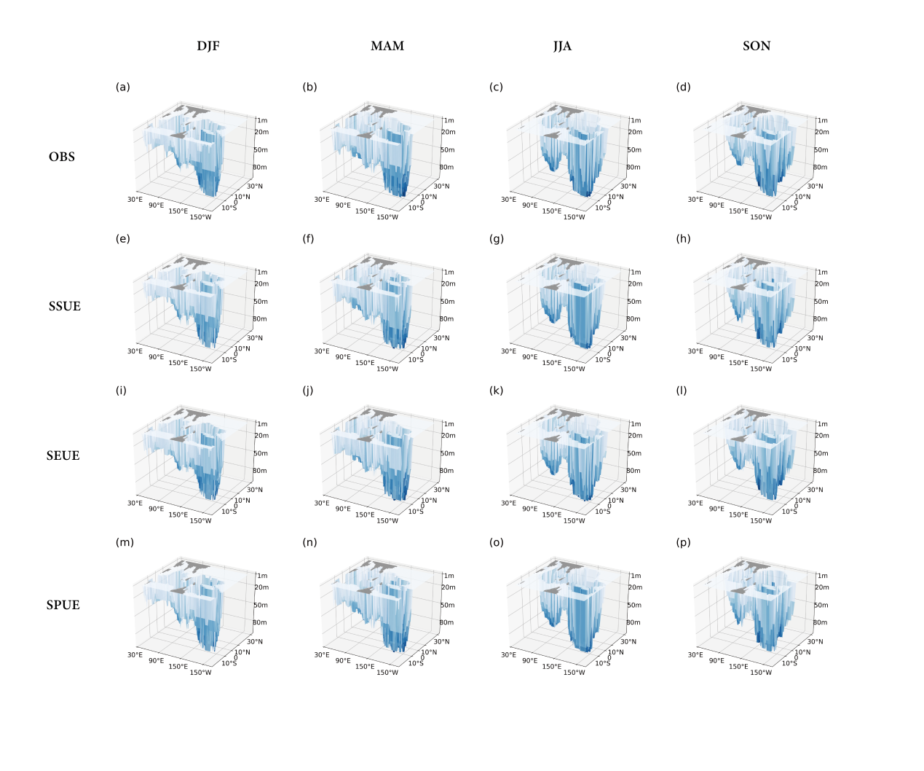
Figure S5. The spatial shapes of the IPWP in (a, e, i, m) winter, (b, f, j, n) spring, (c, g, k, o) summer and (d, h, l, p) autumn in P2 based on (a, b, c, d) observation, (e, f, g, h) SSUE, (i, j, k, l) SEUE, and (m, n, o, p) SPUE. Results are based on the IAP ocean temperature dataset.
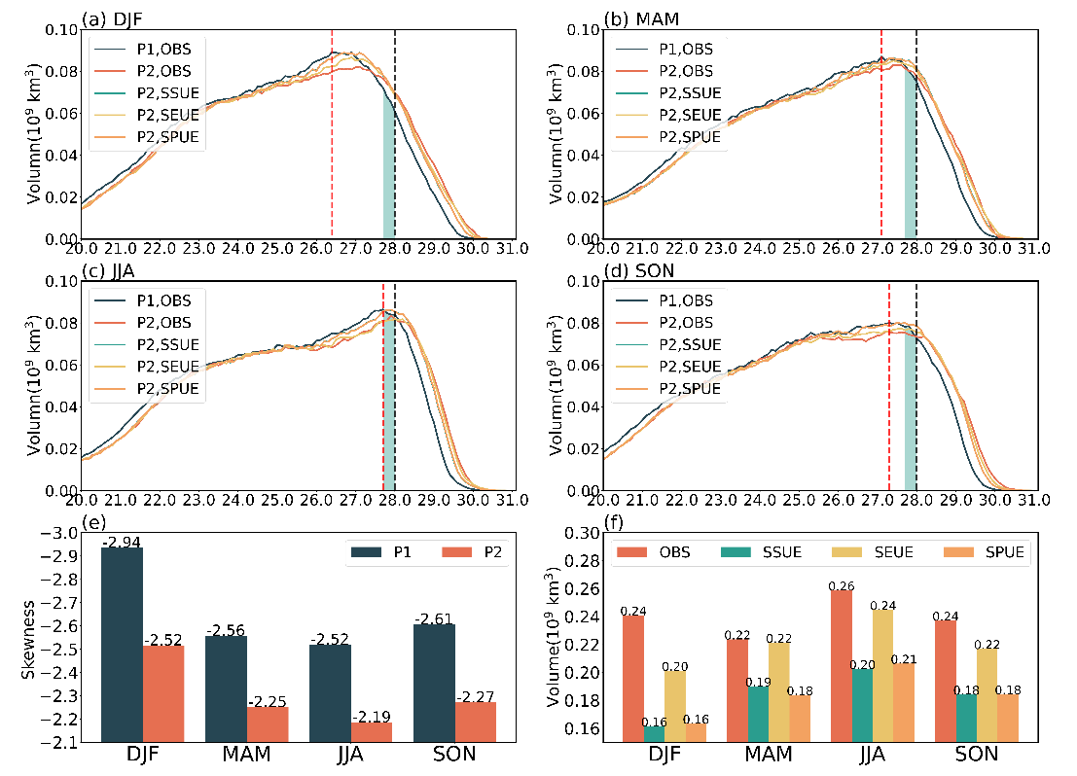
Figure S6. Spatial PFDs of the tropical Indo-Pacific Ocean temperature below 40m in (a) DJF, (b) MAM, (c) JJA, (d) SON. The dark green and red solid lines indicated the observed PFDs in P1(1950-1984) and P2(1985-2020), respectively. The lake green, yellow, and orange solid lines denote the PFDs in P2(1985-2020) in SSUE, SEUE and SPUE. The lake green shaded indicates the capacity for IPWP volume change from P1 to P2. (e) Skewness relative to 28°C of observed PFDs in P1 (dark green) and P2 (red). (f) The observed volume change (red bar, unit:10⁹ km³), capacity for volume change (lake green bar, unit:10⁹ km³), and volume change in SEUE (yellow bar, unit:10⁹ km³) and SPUE (orange bar, unit:10⁹ km³). Results are based on the IAP ocean temperature dataset.
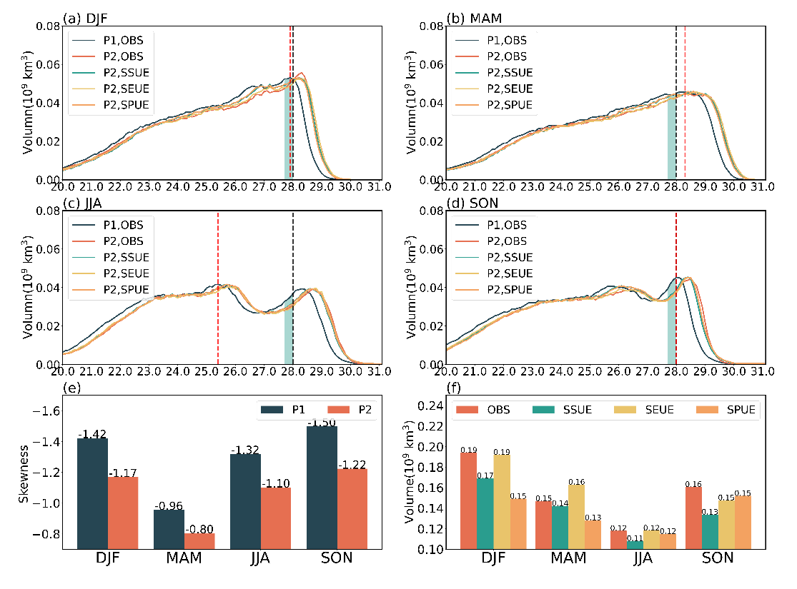
Figure S7. Same as Figure S6, but the statistic tropical Indian Ocean above 100m.

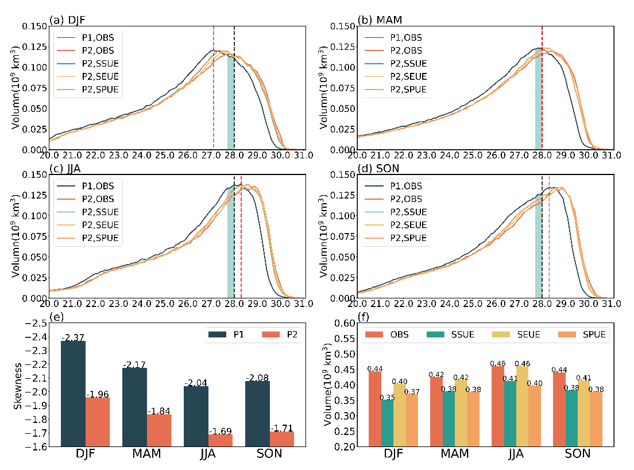
Figure S8. Same as Figure S7, but the statistic tropical western Pacific above 100m.

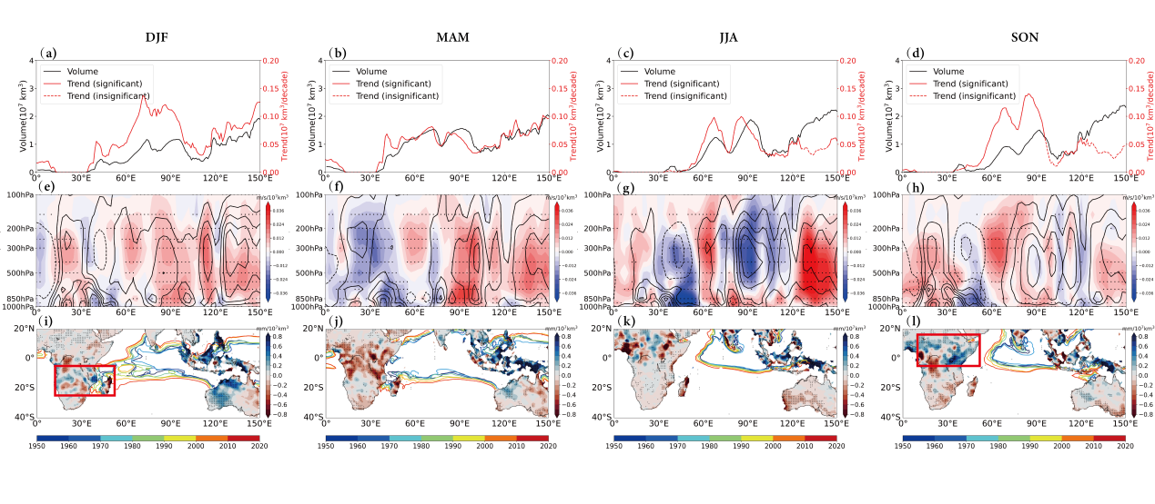
Figure S9. The warm pool volume in each longitude (black line, unit: 10⁷ km³) and its corresponding trend (red line, unit: 10⁷ km³/decade) in (a) DJF, (b) MAM, (c) JJA and (d) SON. The solid red lines in (a), (b), (c) and (d) indicate statistical significance at 99%. The meridional average (20°S–20°N) vertical velocity (contour, unit: m/s) and the regression of meridional average vertical velocity with respect to the IOWP volume index (shaded, unit: m.s⁻¹/ (10⁷ km³)) in (e) DJF, (f) MAM, (g) JJA and (h) SON. Regression of total precipitation with respect to the IOWP volume index (shaded, unit: mm/ (10⁷ km³)) and the change of surface IOWP shape (contour) in (i) DJF, (j) MAM, (k) JJA and (l) SON. Stipples indicate statistical significance at the 99%.

