Supplementary Table 1. The environmental predictors used in the MaxEnt species distribution model (SDM) for Hangul in the study area were as follows:
Data | Name of Variable & Description | Code | Resolution | Database
Climatic Variables | Annual Mean Temperature | Bio1 | 30 arc s | WorldClim
Climatic Variables | Mean Diurnal Range | Bio2 | 30 arc s | WorldClim
Climatic Variables | Temperature Seasonality (sd ×100) | Bio4 | 30 arc s | WorldClim
Climatic Variables | Isothermality (Bio2/Bio7) (×100) | Bio3 | 30 arc s | WorldClim
Climatic Variables | Mean Temperature of Wettest Quarter | Bio8 | 30 arc s | WorldClim
Climatic Variables | Mean Temperature of Driest Quarter | Bio9 | 30 arc s | WorldClim
Climatic Variables | Mean Temperature of Warmest Quarter | Bio10 | 30 arc s | WorldClim
Climatic Variables | Mean Temperature of Coldest Quarter | Bio11 | 30 arc s | WorldClim
Climatic Variables | Temperature Annual Range | Bio7 | 30 arc s | WorldClim
Climatic Variables | Max. Temperature of Warmest Month | Bio5 | 30 arc s | WorldClim
Climatic Variables | Min. Temperature of Coldest Month | Bio6 | 30 arc s | WorldClim
Climatic Variables | Annual Precipitation | Bio12 | 30 arc s | WorldClim
Climatic Variables | Precipitation of Wettest Month | Bio13 | 30 arc s | WorldClim
Climatic Variables | Precipitation of Driest Month | Bio14 | 30 arc s | WorldClim
Climatic Variables | Precipitation of Wettest Quarter | Bio16 | 30 arc s | WorldClim
Climatic Variables | Precipitation of Driest Quarter | Bio17 | 30 arc s | WorldClim
Climatic Variables | Precipitation Seasonality (CV) | Bio15 | 30 arc s | WorldClim
Climatic Variables | Precipitation of Warmest Quarter | Bio18 | 30 arc s | WorldClim
Climatic Variables | Precipitation of Coldest Quarter | Bio19 | 30 arc s | WorldClim
Vegetation | Enhanced Vegetation Index | EVI | 30 arc s | Moderate Resolution  Imaging Spectroradiometer  MODIS/Terr
Topographical  Variables | Elevation | Elev | 30 arc s | SRTM DEM Global
Topographical  Variables | Aspect | Aspect | 30 arc s | SRTM DEM Global
Topographical  Variables | Slope | Slope | 30 arc s | SRTM DEM Global
Anthropogenic  Variables | Human Footprint | HFP | 30 arc s | http://sedac.ciesin.columbia.edu
Anthropogenic  Variables | Road proximity | RP | 30 arc s | http://sedac.ciesin.columbia.edu
Anthropogenic  Variables | Land cover | LC | 30 arc s | http://www-modis.bu.edu/landcover
Anthropogenic  Variables | Population density | PD | 30 arc s | http://www.ornl.gov/sci/landscan

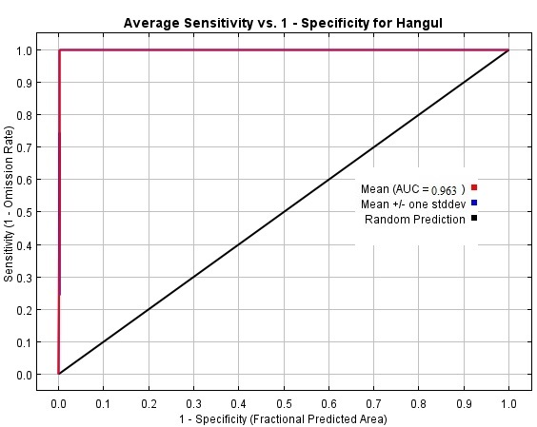
Figure S1. ROC prediction using the MaxEnt model. The model's precision was 0.963.
Figure S2. Contribution of Climatic Variables for Hangul Nest Habitat Model Construction. The figure illustrates the percentage contribution of various climatic variables towards the construction of a model for determining the potential distribution of suitable nest habitats for Hangul.
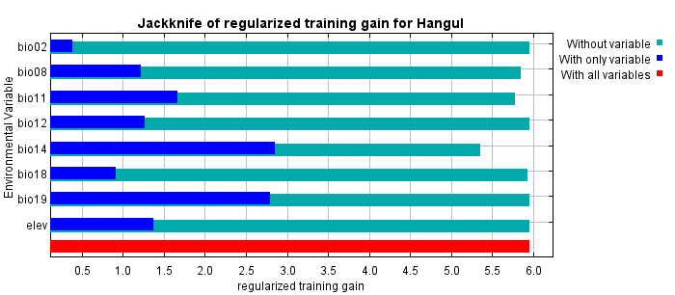
Figure S3. MaxEnt modeling of Hangul: evaluating the predictive power of environmental variables using Jackknife regularized training gain.
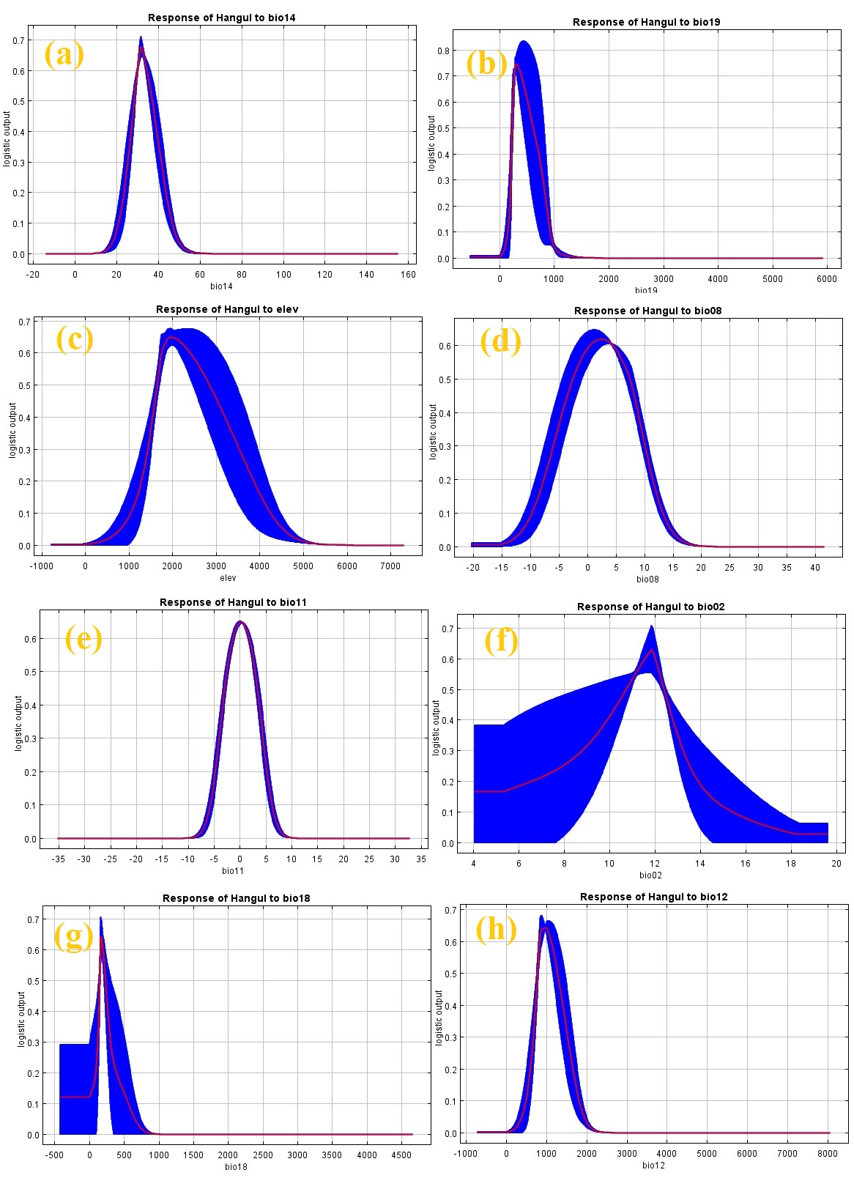
Figure S4. Variable response curves (ROC) of the distribution of Hangul. a; precipitation of driest month (bio14), b; precipitation of coldest month (bio19), c; elevation (elev), d; mean temperature of wettest quarter (bio08), e; mean temperature of coldest quarter (bio11), f; mean diurnal range (bio02), g; precipitation of warmest quarter (bio18), and h; annual precipitation (bio12).

Figure S5. The displacement of Hangul habitats to varying altitudes in response to climate conditions.

