Cross-validation on the ridge regression to minimise prediction error

A ridge regression was applied because the predictor variables are likely to be highly correlated, which can lead to unstable coefficient estimates and overfitting in ordinary least squares regression.
A participant-level 5-fold cross-validation was performed to identify the optimal regularisation parameter (lambda) for the multivariate ridge regression model. Logarithmically spaced lambda values were tested between 1 and 10. Within each fold, ridge regression coefficients were estimated to associate the predictor matrices (microstate activity, A_ms) and target ROI time-courses from all training participants using the closed-form ridge solution. Prediction accuracy was quantified using mean squared error (MSE), averaged across test participants and folds to produce a cross-validated error estimate for each lambda (Figure 1). Finally, lambda = ${10}^{4}$producing the lowest average MSE was selected as the best regularisation parameter. By selecting the regularisation parameter through cross-validation, the model balances goodness-of-fit against model complexity, resulting in more robust predictions of ROI timecourses across participants.

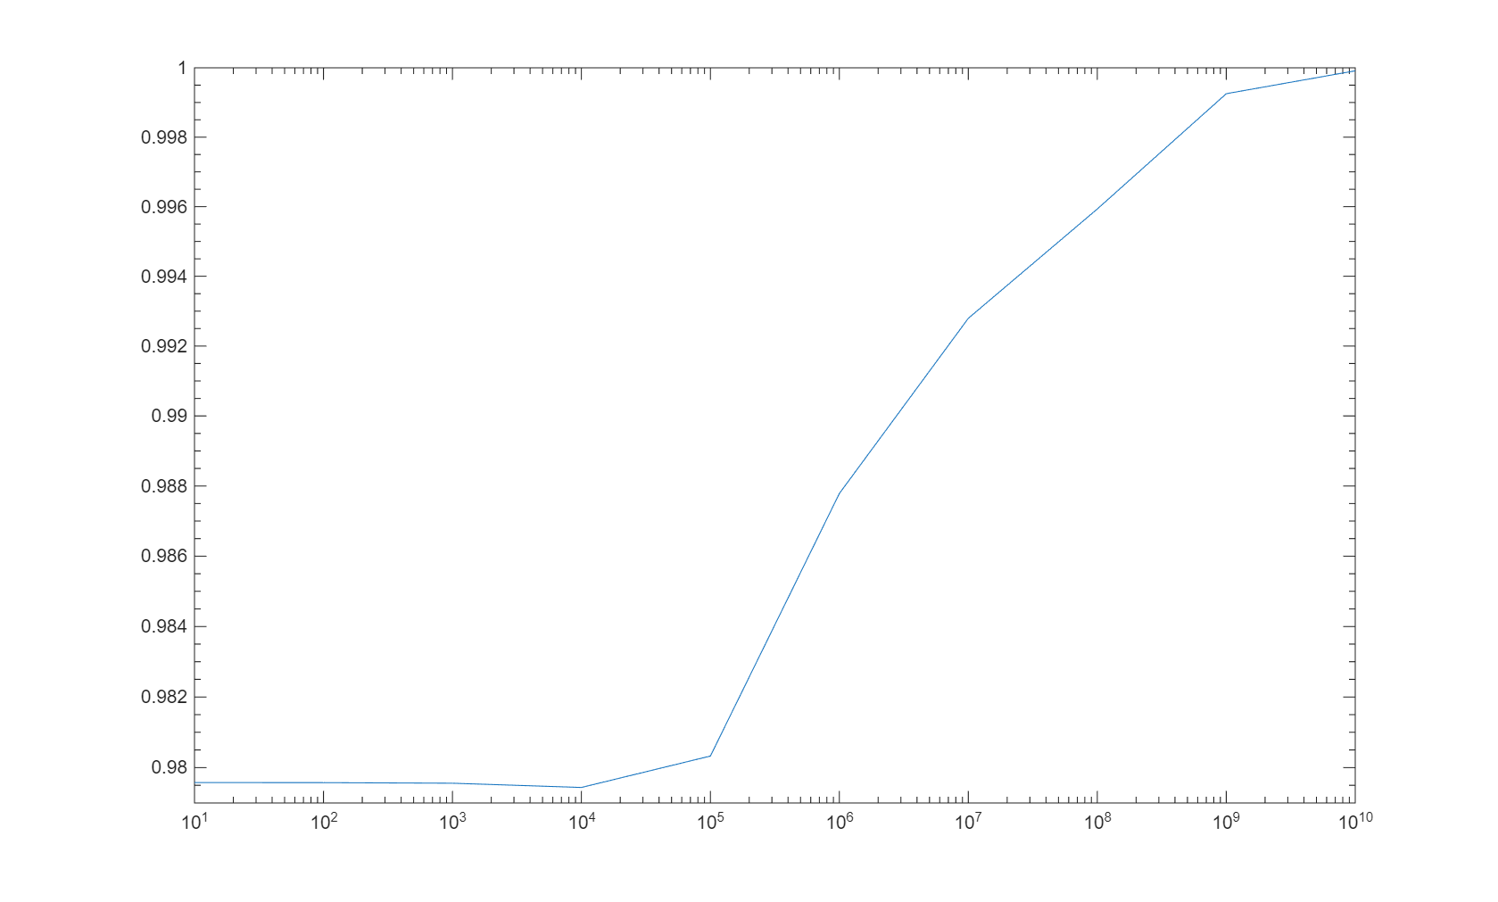
Figure 1: Log-log plot of test-set mean squared error (MSE) across regularisation parameters (lambda), averaged across folds and participants, showing a minimum at lambda = 10⁴, which was selected as the optimal value for the ridge regression model predicting ROI timecourses from microstate activity.

Block-permutation null model preserving temporal autocorrelation in microstate-source coupling
Block permutation-based significance testing demonstrated that the observed microstate-ROI regression coefficients were consistently larger than those expected under the null model. Across microstates A-D, the mean absolute coefficients derived from the HC data were located beyond the upper bound of the corresponding permutation distributions. This suggests that the identified microstate-source coupling capture meaningful temporal associations with ROI activity that are unlikely to arise from the intrinsic temporal structure of the microstate sequences alone (Figure 2).
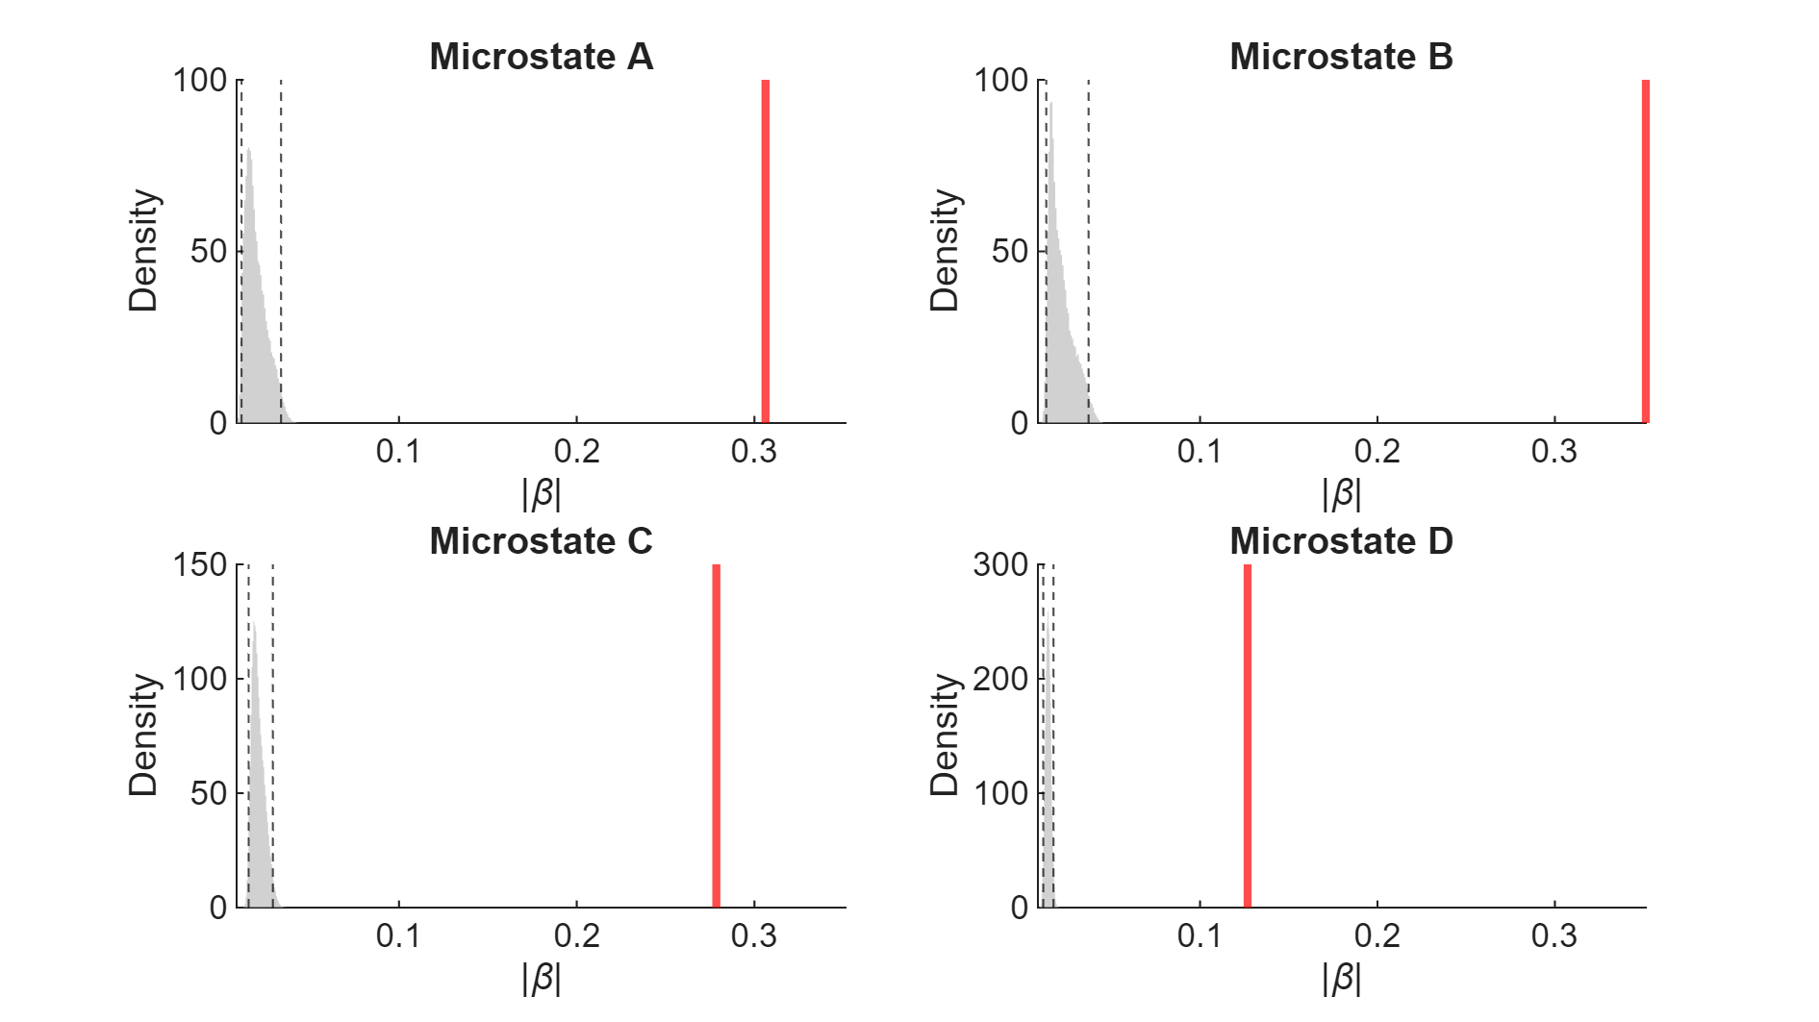
Figure 2: Observed versus null distributions of microstate–ROI regression coefficients. The null distributions of absolute ridge-regression coefficients (|β|) for microstates A-D were obtained from a block permutation procedure. For each microstate, histograms represent the pooled distribution of permutation-derived coefficients across all ROIs and 1,000 permutations, providing a temporally structured null model that preserves local autocorrelation within microstate sequences while disrupting their temporal alignment with ROI activity. The red vertical line indicates the mean observed absolute regression coefficient in the healthy control (HC) group, and the dashed black lines denote the 95% confidence interval of the null distribution. Observed values lying outside the null interval indicate microstate-ROI associations stronger than expected under the null model.

Control analyses for potential confounding variables

Controlling for gender in microstate-source coupling comparisons
We assessed differences in microstate-source coupling between ALS and HC groups using a non-parametric permutation framework based on the Freedman-Lane procedure (Freedman & Lane, 1983) within a general linear model (GLM). For each microstate and region of interest (ROI), a linear model was specified including an intercept, group membership (ALS or HC), and gender:
$$Y=b_{0}+b_{1}\left(group\right)+b_{2}(gender)$$where Y is the microstate-source coupling. The effect of group was tested using a t-contrast on $b_{1}$.
Statistical significance was assessed non-parametrically (permutation testing does not require the normal distribution of the residuals, an assumption which is probable not met given the modest sample size and the right-skewed distribution of the absolute coupling values). To generate a null while preserving the effect of gender, we used the Freedman-Lane approach: a reduced model containing only the intercept and gender was fit to obtain fitted values and residuals; the residuals were permuted across participants and added back to the fitted values to create a surrogate dataset that retains the gender structure of the data but removes any association between group and the outcome. The full model was then refit to each surrogate dataset to obtain a null t-statistic, repeated over 5,000 permutations to build an empirical null distribution for each microstate-ROI combination. Two-sided permutation p-values were derived by comparing observed t-statistics against the empirical null distribution for each microstate-ROI combination, with multiple comparisons controlled using adaptive false discovery rate (FDR) correction (q < 0.05). Across all microstate and ROIs, no group differences in microstate-source coupling survived correction, indicating no robust evidence of altered coupling in ALS relative to HC after accounting for gender.

Riluzole medication does not significantly affect microstate-source coupling
To assess whether riluzole medication influenced the microstate-source coupling results, we compared regression coefficient magnitudes (|β|) between medicated (n = 109) and unmedicated (n = 11) participants with ALS using the same non-parametric cluster-based permutation framework applied in the main analysis. For each microstate class, spatial neighbours were defined based on Euclidean distance between ROI centroids, and group differences were evaluated using an independent-samples t-statistic (two-tailed, α = 0.05) within a Monte Carlo permutation framework (10,000 permutations), with cluster-level inference performed at p < 0.05. Clusters were identified but none reached significance for any microstate class, indicating that microstate-source coupling did not differ significantly between medicated and unmedicated participants with ALS. These results suggest that the absence of group differences reported in the main analysis between ALS and healthy control groups are unlikely to be primarily driven by Riluzole medication, though we note this comparison is limited in power given the small unmedicated subsample.

Lists of brain regions associated with microstates

Lists of ROIs associated with each canonical microstate

For each canonical microstate, the specific AAL regions associated are listed below, ordered by coupling strength. As described for Figure 4, ROI coupling was derived from ridge regression between EEG microstate timecourses and source-reconstructed activity across 90 AAL ROIs in the HC group (n = 122), with polarity-invariant coupling strength (|β|) averaged across participants and thresholded at z-scores exceeding |z| > 1.

A | B | C | D
Thalamus L  Temporal Inf R  Putamen R  Temporal Pole Mid R  Calcarine R  Calcarine L  Pallidum R  Olfactory R  Lingual L  Cingulum Post L  Thalamus R  Cingulum Post R  Amygdala R  Lingual R  Fusiform R  Hippocampus R  ParaHippocampal R | Lingual R  Temporal Pole Sup L  Insula L  Caudate L  Thalamus R  Temporal Pole Mid L  Lingual L  Cingulum Post R  Fusiform L  Cingulum Post L  Putamen L  Olfactory L  Pallidum L  Hippocampus L  Thalamus L  Amygdala L  ParaHippocampal L | Supp Motor Area R  Temporal Pole Mid R  Cingulum Post R  Caudate R  Temporal Sup R  Hippocampus R  Temporal Pole Sup R  Amygdala R  Precentral R  Rolandic Oper R  Thalamus R  Pallidum R  Putamen R  Insula R  Heschl R  Cingulum Mid L  Cingulum Mid R | Thalamus R  Rolandic Oper R  Temporal Mid R  Temporal Pole Mid R  Paracentral Lobule R  Temporal Sup R  Cingulum Post L  Fusiform R  Temporal Inf L  Occipital Inf R  Calcarine R  Fusiform L  Cingulum Post R  Heschl R  Lingual R

Lists of ROIs associated with all canonical microstates

The table below lists the AAL ROIs contributing to the overlap map shown in Figure 4, ordered by combined coupling strength. The overlap was derived by computing the combined z-score of microstate-ROI coupling strength across all four microstates in the HC group, thresholded at |z| > 2.

All microstates (A-D)
Lingual R
Hippocampus R
Cingulum Post L
Thalamus R
Cingulum Post R

Microstate-source coupling is invariant to global rescaling, but not to regional or connectivity changes in source signal

Let $X(t)$ denote the EEG signal and $s(t)$ the true source activity, related through the forward model $X\left(t\right)=L ∙s(t)+η(t)$, where $L$ is the leadfield defined by the template head model and $η(t)$ represents noise. Substituting this into the definitions of the microstate activation coefficients, gives:

$$\hat{A}\left(t\right)=M^{+}X\left(t\right) \\ \hat{A}\left(t\right)=M^{+}\left(Ls\left(t\right)+η\left(t\right)\right) \\ \hat{A}\left(t\right)=G s(t)+ η_{1}\text{(t)}$$

And to the beamformer-derived ROI signal, gives:
$$y_{r}\left(t\right)=w_{r}^{⊤}X\left(t\right) +η_{2}(t) \\ y_{r}\left(t\right)= h_{r}^{⊤}s(t)+η_{2}(t)$$

with $G=M^{+}L$ and $h_{r}=L^{⊤}w_{r}$. The (pooled) microstate templates $M$ and the leadfield $L$ (based on a template-MRI head model) are identical for every participant in both groups. The beamforder weights are, however, estimated from each participant’s own covariance data and are participant-specific. Any group difference in coupling can only come from $Σ_{s}=Cov(s(t))$, the covariance of the source activity.

Based on the ridge regression: $β_{r}={\left(E\left(\hat{A}{\hat{A}}^{T}\right)\right)}^{-1}E(\hat{A}y_{r})$. Since both quantities are z-scored, they are zero-mean, so $E[\hat{A}{\hat{A}}^{⊤}]=Cov\left(\hat{A}\right)$ and $E[\hat{A} y_{r}]=Cov(\hat{A},y_{r})$. Therefore:
$$β_{r}=Cov(\hat{A})^{-1} Cov(\hat{A},y_{r}) \\ β_{r}={\left(GΣ_{s}G^{⊤}\right)}^{-1}GΣ_{s}h_{r}$$

If the ALS-related change in source activity is spatially uniform: $Σ_{s}^{ALS}=c Σ_{s}^{HC}$, with c a scalar, which would correspond to a proportionally scaled but otherwise identically distributed pattern of band power, then: $β_{r}^{ALS}=β_{r}^{HC}$. Such a group difference leaves the estimated coupling unchanged.
This cancellation is specific to a spatially uniform scalar $c$, it does not extend to a regionally heterogeneous rescaling of $Σ_{s}$, nor to a change confined to its off-diagonal structure (i.e., change in functional connectivity), which remains capable, in principle, of causing a difference in $β_{r}$ between groups. A regionally heterogeneous or connectivity change would alter the affected participant’s own covariance data and therefore their own beamformer weights.

Freedman, D., & Lane, D. (1983). A Nonstochastic Interpretation of Reported Significance Levels. Journal of Business & Economic Statistics, 1(4), 292–298. https://doi.org/10.2307/1391660

