Supplementary Materials
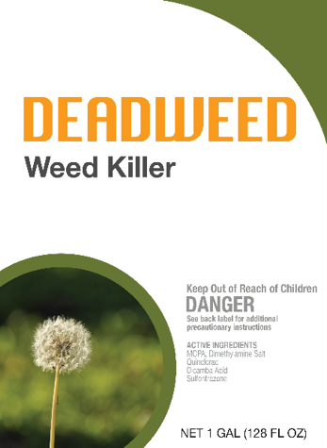
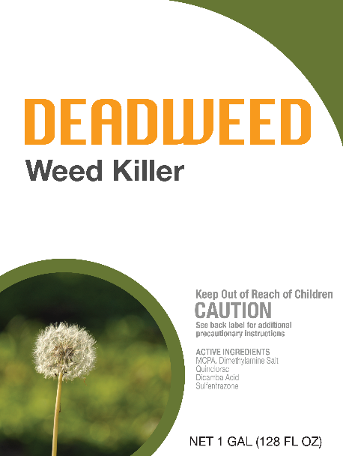
Table 1. Labeling format under each treatment for choice scenario High Toxicity-Low Toxicity
Signal Word

Traffic Light |  | 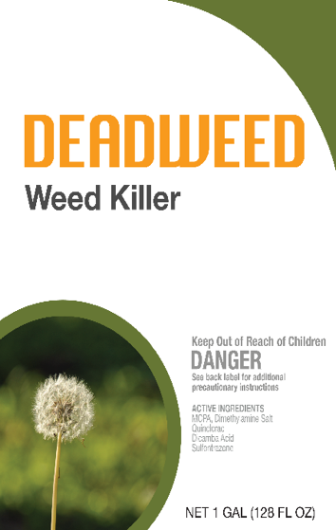  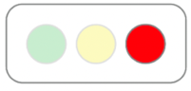  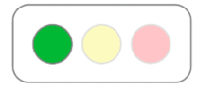
Skull Intensity Symbol | 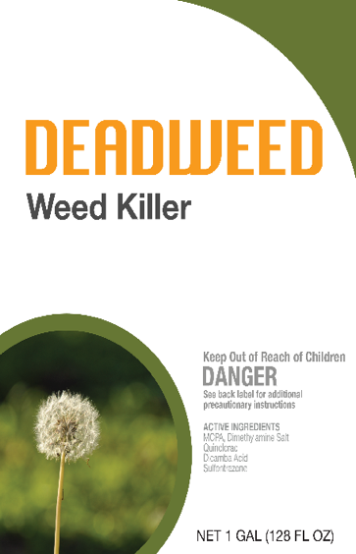    
Table 2. Herbicide choice sets under the signal word treatment for choice scenario High Toxicity-Low Toxicity
Choice Set | Option A |  | Option B
 | Price | Toxicity | Price | Toxicity
1 | $10 | DANGER | $20 | CAUTION
2 | $10 | DANGER | $19 | CAUTION
3 | $10 | DANGER | $18 | CAUTION
4 | $10 | DANGER | $17 | CAUTION
5 | $10 | DANGER | $16 | CAUTION
6 | $10 | DANGER | $15 | CAUTION
7 | $10 | DANGER | $14 | CAUTION
8 | $10 | DANGER | $13 | CAUTION
9 | $10 | DANGER | $12 | CAUTION
10 | $10 | DANGER | $11 | CAUTION
11 | $10 | DANGER | $10 | CAUTION
12 | $10 | DANGER | $9 | CAUTION

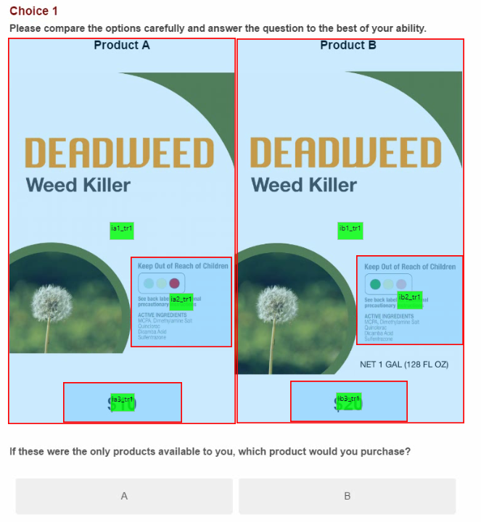
Figure 1. Example of AOI

Table 3. Socio-demographic characteristics of participants by label assessment
Label Format | Assessment | College | White | Male | Income>$55K
Signal Word | Right= 56% | 58% | 53% | 45% | 55%
Signal Word | Wrong=44% | 49% | 36% | 36% | 45%
Traffic Light | Right= 88% | 53% | 45% | 41% | 51%
Traffic Light | Wrong=12% | 65% | 50% | 40% | 45%
Intensity Symbol | Right= 87% | 53% | 45% | 39% | 52%
Intensity Symbol | Wrong=13% | 63% | 45% | 55% | 41%
We used the total sample N=166, because all participants in all treatments were asked to assess the three labeling formats.

Table 4. Effect of signal word labels understanding on the premium of the less toxic option by toxicity level

Toxicity level | Signal Word Right, N=31  Mean (SD) | Signal Word Wrong, N=26  Mean (SD) | Mann-Whitney U  p-value
High-Low | 1.8 (3.0) | 0.76 (2.3) | 0.06
High-Medium | 1.3 (3.0) | 1.2 (2.7) | 0.7
Medium-Low | 0.9 (2.4) | 0.72 (2.2) | 0.6
Note: Signal Word Right refer to participants who ranked the signal word labels correctly; Signal Word Wrong refer to participants who ranked the signal word labels incorrectly.

Table 5. Impact of label design on the premium of the less toxic option
Independent Variable | (1) | (2) | (3)
Signal word | -1.49 (0.53) *** | -1.13 (0.57) * | -0.94 (0.57)
Light | 1.06 (0.63) * | 1.21 (0.67) * | 1.24 (0.66) **
High-Low | 0.74 (0.16) *** | 0.96 (0.27) *** | 0.96 (0.27) ***
Medium-Low | -0.53 (0.17) *** | -0.23 (0.21) *** | -0.23 (0.21) ***
High-Low*Signal word |  | -0.89 (0.35) ** | -0.89 (0.35) **
High-Low*Light |  | 0.25 (0.40) | 0.25 (0.40)
Medium-Low* Signal word |  | -0.19 (0.34) | -0.19 (0.34)
Medium-Low*Light |  | -0.70 (0.43) * | -0.70 (0.43) *
Age |  |  | -0.03 (0.02)
Male |  |  | -0.95 (0.46) *
White |  |  | 0.24 (0.51)
Income |  |  | -0.05 (0.04)
College |  |  | 0.41 (0.55)
Constant | 2.55 (0.42) *** | 2.38 (0.42) *** | 3.47 (1.25) ***
Observations | 498 | 498 | 498
Adjusted R² | 0.13 | 0.15 | 0.16
F statistics | 75.49*** | 96.89*** | 105.59***
Notes: Reported values are the estimated coefficients. Single, double, and triple asterisks (*, **, ***)
indicate significance at the 10%, 5%, and 1% levels. Values in parenthesis are robust standard errors.

