Additional file 1: Comparison of patients’ characteristics between included and excluded patients
 | Inclusion
 | No | Yes | p
 | n = 222 | n = 50 | p
Age (years) | 61.3 (15.5) | 58.3 (12.3) | 0.2
Gender (men) | 100 (45) | 19 (38) | 0.45
Weight (kg) | 70.8 (15.4) | 71.1 (16.5) | 0.92
BMI (kg/m²) | 25.3 (4.9) | 25.2 (5.2) | 0.97
SAPS II | 28.6 (15.1) | 24.5 (7.8) | 0.4
Comorbidities
Cardio-vascular | 102 (45.9) | 25 (50) | 0.72
Myocardial infarction | 20 (9) | 4 (8) | 1
Valvulopathy | 6 (2.7) | 0 (0) | 0.52
Arrhythmia | 21 (9.5) | 1 (2) | 0.14
Hypertension | 90 (40.5) | 25 (50) | 0.29
Arteritis | 11 (5) | 1 (2) | 0.59
COPD | 15 (6.8) | 3 (6) | 1
Diabetes | 16 (7.2) | 1 (2) | 0.29
Chronic kidney disease | 10 (4.5) | 5 (10) | 0.23
Medication
Anti-hypertensive agents | 73 (32.9) | 20 (40) | 0.43
Beta-blockers | 41 (18.5) | 2 (4) | 0.02
ASA score |  |  | 0.67
1-2 | 132 (58.7) | 32 (63.3)
3-5 | 90 (41.3) | 18 (36.7)
Reason for neuro radiological procedure
Emergency procedure for SAH | 27 (12.2) | 19 (38) | <0.001
Fisher score |  |  | 0.42
1 | 3 (11.5) | 1 (5.3)
2 | 4 (15.4) | 1 (5.3)
3 | 3 (11.5) | 5 (26.3)
4 | 16 (61.5) | 12 (63.2)
WFNS score |  |  | 0.27
1 | 13 (50) | 14 (73.7)
2 | 7 (26.9) | 1 (5.3)
4 | 3 (11.5) | 2 (10.5)
5 | 3 (11.5) | 2 (10.5)
Stroke | 43 (19.4) | 0 (0) | 0.001
Type of procedure |  |  | <0.001
Arteriography | 130 (58.6) | 3 (6)
Embolization | 48 (21.6) | 47 (94)
Thrombectomy | 44 (19.8) | 0 (0)
General anaesthesia | 85 (38.3) | 48 (96) | <0.001

Data are given as n (%) or mean ± SD. ASA: American Society of Anaesthesiologists; BMI: Body Mass Index; COPD: Chronic Obstructive Pulmonary Disease; SAH: Sub-Arachnoid Haemorrhage; SAPS: Simplified Acute Physiology Score; SD: Standard Deviation; WFNS: World Federation of Neurologic Surgeons.

Additional file 2: Flow diagram

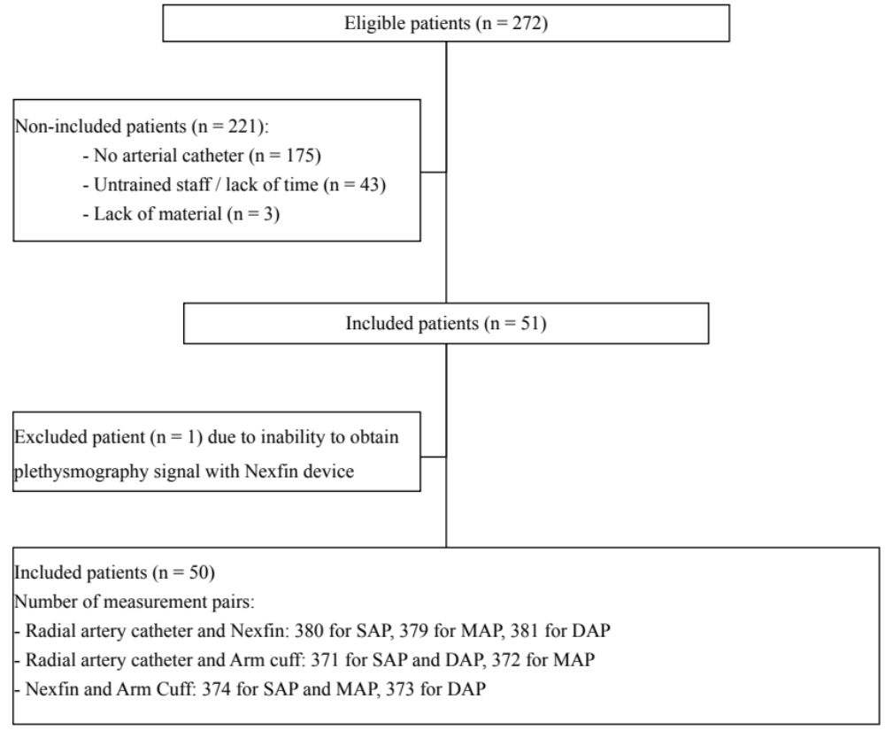

ABP: Arterial Blood Pressure; DAP: Diastolic Arterial Pressure; MAP: Mean Arterial Pressure; SAP: Systolic Arterial Pressure.

Additional file 3: Relationship between absolute values of diastolic arterial pressure (DAP) on invasive (radial artery, kt) and non-invasive (Nexfin and Arm Cuff) devices. A: DAP measures with Nexfin and invasive method (381 pairs). B: DAP measures with intermittent Arm Cuff and invasive method (371 pairs). C: DAP measures with intermittent Arm Cuff and invasive method (373 pairs). DAP: Diastolic Arterial Pressure.

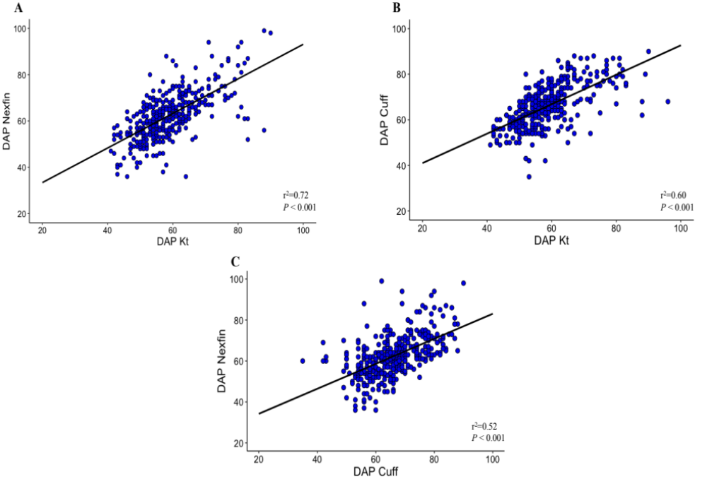

Additional file 4: Bland-Altman analysis of diastolic arterial pressure (DAP) obtained with invasive (radial artery, kt) and non-invasive (Nexfin and Arm Cuff) devices. A: Accuracy and precision for DAP measures between Nexfin device and invasive method. B: Accuracy and precision for DAP measures between intermittent Arm Cuff and invasive method. C: Accuracy and precision for DAP measures between Nexfin device and intermittent Arm Cuff. DAP: Diastolic Arterial Pressure.
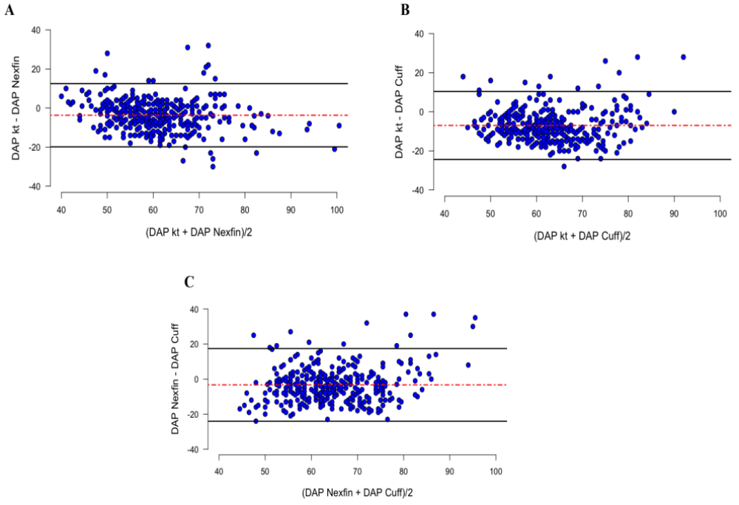

Additional file 5: Evolution of SAP (panel A), MAP (panel B) and DAP (panel C) before the beginning and along the neuro radiological procedure obtained with the three devices
