Supplemental Online Materials
to accompany

Intuitive Moral Bias Favors the Religiously Faithful: Evidence from Two Societies

Table of Contents

Supplemental tables and analyses

- Political Orientation
- Spiritual Connection to God

Study Materials
- Survey

The pre-registration, study materials, datasets, and code are available at https://osf.io/2jq35/

Political Orientation
Political orientation was assessed using a modification of Dodd et al.’s (2012) version of Wilson and Patterson’s (1968) issues index. Participants were asked to indicate whether they agree, disagree, or are uncertain about various prominent issues in contemporary U.S. politics (e.g., abortion, tax rates, gun control). Agreement was scored as +1, disagreement as -1, and uncertainty as 0; liberal items were reverse scored and then the responses were composited, hence increasing positive values reflect greater conservatism (M_{Political Orientation} = -3.65, SD = 9.25).

Table S1

Full Model Summary of the Effects of Target, Belief in God, Political Orientation, Age, Gender, and Subjective Social Status in the Serial Helper Condition (U.S., Study 1)
 |  |  | 95% HPDI
Fixed effects | Coefficient | SD | 2.5% | 97.5%
Target:Religious vs. Atheist | -2.04 | 0.28 | -2.63 | -1.53
Belief in God | 0.60 | 0.20 | 0.21 | 0.99
Age | 0.10 | 0.16 | -0.20 | 0.41
Gender | -0.11 | 0.15 | -0.41 | 0.18
SSES | 0.14 | 0.15 | -0.16 | 0.44
Political orientation | 0.67 | 0.21 | 0.26 | 1.10
Target X Belief | -1.92 | 0.53 | -3.02 | -0.96
Target X Politics | -1.06 | 0.42 | -1.92 | -0.26
Note. Age, gender, subjective socioeconomic status (SSES) and participant belief in God were standardized. Religious vs. atheist target was coded: atheist = 1, religious = 0. The 95% highest posterior density intervals (HPDI) illustrate uncertainty around posterior means, and indexes the interval in which the 95% most credible estimates lie.

The full model reveals a significant effect of target type (target = -2.04, sd = 0.28, HPDI Low = -2.63, HPDI High = -1.53), as well as a main effect of belief in God qualified by a significant interaction with target type (target x belief = -1.92, sd = 0.53, HPDI Low = -3.02, HPDI High = -0.96), such that participants who reported higher levels of belief in God were more likely to commit the conjunction fallacy rates in the religious target condition. There was a comparable effect of political orientation qualified by a significant interaction between target type and political orientation (target x politics = -1.06, sd = 0.42, HPDI Low = -1.92, HPDI High = -0.26), such that higher levels of conservatism predicted greater conjunction fallacy rates for religious targets. Hence, political conservatism appeared to operate similarly to religious belief with respect to intuitively conceptualizing religious believers as prosocial.

Table S2

Full Model Summary of the Effects of Target, Belief in God, Political Orientation, Age, Gender, and Subjective Social Status in the Serial Killer Condition (U.S., Study 1)
 |  |  | 95% HPDI
Fixed effects | Coefficient | SD | 2.5% | 97.5%
Target:Religious vs. Atheist | 2.15 | 0.28 | 1.61 | 2.71
Belief in God | 0.19 | 0.21 | -0.20 | 0.61
Age | 0.03 | 0.13 | -0.24 | 0.30
Gender | -0.05 | 0.14 | -0.31 | 0.22
SSES | -0.06 | 0.14 | -0.33 | 0.21
Political orientation | -0.16 | 0.22 | -0.60 | 0.28
Target X Belief | 0.29 | 0.28 | -0.27 | 0.85
Target X Politics | 0.82 | 0.29 | 0.25 | 1.41
Note. Age, gender, subjective socioeconomic status (SSES) and participant belief in God were standardized. Religious vs. atheist target was coded: atheist = 1, religious = 0. The 95% highest posterior density intervals (HPDI) illustrate uncertainty around posterior means, and indexes the interval in which the 95% most credible estimates lie.

The full model reveals a significant effect of target type (target = 2.15, sd = 0.28, HPDI Low = 1.61, HPDI High = 2.71), but no main effect of belief in God nor an interaction between target type and belief in God. However, there was a significant interaction between target type and political orientation such that participants who reported a higher levels of political conservatism were more likely to commit the conjunction fallacy in the atheist target condition (target x politics = 0.82, sd = 0.29, HPDI Low = 0.25, HPDI High = 1.41)

Spiritual Connection to God

Spiritual connection to God was measured using a modified version of the Inclusion of the Other in the Self scale composed of seven pairs of circles ranging from nonoverlapping to almost entirely overlapping (Aron, Aron, & Smollan, 1992) This closeness measure was framed as distinct from trait religious belief because individuals may feel a spiritual connection to God while simultaneously lacking a firm belief in God.

Table S3

Full Model Summary of the Effects of Target, Spiritual Connection, Age, Gender, and Subjective Social Status in the Serial Killer Condition (U.S., Study 1)
 |  |  | 95% HPDI
Fixed effects | Coefficient | SD | 2.5% | 97.5%
Target:Religious vs. Atheist | 2.08 | 0.25 | 1.58 | 2.56
Spiritual | 0.26 | 0.17 | -0.07 | 0.60
Age | 0.02 | 0.13 | -0.23 | 0.27
Gender | -0.07 | 0.13 | -0.32 | 0.19
SSES | -0.09 | 0.13 | -0.34 | 0.16
Target X Spiritual | 0.30 | 0.24 | -0.16 | 0.78
Note. Age, gender, subjective socioeconomic status (SSES) and participant belief in God were standardized. Religious vs. atheist target was coded: atheist = 1, religious = 0. The 95% highest posterior density intervals (HPDI) illustrate uncertainty around posterior means, and indexes the interval in which the 95% most credible estimates lie.

The full model reveals a significant effect of target type (target = 2.08, sd = 0.25, HPDI Low = 1.58, HPDI High = 2.56). There was no effect of spiritual connection, nor interaction between target type and spiritual connection to God (target x spiritual = 0.30, sd = 0.24, HPDI Low = -0.16, HPDI High = 0.78).

Table S4

Full Model Summary of the Effects of Target, Spiritual Connection, Age, Gender, and Subjective Social Status in the Serial Helper Condition (U.S., Study 1)
 |  |  | 95% HPDI
Fixed effects | Coefficient | SD | 2.5% | 97.5%
Target:Religious vs. Atheist | -3.55 | 0.44 | -4.50 | -2.76
Spiritual | 0.63 | 0.16 | 0.32 | 0.94
Age | 0.19 | 0.14 | -0.09 | 0.47
Gender | -0.07 | 0.14 | -0.35 | 0.20
SSES | 0.09 | 0.14 | -0.18 | 0.37
Target X Spiritual | -1.74 | 0.44 | -2.66 | -0.94
Note. Age, gender, subjective socioeconomic status (SSES) and participant belief in God were standardized. Religious vs. atheist target was coded: atheist = 1, religious = 0. The 95% highest posterior density intervals (HPDI) illustrate uncertainty around posterior means, and indexes the interval in which the 95% most credible estimates lie.

The full model reveals a significant effect of target type (target = 3.55, sd = 0.44, HPDI Low = -4.50, HPDI High = 2.76). There was a significant interaction between target type and spiritual connection to God (target x spiritual = -1.74, sd = 0.44, HPDI Low = -2.66, HPDI High = -0.94), such that higher levels of spirituality predicted greater conjunction fallacy rates for religious targets, comparable to the pattern observed for Belief in God (see main text).
Table S5

Full Model Summary of the Effects of Target, Spiritual Connection, Age, Gender, and Subjective Social Status in the Serial Killer Condition (N.Z., Study 2)
 |  |  | 95% HPDI
Fixed effects | Coefficient | SD | 2.5% | 97.5%
Target:Religious vs. Atheist | 0.86 | 0.36 | 0.15 | 1.60
Spiritual | - 0.62 | 0.30 | -1.24 | -0.07
Age | 0.18 | 0.17 | - 0.17 | 0.52
Gender | - 0.004 | 0.17 | -0.35 | 0.33
SSES | 0.41 | 0.18 | 0.06 | 0.76
Target X Spiritual | 0.96 | 0.37 | 0.28 | 1.70
Note. Age, gender, subjective socioeconomic status (SSES) and participant belief in God were standardized. Religious vs. atheist target was coded: atheist = 1, religious = 0. The 95% highest posterior density intervals (HPDI) illustrate uncertainty around posterior means, and indexes the interval in which the 95% most credible estimates lie.

The full model reveals a significant effect of target type (target = 0.86, sd = 0.36, HPDI Low = 0.15, HPDI High = 1.60). There was also a significant interaction between target type and spiritual connection to God (target x spiritual = 0.96, sd = 0.37, HPDI Low = 0.28, HPDI High = 1.70), such that higher levels of spirituality predicted greater conjunction fallacy rates for atheist targets.
Table S6

Full Model Summary of the Effects of Target, Spiritual Connection, Age, Gender, and Subjective Social Status in the Serial Helper Condition (N.Z., Study 2)
 |  |  | 95% HPDI
Fixed effects | Coefficient | SD | 2.5% | 97.5%
Target:Religious vs. Atheist | -2.87 | 0.52 | -3.95 | -1.92
Spiritual | 0.45 | 0.25 | -0.04 | 0.95
Age | 0.08 | 0.20 | -0.33 | 0.47
Gender | -0.24 | 0.20 | -0.64 | 0.15
SSES | 0.33 | 0.20 | -0.05 | 0.73
Target X Spiritual | -1.46 | 0.55 | -2.64 | -0.45
Note. Age, gender, subjective socioeconomic status (SSES) and participant belief in God were standardized. Religious vs. atheist target was coded: atheist = 1, religious = 0. The 95% highest posterior density intervals (HPDI) illustrate uncertainty around posterior means, and indexes the interval in which the 95% most credible estimates lie.

The full model reveals a significant effect of target type (target = 2.87, sd = 0.52, HPDI Low = -3.95, HPDI High = -1.92). There was a significant interaction between target type and spiritual connection to God (target x spiritual = -1.46, sd = 0.55, HPDI Low = -2.64, HPDI High = -0.45), such that higher levels of spirituality predicted greater conjunction fallacy rates for religious targets.

Survey

Q1 (Serial Killer—Belief)
When a man was young, he began inflicting harm on animals. It started with just pulling the wings off flies, but eventually progressed to torturing stray cats and other animals in his neighborhood.
As an adult, the man found that he did not get much thrill from harming animals, so he began hurting people instead. He has killed 5 homeless people that he abducted from poor neighborhoods in his home city. Their dismembered bodies are currently buried in his basement.

Which is more probable?
o The man is a teacher.
o The man is a teacher and does believe in God.
Q1 (Serial Killer—No Belief)
When a man was young, he began inflicting harm on animals. It started with just pulling the wings off flies, but eventually progressed to torturing stray cats and other animals in his neighborhood.
As an adult, the man found that he did not get much thrill from harming animals, so he began hurting people instead. He has killed 5 homeless people that he abducted from poor neighborhoods in his home city. Their dismembered bodies are currently buried in his basement.
o The man is a teacher.
o The man is a teacher and does not believe in God.

Q1 (Serial Helper—Belief)
When a man was young, he began helping stray animals. It started with just putting out water for birds, but eventually progressed to fostering stray cats and other animals in his neighborhood.
As an adult, the man felt inspired to help people in need as well. Each week he visits poor neighborhoods in his city and offers food and clothes to homeless people. Sometimes when the weather is very cold he offers homeless families a place to stay in a spare room in his house.
Which is more probable?
o The man is a teacher.
o The man is a teacher and does believe in God.

Q1 (Serial Helper—No Belief)

When a man was young, he began helping stray animals. It started with just putting out water for birds, but eventually progressed to fostering stray cats and other animals in his neighborhood.
As an adult, the man felt inspired to help people in need as well. Each week he visits poor neighborhoods in his city and offers food and clothes to homeless people. Sometimes when the weather is very cold he offers homeless families a place to stay in a spare room in his house.
Which is more probable?
o The man is a teacher.
o The man is a teacher and does not believe in God.

Q2 Puzzles
In a lake, there is a patch of lily pads. Every day, the patch doubles in size. If it takes 48 days for the patch to cover the entire lake, how long would it take for the patch to cover half of the lake?
________________________________________________________________

If it takes 5 machines 5 minutes to make 5 widgets, how long would it take 100 machines to make 100 widgets?
________________________________________________________________

A bat and a ball cost $1.10 in total. The bast costs $1.00 more than the ball. How much does the ball cost?
________________________________________________________________

Q3 Attention Check
Here is a different type of question. SKIP THIS QUESTION, PLEASE. It is only included to ensure that you are paying attention and reading directions. Do not leave an answer for the question about US presidents.

Who is the current President of the United States of America?
o Donald J. Trump
o Mitt Romney
o Steve Perry
o George Washington

Q4 Suspicion

What do you think this study is mainly about so far?
o Stereotyping and prejudice
o Logic and reasoning
o Language fluency
o Emotion perception
o Memory

Demographic Questions

Q5 How old are you?
________________________________________________________________

Q6 What is your gender?
o Male
o Female
o Other

Q7 What country do you live in?
o United States
o Germany
o New Zealand
o Mexico
o United Kingdom
o India
o Other

Q8 What is your religious affiliation?
o Christian (Catholic)
o Christian (Baptist)
o Christian (Other)
o Hindu
o Buddhist
o Muslim
o Jewish
o Sikh
o None
o Atheist
o Agnostic
o Other (Please specify) ________________________________________________

Q9 Perceived SES

We are interested in how you perceive your life. Think of a ladder representing where people stand in (the U.S. or New Zealand). At the top of the ladder are people who are the best off--those who have the most money, the most education, and the most respected jobs. At the bottom are the people who are worst off--who have the least money, the least education, and the least respected jobs or no job. The higher up you are on this ladder, the closer you are to the top; the lower you are, the closer you are to people at the very bottom. Imagine this rating scale represents the ladder. Where would you place yourself, relative to the other people in (the U.S. or New Zealand? A response of '0' represents the bottom of the ladder and a response of '10' represents the top of the ladder.
o 10
o 9
o 8
o 7
o 6
o 5
o 4
o 3
o 2
o 1
o 0
Q10 Belief in God

Religious Scale How strongly do you believe in God or gods (from 0-100)? To clarify, if you are certain that God (or gods) does not exist, please put "0" and if you are certain that God (or gods) does exist, then put "100).
________________________________________________________________

Q11(US Version) How would you describe your race/ethnicity?
o White
o Hispanic/Latinx
o Black/African American
o American Indian/Alaskan Native
o Asian
o Native Hawaiian/Pacific Islander
o Mixed
o Other: ________________________________________________

Q11(NZ Version) How would you describe your race/ethnicity?
o New Zealand European
o Maori
o Samoan
o Cook Islands Maori
o Tongan
o Niuean
o Chinese
o Indian
o Other: ________________________________________________

Q12 Spiritual Connection

People feel different levels of connection with God or a Higher Power. Some people may have firm belief, but not feel a strong connection, while other people may have less firm belief, but still feel a strong connection.
Imagine that the pairs of circles below represent you and God or a Higher Power. Please select the option below that best describes how closely connected you feel with God or a Higher Power:

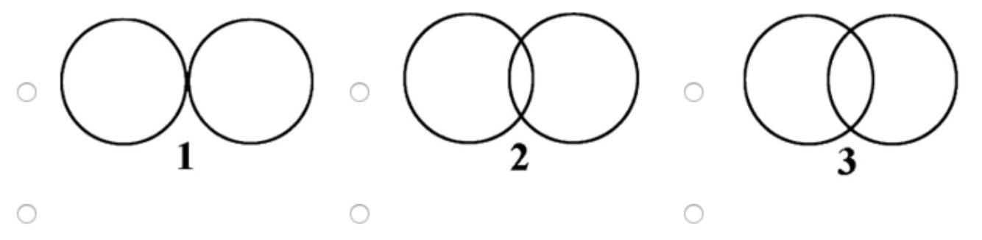
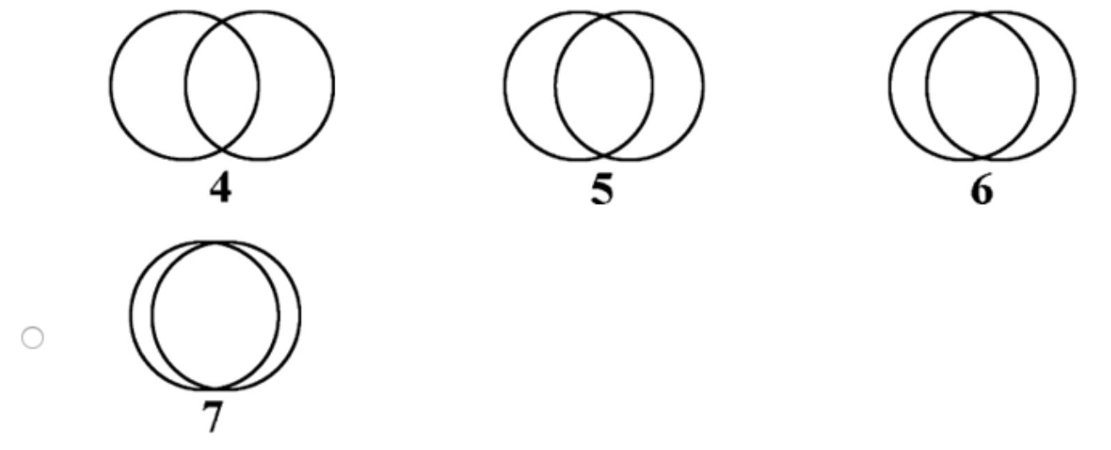

Please rate the extent to which you AGREE with the following statements about your religious beliefs:

Q13 I believe in a personal God or a Higher Power.
 | 1 | 2 | 3 | 4 | 5 | 6 | 7 | 8 | 9
Not at all | o | o | o | o | o | o | o | o | o | Extremely

Q14 When I am in trouble, I find myself wanting to ask God or a Higher Power for help.
 | 1 | 2 | 3 | 4 | 5 | 6 | 7 | 8 | 9
Not at all | o | o | o | o | o | o | o | o | o | Extremely

Q15 When people pray, they are only talking to themselves.
 | 1 | 2 | 3 | 4 | 5 | 6 | 7 | 8 | 9
Not at all | o | o | o | o | o | o | o | o | o | Extremely

Q16 What is the highest degree of education you have completed?
o Some high school
o Completed high school or equivalent
o Some university/college
o Completed university/college
o Some postgraduate work
o Completed a postgraduate degree

Q17 How much do you agree with the following statement?
In today's world, legal and educational systems are more important than religious belief to make sure that people do not harm one another.
o Strongly disagree
o Disagree
o Somewhat disagree
o Neither agree nor disagree
o Somewhat agree
o Somewhat agree
o Agree
o Strongly agree

Q18 How much do you agree with the following statement?
In today's world, legal and educational systems are more important than religious belief to make sure that people help one another.
o Strongly disagree
o Disagree
o Somewhat disagree
o Neither agree nor disagree
o Somewhat agree
o Somewhat agree
o Agree
o Strongly agree

Q19 Politics (US only)

Please indicate whether you AGREE, DISAGREE, or are UNCERTAIN, with regard to each topic listed below:
Agree Disagree Uncertain
Pacifism 

More restricted immigration

Death penalty

Harsh interrogation of
suspected terrorists
Military attacks of foreign
enemies
School prayer

Socialism

Same sex marriage

Abortion rights

Please indicate whether you AGREE, DISAGREE, or are UNCERTAIN, with regard to each topic listed below:
Agree Disagree Uncertain
Military spending

Warrentless searches

Drone strikes on terror suspects

Harsh interrogation of
suspected terrorists
Obedience to authority

Compromise with enemies

Literal existence of God

Welfare spending

Tax cuts

Reduce regulations on business

Recreational drug use

References

Aron, A., Aron, E. N., & Smollan, D. (1992). Inclusion of other in the self scale and the

structure of interpersonal closeness. Journal of personality and social psychology, 63(4),

596.
Dodd, M. D., Balzer, A., Jacobs, C. M., Gruszczynski, M. W., Smith, K. B., & Hibbing, J. R.
(2012). The political left rolls with the good and the political right confronts the bad: connecting physiology and cognition to preferences. Philosophical Transactions of the Royal Society B: Biological Sciences, 367(1589), 640-649.

