Supplement 1.
Funnel plot and forest plot for the assessment of surgical site infection comparing controlled studies with biological mesh and synthetic polypropylene mesh, with subgroup evaluation of studies falling within the heterogeneity analysis of the funnel plot.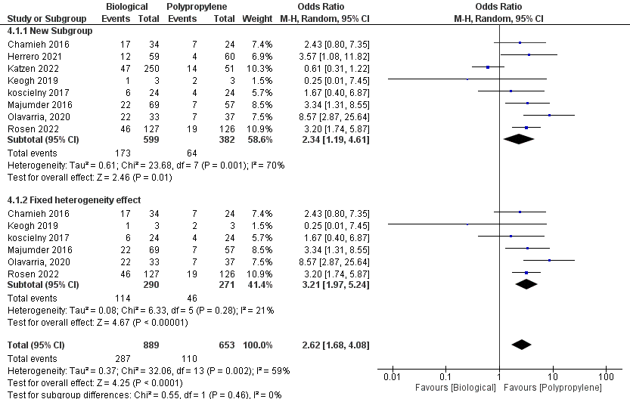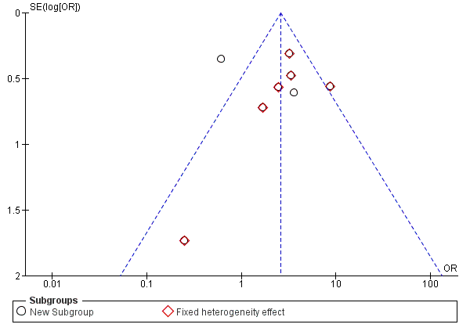

Supplement 2
Forest plot and funnel plot for assessing controlled studies comparing the outcome of reoperation in postoperative abdominal reconstruction using synthetic or biological matrix mesh in patients with hernias in contaminated environments, with a subgroup analysis of studies evaluating only the outcome in randomized clinical trials.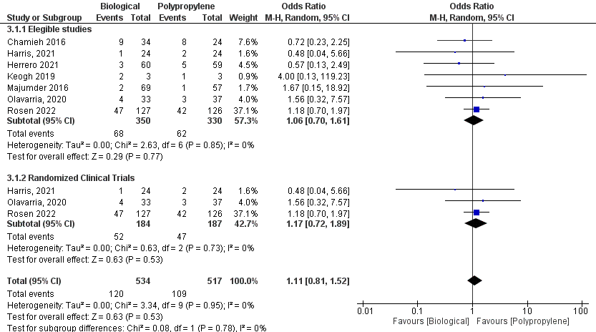

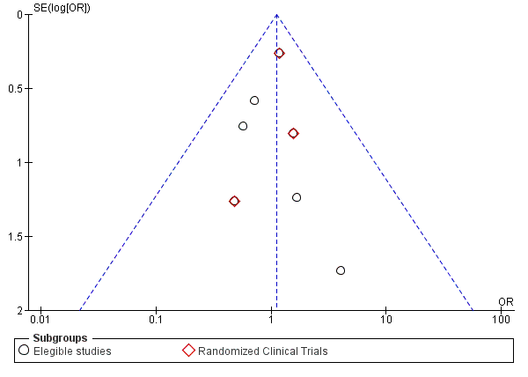
Supplement 3
Forest plot and funnel plot for the evaluation of controlled studies comparing the outcome of recurrence of the hernia defect in postoperative abdominal wall reconstruction among patients with hernia in contaminated environments, with subgroup analysis of studies assessing only the outcome in randomized clinical trials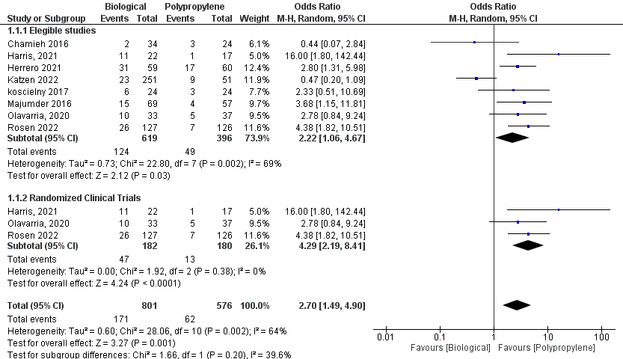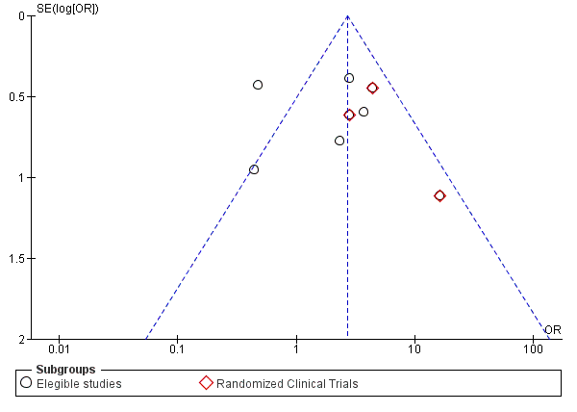

Supplement 4
Forest plot for the evaluation of controlled studies comparing the outcome of mesh removal in postoperative abdominal wall reconstruction with synthetic or biological mesh in contaminated environments, with subgroup analysis of studies assessing only the outcome in randomized clinical trials.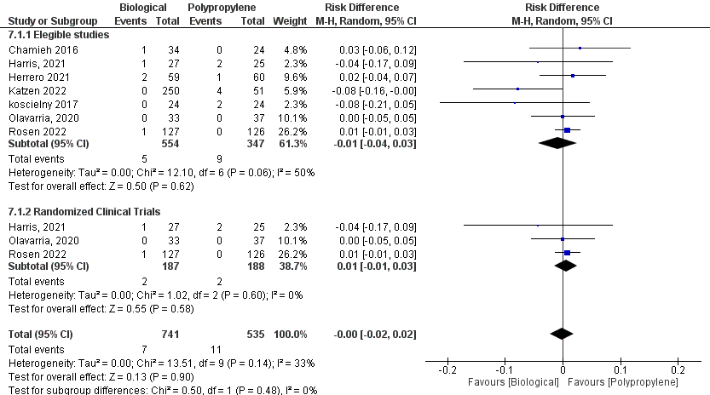
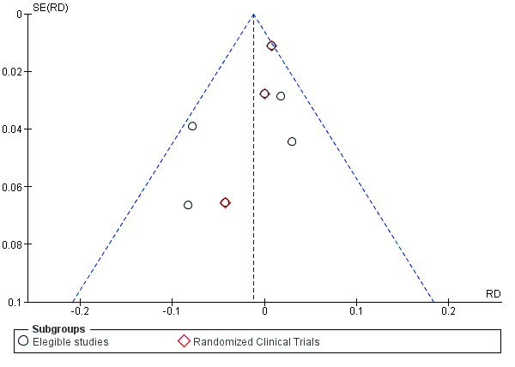

Supplement 5
Forest plot and funnel plot for the evaluation of controlled studies comparing the outcome of readmission in postoperative abdominal hernia reconstruction in a contaminated environment with synthetic mesh or biological matrix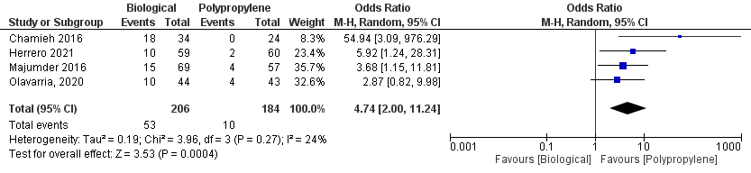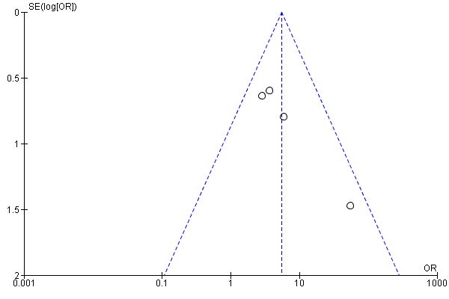

Supplement 6
Forest plot and funnel plot for the assessment of controlled studies comparing the outcome of intra-abdominal infection in postoperative abdominal wall reconstruction in a contaminated environment with biological or synthetic mesh.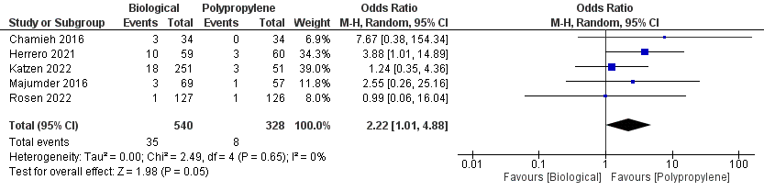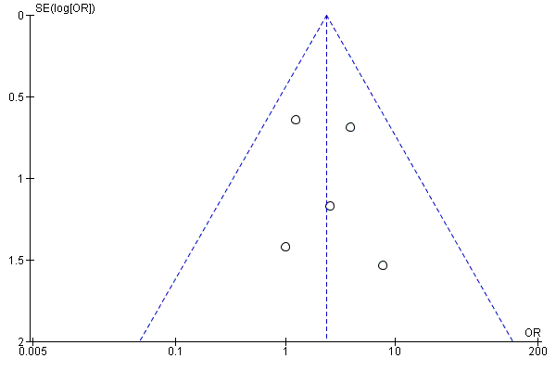

Supplement 7
Forest plot and funnel plot for the assessment of controlled studies comparing the outcome of seroma in postoperative abdominal wall reconstruction in a contaminated environment with biological or synthetic mesh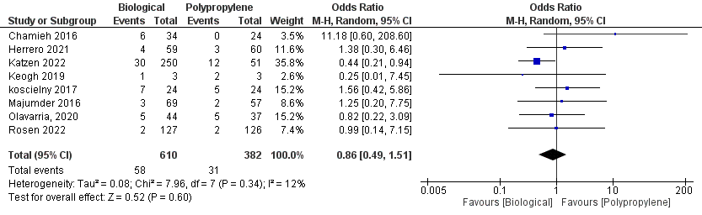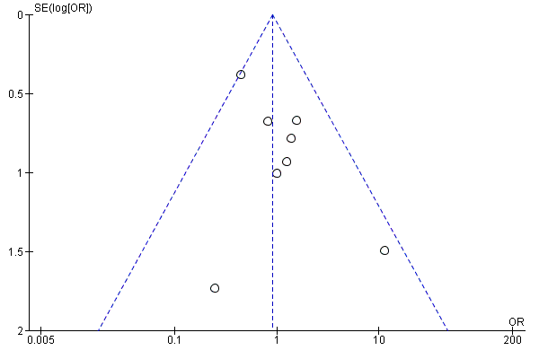

Supplement 8
Forest plot and funnel plot for the assessment of controlled studies comparing the outcome of hematoma in postoperative abdominal wall reconstruction in a contaminated environment with biological or synthetic mesh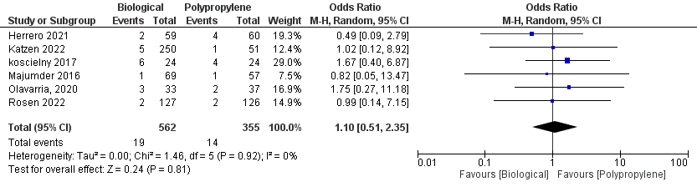
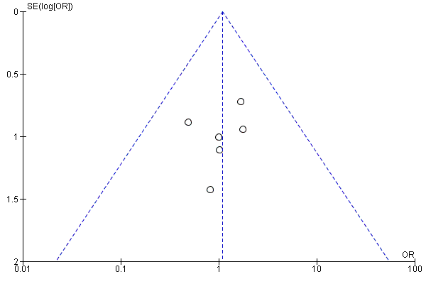

Supplement 9
Forest plot and funnel plot for the assessment of controlled studies comparing the outcome of hospitalization time in postoperative abdominal wall reconstruction in a contaminated environment with biological or synthetic mesh