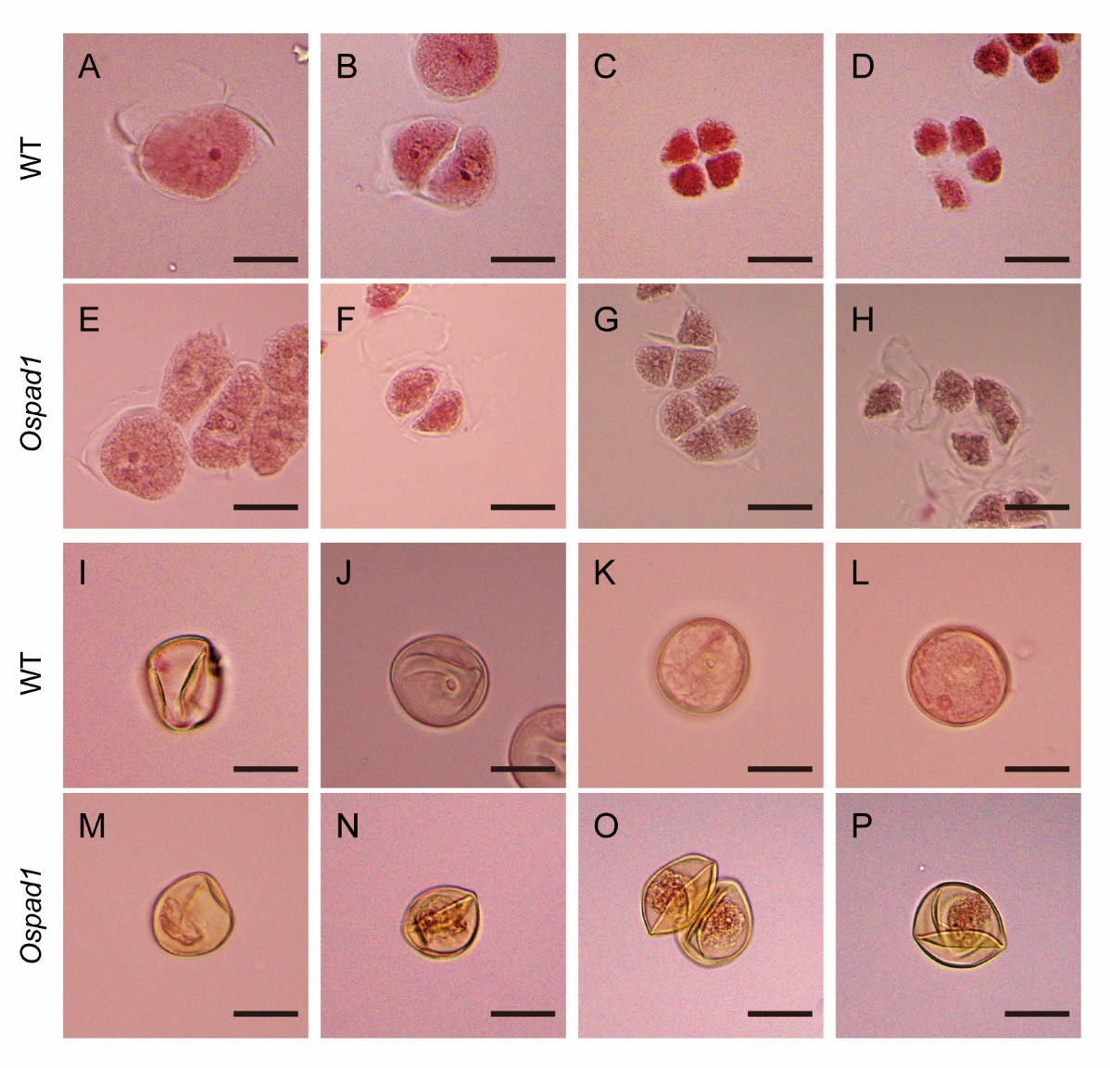
Supplemental Figure 1. Magenta acetate staining of microspores in WT and Ospad1 mutants at various periods.
The development of microspores in the stage 7 (A, E), stage 8a (B, F), stage 8b (D, G), stage 9 (D, H), stage 10 (I, M), stage 11 (J, N), stage 12 (K, O) and stage 13 (L, P) is shown. Bars=20µm

Supplemental Figure 2. Amino acid sequence alignment of OsPAD1 and homologues in other species.
A Amino acid sequences from NCBI were compared using MEGA7. The pink letters represent the region with the highest amino acid similarity. The blue letters indicate regions with lower amino acid homology. Black rectangle indicates the 10 amino acids that are missing in the Ospad1 mutant. B Neighbor-joining phylogenetic tree of OsPAD1 revealed evolutionary relationships with homologs in other species.

Supplemental Figure 3. Phenotypes of WT, mutants and transgenic plants.
A-D Phenotypic comparison of WT (A), Ospad1 mutant (B), CL (pOsPAD1-gOsPAD1 complementation line) (C) and a Cri-Ospad1 mutant (D) created by CRISPR-Cas9. Scale bars = 1.5 mm. E Pollen fertility of WT, Ospad1, CL and Cri-Ospad1 mutants at stage 14. Error bars indicate SD (n=20) (two-tailed Student’s t-tests; *** P <0.001). F Seed setting in WT, Ospad1, CL and Cri-Ospad1 mutants after maturation. Error bars indicate SD (n=50) (two-tailed Student’s t-tests; *** P <0.001).

Supplemental Figure 4. Structural analysis of OsPAD1 protein and phenotypic comparison of OsPAD1-YFP and Ospad1 mutant.
A Site prediction results for the transmembrane structural domain in OsPAD1 protein. Data from http://www.cbs.dtu.dk/services/TMHMM/. B and C Photograph of OsPAD1-YFP (B) and Ospad1 mutant (C). Scale bar = 10 cm. D and E Floral organs of OsPAD1-YFP (D) and Ospad1 mutant (E). Scale bars = 1 mm. F and G Pollen of OsPAD1-YFP (F) and Ospad1 mutant (G). Scale bars = 200 µm. H and I TEM observation of OsPAD1-YFP (H) and Ospad1 mutant (I) pollen for the aperture. Scale bars = 5 µm.

Supplemental Figure 5. Localization of OsPAD1 on pollen at various stages.
A stage 8a. B stage 8b. C stage 9. D stage 10. E stage 11. F stage 12. G stage 13. Ap, aperture. Scale bars = 20 µm.

Supplemental Figure 6. Physicochemical properties and structural analysis of OsPAD1 protein.
A Secondary structure analysis of OsPAD1 protein. Data from https://predictprotein.org/. B Prediction of the protein structural domain of OsPAD1 protein. Data from Results - InterPro (ebi.ac.uk).

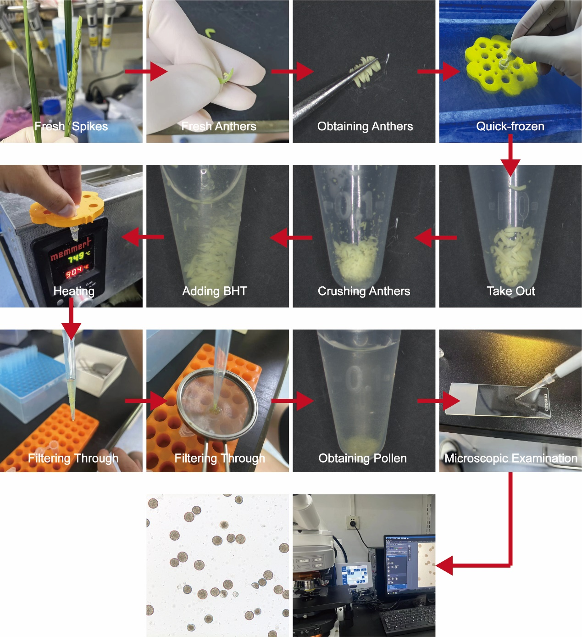
Supplemental Figure 7. Experimental procedure for obtaining pollen grains.

Supplemental Figure 8. Differences in the specific fractions of various types of lipids in mature pollen of WT and Ospad1 mutant.
A Phosphatidylserines. B Lyso-phosphatidic acids. C Phosphatidic acids. D Cardiolipins. E Free fatty acids. F Phosphatidylinositols. G Phosphatidylglycerols. H Diacylglycerols. Each value is the mean of three biological replicates ± SD. *, P <0.05; **, P <0.01; ***, P <0.001.

Supplemental Figure 9. Differences in the specific fractions of various types of lipids in mature pollen of WT and Ospad1 mutant.
A Phosphatidylethanolamines. B Digalactosyl diacylglycerols. C Triacylglycerols. D Phosphatidylcholines. E Monogalactosyl diacylglycerols. Each value is the mean of three biological replicates ± SD. *, P <0.05; **, P <0.01; ***, P <0.001.

