Supplementary Information for
Complete breakup of liquids into ultrafine droplets by grid turbulence
Ziwei Li^{1†}, Yansong Li^{2†}, Zhiwen Cui^{2†}, Zekun Cheng^{1†}, Shanyu Zhao³, Ya Huang⁴, Shuojin Li², Haiyang Wang¹, Yiqian Zhou¹, Yuchen Fan¹, Peng Du¹, Sheng Lu¹, Lihao Zhao^{2 ✉}, and Hui Wu^{1 ✉}

This PDF file includes:

Materials and chemicals
Fabrication of powders by GTA
Supplementary Note 1
Supplementary Figs. 1 to 18
Supplementary Tables 1 and 2
Captions for Supplementary Videos 1 to 9
Supplementary References

Other Supplementary Materials for this manuscript include the following:

Supplementary Videos 1 to 9 (.mp4)

Table of Contents

Materials and chemicals 4

Fabrication of powders by GTA 5

Supplementary Note 7
Supplementary Note 1: Kolmogorov-Hinze (KH) theory 7

Supplementary Figures 8
Supplementary Fig. 1 | Photographs and SEM images of meshes with different counts. 8
Supplementary Fig. 2 | The wettability of different liquids on a stainless steel mesh. 9
Supplementary Fig. 3 | The wettability of water on various material substrates. 10
Supplementary Fig. 4 | High-speed camera images demonstrating universality of GTA to spray various liquids. 11
Supplementary Fig. 5 | Photographs capturing the ultrasonic atomization of various liquids using a commercial ultrasonic atomizer equipped with a 1.7 MHz ultrasonic chip. 12
Supplementary Fig. 6 | Schematics of the computational model and domain. 13
Supplementary Fig. 7 | Evolution of grid turbulence captured at different time intervals. 14
Supplementary Fig. 8 | Schematic diagram of the smoke-wire system used for flow visualization. 15
Supplementary Fig. 9 | CFD simulation of the nondimensionalized airflow velocities using meshes with different counts. 16
Supplementary Fig. 10 | CFD simulation of the Q coupled with the dispersed liquid droplets. 17
Supplementary Fig. 11 | Water droplet size generated by ultrasonic atomization at different frequencies.. 18
Supplementary Fig. 12 | Size distribution of various liquid droplets generated by GTA. 19
Supplementary Fig. 13 | Characterization of one commercial coffee powder. 20
Supplementary Fig. 14 | XRD patterns, SEM images, corresponding elemental mapping images of ceramic powders fabricated by GTA. 21
Supplementary Fig. 15 | Characterization of LiNi_{0.8}Co_{0.1}Mn_{0.1}O₂ powders fabricated by GTA. 22
Supplementary Fig. 16 | Characterization of Li₇La₃Zr₂O₁₂ powders fabricated by GTA. 23
Supplementary Fig. 17 | Size distribution of powders fabricated by GTA. 24
Supplementary Fig. 18 | Humidification Performance of GTA. 25

Supplementary Tables 26
Supplementary Table 1 | The dynamic viscosity of different liquids and their atomization properties. 26
Supplementary Table 2 | Physical properties of glycerol/water mixtures at different weight ratios. 27

Captions for Supplementary Videos 28
Supplementary Video 1 | Design and principle of GTA. 28
Supplementary Video 2 | Water spray by GTA. 28
Supplementary Video 3 | High-speed video capturing GTA spray of water. 28
Supplementary Video 4 | High-speed video capturing GTA spray of various liquids. 28
Supplementary Video 5 | High-speed video capturing GTA spray of high-viscosity silicone oils. 28
Supplementary Video 6 | CFD simulation of grid-turbulence evolution. 28
Supplementary Video 7 | Visualization of grid-turbulence evolution. 28
Supplementary Video 8 | High-speed video capturing the bag breakup of liquid droplets. 28
Supplementary Video 9 | CFD simulation of liquid droplet motion in turbulent flow. 28

Supplementary References 29

Materials and chemicals
The following materials were used. Coffee powder (Black coffee, Catfour Industrial Co., Ltd.); milk (Junlebao Dairy Group); sodium chloride (NaCl, AR, 99.5%, Shanghai Aladdin Biochemical Technology Co., Ltd.); sugar (Sugarman®, Guangzhou Fuzheng Donghai Food Co., Ltd.); tartrazine (Meryer (Shanghai) Biochemical Technology Co., Ltd.); fluorescent green (Water soluble fluorescent leak detectors); polyvinyl alcohol (PVA, 1788, Shanghai Titan Scientific Co., Ltd.); polyvinyl pyrrolidone (PVP, Mn = 1,300,000, Alfa Aesar Chemical Co., Ltd.); tetraethyl orthosilicate (TEOS, 99%, Shanghai Macklin Biochemical Co., Ltd.); phosphoric acid (H₃PO₄, Sinopharm Group Chemical Reagent Co., Ltd.); aluminum chloride hexahydrate (AlCl₃·6H₂O, Sinopharm Group Chemical Reagent Co., Ltd.); zirconium acetate (Zr(OAc)₄, Adamas); lithium acetate (LiOAc, Anhydrous, 99%, Innochem (Beijing) Technology Co., Ltd.); lanthanum (Ⅲ) acetate hydrate (La(OAc)₃·xH₂O, 99.9% metals basis, Innochem (Beijing) Technology Co., Ltd.); zirconium(Ⅳ) oxynitrate hydrate (ZrO(NO₃)₂·xH₂O, AR, 99.5%, Shanghai Aladdin Biochemical Technology Co., Ltd.); nickel(Ⅱ) acetate tetrahydrate (Ni(OAc)₂·4H₂O, 99.9% metals basis, Innochem (Beijing) Technology Co., Ltd.); cobalt (Ⅱ) acetate tetrahydrate (Co(OAc)₂·4H₂O, 98%, Innochem (Beijing) Technology Co., Ltd.); Manganese (Ⅱ) acetate tetrahydrate (Mn(OAc)₂·4H₂O, 99%, Innochem (Beijing) Technology Co., Ltd.)

Fabrication of powders by GTA
Three grams of raw coffee powder, 20 g milk, 3 g NaCl, 3 g sugar, 2 g tartrazine, 2 g fluorescent green, 2 g PVA were dissolved into 100 g deionized water, respectively. The solutions were poured into the vessel, followed by being atomized and dried into corresponding particles, respectively.
As for the oxide ceramic particles, heat treatment was utilized to allow the precursor to be oxidized:
SiO₂ particles. 1g PVA was dissolved into 70 g deionized water by magnetically stirring at 60 °C for 6 h. Then, 31.20 g TEOS and 0.16g H₃PO₄ were added into the PVA solution. The solution was magnetically stirred for 6 h at room temperature. Afterward, the solution was used to prepare precursor particle powder via the GTA process. The powder was immediately treated at 800°C for 2 h with a heating rate of 5°C/min in the air before cooled down in the furnace. Finally, the SiO₂ particles were obtained.
Al₂O₃ particles. 3 g PVP and 6 g AlCl₃·6H₂O were dissolved into 100 g deionized water by magnetically stirring at 60 °C for 6 h. Afterward, the homogeneous solution was used to prepare AlCl₃/PVP particle powder via the GTA process. The particle powder was immediately treated at 1200°C for 2 h with a heating rate of 5°C/min in the air before cooled down in the furnace. Finally, the Al₂O₃ particles were obtained.
ZrO₂ particles. 3 g PVP and 6 g Zr(OAc)₄ were dissolved into 100 g deionized water by magnetically stirring at 60 °C for 6 h. Afterward, the homogeneous solution was used to prepare Zr(OAc)₄/PVP particle powder via the GTA process. The particle powder was immediately treated at 1000°C for 2 h with a heating rate of 5°C/min in the air before cooled down in the furnace. Finally, the ZrO₂ particles were obtained.
Li₇La₃Zr₂O₁₂ particles. 2 g PVA, 2.02 g ZrO(NO₃)₂·xH₂O, 4.21 g La(OAc)₃·xH₂O, and 2.26 g LiOAc were dissolved into 100 g deionized water by magnetically stirring at 60 °C for 6 h. Afterward, the homogeneous solution was used to prepare precursor particle powder via the GTA process. The particle powder was immediately treated at 900°C for 2 h with a heating rate of 5°C/min in the air before cooled down in the furnace. Finally, the Li₇La₃Zr₂O₁₂ particles were obtained.
LiNi_{0.8}Co_{0.1}Mn_{0.1}O₂ particles. 2 g PVA, 3.98 g Ni(OAc)₂·4H₂O, 0.50 g Co(OAc)₂·4H₂O, 0.49 g Mn(OAc)₂·4H₂O, and 1.45 g LiOAc were dissolved into 100 g deionized water by magnetically stirring at 60 °C for 6 h. Afterward, the homogeneous solution was used to prepare precursor particle powder via the GTA process. The particle powder was immediately treated at 800°C for 2 h with a heating rate of 5°C/min in the air before cooled down in the furnace. Finally, the LiNi_{0.8}Co_{0.1}Mn_{0.1}O₂ particles were obtained.

Supplementary Note

Supplementary Note 1: Kolmogorov-Hinze (KH) theory
Kolmogorov-Hinze (KH) theory¹ is the cornerstone of the breakup of small droplets in the turbulence, and identifies a Hinze scale $d_{H}$ for the maximum droplet size, i.e.,
$$d_{H}∝{\left(\frac{σ}{ρ_{c}}\right)}^{\frac{3}{5}}ϵ^{-\frac{2}{5}}.$$Here $σ$ is surface tension, $ϵ$ is the dissipation of turbulence and $ρ_{c}$ is the density of carrier-phase fluid. In this study, the carrier-phase fluid is air. Above the Hinze scale, the droplets disintegrate due to the eddies of turbulence. In contrast, below the Hinze scale, the surface tension of droplets is sufficiently large to withstand the dynamics pressure, thus preventing the breakup of droplets^{1,2}. This equation shows the maximum droplet size depends on the dissipation of turbulence. Generally, an increase in dissipation is indicative of higher turbulence intensity for a given carrier-phase fluid. Therefore, as the turbulence intensity of the flow increases, the size of the droplets decreases.

Supplementary Figures
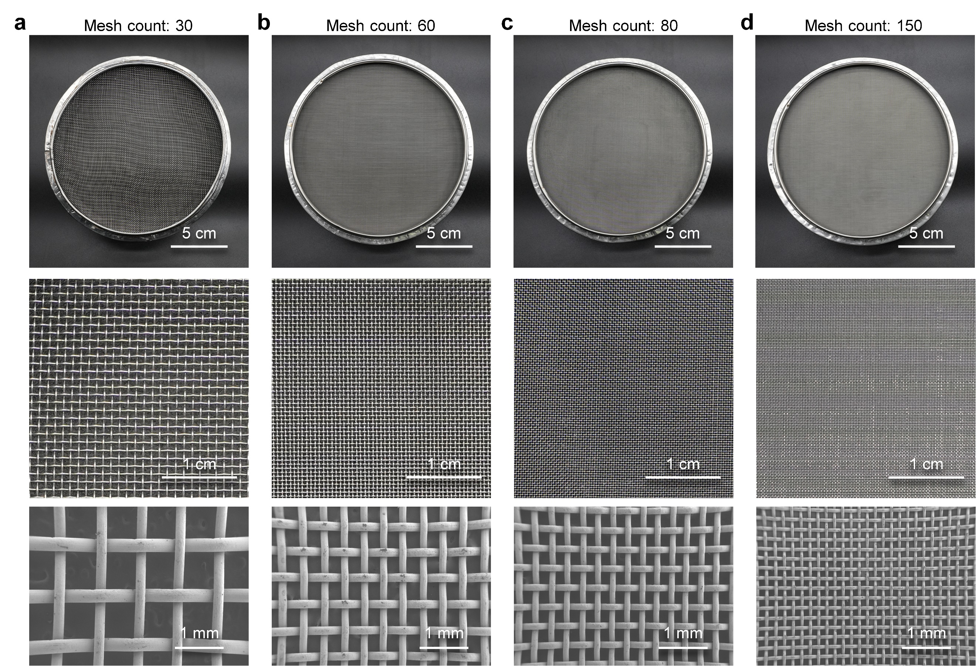

Supplementary Fig. 1 | Photographs and SEM images of meshes with different counts.
a, 30 count. b, 60 count. c, 80 count. d, 150 count.
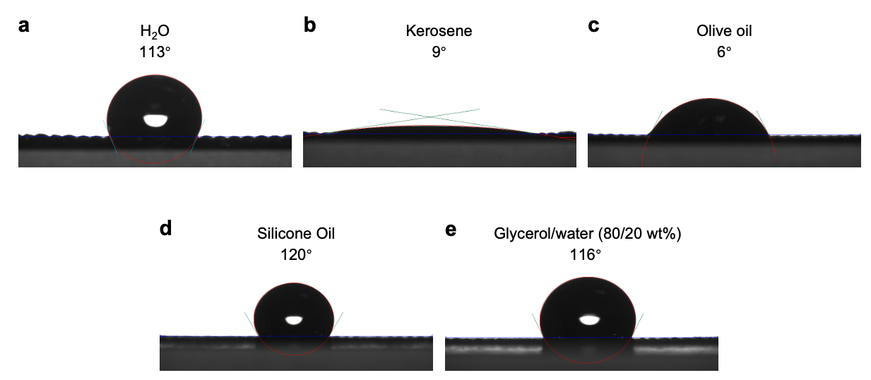

Supplementary Fig. 2 | The wettability of different liquids on a stainless steel mesh.
a, H₂O. b, Kerosene. c, Olive oil. d, Silicone oil. e, Glycerol/water (80/20 wt%). The stainless steel mesh used here has a mesh count of 60.

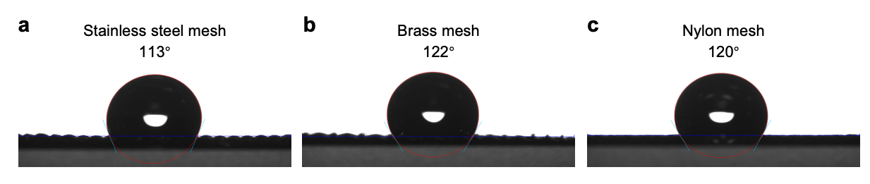

Supplementary Fig. 3 | The wettability of water on various material substrates.
a, Stainless steel mesh. b, Brass mesh. c, Nylon mesh. All meshes used here have a mesh count of 60.

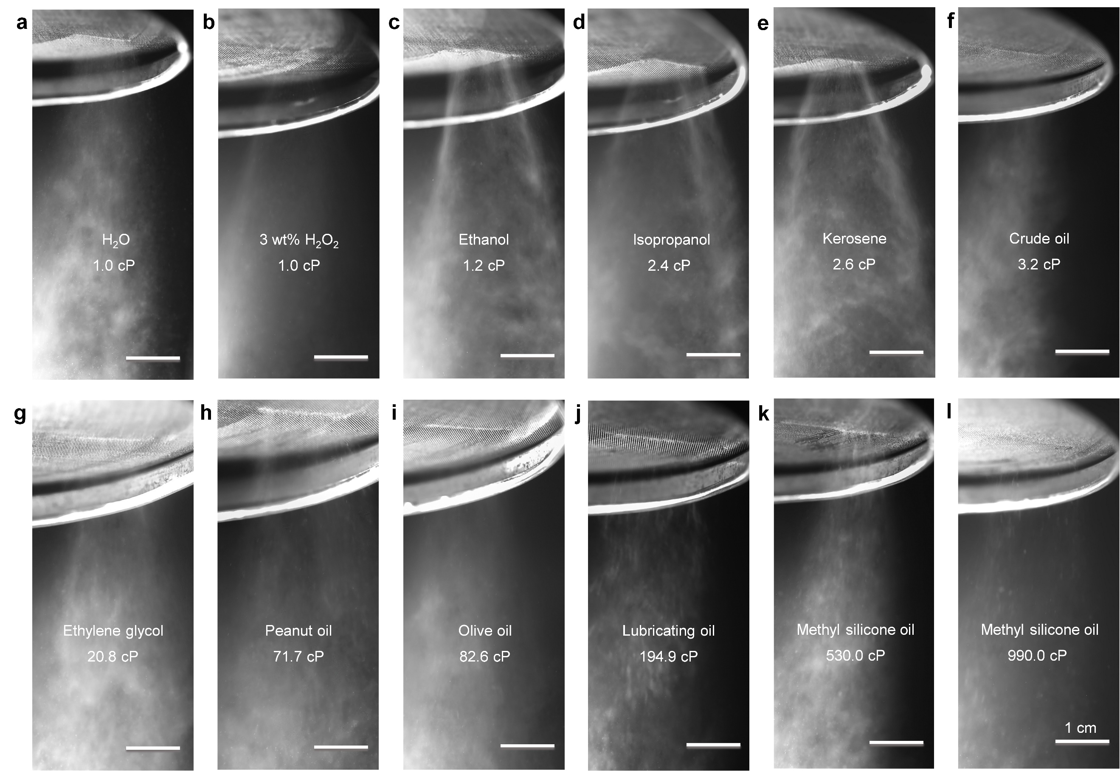

Supplementary Fig. 4 | High-speed camera images demonstrating universality of GTA to spray various liquids.
a, H₂O. b, 3 wt% H₂O₂. c, Ethanol. d, Isopropanol. e, Kerosene. f, Crude oil. g, Ethylene glycol. h, Peanut oil. i, Olive oil. j, Lubricating oil. k, Methyl silicone oil (530.0 cP). l, Methyl silicone oil (990.0 cP).

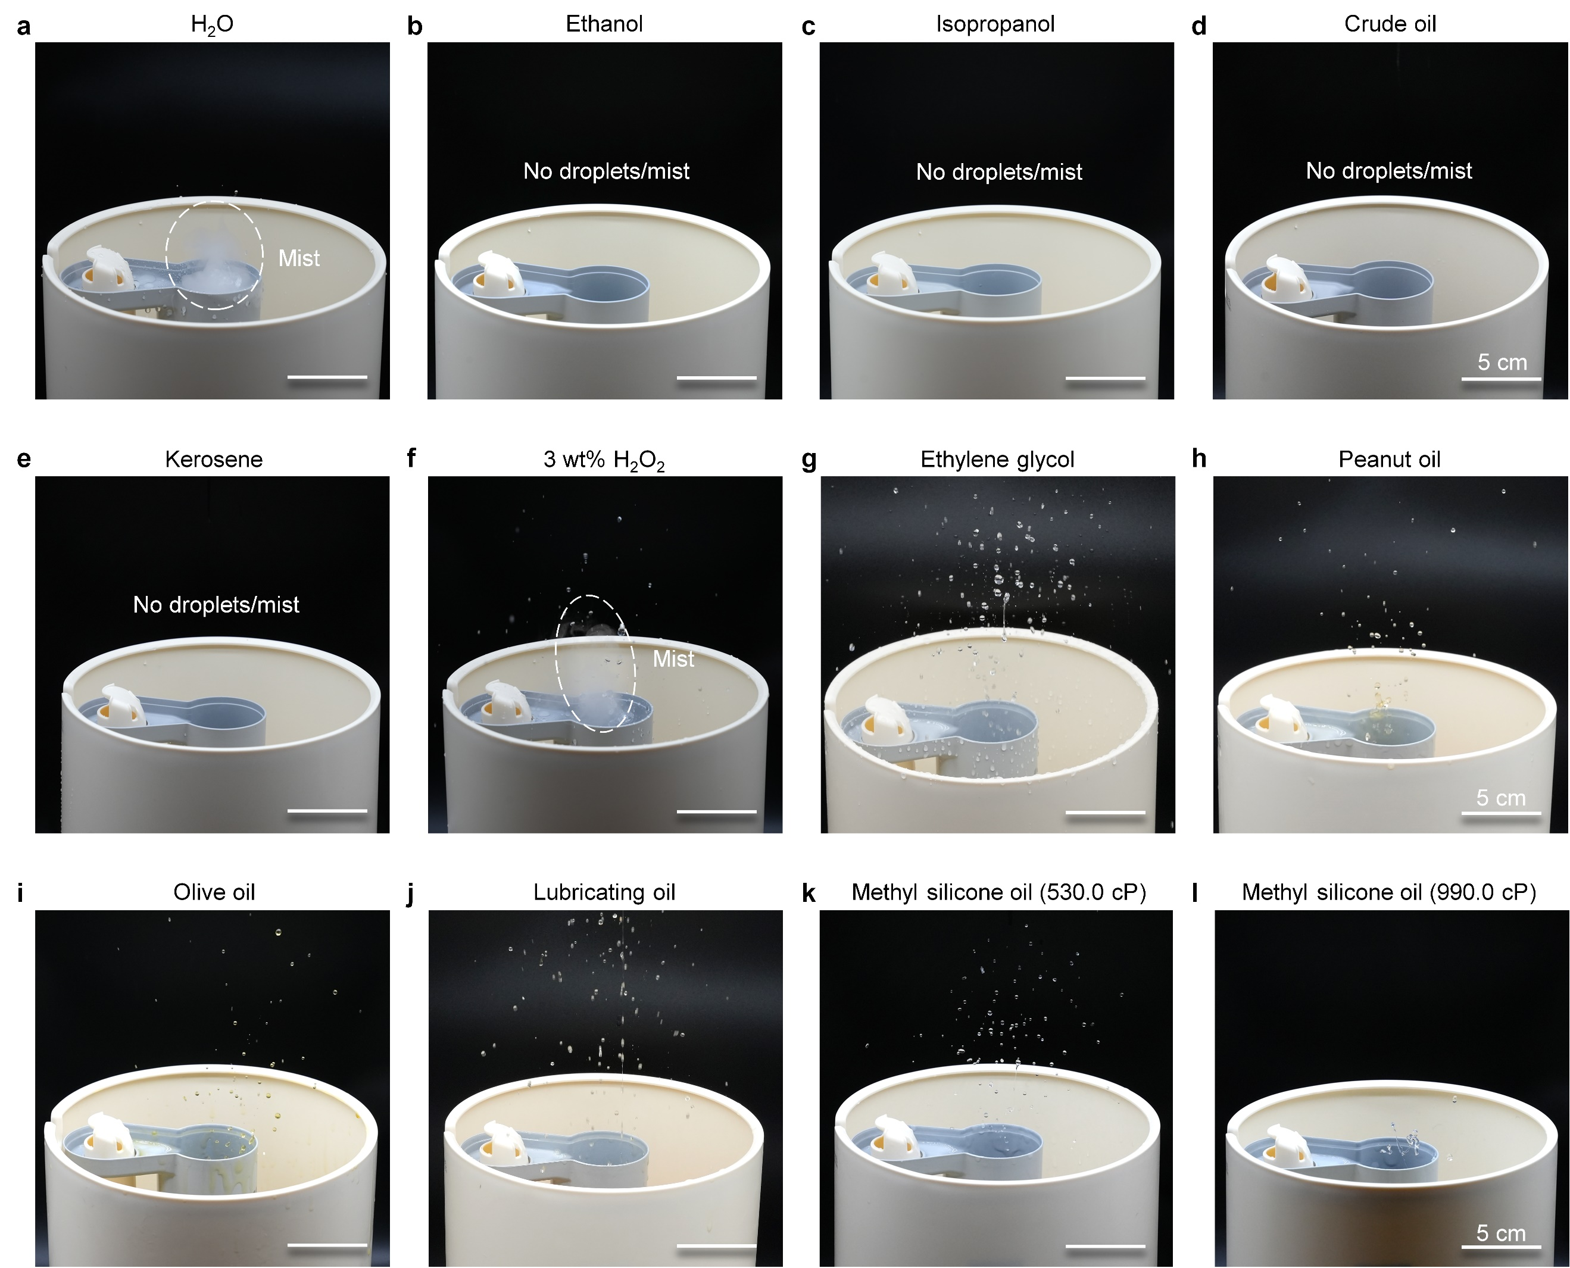

Supplementary Fig. 5 | Photographs capturing the ultrasonic atomization of various liquids using a commercial ultrasonic atomizer equipped with a 1.7 MHz ultrasonic chip.
a, H₂O. b, Ethanol. c, Isopropanol. d, Crude oil. e, Kerosene. f, 3 wt% H₂O₂. g, Ethylene glycol. h, Peanut oil. i, Olive oil. j, Lubricating oil. k, Methyl silicone oil (530.0 cP). l, Methyl silicone oil (990.0 cP).

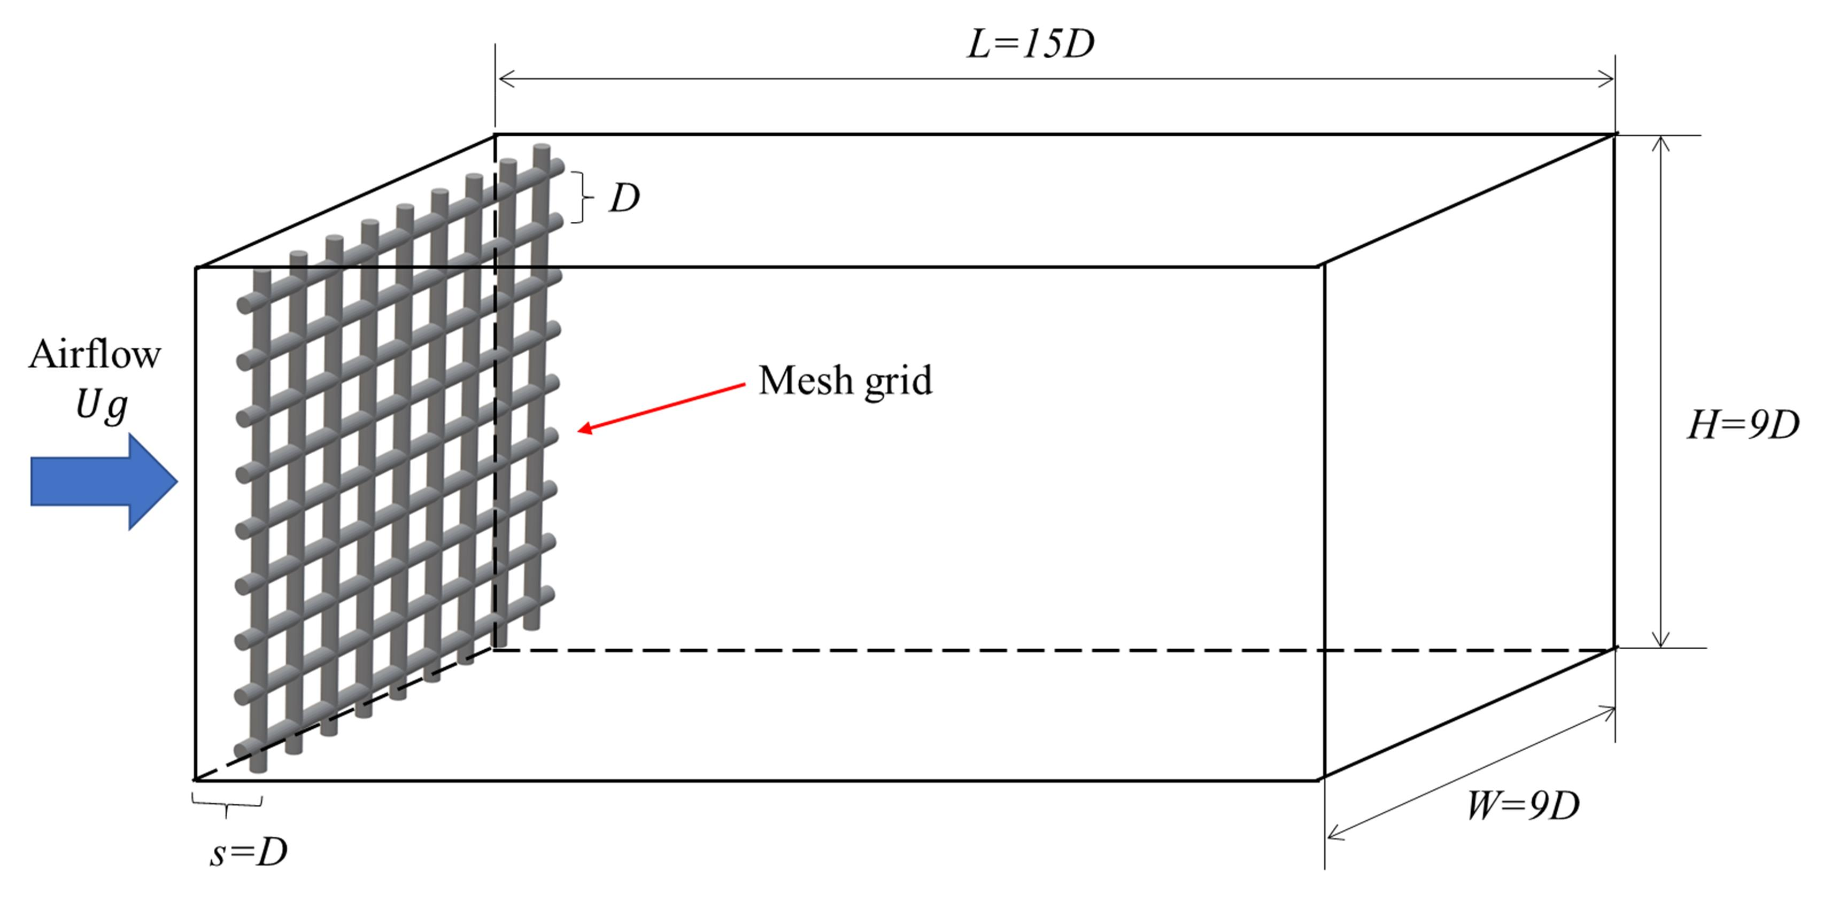

Supplementary Fig. 6 | Schematics of the computational model and domain.

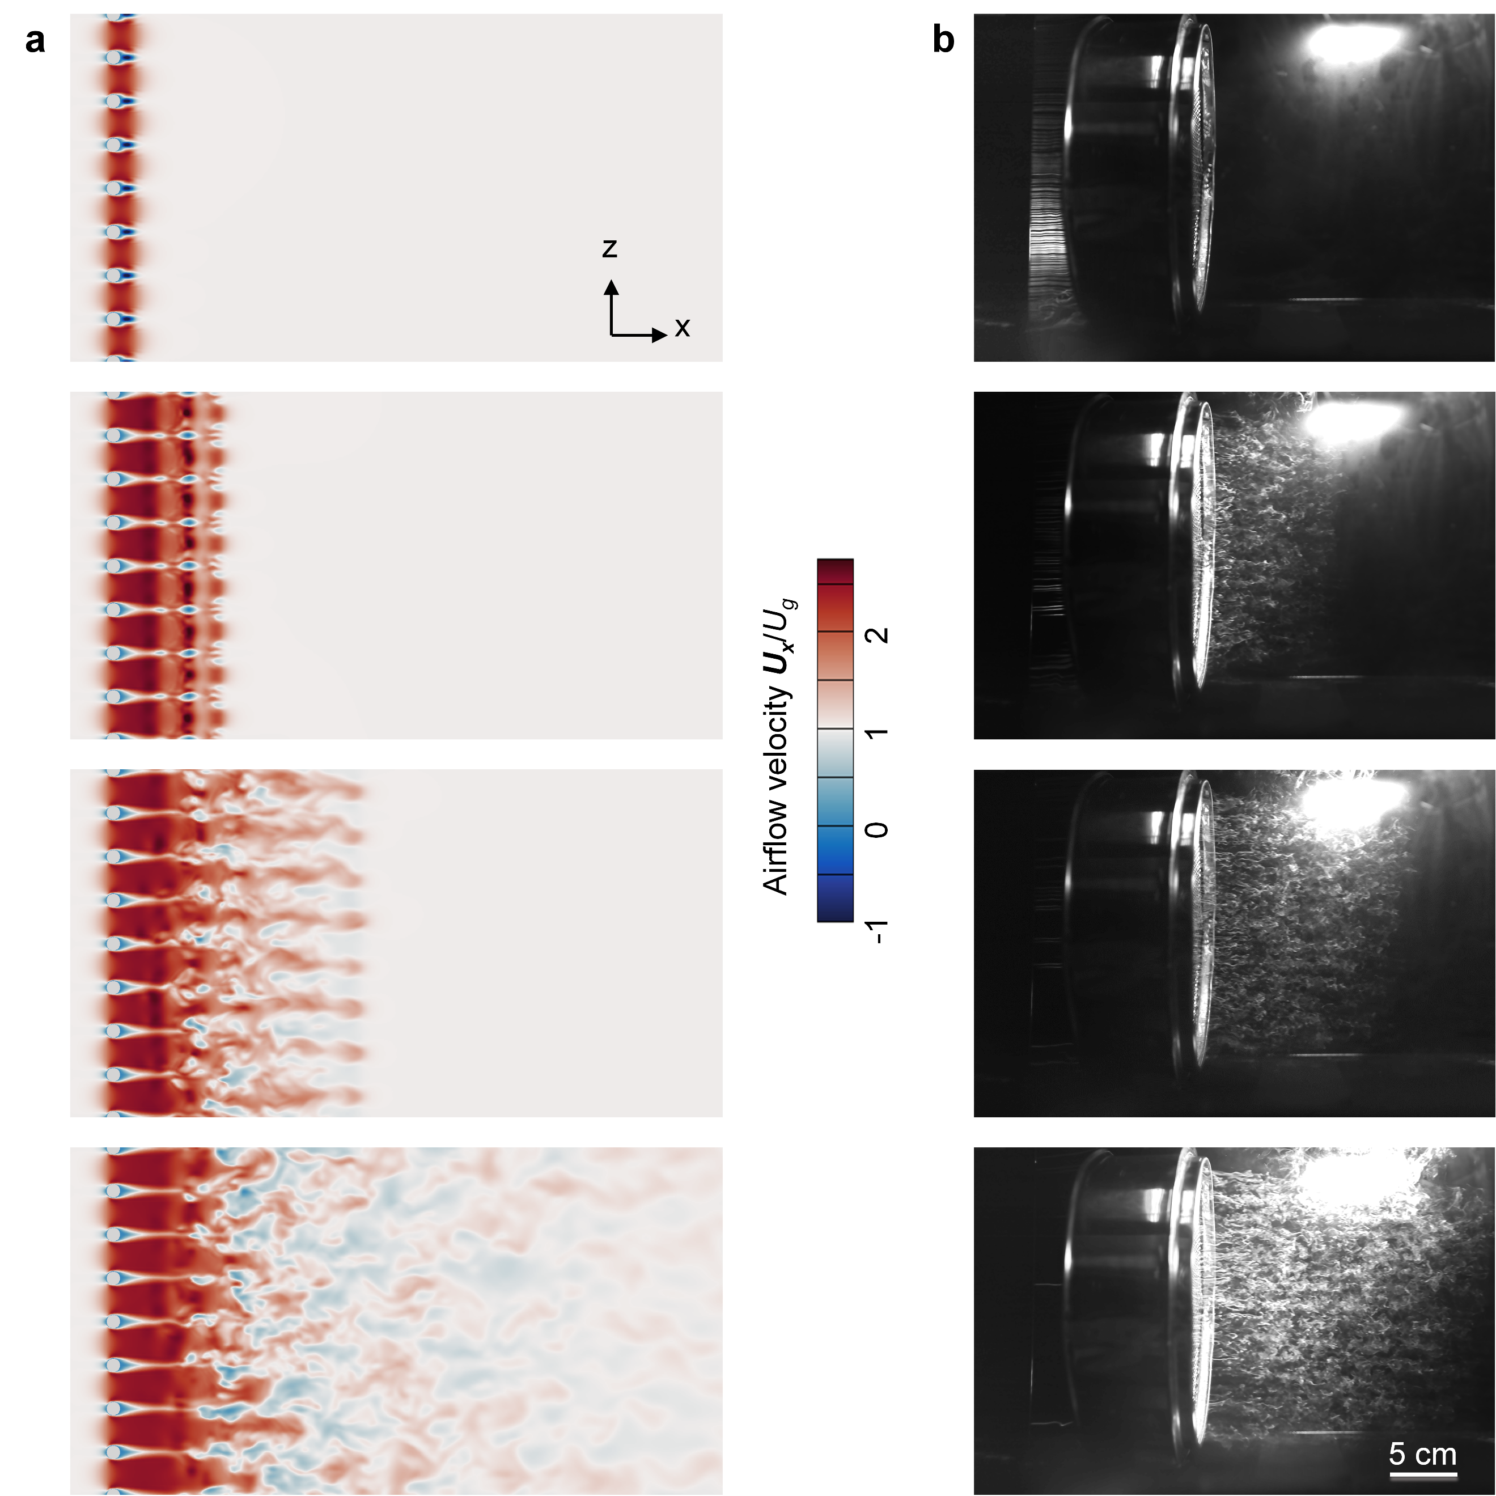

Supplementary Fig. 7 | Evolution of grid turbulence captured at different time intervals.
a, CFD simulation depicting the nondimensionalized airflow velocity U_{x}/U_{g}. $U_{x}$ is the airflow velocity along the x-axis, and $U_{g}$ is the magnitude of the initial airflow velocity. b, Experimental flow visualization. The airflow patterns were visualized using smoke streaklines, which were generated by a smoke-wire system.

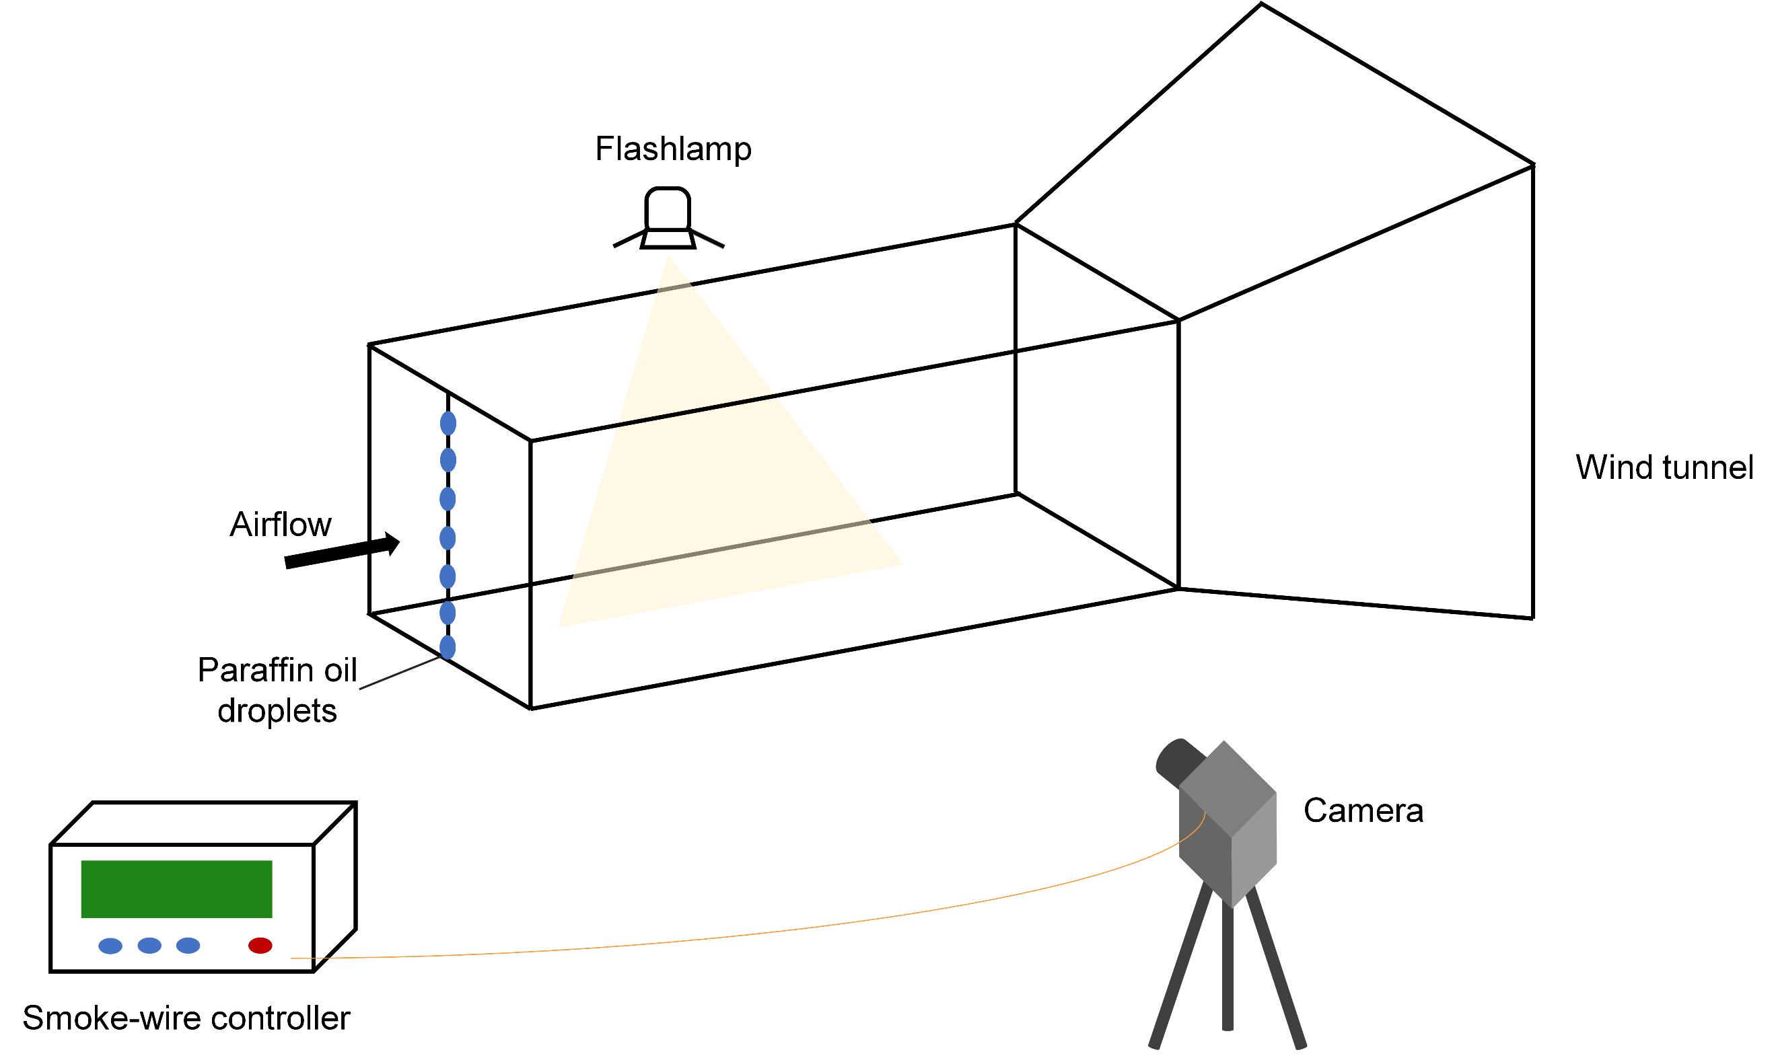

Supplementary Fig. 8 | Schematic diagram of the smoke-wire system used for flow visualization.

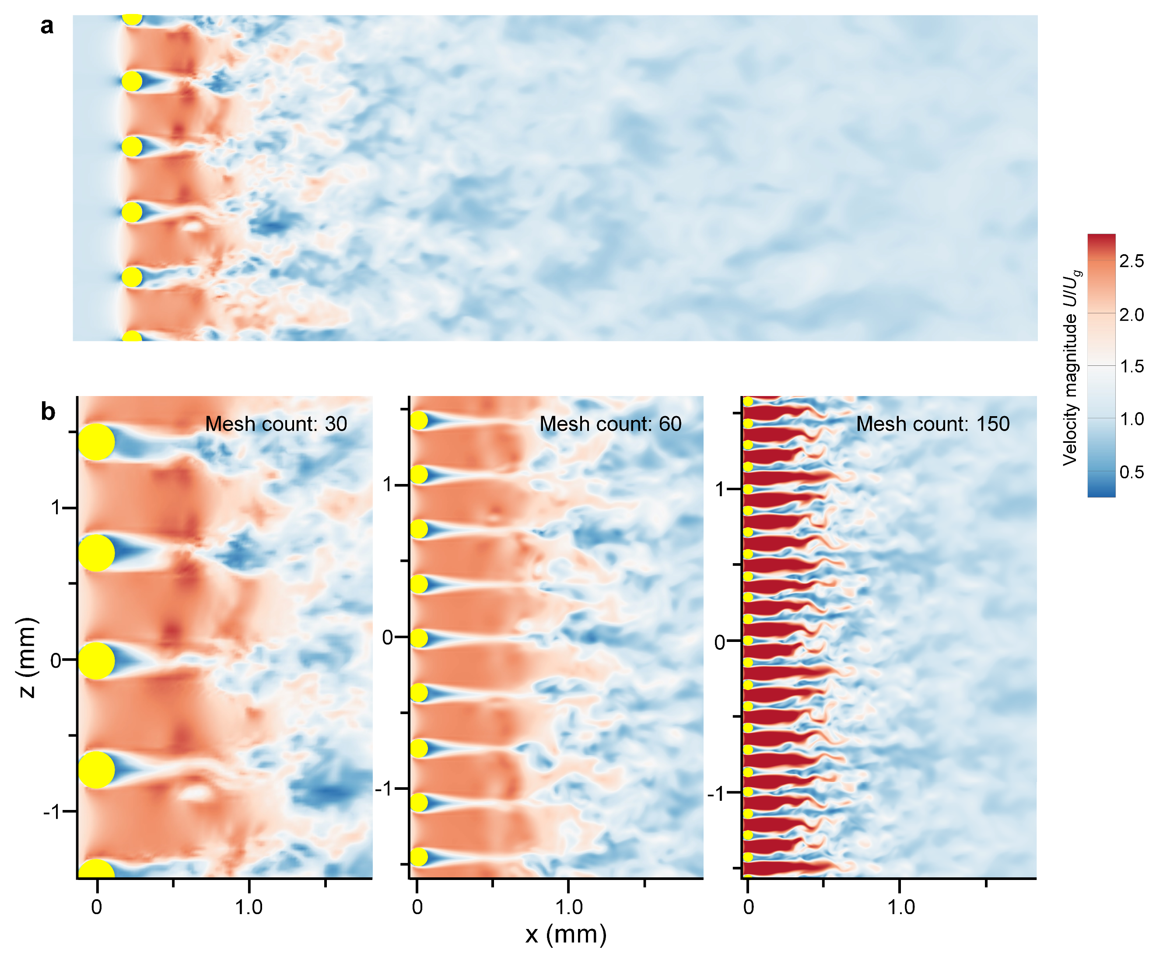

Supplementary Fig. 9 | CFD simulation of the nondimensionalized airflow velocities using meshes with different counts.
a, CFD simulation depicting the nondimensionalized airflow velocity magnitude as the airflow passed through a mesh with 30 counts. $U$ is the airflow velocity magnitude, and $U_{g}$ is the magnitude of the initial airflow velocity. b, Detailed CFD simulations using meshes with different counts. As mesh count increases, the transition of airflow from laminar to turbulent flow was accelerated.

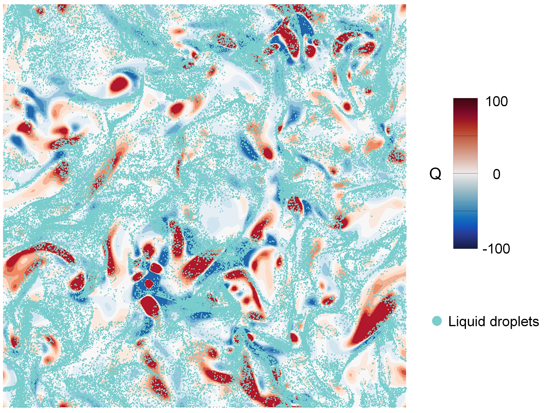

Supplementary Fig. 10 | CFD simulation of the Q coupled with the dispersed liquid droplets.
Here, the Q value reflects the difference between the magnitudes of the fluid vorticity and strain rate. Q > 0 represents vorticity-dominant region and Q < 0 signifies strain-dominant region. Droplets tended to concentrate in the strain-dominant region, which exhibited higher pressure and strong shear.

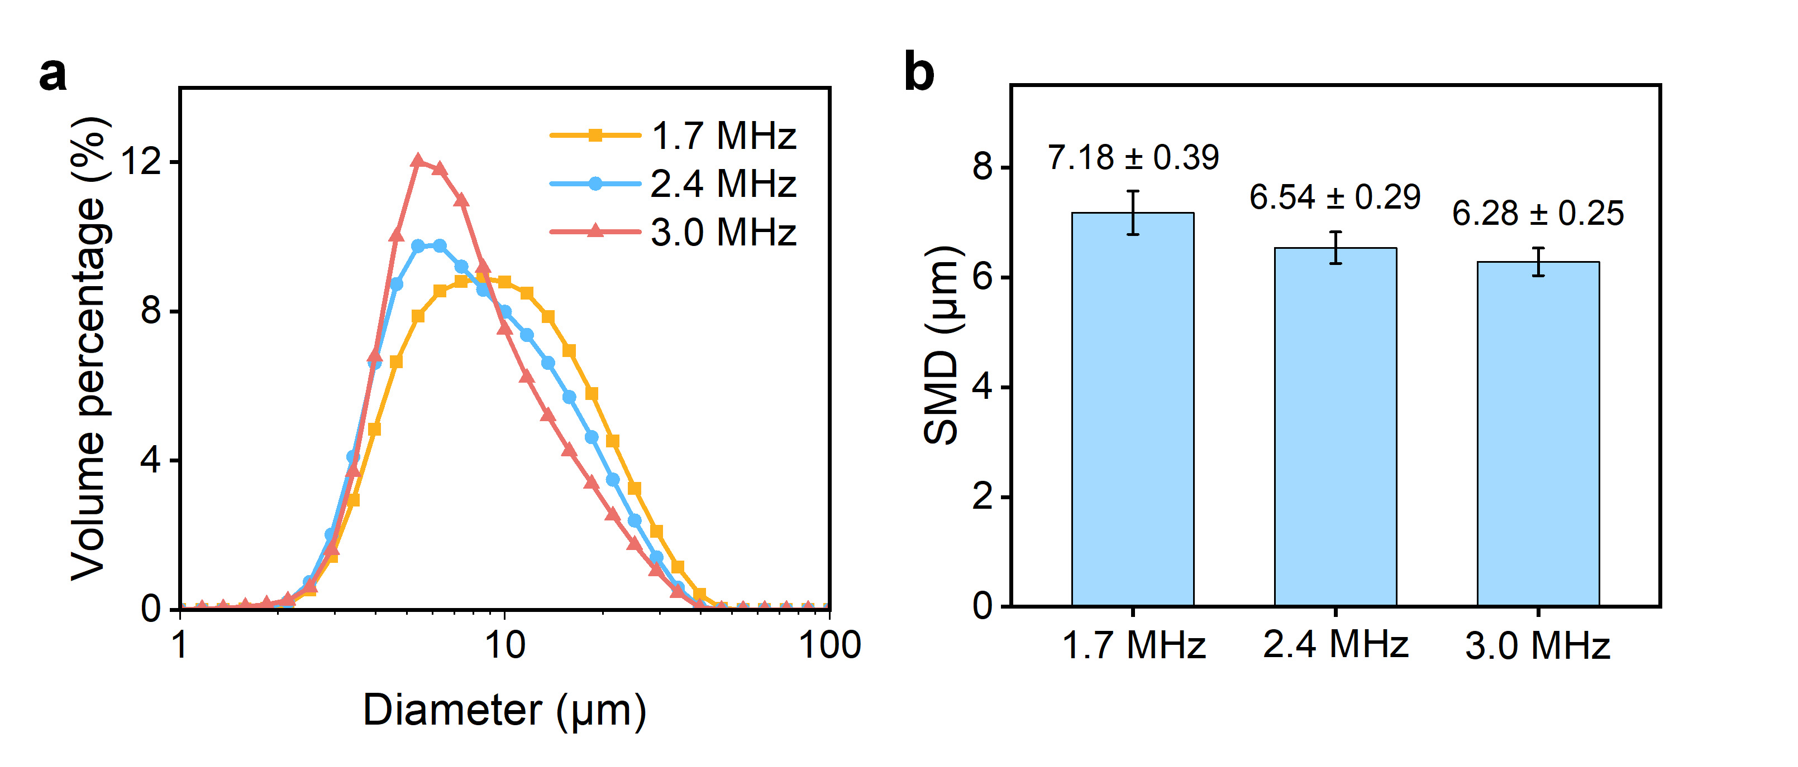

Supplementary Fig. 11 | Water droplet size generated by ultrasonic atomization at different frequencies.
a, Size distribution of water droplets generated by ultrasonic atomization at different frequencies. b, Sauter Mean Diameter (SMD) of water droplets at different ultrasonic frequencies.

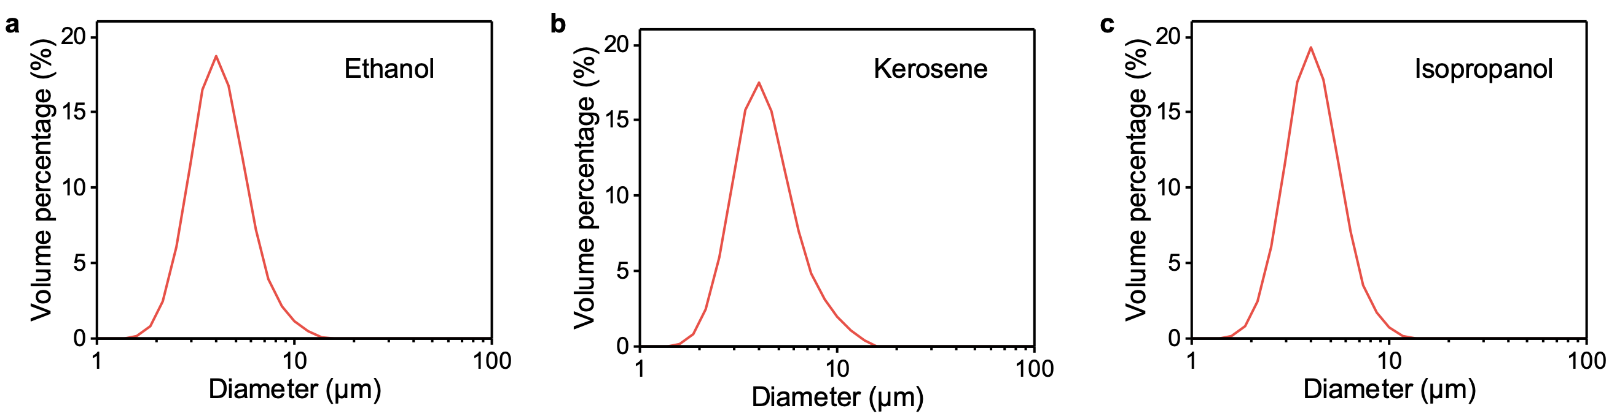

Supplementary Fig. 12 | Size distribution of various liquid droplets generated by GTA.
a, Ethanol. b, Kerosene. c, Isopropanol.

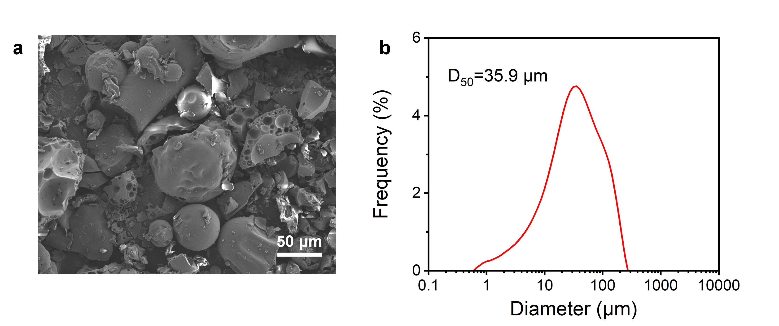

Supplementary Fig. 13 | Characterization of one commercial coffee powder.
a, a SEM image. b, size distribution. Dissolving the commercial coffee powder in water and then spray-drying it using the GTA method could result in a smaller diameter coffee powder.

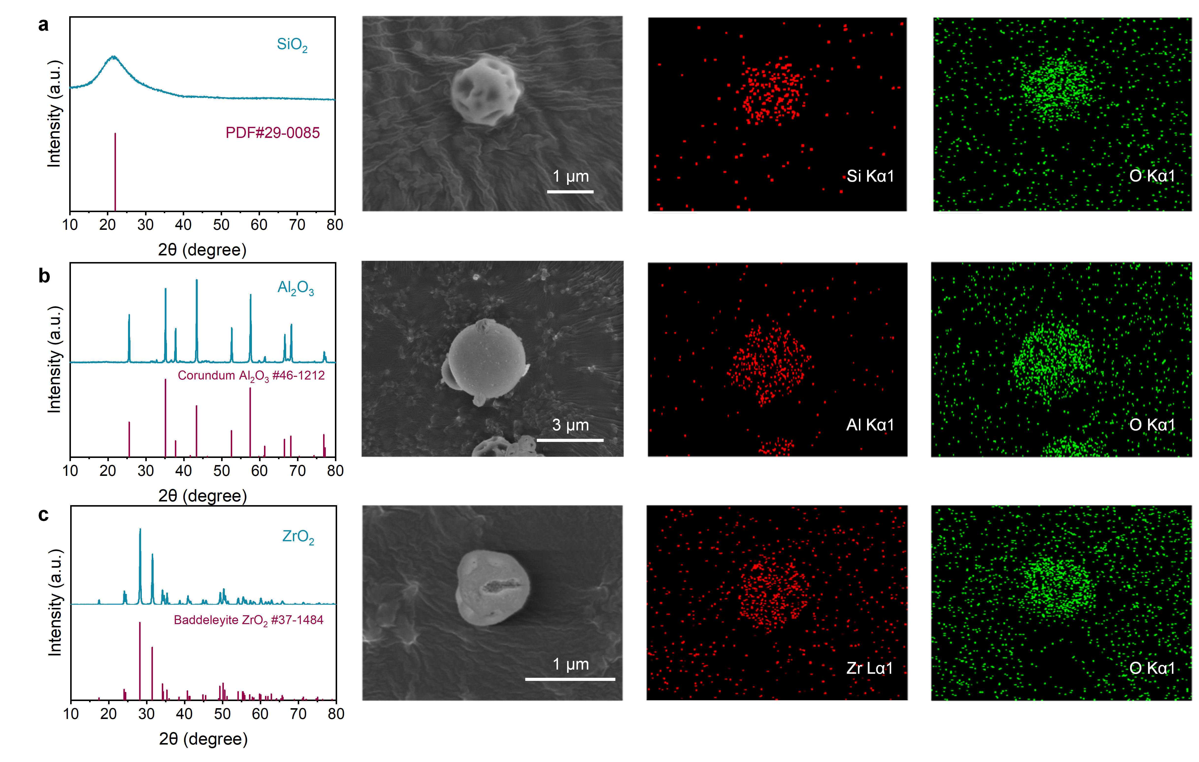

Supplementary Fig. 14 | XRD patterns, SEM images, corresponding elemental mapping images of ceramic powders fabricated by GTA.
a, SiO₂. b, Al₂O₃. c, ZrO₂.

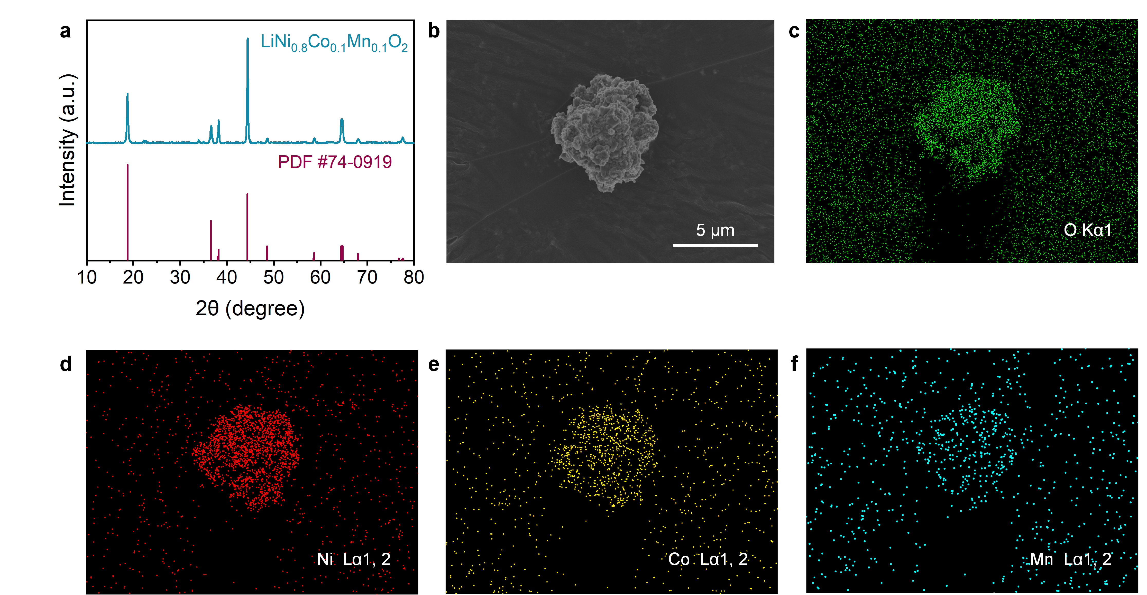

Supplementary Fig. 15 | Characterization of LiNi_{0.8}Co_{0.1}Mn_{0.1}O₂ powders fabricated by GTA.
a, XRD pattern of LiNi_{0.8}Co_{0.1}Mn_{0.1}O₂ powders. b-f, SEM and corresponding elemental mapping images of LiNi_{0.8}Co_{0.1}Mn_{0.1}O₂ powders.
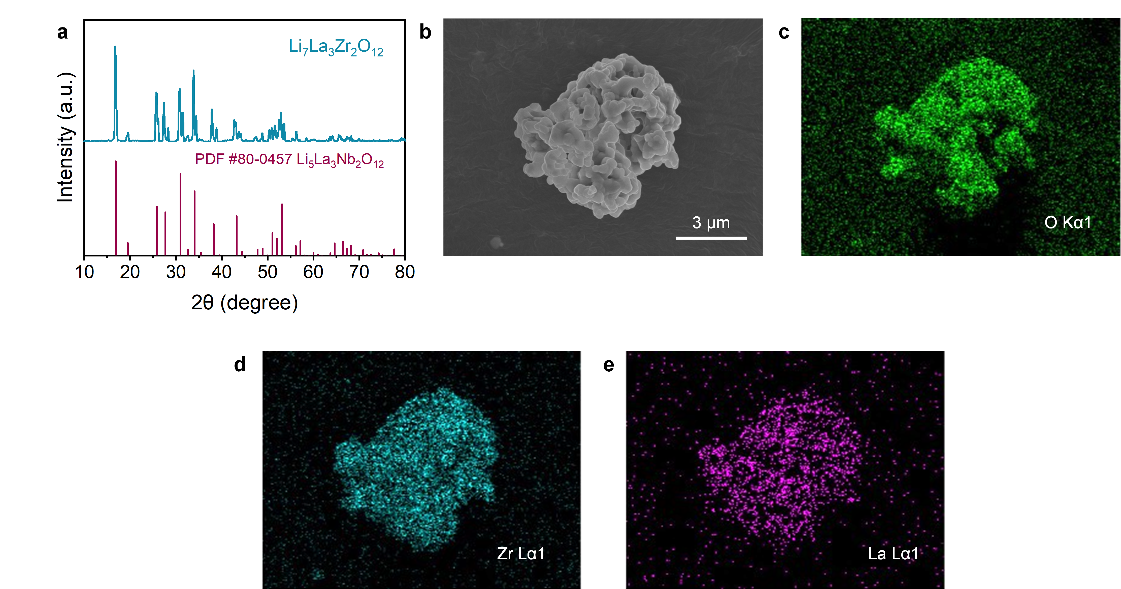

Supplementary Fig. 16 | Characterization of Li₇La₃Zr₂O₁₂ powders fabricated by GTA.
a, XRD pattern of Li₇La₃Zr₂O₁₂ powders. b-e, SEM and corresponding elemental mapping images of Li₇La₃Zr₂O₁₂ powders.

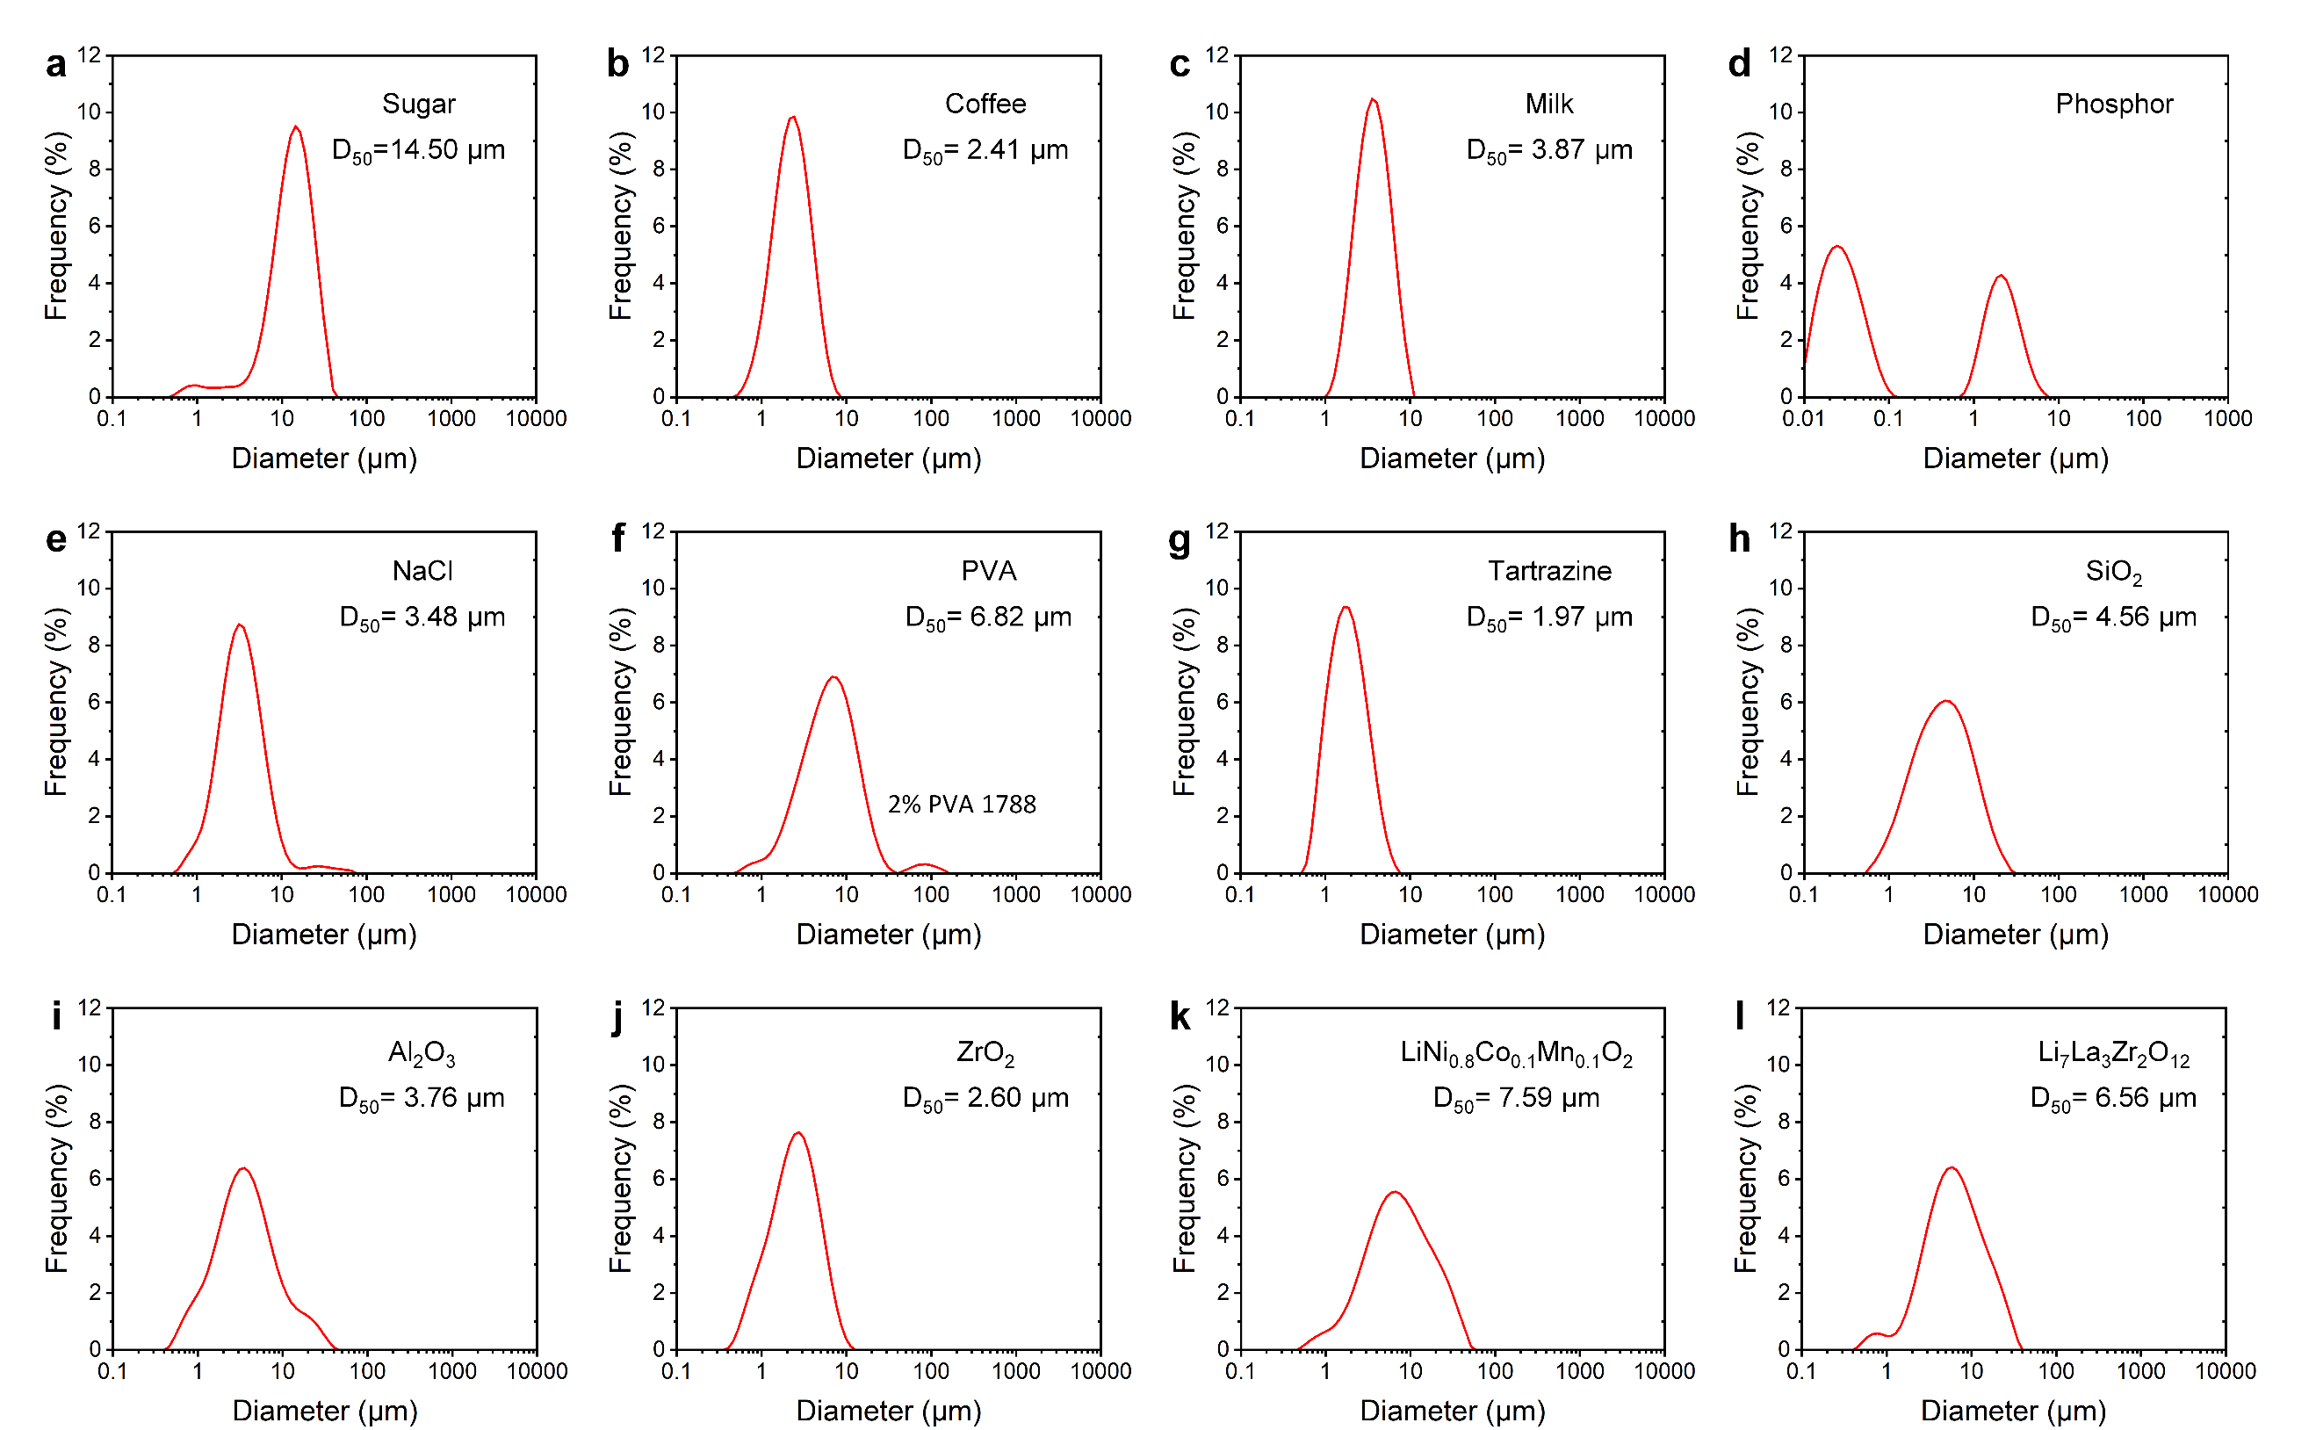

Supplementary Fig. 17 | Size distribution of powders fabricated by GTA.
a, Sugar. b, Coffee. c, Milk. d, Phosphor. e, NaCl. f, PVA. g, Tartrazine. h, SiO₂. i, Al₂O₃. j, ZrO₂. k, LiNi_{0.8}Co_{0.1}Mn_{0.1}O₂. l, Li₇La₃Zr₂O₁₂.

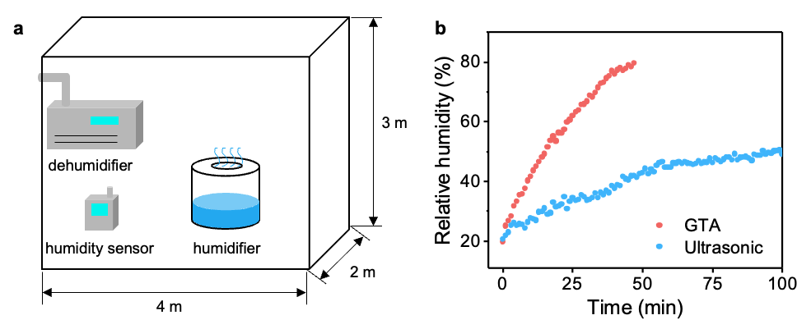

Supplementary Fig. 18 | Humidification Performance of GTA.
a, A Schematic diagram of the test system for atomizing humidification efficiency. b, Curves of humidity versus time when using GTA and ultrasonic atomization. The experiment was conducted in an enclosed room with dimensions of 2 m × 3 m × 4 m (as depicted in figure a). Here, the flow rate of the GTA was approximately 400 mL/h, while the ultrasonic atomizer operated at 100 mL/h. This difference is primarily due to the typical flow rate differences between the two methods.

Supplementary Tables

Supplementary Table 1 | The dynamic viscosity of different liquids and their atomization properties.

Liquid | Viscosity / cP  (Tested at 20 °C) | Ultrasonic atomization  (1.7 MHz, 30W) | GTA  (This work)
Water | 0.99 | √ | √
3 wt% H₂O₂ | 1.03 | √ | √
Ethanol | 1.24 | × | √
Isopropanol | 2.39 | × | √
Kerosene | 2.56 | × | √
Crude oil | 3.20 | × | √
Ethylene glycol | 20.80 | × | √
Peanut oil | 71.68 | × | √
Olive oil | 82.56 | × | √
Lubricating oil | 194.88 | × | √
Methyl silicone oil #1 | 343.50 | × | √
Methyl silicone oil #2 | 530.00 | × | √
Methyl silicone oil #3 | 990.00 | × | √

Supplementary Table 2 | Physical properties of glycerol/water mixtures at different weight ratios.

Liquid | Viscosity / cP  (Tested at 25 °C) | Surface tension / mN·m⁻¹ | Density / g·cm⁻¹
Glycerin/water (50/50 wt%) | 3.52±0.16 | 64.17±0.65 | 1.124
Glycerin/water (60/40 wt%) | 8.19±0.18 | 61.07±0.40 | 1.151
Glycerin/water (70/30 wt%) | 16.06±0.14 | 60.00±0.44 | 1.178
Glycerin/water (80/20 wt%) | 48.00±0.09 | 64.23±0.25 | 1.205
Glycerin/water (90/10 wt%) | 159.04±0.12 | 70.43±0.21 | 1.231
Glycerin | 807.50±0.15 | 70.83±0.06 | 1.258

Captions for Supplementary Videos

Supplementary Video 1 | Design and principle of GTA.

Supplementary Video 2 | Water spray by GTA.

Supplementary Video 3 | High-speed video capturing GTA spray of water (played at real time, 1/133× speed, and 1/267× speed).

Supplementary Video 4 | High-speed video capturing GTA spray of various liquids (played at 1/133× speed).
These liquids including water, ethanol, isopropanol, crude oil, kerosene, 3 wt% H₂O₂, ethylene glycol, peanut oil, olive oil, and lubricating oil.

Supplementary Video 5 | High-speed video capturing GTA spray of high-viscosity silicone oils (with viscosity of 343.5, 530.0, and 990.0 cP, played at 1/133× speed).

Supplementary Video 6 | CFD simulation of grid-turbulence evolution.

Supplementary Video 7 | Visualization of grid-turbulence evolution (played at 1/90x speed).

Supplementary Video 8 | High-speed video capturing the bag breakup of liquid droplets (played at 1/267× speed).

Supplementary Video 9 | CFD simulation of liquid droplet motion in turbulent flow.

Supplementary References
1 Hinze, J. O. Fundamentals of the hydrodynamic mechanism of splitting in dispersion processes. AIChE Journal 1, 289-295 (1955).
2 Crialesi-Esposito, M., Chibbaro, S. & Brandt, L. The interaction of droplet dynamics and turbulence cascade. Communications Physics 6, 5 (2023).

