Supporting Information

Physico-chemical properties of sunflower oil Pickering emulsions stabilized by cellulose nanocrystals-chitosan complex
Vasily I. Mikhaylov¹, Mikhail A. Torlopov¹, Irina N. Vaseneva¹, Ilia S. Martakov¹, Philipp V. Legki^{1,2}, Nikita M. Paderin³, Petr A. Sitnikov¹
¹ Institute of Chemistry of Federal Research Centre “Komi Science Centre of the Ural Branch of Russian Academy of Sciences”, 167000, 48 Pervomayskaya St., Syktyvkar, Russian Federation
² Federal State Budgetary Educational Institution of Higher Education «Pitirim Sorokin Syktyvkar State University», 167000, 55 Oktyabrskiy Av., Syktyvkar, Russian Federation
³ Institute of Physiology of Federal Research Centre “Коmi Science Centre of the Ural Branch of the Russian Academy of Sciences”, 50, Pervomayskaya St., Syktyvkar 167982, Russian Federation
Corresponding Author: gmartakov@gmail.com

Methods
The stability of the emulsions was evaluated by observing delamination after one month of storage. The change in the thickness of the emulsion layer was observed and recorded with a digital camera (Sony, Japan). Creaming index (CI) was determined after a month of storage. The volume of the formed cream was measured and creaming percentage determined according to the Eq. (1)
CI(%) = 100*(H_{S}/H_{T}), (1)
Optical micrographs of Pickering emulsions were used to measure drop sizes and distribution using BX53 optical microscope (Olympus) equipped with a digital camera. To increase the aperture of the optical system, we used immersion oil of mineral origin with a refractive index of 1.515. Microphotographs were taken in bright field mode under white light irradiation. The processing of optical micrographs for determining the droplet sizes and distribution was carried out using ImageJ 1.53m software. For statistical data processing, at least 100 measurements were used for each sample. One-way analysis of variance (ANOVA) was performed used the Microsoft Excel software to compare different groups and a value of p < 0.05 was considered statistically significant.
The hydrodynamic diameter and zeta potentials of hybrid particles and droplets in 100-fold diluted emulsions were experimentally determined by the methods of dynamic light scattering (DLS) and laser Doppler electrophoresis (Malvern ZetaSizer Nano ZS, 4 mW He/Ne laser, 633 nm) at 25 °C in a DTS1070 disposable capillary cell. All the measurements were taken at least three times.
To study the effect of pH on the characteristics of emulsions (droplet sizes, zeta potential), 10-fold diluted SO/CNC-1%Chit emulsion was used. To vary the pH value, 0.01 M and 0.1 M solutions of HCl or NaOH were used.
Stability of emulsion microdroplets in the field of centrifugal forces. Samples of the emulsion were centrifuged at RCF up to 2000 g for 60–360 s and then external appearance of samples and morphology of microdroplets were analyzed.
The study of the acid-base properties of polyelectrolyte molecules was carried out by potentiometric titration in an argon environment using an Aquilon ATP-02 automatic titrator with a combined electrode ESLK-01.7. Titration was performed with 0.01n KOH. pH values were measured after the addition of each titrant portion (Vtitr) and only after equilibrium was established. Each sample was titrated three times. Based on the obtained dependence Vtitr(pH), the Gibbs adsorption (ΓH) on the surface under study was calculated as a function of the solution pH (per 1.0 g of the studied sample):
$Γ_{H}=\frac{V_{total}(C_{H^{+},{OH}^{-},0}-C_{H^{+},{OH}^{-},e})}{m}$ mmol/g (2)
When calculating the values of ionization constants (pKa), we used the mathematical model described by Ryazanov and Dudkin (2009).
Rheology of O/W emulsions was studied using a DV-III+ Ultra rheometer (Brookfield, USA), with a set of interchangeable spindles. The sample in the measuring cell (small sample adapter) was preliminarily thermostated for 25 minutes. Duration of measurement at a point was 20 s. The area of the hysteresis loop was calculated by the trapezoidal method in the coordinates shear stress vs shear rate.
In vitro model of simulated digestion
a) Initial stage
The original emulsion (SO/ChNC or SO/ChNC-Alg) with a volume of 1.45 ml was transferred into a 100 ml conical flask and diluted with 18.55 ml of deionized water, after which it was mixed and thermostated in a shaker-incubator at 37 ºC and 100 rpm for 20 min. The content of sunflower oil in the diluted emulsion was 2 wt%.
b) Oral cavity stage.
At this stage, shaking of a diluted emulsion in the oral cavity was simulated. The liquid simulating saliva contained 15 mg/ml suspension of mucin in deionized water. At the end of thermostating and mixing, a 20 ml mucin suspension was transferred to a flask with a diluted emulsion. The resulting mixture was stirred and thermostated in a shaker-incubator at 37 °C and 100 rpm within 5 min.
c) Stomach stage
This stage simulated digestion of the emulsion in stomach cavity. The liquid simulating gastric juices contained 3.2 mg/ml of the pepsin enzyme, 2.0 mg/ml NaCl and 0.1 M HCl in deionized water. At the end of the oral cavity stage, 20 ml of the resulting mixture was transferred into a liquid simulating gastric juices with a volume of 20 ml. To control the acidity of the medium, a pH meter with a combined electrode and thermometer with the ability to approximate the values by temperature was used. The pH of the resulting mixture was 1.28±0.10. The mixture was stirred and thermostated in a shaker-incubator at 37 °C and 100 rpm for 120 min, after which the mixture was gradually neutralized with NaOH solution (1.0 M) to pH 7.00 ± 0.10. The total volume of the added alkali solution was 2.10±0.01 ml.
d) Small intestine stage
This stage simulated digestion of the emulsion in the cavity of the small intestine. The liquid simulating the environment of the small intestine contained 0.2 mg/ml lipase enzyme, 18.75 mM CaCl₂, 281.25 mM NaCl and 0.875 mg/l bile. Calcium chloride binds fatty acids formed during the digestion of oil into insoluble calcium salts, simulating the adsorption of fatty acids in the small intestine. At the end of the stomach stage, 20 ml of the resulting mixture was transferred into a liquid simulating the medium of the small intestine with a volume of 20 ml. The acidity of the medium and its changes were controlled in a similar way from the previous stage (see above “stomach stage”). The mixture was stirred and thermostated in a shaker-incubator at 37 ºC and 100 rpm for 120 min. When the pH dropped below 6.80, 30 μl of NaOH solution (1.0 M) was gradually added to the mixture, bringing the pH to 7.00–7.10 in order to maintain enzyme activity. The total volume of added alkali solution was 150–180 μl.
At the end of each of the stages 20 μl of the mixture was taken for examination by optical microscopy to assess the digestion process.

Results
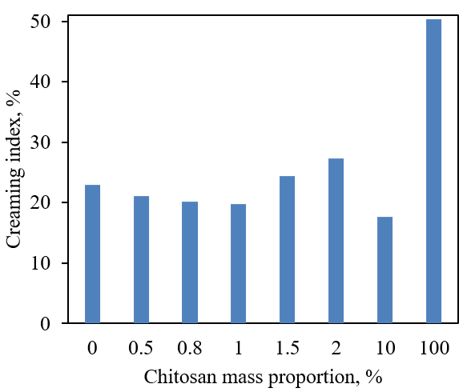
Fig. S1. Creaming indexes of sunflower oil emulsions after a month of storage

Fig. S2. Dependence of the average diameter of droplets of SO/CNC-1%Chit emulsion on time and centrifugal force.

b)
a)
Fig. S3. (a) Change in proton sorption vs. pH for initial compounds, CNC-Chit complexes, and emulsions stabilized by them, (b) full curve for Chit solution.

Fig. S4. Changes of contact angle of SO/CNC-Chit emulsions depending on the mass fraction of chitosan.
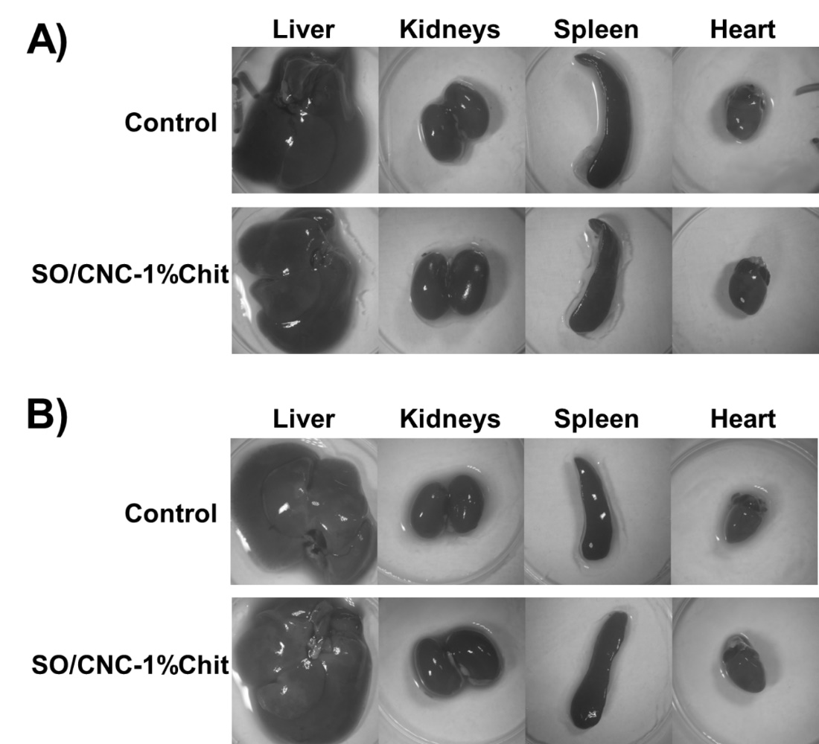
Fig. S5. Representative photographs of male (A) and female mice (B) liver, kidneys, spleen and heart after the administration of SO/CNC-1%Chit.

Table S1. ANOVA analysis of the droplet size of emulsions with increasing mass fraction of chitosan in CNC-Chit complex
 | Chitosan mass fraction 1, % | Chitosan mass fraction 2, % | p value | Significance
Fresh emulsions | 0 | 0.5 | 6·10⁻⁴ | S
Fresh emulsions | 0.5 | 0.8 | 7·10⁻⁴ | S
Fresh emulsions | 0.8 | 1 | 0.002 | S
Fresh emulsions | 1 | 1.5 | 5·10⁻⁵ | S
Fresh emulsions | 1.5 | 2 | 3·10⁻⁴ | S
Fresh emulsions | 2 | 10 | 4·10⁻²³ | S
Emulsions after month of storage | 0 | 0.5 | 2·10⁻⁸ | S
Emulsions after month of storage | 0.5 | 0.8 | 4·10⁻⁷ | S
Emulsions after month of storage | 0.8 | 1 | 0.012 | S
Emulsions after month of storage | 1 | 1.5 | 7·10⁻¹⁹ | S
Emulsions after month of storage | 1.5 | 2 | 7·10⁻⁶ | S
Emulsions after month of storage | 2 | 10 | 2·10⁻⁵ | S
S – significant (p<0.05); NS – not significant (p>0.05)

Table S2. Dispersion analysis of droplet size of emulsions freshly obtained and after a month of storage
Chitosan mass fraction, % | p value | Significance
0 | 1·10⁻⁴ | S
0.5 | 0.268 | NS
0.8 | 0.515 | NS
1 | 0.737 | NS
1.5 | 4·10⁻⁴ | S
2 | 0.001 | S
10 | 8·10⁻⁷ | S
S – significant (p<0.05); NS – not significant (p>0.05)

Table S3. ANOVA analysis of pH effect on droplet size of SO/CNC-1%Chit emulsions
pH₁ | pH₂ | p value | Significance
2.66 | 4.00 | 0.284 | NS
4.00 | 5.36 | 0.650 | NS
5.36 | 7.6 | 0.665 | NS
7.6 | 9.6 | 0.562 | NS
2.66 (initial) | 2.66 (storage) | 0.240 | NS
5.36 (initial) | 5.36 (storage) | 0.827 | NS
9.6 (initial) | 9.6 (storage) | 0.507 | NS
S – significant (p<0.05); NS – not significant (p>0.05)

Table S4. ANOVA analysis of the effect of NaCl concentration on the droplet size of SO/CNC-1%Chit emulsions
C₁(NaCl), mM | C₂(NaCl), mM | p value | Significance
0 | 10 | 0.223 | NS
10 | 150 | 0.271 | NS
S – significant (p<0.05); NS – not significant (p>0.05)

Table S5. ANOVA analysis of the influence of centrifugation time at different speeds on the droplet size of SO/CNC-1%Chit emulsions
RCF | t₁ (s) | t₂ (s) | p value | Significance
200 | initial | 60 | 0.849 | NS
200 | 60 | 180 | 0.758 | NS
200 | 180 | 360 | 0.213 | NS
900 | initial | 60 | 0.583 | NS
900 | 60 | 180 | 0.498 | NS
900 | 180 | 360 | 0.541 | NS
2000 | initial | 60 | 0.859 | NS
2000 | 60 | 180 | 0.876 | NS
2000 | 180 | 360 | 0.939 | NS
S – significant (p<0.05); NS – not significant (p>0.05)

Table S6. ANOVA analysis of the influence of centrifugation speed at a centrifugation time of 360 sec on the droplet size of SO/CNC-1%Chit emulsions
RCF₁, g | RCF₂, g | p value | Significance
initial | 200 | 0.490 | NS
200 | 900 | 0.178 | NS
900 | 2000 | 0.851 | NS
S – significant (p<0.05); NS – not significant (p>0.05)

Table S7. Relative organ weight after the administration of SO/CNC-1%Chit.
 |  |  | Control | SO/CNC-1%Chit
male | liver |  | 65.2±2.8 | 64.6±2.6
male | kidney | right | 11.5±0.5 | 10.4±0.6
male | kidney | left | 11.7±0.5 | 10.5±0.4
male | spleen |  | 14.1±1.7 | 16.5±0.4
male | heart |  | 9.9±1.3 | 8.4±0.4
female | liver |  | 67.5±2.7 | 66.1±3.4
female | kidney | right | 11.3±0.5 | 10.2±1.0
female | kidney | left | 11.3±0.7 | 10.1±1.0
female | spleen |  | 12.8±1.2 | 9.6±1.7
female | heart |  | 11.7±1.0 | 9.5±1.6
Data are expressed as mean ± SEM. n=5.

References
Ryazanov MA, Dudkin BN (2009) Acid-base properties of the surface of the α-Al2O3 suspension. Russ J Phys Chem A. 83:2318–2321. https://doi:10.1134/S0036024409130238.

