Supplementary Materials for “High brightness terahertz quantum cascade laser with near-diffraction-limited Gaussian beam”
Rusong Li^{1,2,3,5}, Yunfei Xu^{4,5}, Shichen Zhang^{1,5}, Yu Ma¹, Junhong Liu⁴, Binru Zhou^{1,2,3}, Lijun Wang^{4,}*, Ning Zhuo⁴, Junqi Liu⁴, Jinchuan Zhang⁴, Shenqiang Zhai⁴, Shuman Liu⁴, Fengqi Liu^{4,1}, & Quanyong Lu^{1,}*
¹Division of Quantum Materials and Devices, Beijing Academy of Quantum Information Sciences, Beijing 100193, China;
²Beijing National Laboratory for Condensed Matter Physics, Institute of Physics, Chinese Academy of Sciences, Beijing 100190, China;
³School of Physical Sciences, University of Chinese Academy of Sciences, Beijing 100049, China;
⁴Key Laboratory of Semiconductor Materials Science, Institute of Semiconductors, Chinese Academy of Sciences, Beijing 100083, China;
⁵These authors contributed equally to this work.
*Correspondence: ljwang@semi.ac.cn; luqy@baqis.ac.cn

1. Emission characteristics of conventional ridge lasers
The quantum cascade laser (QCL) region is based on a bound-to-bound (BTB) optical transition hybridized with a miniband transportation and phonon-assisted depopulation scheme^{[1]}. The intersubband transition process is shown in Figure S1(a). The QCL active region core is designed with layer thickness in angstrom of 48/90/35/103/11/98/52/172 targeting a frequency of 3.9 THz. The 12.15-μm thick QCL active region is sandwiched between two metallic cladding layers to create a double-metal waveguide with an almost unitary confinement factor. Figure S1(b) show the QCL active region gain spectrum peaks around 3.9 THz, where the bias voltage is 56 mV/module. A FP device with a cavity length of 1.7 mm and a ridge width of 80 μm shows output power of 4 mW at 13 K with a slope efficiency of 35 mW/A, as shown in Figure S1(c). The device exhibits a low threshold current density 108 A/cm² due the strong gain active design and a low doping level in the active region^{[1]}.
Figure S1. Conventional ridge laser has been fabricated and characterized. (a) Conduction band diagram of a THz QCL with four quantum wells per module in the active region. (b) The gain peak is at approximately 3.9 THz. (c) P-I-V characterization of a 1.7 mm long, 80-μm wide FP device at 13 K.

- Double-lattice photonic-crystal resonators at different shifts
Figure S2(a) presents a schematic of a double-lattice photonic-crystal (DLPC) lattice, which is composed of two sets of lattice groups (indicated in ellipse and circle), the circle lattice is shifted in the x and y directions by d from the ellipse points (a is the lattice constant and is approximately equal to the wavelength in the material, λ). Double lattice photonic-crystal resonator at d=0.3a is used as an example to illustrate the construction of a DLPC lattice. This unique DLPC structure produces the THz wave resonance effect in a broad area, which is not observed in conventional single-lattice structures, as shown in the following. As a result of the couplings among the fundamental Bloch waves, the eigensolutions of the DLPC structure become four band-edge modes at the Γ₂ point: mode A, B, C and D. Figure S2(b) shown the Transverse-Magnetic (TM) band structure around the Γ₂-point band edges of a typical DLPC, as indicated by the red circle. Here the band of the DLPC is obtained by using the equivalent 2D COMSOL simulation. The electric field patterns of the four band-edge modes in a DLPC are shown in Figure S2(c), where the color-map indicates the out-of-plane component E_{z}, and the vector map exhibits the in-plane components E_{x} and E_{y}. The normalized mode frequencies and the vertical losses of the DLPC band-edge modes are obtained by using the three-dimensional full wave simulations via finite element method based on the commercial software of COMSOL Multiphysics, as shown in Figure S2(d). Periodic boundary conditions are adopted in the simulation, which means the in-plane energy leakage is not considered. The vertical losses are defined as the DLPC resonators losses of the eigenmodes in the simulation: $α=2π/(aQ)$, where is the lattice constant of the DLPC supercell, and Q is the quality factor. At the shift of d = 0.3a, the optical overlap factors with the active region ($Γ=\int_{Act}{{\left|E_{z}\right|}^{2}}dV/\int_{All}{{\left|E_{z}\right|}^{2}}dV$) for modes A, B, C and D are 99.943%, 99.809%, 99.566% and 99.218%, respectively, It can be seen that they have almost the same overlap factor. Due to the high vertical loss, mode A is unlikely to be the lasing mode. Mode D instead, with the lowest loss, would be the lasing candidate.
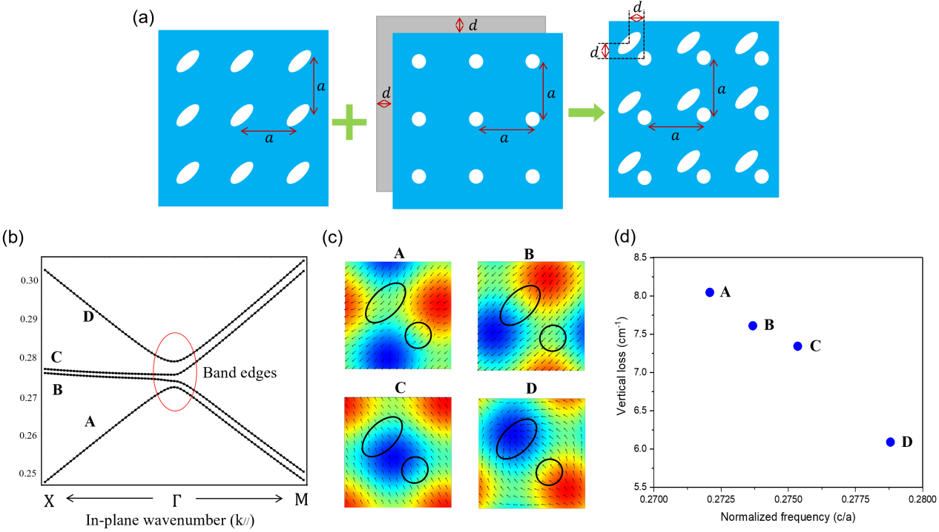
Figure S2. Construction of THz DLPC and Photonic band structure (TM) diagram. (a) Construction of double-lattice photonic-crystal resonators by shifting the circular-unit-cell lattice with respect to the elliptical-unit-cell lattice by a phase shift d in x and y directions; (b) Band structure of a double-lattice photonic-crystal for Transverse-Magnetic (TM) modes. An enlarged image of this band structure around the Γ₂-point band edges, whose edges of bands A~D are circled in red. (c) The mode patterns in a double-lattice photonic-crystal of the four band-edge modes at the Γ₂ point of the THz DLPC QCL. The color-map indicates the out-of-plane component Ez, and the vector map indicates the in-plane electric field components Ex and Ey. (d) Modal vertical loss of Double-lattice photonic-crystal lattice as a function of modal frequency. The period of the double-lattice photonic-crystal is 21.5 µm in the simulation.

- Brightness of THz DLPCSEQCL beams
The brightness B of a terahertz quantum cascade laser (QCL) is given by^{[2]}:
(S1)
where P_{out}, S, Ω, λ and M² are the output power, emission area, solid angle, wavelength and beam quality factor of the THz surface emission QCL, respectively. The beam quality factor M² is calculated according to , where and are the standard deviations of the calculated near field profile of the fundamental lateral mode for a 1.6×1.6 mm² cavity and the measured far field profile, respectively^{[3]}. According to Eq.(S1), higher brightness can be achieved by increasing the output power P_{out} while keeping the product of the emission area S and the beam divergence Ω as small as possible^{[4]}. Ideally, for a THz QCL with a single (lateral) mode, the output power P_{out} is proportional to the emission area S, and increasing S narrows the solid angle Ω of the emitted beam. Altogether, P∝S and Ω∝1/S. For our THz DLPC QCL, the output power at 6A is 185mW, which translates to a brightness value B=1.6×10⁷ Wsr⁻¹m⁻², according to the measured M²=1.4. The measured output optical power and beam quality of the THz DLPC QCL were used to determine the optical brightness from Eq. (S1).
Theoretically, our DLPCSEQCL can achieve even higher brightness by increasing the size of the DLPC or by optimizing the spacing between the elliptical air hole and the circular air hole of the DLPC. Figure S3(a) shows the DLPC supercell, which is composed of elliptical and circular lattice points with a shift of d~0.25a along the x and y directions. According to the 3D coupled wave theory^{[5-8]}, it can be concluded that the double lattice photonic crystal resonant cavity is the most advantageous when d~0.25a, owing to this (1/4)λ shift, a (1/2)λ optical path difference exists between every two adjacent lattice points (see the red arrows in Figure S3(a)), resulting in the destructive interference of the back-diffracted light waves. As a result, the effect of in-plane optical feedback (or confinement) weakens, and the light distribution within the photonic crystal plane becomes flattened. On the other hand, the (1/2)λ optical path difference does not exist for light waves diffracted 90°, so a similar cancellation does not occur in these directions. In this way, the double-lattice photonic crystal spreads out the overall light distribution while continues acts a resonator via the preservation of 2D optical coupling. Actually, the light waves propagating inside a periodic metallic double-lattice photonic crystal resonators include a large number of wave-vector components and they interact with each other in a more complex manner, Figure S3(b) illustrates the out-of-plane coupling between the basic waves and radiative waves (red arrow) that is induced by first-order Bragg diffraction.
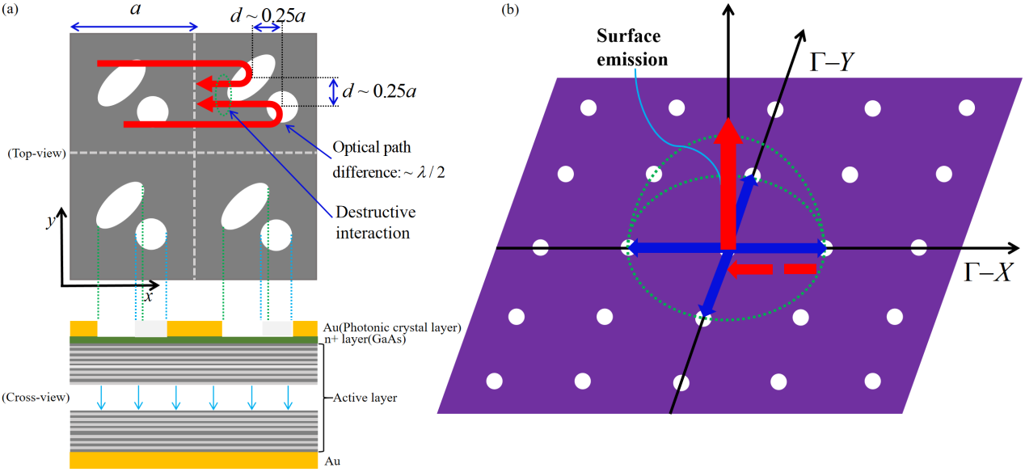
Figure S3. Schematic of optical coupling inside the DLPC lattice. (a) Schematic of in-plane destructive interference for 1D coupling inside a photonic-crystal resonator with d~0.25a and its cross-section view; (b) Schematic of out-of-plane coupling due to first order Bragg diffraction in a double lattice photonic crystal (blue arrow).

- Modelling of a PC QCL
Figures S4(a-c) show the electric-field distributions of the fundamental mode, first high-order mode, second high-order mode for a PC QCL. For a fair comparison, the PC structure has the same filling factor and lattice constant as these of DLPC. Different cavity modes have different mode losses, where the fundamental mode has the lowest loss, and the first and second high-order modes have lower quality factors (or higher losses). Figure S4(e) shows the In-Plane loss margins between the fundamental mode and first higher-order mode, and second higher-order mode of the PC resonator as a function of different device area. When the size L of the PhC resonator increases, the losses of the fundamental and high-order modes are converging to the same level. This means decent loss margins between the fundamental and higher-order modes can only be obtained by decreasing the device area, as shown in Figure S4(f), which is opposite to the strategy of beam brightness upscaling with device area. In addition, for a PC QCL and DLPC QCL (d=0.3a) with the same area of 1.3×1.3mm², the calculated out-plane loss of DLPC QCL is almost twice that of PC QCL, this means twice the output optical power for DLPC QCL over PC QCL.
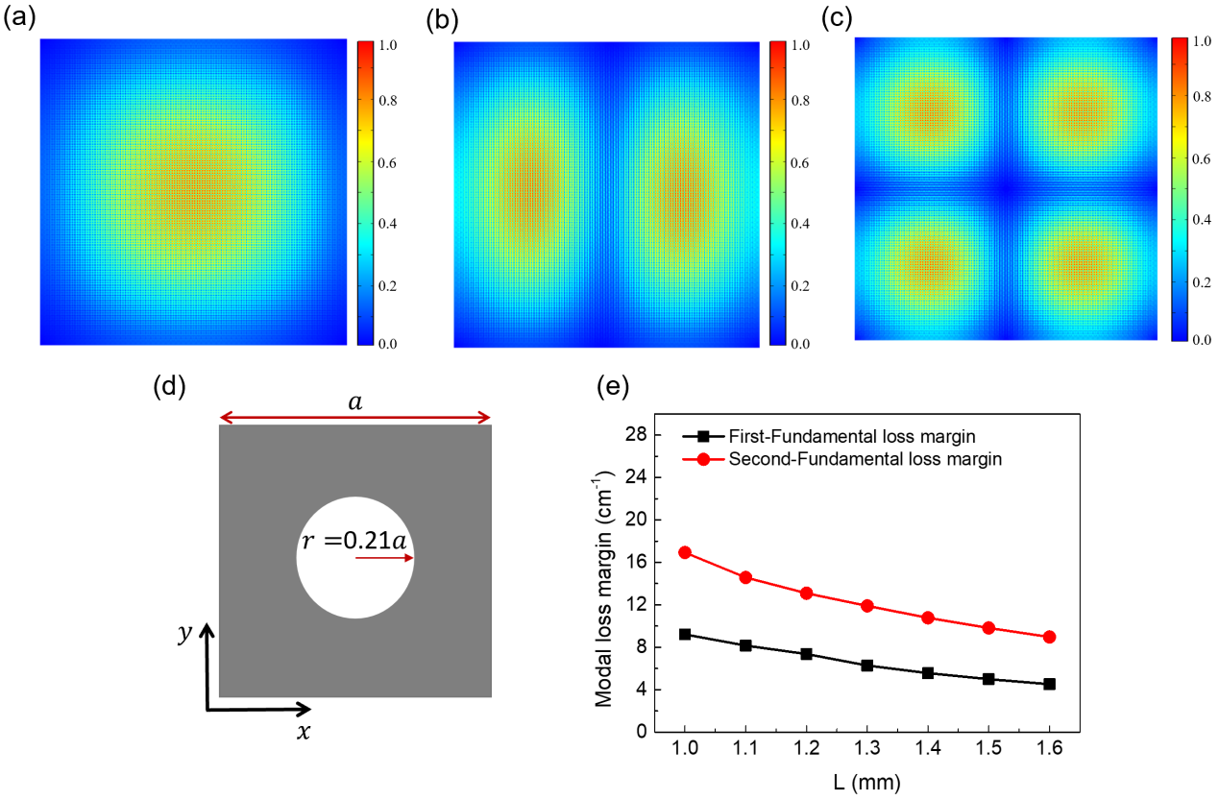
Figure S4. Electric-field distributions and in-plane loss margins of eigenmodes. (a)-(c) Calculated electric-field distributions of the fundamental mode, first high-order mode, second high-order mode in a PC QCL with L=1.3 mm; (d) Schematic of a unit cell of the PC lattice. (e) Modal loss margins between the fundamental and first high-order modes, and fundamental and second high-order modes in PC resonator as a function of the device size L.

- Output power of THz DLPC QCLs at different shifts

Based on the same QCL wafer, we also investigated the influence of shift d over the output power for the DLPC QCLs. In the experiment, and we fabricated and tested THz DLPC QCLs with different shift d values, while keeping the rest parameters the same for comparison. As shown in Fig. S5, the power of the devices with d=0.3a has the maximum output optical power (over 185 mW). Theoretically, as d decreases to 0.25a, the out of plane radiation loss will increase when sufficient in-plane coupling is provided. For the device area used in this work, the inplane optical feedback is under coupled when d=0.25a, which leads to greater in-plane losses and lower output power as shown in Fig. S5. Consider the coupling coefficients showing in Fig. 2(d) for d=0.25a, the device size needs to be greater than 3.0×3.0 mm² for stable single-mode lasing operation with an optimal output efficiency, which would be our future work.
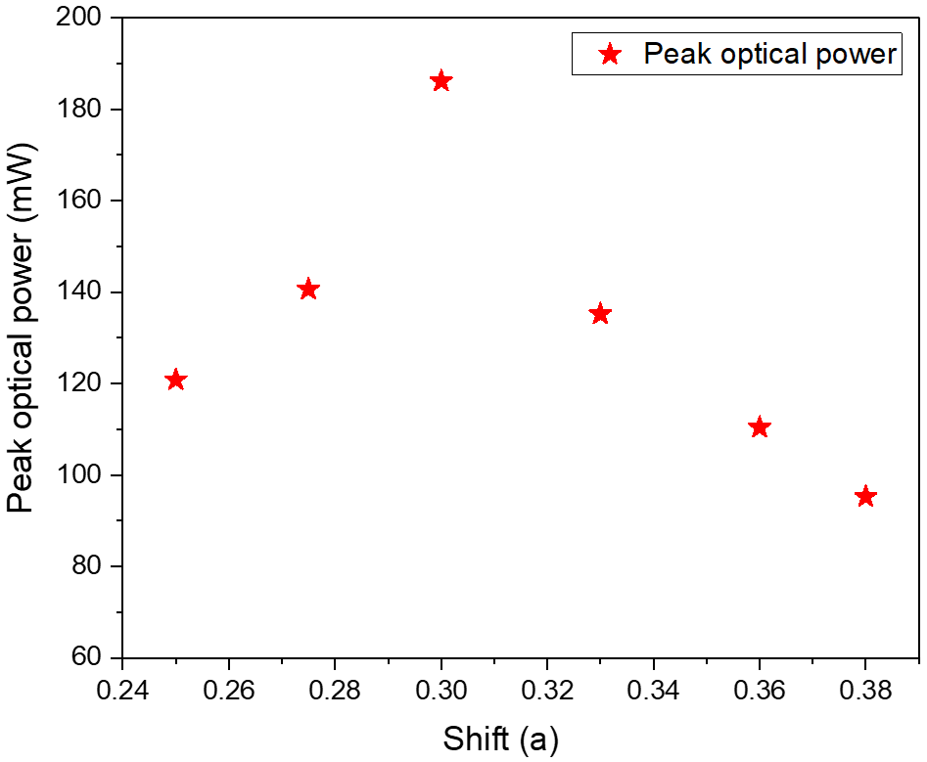
Figure S5. The output power of THz DLPC QCLs at different shifts with L=1.6 mm.

- Power performance comparison between different devices sizes and lattices
Based on the same QCL wafer, we also manufactured devices with different sizes of 1.3×1.3 and 1.6×1.6 mm² with adjusted shift d = 0.36a and 0.3a correspondingly for the brightness upscaling experiment. As shown in the Figure S6, the power of the device with L=1.6 mm is much higher than that of device with L=1.3 mm. Therefore, if the size of the device is further increased, the output power can be further improved. Furthermore, to confirm that our double-lattice photonic-crystal resonators has a better out-plane radiation characteristics, we also fabricated a regular square single lattice photonic crystal surface emission QCL (PCSEQCL) with the same filling factor as the DLPC. As shown in the Figure S6(a), under the same device size and the same QCL wafer, the DLPC surface emitting QCL has more than twice the output power of a regular square lattice photonic crystal surface emitting QCL. Figure S6(b) show the experiment far-field emission pattern for the THz DLPC QCL with L=1.3 mm, and the far-field emission pattern is primarily a single-lobed distribution. Figure S6(c) show the experiment far-field emission pattern for the regular square single lattice PC surface emission QCL with the same device area. Multi-lobed far field is observed due to the much smaller modal loss margin as discussed above.
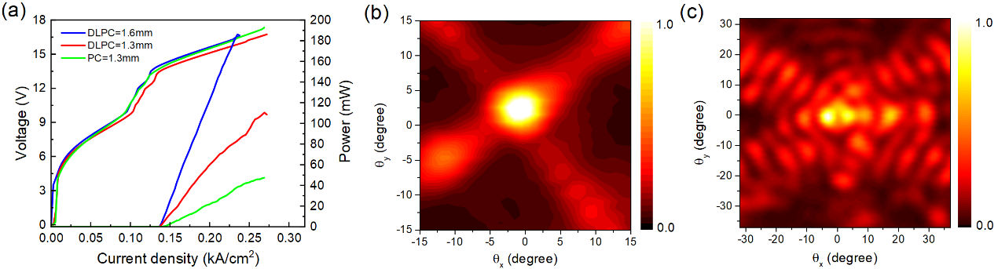
Figure S6. Comparison of power performance of devices with different device size and different lattices. (a) PIV curves of DLPC QCLs with L=1.6 mm, L=1.3 mm, and a PC QCL device with L=1.3 mm. (b)-(c) Far-fields measured from the DLPC QCL and PC QCL with the same filling factor and device area.

Reference
- Li W, Li Y, Ma Y, et al. Continuous-wave terahertz quantum cascade laser based on a hybrid bound to bound quantum design[J]. Frontiers in Photonics, 2022, 3: 1071879.
- Naidoo D, Litvin I A, Forbes A. Brightness enhancement in a solid-state laser by mode transformation[J]. Optica, 2018, 5(7): 836-843.
- Heydari D, Bai Y, Bandyopadhyay N, et al. High brightness angled cavity quantum cascade lasers[J]. Applied Physics Letters, 2015, 106(9).
- Yoshida M, De Zoysa M, Ishizaki K, et al. Double-lattice photonic-crystal resonators enabling high-brightness semiconductor lasers with symmetric narrow-divergence beams[J]. Nature Materials, 2019, 18(2): 121–128.
- Liang Y, Peng C, Sakai K, et al. Three-dimensional coupled-wave analysis for square-lattice photonic crystal surface emitting lasers with transverse-electric polarization: finite-size effects[J]. Optics express, 2012, 20(14): 15945-15961.
- Peng C, Liang Y, Sakai K, et al. Three-dimensional coupled-wave theory analysis of a centered-rectangular lattice photonic crystal laser with a transverse-electric-like mode[J]. Physical Review B, 2012, 86(3): 035108.
- Liang Y, Peng C, Ishizaki K, et al. Three-dimensional coupled-wave analysis for triangular-lattice photonic-crystal surface-emitting lasers with transverse-electric polarization[J]. Optics express, 2013, 21(1): 565-580.
- Yang Y, Peng C, Liang Y, et al. Three-dimensional coupled-wave theory for the guided mode resonance in photonic crystal slabs: TM-like polarization[J]. Optics Letters, 2014, 39(15): 4498-4501.

