Supporting Information
Low-cost conversion of Mo industrial waste powder into MoO₃ nanobelts catalysts for Oxygen Evolution Reaction
F. Ursino^{1,2}, G. Mineo¹, A. Scandurra^{1,2}, Angelo Forestan³, Catya Alba³, R. Reitano¹, A. Terrasi^{1,2} and S. Mirabella^{1,2*}
¹ Dipartimento di Fisica e Astronomia “Ettore Majorana”, Università degli Studi di Catania, via S. Sofia 64, 95123 Catania, Italy.
² CNR-IMM, Università di Catania, via S. Sofia 64, 95123 Catania, Italy.
³R&D Spirit Srl-Soc. Unipersonale, Via dei Laghi 67, 36072 Vicenza, Italy.
*E-mail corresponding: salvo.mirabella@dfa.unict.it

RBS analysis

The Mo and O atomic doses were estimated thanks to Rutherford Backscattering Spectrometry (RBS). For stoichiometric MoO₃ the expected O/Mo atomic dose ratio is equal to 3. The doses were calculated for the signal starting at 0.7 and 2.1 MeV (Figure S 1a-b), which stand, respectively, for He⁺ backscattered by oxygen (O) and by molybdenum (Mo). The area under the peak is proportional to the atomic dose multiplied by the back-scatering atomic cross section. The O/Mo ratio for Mo-based powder is equal to 2.0, while for pH 1.26 sample the ratio is close to 3.4. From these results we assign pH 1.26 sample to MoO₃, while the Mo-based starting powder are substoichimetric molybdenum oxide.
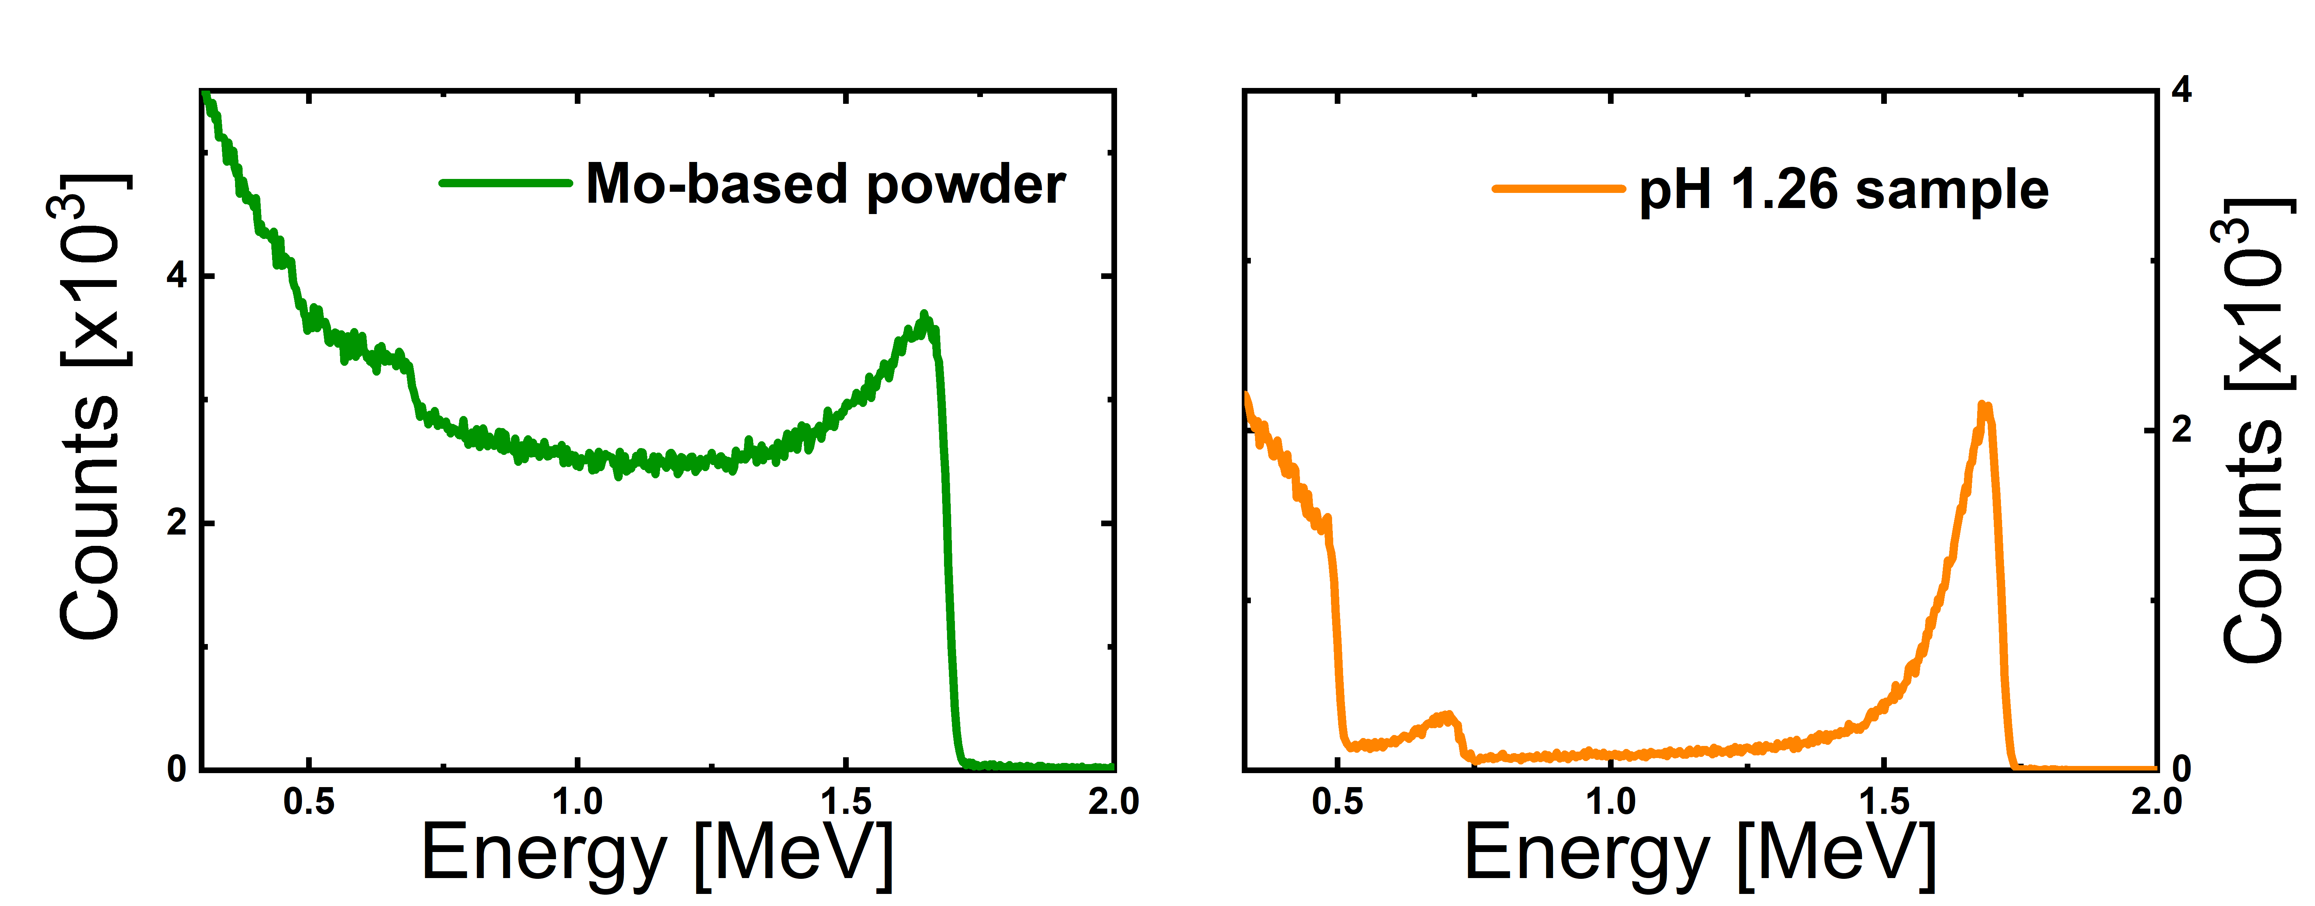
Figure S 1 RBS analysis of: a) Mo-based powder with a Mo/O ratio of about 11 b) pH 1.26 synthesis with a Mo/O ratio equal to 6.

SEM images

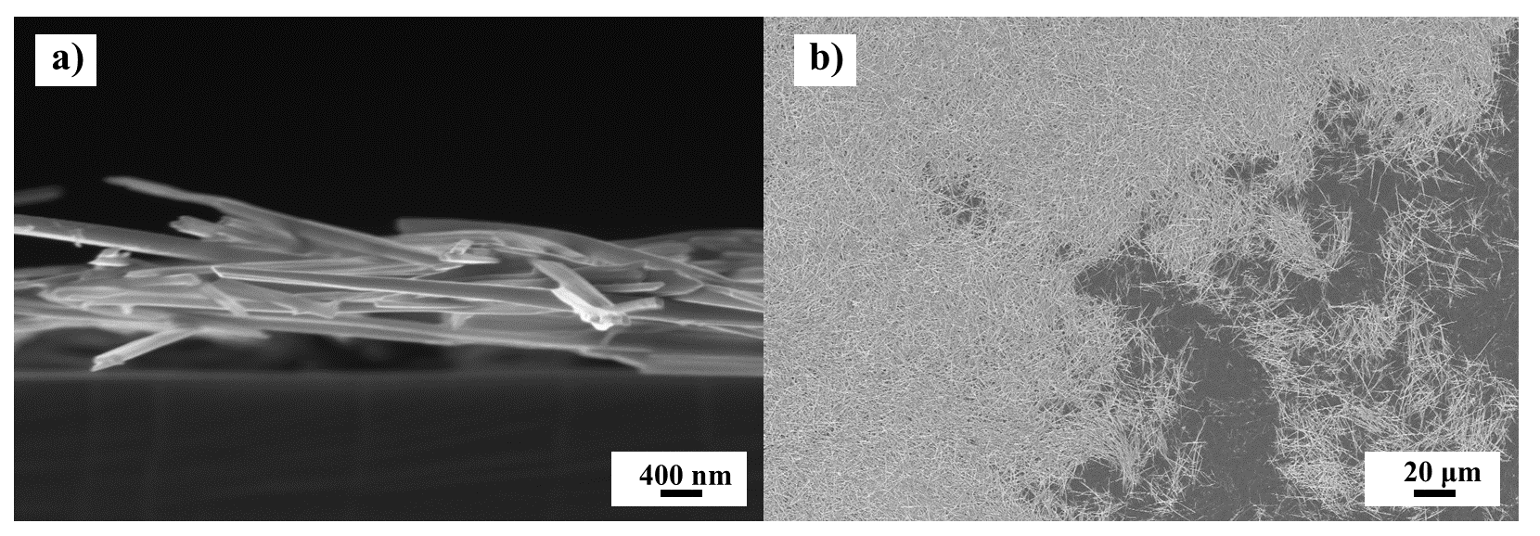
Figure S 2 SEM images of pH1.26 synthesis a) cross-section of the nanobelts; b) low-magnification to highlight the absence of spheres within the sample.

EIS measurements
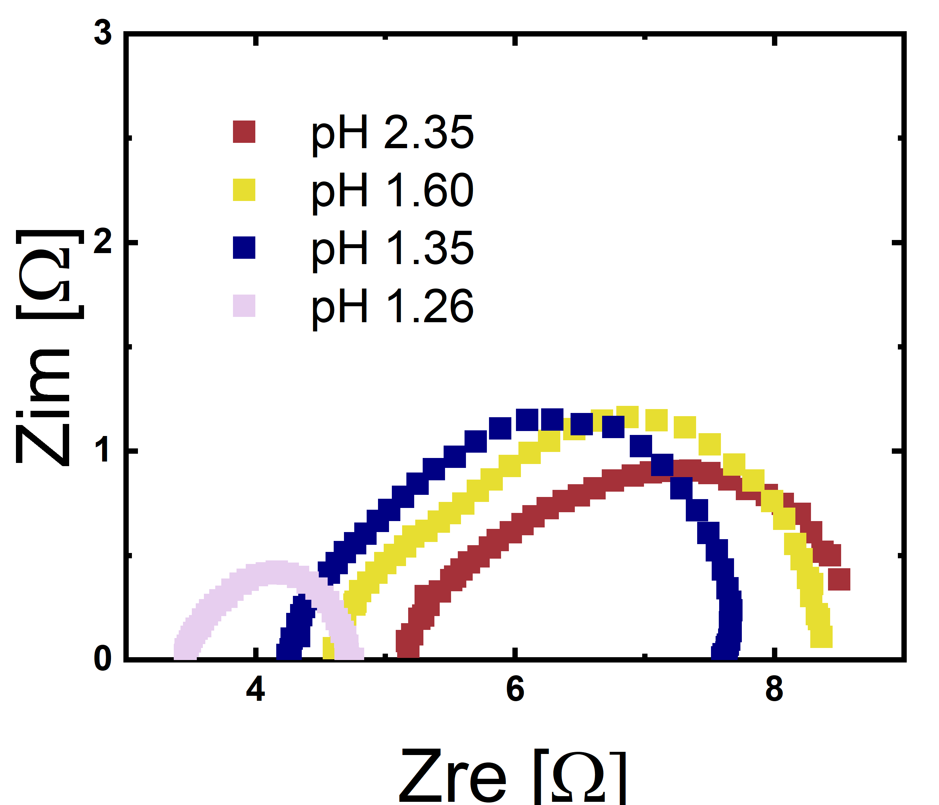
Figure S 3 EIS measurements for pH 1.26 sample (lilac curve), pH 1.35 sample (blue curve), pH 1.60 sample (yellow curve), pH 2.35 sample (burgundy curve).

Mass Activity

Table S 1 Summary of the values reported in Figure 4c.
Overpotential [V] | Mass Activity [A mg⁻¹] | Catalyst loading [mg] | Catalyst | Reference
0.318 | 0.00667 | 1.5 | Zr-baed MOF-Mo₂C/NF | [1]
0.310 | 0.01471 | 0.68 | NiMo HNRs/TiM | [2]
0.340 | 0.01 | 1 | MoO_{3-x} | This work
0.324 | 0.0125 | 0.8 | MoO₃-nanobelts | This work

Mott-Schottky measurements
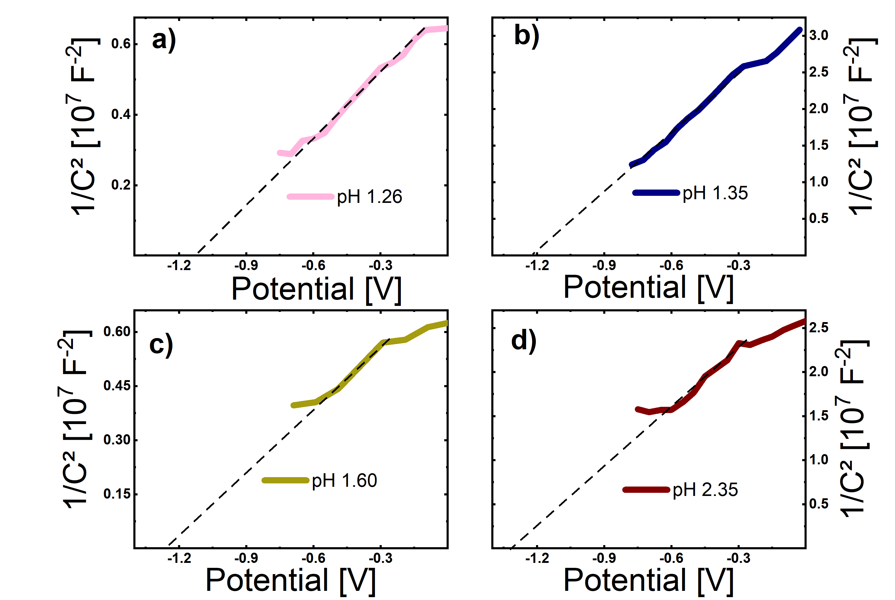
Figure S 4 a-d) Mott-Schottky measurements for pH 1.26 sample (lilac curve), pH 1.35 sample (blue curve), pH 1.60 sample (yellow curve), pH 2.35 sample (burgundy curve.

References

[1] | M. Ali et al. «Enhancing the Overall Electrocatalytic Water-Splitting Efficiency of Mo2C Nanoparticles by Forming Hybrids with UiO-66 MOF,» ACS Omega, vol. 6, pp. 34193-35144, 2021.
[2] | J. Tian et al. «Self-supported NiMo hollow nanorod array: an efficient 3D bifunctional catalytic electrode for overall water splitting,» Journal of Materials Chemistry A, vol. 3, pp. 20056-20059, 2015.

