Extended Data for
Probabilistic Photonic Computing with Chaotic Light
Frank Brückerhoff-Plückelmann¹, Hendrik Borras², Bernhard Klein², Akhil Varri¹, Marlon Becker^{3,4}, Jelle Dijkstra⁵, Martin Brückerhoff⁶, C. David Wright⁷, Martin Salinga⁸, Harish Bhaskaran⁹, Benjamin Risse^{3,4}, Holger Fröning², Wolfram Pernice^{1,5*}
¹Physical Institute, University of Münster; Münster, 48149, Germany.
²Institute of Computer Engineering, University of Heidelberg; Heidelberg, 69120, Germany.
³Institute for Geoinformatics, University of Münster; Münster, 48149, Germany.
⁴Faculty of Mathematics & Computer Science, University of Münster; Münster, 48149, Germany
⁵Kirchhoff-Institute for Physics, University of Heidelberg; Heidelberg, 69120, Germany.
⁶DEVK RE; Cologne, 50668, Germany.
⁷Department of Engineering, University of Exeter; Exeter, EX44QF, UK.
⁸Institute of Materials Physics, University of Münster; Münster, 48149, Germany.
⁹Department of Materials, University of Oxford; Oxford, OX43PJ, UK.
*Correspondence to: wolfram.pernice@kip.uni-heidelberg.de

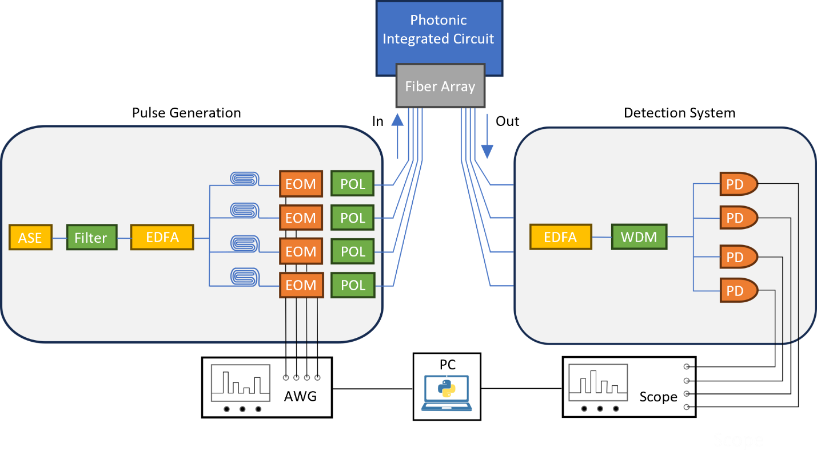
Extended Data Fig. 1. Experimental setup for driving the probabilistic processor. We split the chaotic light into four arms and delay them with respect to each other before shaping the pulse forms with an electro-optic modulator. Before coupling to the photonic crossbar array, we adjust the polarization of each pulse shape independently. We amplify the output of the integrated photonic circuit upon spectral sampling.

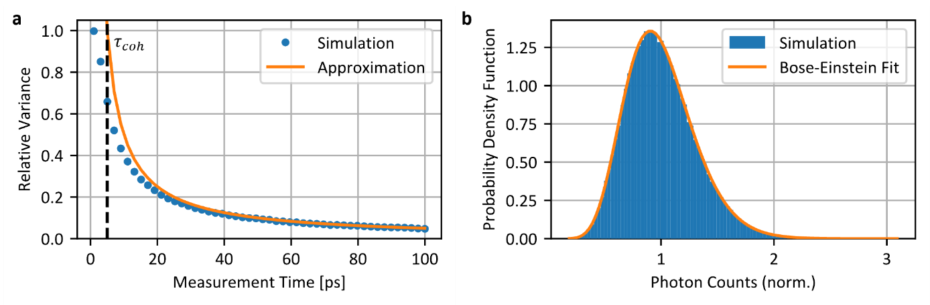
Extended Data Fig. 2. Photon count statistics of a chaotic light source with 5 ps coherence time. a, The relative variance of the number of photons measured within a time interval depends on the ratio between the measurement time and the coherence time of the light. It decreases for an increasing measurement time as the fluctuations average each other out. b, The probability density function for a measurement time of 50 ps follows a M-fold Bose Einstein distribution with degeneracy factor M=10.64.

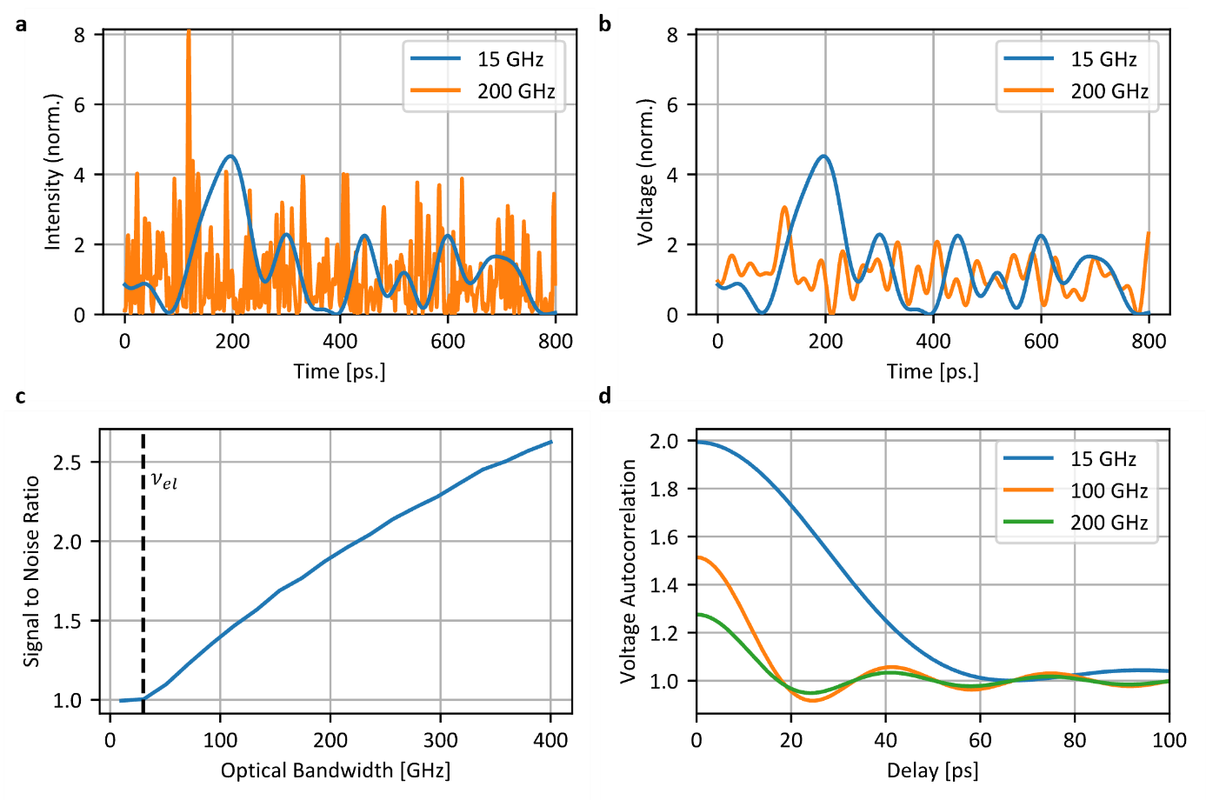
Extended Data Fig. 3. Measuring chaotic light with a bandwidth limited electrical system. a, The random beating between the various frequency components of the chaotic light leads to fluctuations in the intensity of the field. The time scale of the fluctuation’s scales inversely to the bandwidth of the chaotic light. b, Simulated detector voltage trace of the chaotic field with an electrical bandwidth limited to 30 GHz. The lowpass filter removes potential high frequency components in the optical intensity profile, effectively smoothening the measured signal for large optical bandwidth. c, Due to the lowpass filtering effect of the detector, the signal to noise ratio increases for increasing optical bandwidth. d, The autocorrelation of the detector voltage depends on the optical and electrical bandwidth. In case the electrical system can fully resolve the intensity fluctuations, the correlation time is inversely proportional to the optical bandwidth, otherwise it depends on the electrical bandwidth.

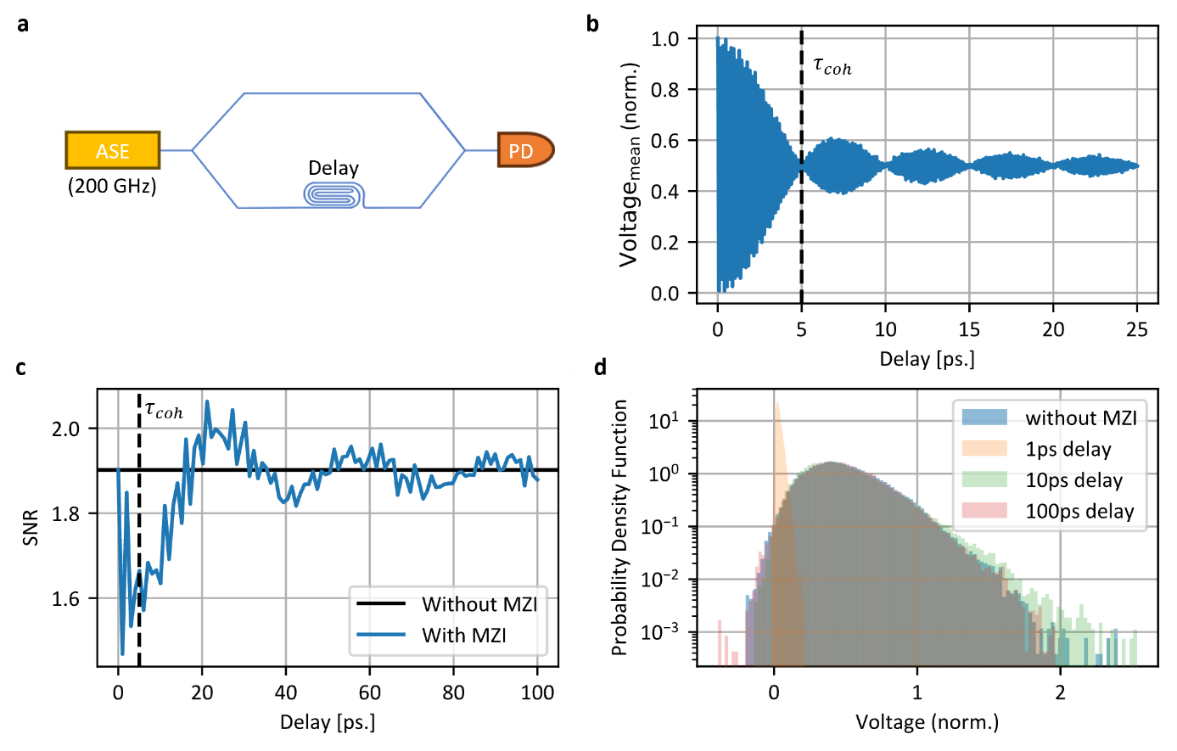
Extended Data Fig. 4. Interference of chaotic light fields. a, We deploy delay lines to effectively create independent copies from a single chaotic light source instead of using several physical independent chaotic sources. (B) For delay times much larger than the coherence length, interference effects are averaging out and the output intensity is the sum of the input intensities. b, For large delay times also the SNR recovers to the value of a single chaotic light source as the impact of the effective spectral filter decreases. (C) Overall, the probability density function is the one of a single of chaotic source for large delay times.

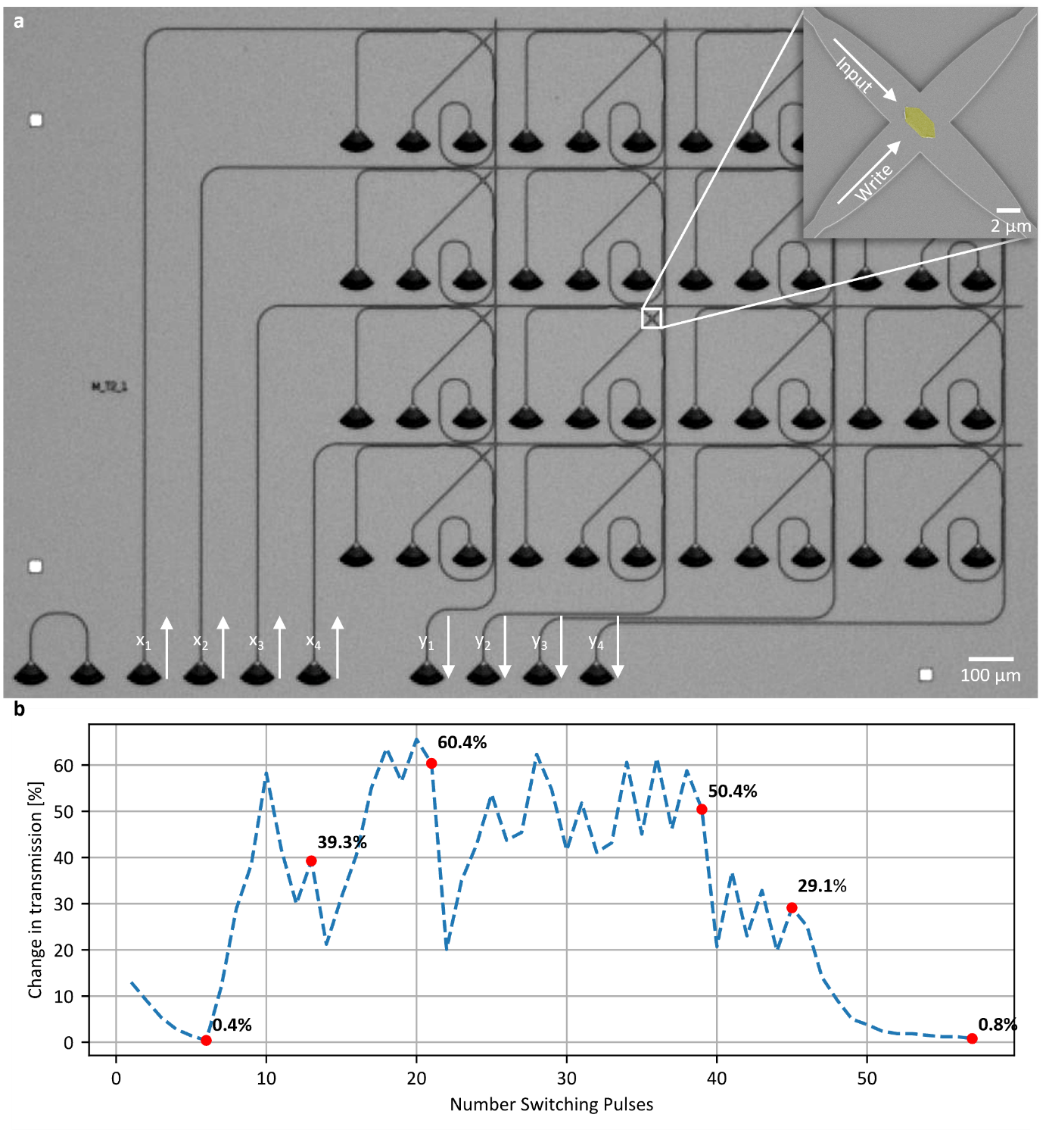
Extended Data Fig. 5. Computing with phase change materials. a, We integrate GST cells into the photonic circuit as tunable non-volatile attenuators. For the photonic crossbar array, each matrix element is represented by one crossbar array cell which consists of directional couplers, a crossing with the GST and couplers to switch the GST. b, By sending high power optical pulses through the GST cell we can increase the transmission by amorphizing the GST and decrease the transmission by crystallizing. We can program the transmission through the GST with an error smaller than 1%.

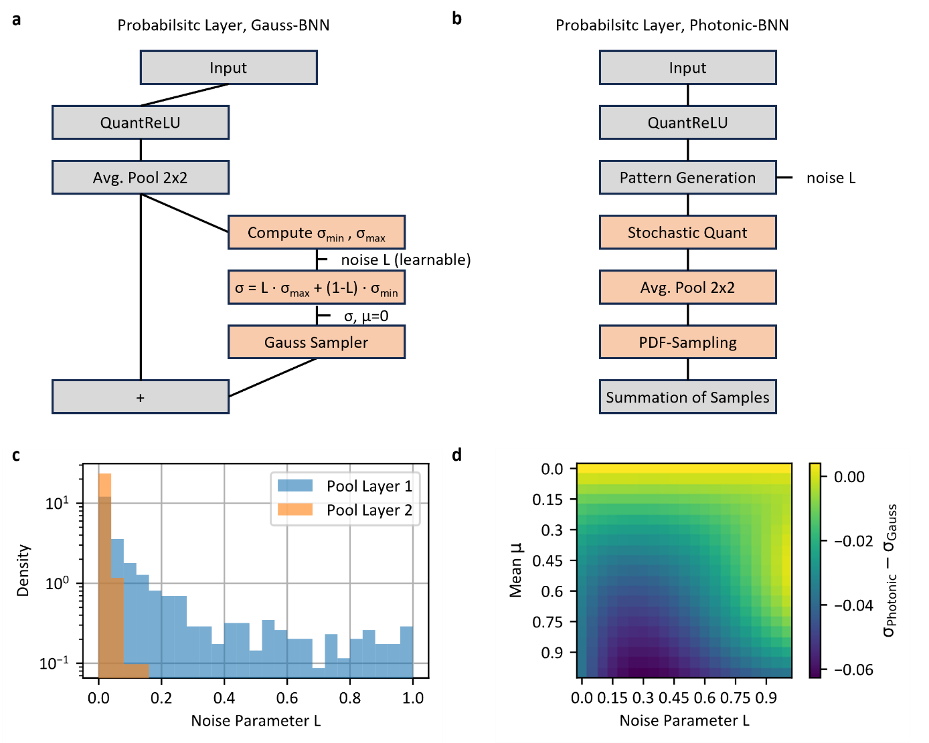
Extended Data Fig. 6. Bayesian neural network model. a, Schematic of the probabilistic average pooling layer for the Gaussian BNN. Here the photonic PDF with the encoding of Fig.2f is approximated as a single gaussian distribution. b, Schematic of the probabilistic average pooling layer for the photonic BNN. Here the photonic PDF is computed exactly, along with hardware imperfections being represented by the stochastic quantization. The model also takes care of effectively caching pre-computed PDFs, thus drastically reducing the computational overhead. Furthermore, we also effectively suppress floating point rounding errors, to further improve computational performance. Note, that this model introduces no new parameters, when compared to the Gaussian BNN in (a) and is used as a direct drop-in replacement thereof. c, Final distribution of noise levels for the two probabilistic average pooling layers of the developed Gauss BNN, based on LeNet-5. It is of note that the noise levels are per-design clamped between 0 and 1 and that the first layer appears to have a much more use for significant noise levels, compared to the second. d, Difference in the standard deviation of the programmed noise levels when transferring the model parameters from the Gauss BNN to the Photonic BNN. The maximal absolute difference in the standard deviation is ca. 0.06 which does not impact the overall performance of then BNN as shown in the main text.

