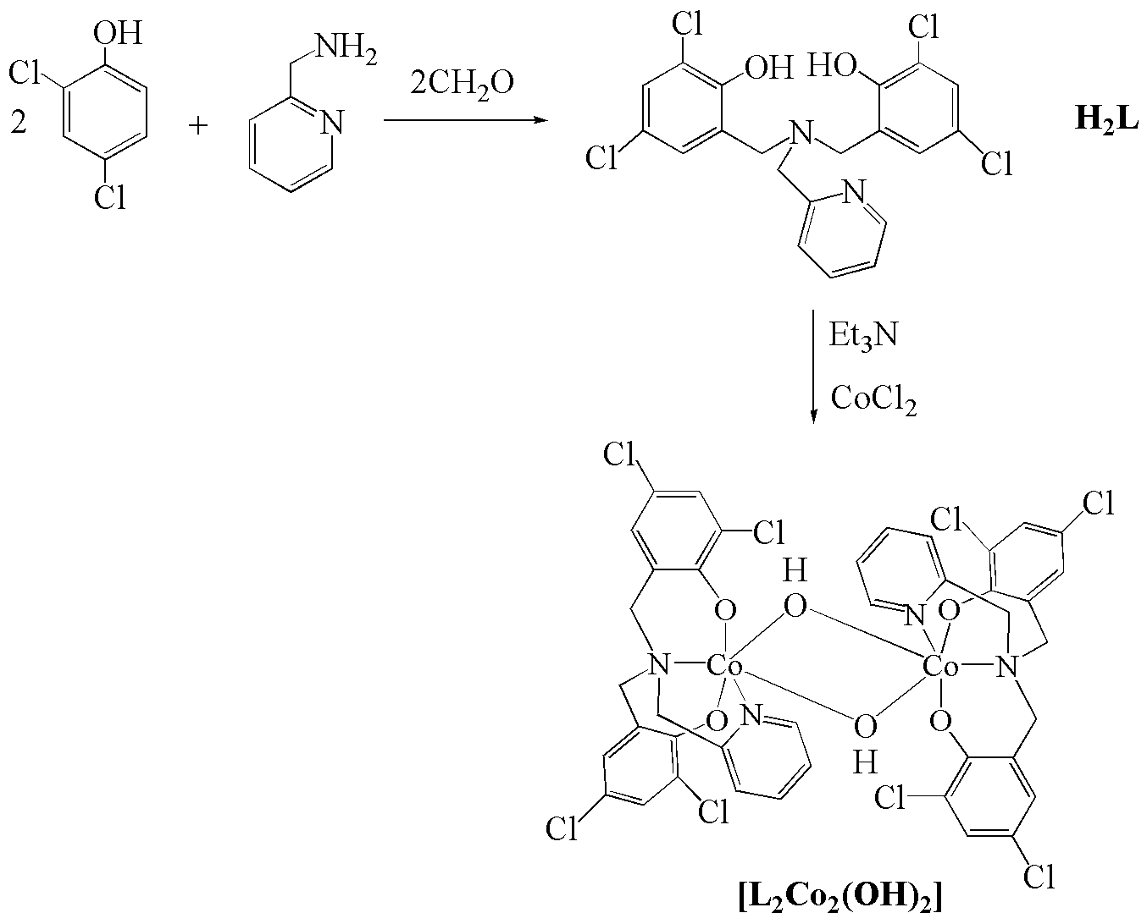
Scheme 1 Synthesis of the cobalt complex, [L-Co-μ₂(OH)₂-Co-L].
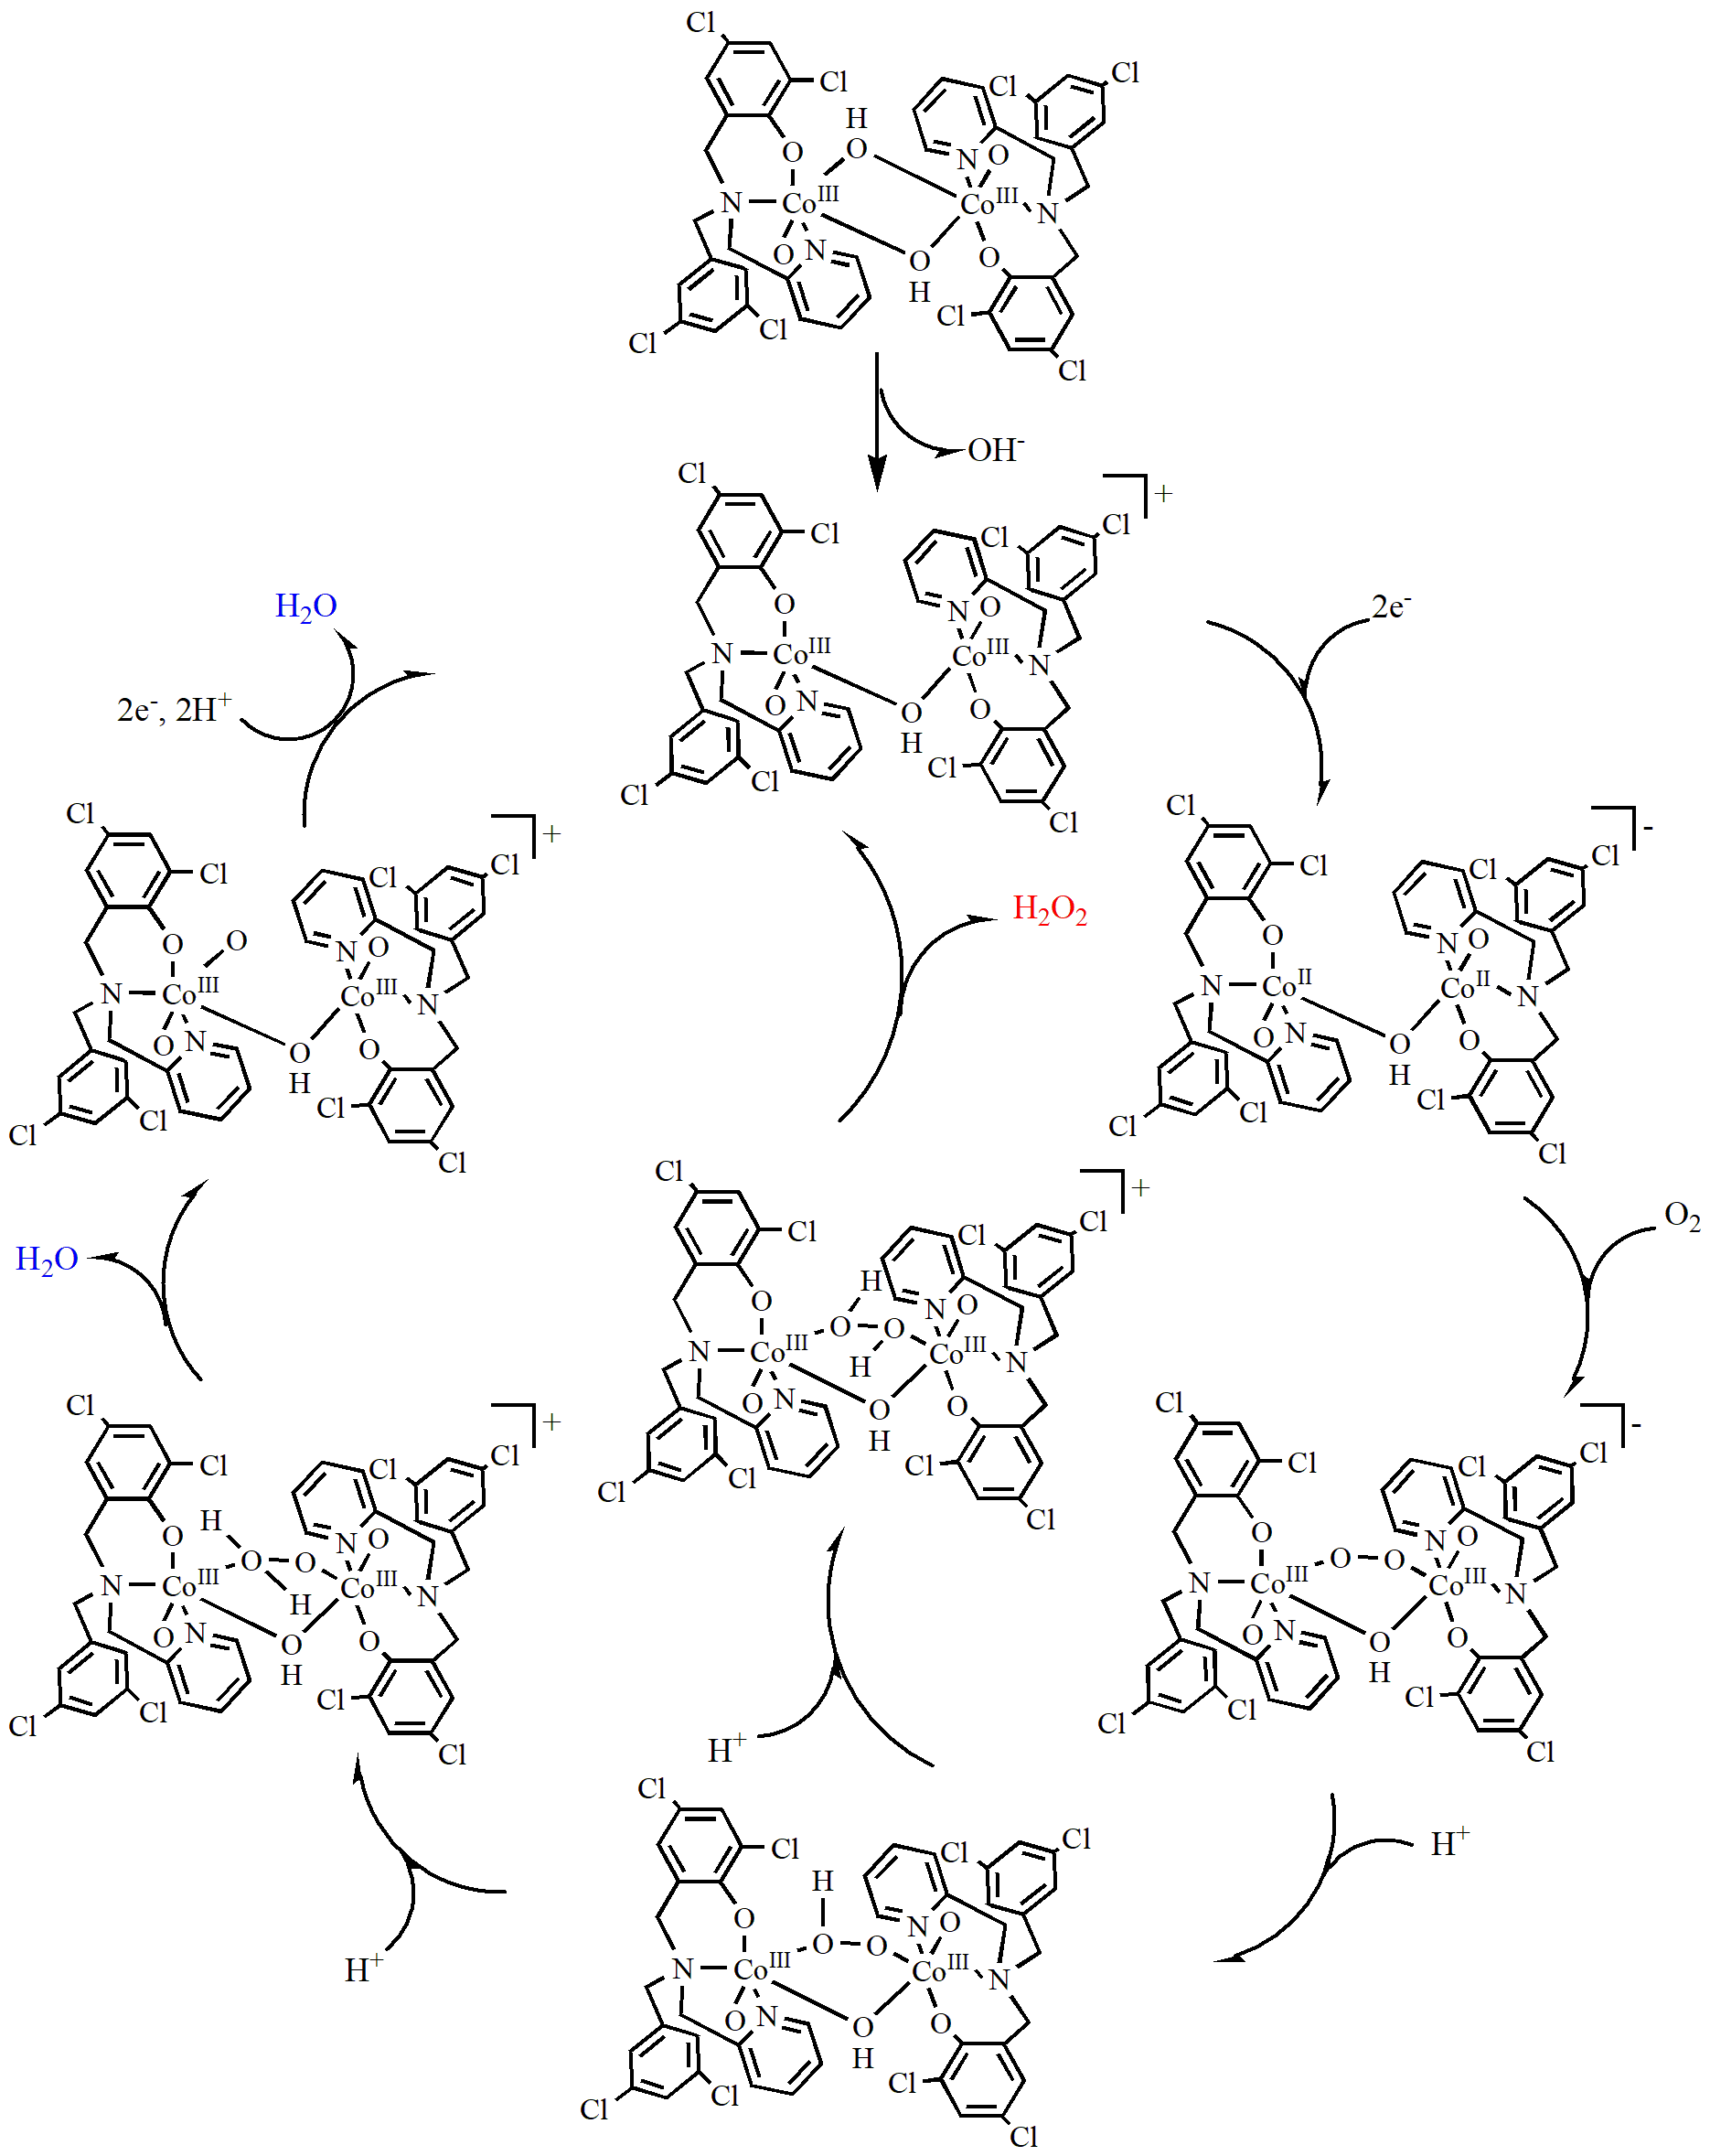
Scheme 2 Possible catalytic mechanism for the reduction of O₂ by the binuclear cobalt complex, [L-Co-μ₂(OH)₂-Co-L].

