Electronic supplemental material

Presumably BiOS-induced zooplankton invasion from the western Mediterranean to the east, eventually introduced by Acartia (Hypoacartia) adriatica (Crustacea: Copepoda)

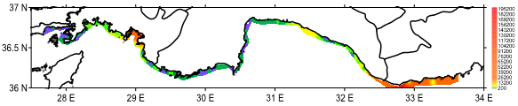
Diatom cell/L
Dinoflagellate cell/L
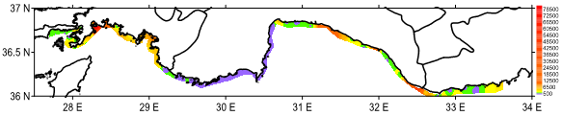
Online Resource 1. Cell density (cell/L) of the diatom and dinoflagellate during the study (Karaca 2023). Arrow shows location of the present study station.

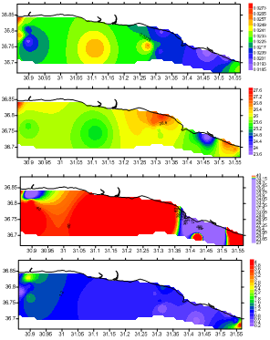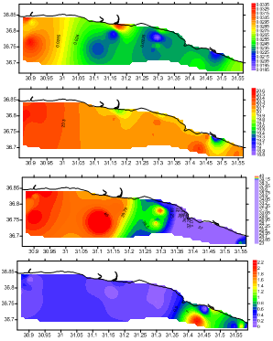
August 2014
Chl-a (µg/L)
SSS (psu)
SST (ºC)
TSM (mg/L)
February 2015
Online Resource 2. Physicochemical characteristics of the sea surface water in the Antalya Gulf during summer and winter in 2014-2015 (de Meo et al. 2018).

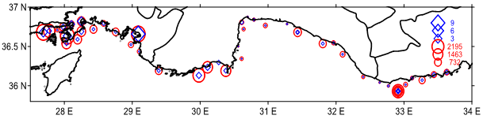
Online Resource 3. Mesosagitta minima: distribution of the abundance (ind./m², circle) and (ind./m³, diamond) in the study area during June/July 2019 (Duman, 2023) (symbols were square-rooted). Arrow shows location of the present study station.

c
b
a
e
d
g
f
i
h
Online Resource 4. T-S diagram of water within the study area (a, colors denotes locations) during winter and summer in 2018-2019 (sea surface water, b, c, respectivley; contours showed isopycnals in σ_{t}, and near-bottom water; d, e respectively), 2014-2015 (sea surface; f, g, respectivley) (de Meo et al. 2018), and 2011-2012 (sea surface; h, i, respectivley) (Mutlu et al. 2020b). Arrow shows location of the present study station.

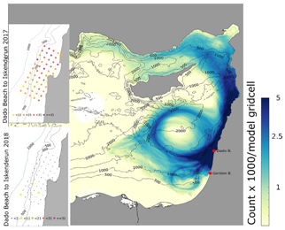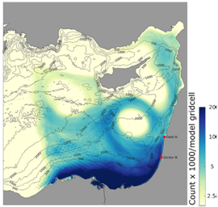
b
a
Online Resource 5. To simulate dispersion of the jellyfish, total number of particle hits per each model gridcell, when released from Haifa coast (a), and released from the Egyptian coast (b) in April-August 2018 (from Edelist et al. 2022). Arrow shows location of the present study station.

x
+
*
Online Resource 6. Water salinity at a deep layer having σ_{t}=29.18 (LIW) to show depth-wise changes of the layer along the different seas interaction in 1991 (from Briand et al. 2000). + denotes records by Gülşahin et al. (2013); Gülşahin et al. (2016), x records by the present study, and Karaca (2023) and * records by Mutlu and Özvarol (2022a, b) (see Table S1).

Online Resource 7. Near-past records and sampling year of gelatinous zooplankton in the Turkish marine coasts. * is not a new record but is, at one location, extremely abundant specimens (see Table 2) and ** is open water species but abundantly found at locations in Fig. 1 (see Fig. S3), which is found in West Mediterranean Sea and recorded in area symbolized in Fig. 1.
Taxa | Regions | Year | Citations
Published specimen
One ctenophore | Bosporus exit to Black Sea | 2007 | Öztürk et al. 2011
Sixteen hydrozoans, one scyphozoan | Sea of Marmara, Aegean Sea | 2006-2013 | İşinibilir et al. 2015a; Isinibilir et al. 2015b; İşinibilir et al. 2019
One hydrozoan | Sea of Marmara | 2015 | Yılmaz et al. 2017
Two scyphozoans, one hydrozoan,one thaliacean | Sea of Marmara | 2019-2020 | İşinibilir et al. 2022
Two hydrozoans | Aegean Sea | 2012, 2015-2016 | Gülşahin et al. 2013; Gülşahin et al. 2016
One ctenophore | Aegean Sea | 2015-2018 | Killi et al. 2019
One hydrozoan | Northernmost Aegean Sea | 2021 | Isinibilir et al. 2021
One lobat ctenophore | Turkish water | 2015 | Gülşahin and Türker 2017
One new scyphozoan | Levant Sea | 2018 | Mutlu et al. 2020a
One lobat ctenophore | Levant Sea | 2020 | Gokoglu and Galil 2020
One cydippid ctenophore | Levant Sea | 2019 | Mutlu and Özvarol 2022a
One hydrozoan | Levant Sea | 2019 | Mutlu and Ozvarol 2022b
Two hydrozoan, one lobat ctenophore | Levant Sea | 2019 | Mutlu an Karaca 2024
Unpublished specimens noticed
Four phytoplankton* | Levant Sea | 2019 | Karaca 2023
One cheatognath** | Levant Sea | 2019 | Duman 2023

Online Resource 8. Average essential nutrients (µM), salinity (psu), and chl-a (µg/L) distribution of the surface (prefix S) and near-bottom (prefix N) waters in the Antalya Gulf in 2011-2012 (a), 2014 (b), and in the present study area (PSA) and Antalya Gulf (AG) in winter (red numbers) and summer 2019 (c). Empty cells denote no measurements.
a | SNO₃+NO₂ | SNH₄ | SPO₄ | NNO₃+NO₂ | NNH₄ | NPO₄ | Ssi | NSi | SSS | SChl-a
Dec-2011 | 22.87 | 174.07 | 2.00 | 21.20 | 170.75 | 2.00 |  |  | 39.41
Jan-2012 | 18.61 | 210.66 | 1.90 | 12.59 | 215.65 | 1.79 |  |  | 35.86
Jul-2011 | 17.59 | 71.51 | 0.95 | 15.46 | 71.51 | 1.26 |  |  | 38.41
Aug-2012 | 5.74 | 516.12 | 3.26 | 5.74 | 455.14 | 3.37 |  |  | 39.44
Sep-2011 | 14.65 | 8.86 | 2.14 | 12.36 | 8.66 | 2.81 |  |  | 38.26
b
Aug-2014 |  |  |  |  |  |  |  |  | 39.42 | 1.14
Oct-2014 |  |  |  |  |  |  |  |  | 39.42 | 0.59
Feb-2015 |  |  |  |  |  |  |  |  | 38.88 | 0.48
c
PSA |  |  |  |  |  |  |  |  | 37.92
AG |  |  |  |  |  |  |  |  | 38.39
PSA | 2.39 | 137.83 | 8.77 | 1.81 | 185.94 | 7.51 | 61.47 | 34.85 | 36.78 | 0.728
AG | 2.19 | 125.50 | 8.35 | 1.51 | 108.12 | 4.59 | 75.23 | 33.50 | 35.97 | 1.393

