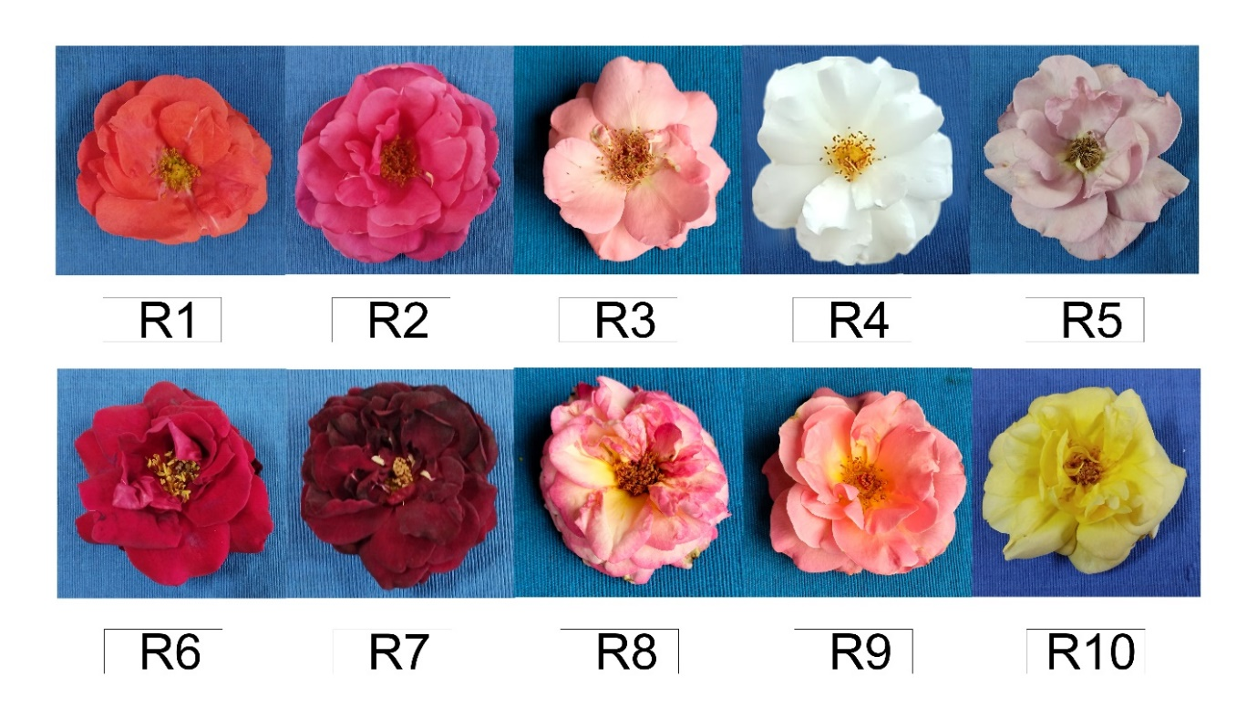

Supplementary Figure 1. Ten rose accession flowers used for analysis of color parameters and secondary metabolites.

