Supplementary table A. A summary of studies comparing gray and white matter modulus in the CNS.
Model | Methodology | Elastic Modulus (KPa) |  | Ref.
Model | Methodology | Gray matter | White matter | Ref.
Ex vivo | AFM indentation of rat cerebrum | Coronal: 0.128* | Coronal: 0.075* | [79]
Ex vivo | Indentation of mouse spinal cord | 1.40 ± 0.29 | 1.90 ± 0.59 | [80]
In situ | MRE of human brain | 7.5 ± 1.6 | 11.6 ± 2.4 | [81]
In situ | MRE of human brain | 12.90 ± 0.90 | 15.20 ± 1.4 | [82]
In situ | MRE of human brain | Cerebrum: 2.34 ± 0.22 | Cerebrum: 2.41 ± 0.23 | [83]
Ex vivo | AFM indentation of Nano-SDF | 3.21 ± 0.5 |  | This study
The table depicts the mean modulus value reported by the research group's mean ± standard deviation of mean. An asterisk (*) indicates median values. Abbreviations used: AFM (Atomic Force Microscopy) and MRE (Magnetic Resonance Elastography).

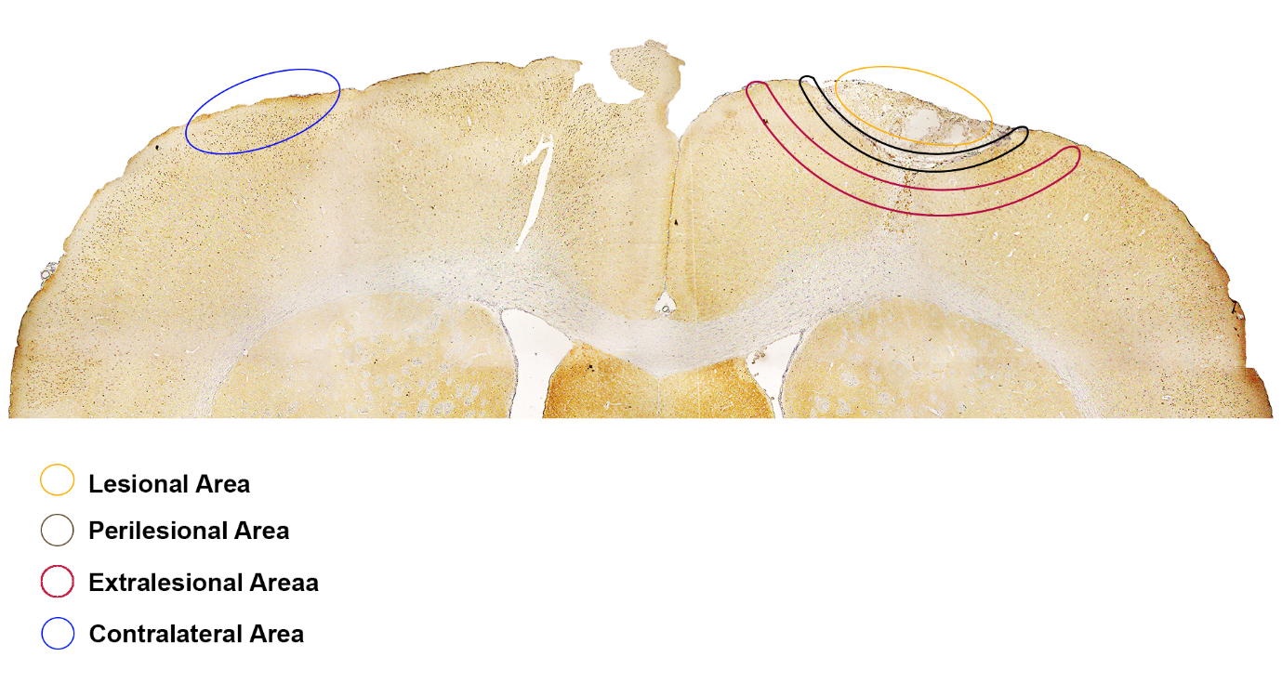
Supplementary Figure A. Four different accessed brain areas; including the lesional area, the perilesional area, the extralesional area, and the contralateral area.

