Supplementary Material 1. Deep learning (DL) model for lung cancer dose prediction
- Dataset
A total of 235 high-quality, previously approved, peer reviewed and delivered patient RT treatment plans generated by an experienced team was used to establish the DL model for lung cancer dose prediction. The model was trained and validated on a dataset of 188 plans. The performance of the model was analyzed on a test set comprising 47 plans.
- Architecture of the DL model
A deep U-Net network based on our previous study¹⁴, incorporating residual convolutional and deconvolutional blocks, was retrained for dose prediction of lung cancers. For the sake of completeness of the article, the architecture of the DL model is displayed in Supplementary Figure 1. It consists of a contracting path (left side) and an expansive path (right side). The contracting path follows the typical architecture of ResNet50 with a modification in taking the output size into account to achieve down-sampling. It firstly goes through one convolutional layer with 7×7 filters, and then another convolutional layer with 7×7 filters and stride 2 for first down-sampling. The second down-sampling is performed by max pooling with 3×3 filters and stride 2. The following down-sampling parts consist of different combination of stacked building blocks of Identity_Block and Conv_Block (shown in Supplementary Figure 1 middle-up) with 1×1 filters and 3×3 filters. At each down-sampling step we double the number of feature maps. Every step in the expansive path consists of an up-sampling of the feature map followed by a deconvolution with 3×3 filters and stride 2 that halves the number of feature maps, a concatenation with the correspondingly feature map from the contracting path, and two convolution layers with 3×3 filters. Zero padding is added during convolution process to maintain the feature map size. The network ends with the two convolutions with 3×3 filters and one deconvolution with 1×1 filters instead of 3×3 filters in order to smoothly reduce number of filters to one.
- Inputs and outputs to the architecture
The inputs to the architecture were the contours and prescriptions. The contours include the planning target volumes (PTVs), organ at risks (OARs), and Body. The contours of PTVs were labeled using the specific prescription doses with an overlapping sequence from minimum to maximum. The contours of OARs and Body were labeled using unique numbers. The contours of the overlapping regions were uniquely labeled. The output was the corresponding dose distributions. The model was trained in 2.5-dimensional (2.5D) by considering three adjacent slices. For each slice, the inputs were structured in the form of a 192×192×21 matrix and the outputs were dose distributions at the corresponding slice, in the form of a 192×192×1 matrix. The inputs and outputs can refer to Supplementary Figure 2.
- Training and validation process
The samples from the 235 patients (8936 slices) were randomly divided into 150 training (5677 slices), 38 validation (1459 slices), and 47 test (1800 slices) samples. The training samples were augmented by randomly flipping, rotating, scaling, or shifting during the training and validation process. The model was implemented in Keras with TensorFlow as the backend, and trained from scratch with the layer kernel weights initialized using Xavier uniform initialization. The Adam optimizer, with an initial learning rate of 10⁻⁴, was used to minimize the loss function (mean squared error) with a batch size of 4. The learning rate was reduced to 20% of its original value if the monitored value on the validation samples did not improve after 10 epochs, and the training process was stopped if the monitored value did not improve after 20 epochs. The model with the best performance on the validation samples was reserved for further testing.
- Model evaluation
The mean absolute error (MAE) of the differences between the clinical plan doses and predicted doses were calculated for the voxels within the outline. MAE is defined as:
$MAE=\frac{1}{n}\sum_{i}^{n}{{|δ|}_{i}}=\frac{1}{n}\sum_{i}^{n}{{|D_{c}-D_{p}|}_{i}}$,
where i denotes the ith voxel and n denotes the total number of voxels.
We calculated the clinical interest DVH metrics (DM) V5, V20, V30, and mean doses (D_{mean}) for Lung all; D_{1cc} for Cord, Trachea, and Esophagus; V30, V40, and D_{mean} for Heart; and D_{mean} for Liver and Stomach. The differences between the clinical plan doses and predicted doses in the DVH metrics were defined as:
$δDM=\frac{{|DM}_{c}-{DM}_{p}|}{{DM}_{c}}$.
The statistical significance of these results was calculated with a paired-samples t-test (p < 0.05).
- Results
Supplementary Figure 3 shows examples of the agreement between the clinical doses and predicted doses for the model. From the dose distributions and DVH comparisons, we can see that the model can predict the dose of lung cancer well.
Supplementary Table 1 shows MAE of the dose differences between the clinical plan doses and predicted doses for all test datasets. The averaged difference is 3.91±5.36 % normalized to the prescription.
Supplementary Table 2 presents the mean absolute errors of the clinical interest DVH metrics of the OARs between the clinical plan doses and predicted doses for all test datasets. Most of the DVH metrics of the OARs have no significant differences between the clinical and predicted results.
The model for predicting lung cancer dose distributions is accurate enough for the following automatic treatment planning.

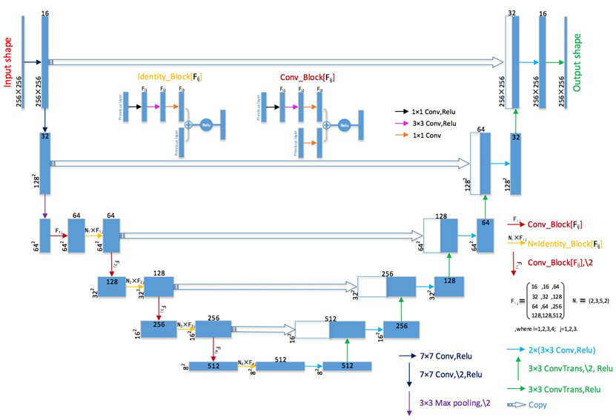
Supplementary Figure 1-1. Architectures for the DL model. Each blue box corresponds to a multi-channel feature map. The number of maps is denoted above or below the upper edge of the box. The dimension size is provided at the lower left edge of the box. White boxes represent copied feature maps. The arrows denote the different operations. The arrows together with F_{ij} or N_{i}×F_{ij} (i=1,2,3,4; j=1,2,3) stand for Conv_Block or number of Identity_Block, which are denoted on middle-up. F_{ij} is the number of filters and N_{i} is the number as shown in right down.
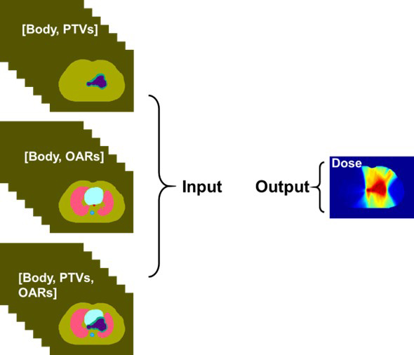

Supplementary Figure 1-2. Inputs and outputs for the DL model.

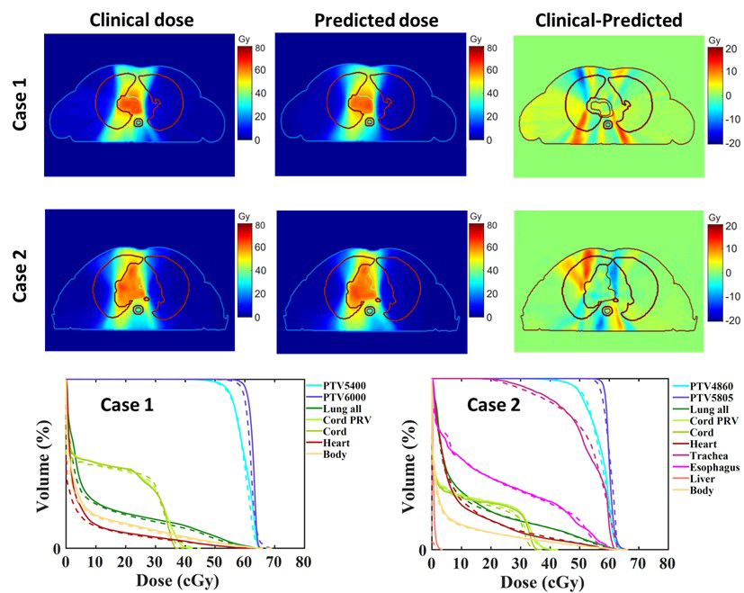
Supplementary Figure 1-3. The top two rows show the agreement between the clinical doses and predicted doses for the model, and the bottom row shows the DVH comparison for two test cases.

Supplementary Table 1-1. Mean absolute errors (MAEs) of the dose differences for all test datasets, normalized to the prescription dose.
Test  datasets | MAE(%) | Test  datasets | MAE(%)
Case1 | 3.7 | Case25 | 2.68
Case2 | 5.22 | Case26 | 5.07
Case3 | 4.44 | Case27 | 5.6
Case4 | 2.51 | Case28 | 4.24
Case5 | 3.41 | Case29 | 4.03
Case6 | 3.29 | Case30 | 2.67
Case7 | 3.23 | Case31 | 3.49
Case8 | 3.25 | Case32 | 3.42
Case9 | 3.5 | Case33 | 3.77
Case10 | 3.42 | Case34 | 4.81
Case11 | 5.22 | Case35 | 2.46
Case12 | 3.68 | Case36 | 2.89
Case13 | 3.73 | Case37 | 4.73
Case14 | 3.59 | Case38 | 4.42
Case15 | 2.85 | Case39 | 5.24
Case16 | 5.16 | Case40 | 4.39
Case17 | 3.72 | Case41 | 6
Case18 | 3.36 | Case42 | 3.5
Case19 | 3.64 | Case43 | 4.47
Case20 | 3.79 | Case44 | 5.58
Case21 | 3.61 | Case45 | 4.61
Case22 | 2.93 | Case46 | 4.32
Case23 | 2.4 | Case47 | 4.69
Case24 | 3.24
Average | 3.91±5.36

Supplementary Table 1-2. The DVH metrics (DM) of OARs were calculated between the clinical doses and predicted doses. The DVH metrics D_{mean} and D_{1cc} were normalized to the prescription dose. The results of the DVH metrics were statistically analyzed with a paired-samples t-test.
OARs | DVH Metrics | Clinical | Predicted | $δDM$ (%) | P-value
Lung all | V5 | 28.8±13.8 | 29.7±13.2 | 3.01±2.22 | 0.113
Lung all | V20 | 14.5±7.1 | 14.6±7.2 | 1.38±1.37 | 0.687
Lung all | V30 (%) | 10.9±5.8 | 10.6±5.7 | 1.16±1.19 | 0.258
Lung all | D_{mean} (Gy) | 8.6±3.8 | 8.5±3.6 | 0.84±0.81 | 0.220
Cord | D_{1cc} | 24.9±13.5 | 26.4±12.5 | 5.64±6.25 | 0.039
Heart | V30 | 17.3±14.0 | 16.6±14.2 | 2.26±3.34 | 0.679
Heart | V40 | 11.3±9.1 | 10.5±8.7 | 2.64±3.28 | 0.266
Heart | D_{mean} | 10.3±8.7 | 10.3±8.5 | 1.82±1.78 | 0.752
Trachea | D_{1cc} | 42.9±24.1 | 42.7±23.3 | 2.84±2.71 | 0.666
Esophagus | D_{1cc} | 43.7±21.9 | 43.2±21.1 | 4.03±3.99 | 0.316
Liver | D_{mean} | 0.65±0.81 | 0.43±0.93 | 0.52±0.35 | 0.002
Stomach | D_{mean} | 1.28±1.27 | 1.28±1.79 | 0.98±1.06 | 0.988

Supplementary Material 2. Planning dose constraints of OARs for lung cancer
Supplementary Table 2-1. Planning dose constraints of OARs for lung cancer.
ROI | Dose Constraint
Lung all | V20＜20%~30%
 | V5＜50%~60%
 | Dmean＜17 Gy
Cord | Dmax＜40 Gy
Cord PRV | Dmax＜45 Gy
Heart | V30＜40%
 | V40＜30%
 | V50＜25%
 | Dmean＜20 Gy
Esophagus | V60＜17%
 | Dmean＜34 Gy
Trachea | Dmax＜80 Gy

Supplementary Material 3. Typical example of dose shaping structures (DSS)
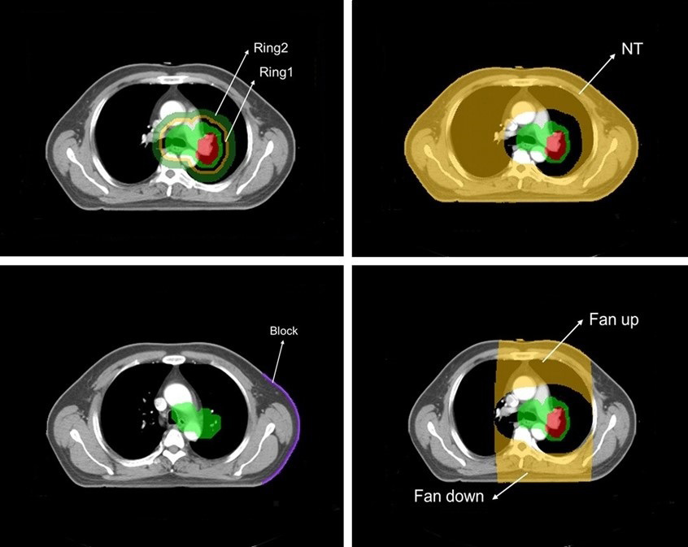

Supplementary Figure 3-1. Dose shaping structures (DSS) in Pinnacle³, including ring of the target (Ring), normal tissue (NT), block, the fan area above and below the target (Fan up and Fan down).

Supplementary Material 4. The description of deep learning-assisted objective functions.
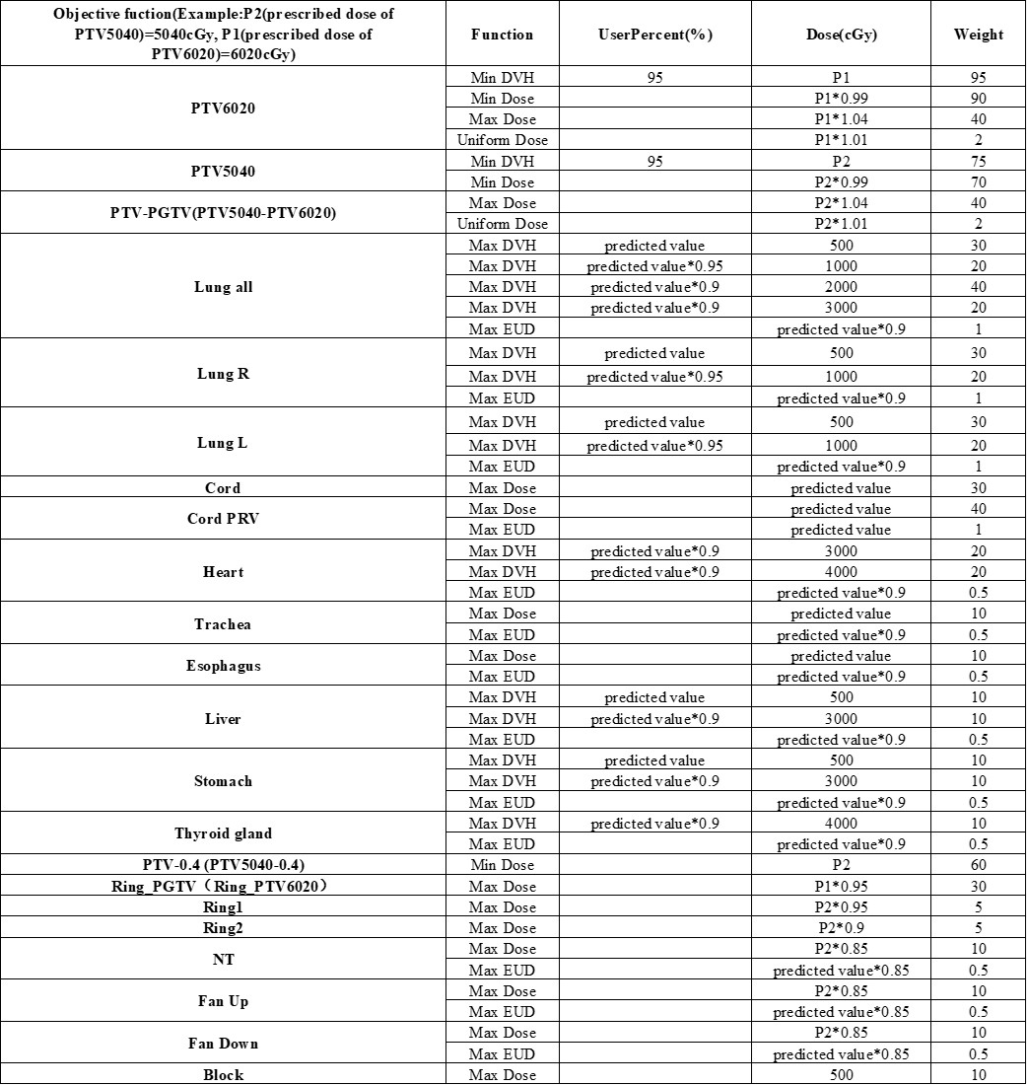

Supplementary Figure 4-1. The description of deep learning-assisted objective functions.

Supplementary Material 5. The lower limit, upper limit, and PQM value range for different submetrics.

Supplementary Table 5-1. Evaluation interval of metric parameters along with their value range.
Structure | Metric |  |  |  | PQM value range
Structure | parameter | lower limit | interval | upper limit | minimum | maximun
PTV (single) | HI | 0 | 0~0.4 | 0.4 | 0 | 10
PTV and PGTV | HI (PTV) | 0 | 0~0.4 | 0.4 | 0 | 5
 | HI (PGTV) | 0 | 0~0.4 | 0.4 | 0 | 5
Lung all | V5 (%) | 10 | 10~60 | 60 | 0 | 10
Lung all | V20 (%) | 0 | 0~30 | 30 | 0 | 10
Lung all | Dmean (Gy) | 0 | 0~16 | 16 | 0 | 10
Heart | V30 (%) | 0 | 0~40 | 40 | 0 | 10
Heart | V40 (%) | 0 | 0~30 | 30 | 0 | 10
Heart | Dmean (Gy) | 0 | 0~30 | 30 | 0 | 10
Cord | Dmax (Gy) | 0 | 0~40 | 40 | 0 | 10
Cord PRV | Dmax (Gy) | 0 | 0~45 | 45 | 0 | 10

Supplementary Material 6. The details of expert review form.
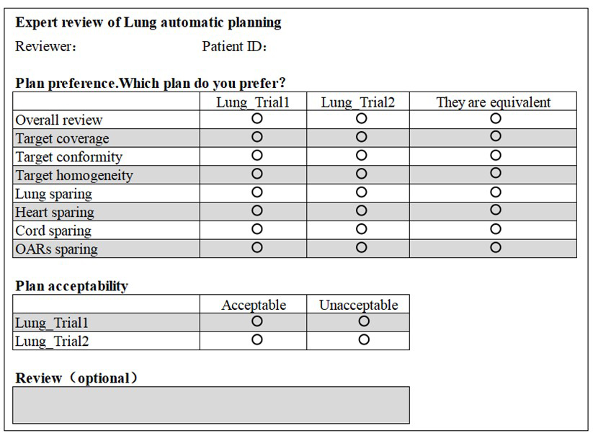

Supplementary Figure 6-1. The details of expert review form, including plan preference and acceptability.

Supplementary Material 7. Typical case of better protection for OARs in automatic plan.

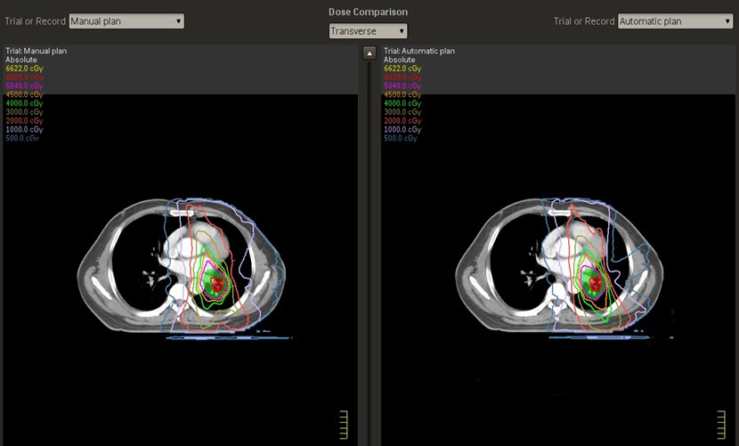
Supplementary Figure 7-1. In this typical case, automatic plan shows better protection for lung and heart. The left figure is manual plan, and the right figure is the automatic plan.

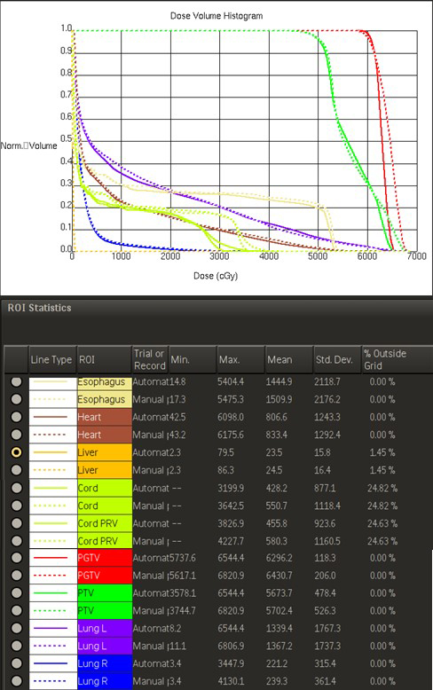

Supplementary Figure 7-2. In this typical case, the comparison of DVH between automatic and manual plans (The unit of dose is cGy). The dotted curve is manual plan, and the solid curve is the automatic plan. It can be seen that Dmean of lung, heart, liver and Dmax of spinal cord, esophagus in the automatic plan are lower than those in the manual plan.

