Targeting CaMKII-δ/DHCR24 axis is a novel strategy against acute myeloid leukemia
Zhaoxing Wu^{1,2}, Qinyuan Gong^{1,2}, Mengyuan Li^{1,2}, Shuwen Zheng^{1,2}, Xuzhao Zhang¹, Yun Liang¹, Rongzhen Xu^{1,2,3*}
¹Department of Hematology (Key Laboratory of Cancer Prevention and Intervention, China National Ministry of Education, Key Laboratory of Molecular Biology in Medical Sciences, Zhejiang Province), The Second Affiliated Hospital, College of Medicine, and ²Cancer Institute, Zhejiang University, Hangzhou, 310009, China.
³Institute of Hematology, Zhejiang University, Hangzhou 310009, China.
*Corresponding authors. E-mail: zrxyk10@zju.edu.cn (R.X).

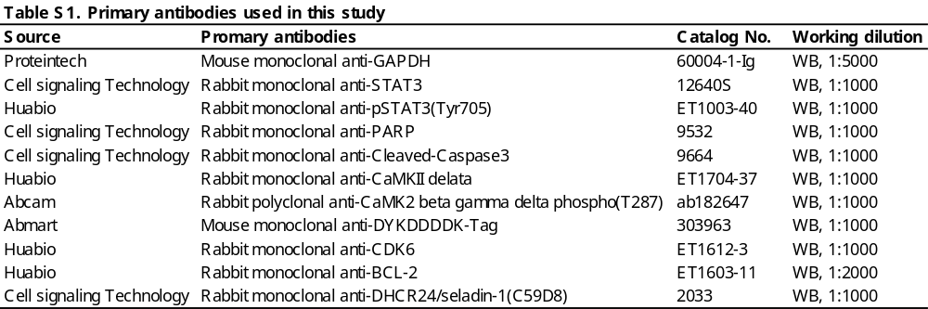

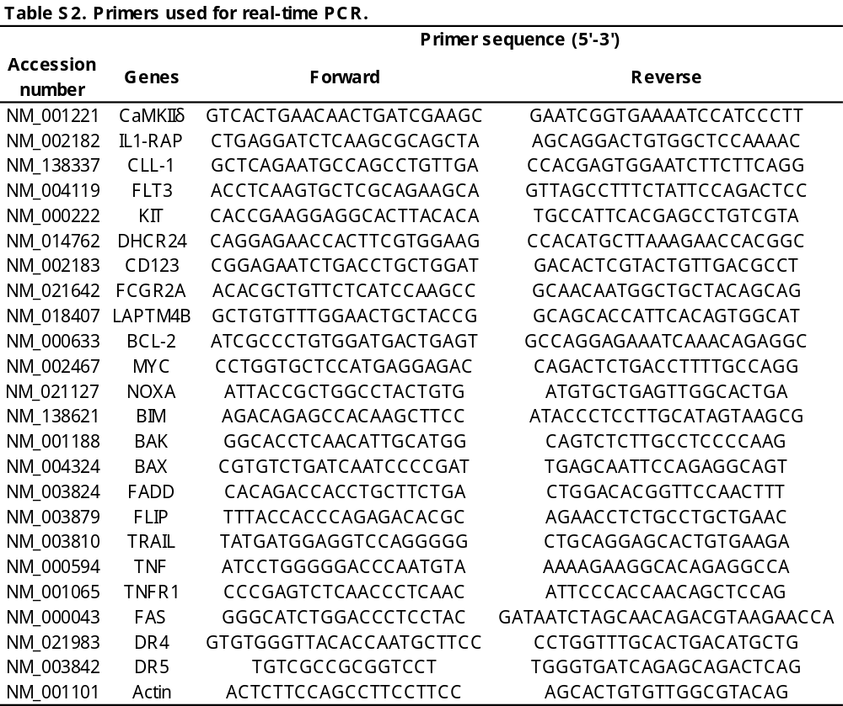

Fig.S1 CaMKⅡδ expression and survival in other cancers. TCGA data analysis reveals the mRNA levels of CaMKⅡδ in PAAD, THYM, GBM and DLBC as compared to corresponding non-tumor cells (a-d). Kaplan-Meier survival curves of CaMKⅡδ for protein level of high and low in PAAD, THYM, GBM and DLBC samples (e-h).
Fig.S2 Inhibiting of CaMKⅡδ increase apoptosis and attenuate the growth of AML cells, and down-regulating expression of pSTAT3(Tyr705), CDK6 and BCL-2. Western blotting analysis of CaMKⅡδ levels after silencing induced by Dox in 3 and 5 days in Molm-13 cells (a). Representative light microscopic images in Molm-13 cells after CaMKⅡδ-KO induced in 0 and 5 days (b). Western blotting shows apoptosis-related markers cleaved Caspase-3 and cleaved-PARP were significantly increased in Molm-13 cells after CaMKⅡδ silencing induced by Dox in 3 and 5 days (c). Real time PCR results shows the increased expression of apoptosis associated factors in Molm-13 cells after CaMKⅡδ silencing induced by Dox in 5 days (d and e). The CaMKⅡinhibitor KN93 (10μM) decreasing the expression of pCaMKⅡδ (T287), CaMKⅡδ, pSTAT3 (Tyr705), CDK6 and BCL-2 in Molm13 and Kasumi-1 cells by immunoblotting(f-i). MTT assay shows the growth of AML cells were significantly inhibited by KN93 in a dose-dependent manner (j).
Fig.S3 The effects of CaMKⅡδ and CaMKⅡδ-mutants on proliferation of AML cells. Western blotting shows the over-expressed CaMKⅡδ in Molm-13 and Kasumi-1 cells (a and c). MTT assay exhibits the proliferation curves of Molm-13 and Kasumi-1 cells with an expression vector harboring CaMKⅡδ (b and d). Comparison of proliferation curves of Kasumi-1 and Molm-13 cells with an expression vector harboring a K43M or T287D mutant CaMKⅡδ by MTT assay (e-h). Representative images and quantification of cell cycle by FCM in Molm-13 cells after Dox-induced CaMKⅡδ-KO in 5 days (i and j).
Fig.S4 CaMKⅡδ regulate genes of apoptosis, cell cycle, cancer metabolism and endoplasmic reticulum stress. Heatmaps showing cell cycle and apoptosis gene expression profiles in Molm-13 cells after CaMKⅡδ-KO compared with the control group (a and b). Cancer associated gene ontology (GO) analysis showing that CaMKⅡδ downregulated genes were predominantly associated with metabolism (c). The CaMKⅡδ upregulated genes were mainly associated with protein processing in endoplasmic reticulum (d). Heatmaps showing endoplasmic reticulum stress and cholesterol biosynthetic process gene expression profiles in Molm-13 cells after CaMKⅡδ-KO compared with the control group (e and f).
Fig.S5 DHCR24 is highly expressed in AML cells and associated with poor prognosis. Immunoblot showing DHCR24 expression is significantly higher in AML cell lines and CD34+ AML cells instead of ALL or lymphoma cells and normal CD34+ cells (a and b). GEO data（GSE12662 and GSE10358） reveals DHCR24 levels were significantly higher in M3 and M5 compared with normal blood cells (c). DHCR24 expression in different types of AML from the Bloodspot Leukemia MILE study (d). GEO data （GSE10358 and GSE1159）shows DHCR24 is highly expressed in FLT3-ITD positive AML patients (e and f). The DHCR24 highly expressed AML samples is demonstrated poor survival time from TCGA data (g).
Fig.S6 Inhibiting DHCR24 hinders the growth of AML stem/progenitor cells. qRT-PCR shows DHCR24 mRNA expression level in AML, ALL and lymphoma cell lines (a). Western blotting shows apoptosis-related molecules cleaved Caspase-3 and cleaved-PARP were significantly increased in Molm-13 cells after DHCR24 silencing (b). Representative images and quantification of colony numbers in Molm-13 and Kasumi-1 cells after DHCR24-KO (c-f).

