Supplementary Table 1: Items, dichotomisation strategy and proportional representation of childhood adversities in the BCS70 cohort.

Item | Age | No risk | N (%) | Risk | N (%) | Report | Miss N (%)
Natural mother absent | 5 | Relationship to mother figure:  - Natural mother | 12254  (74.7%) | Relationship to mother figure:  - Adopted mother  - Stepmother  - Foster Mother  - Grandmother  - Elder sister  - Father Cohabitee  - Other  - No mother | 214 (1.3%) | Parent | 3939 (24.0%)
Natural mother absent | 10 | Relationship to mother figure:  - Natural mother | 12143 (74.0%) |  | 383 (2.3%) | Parent | 3881 (23.7%)
Natural mother absent | 16 | Relationship to mother figure:  - Natural mother | 8206 (50.0%) |  | 338 (2.1%) | Parent | 7863 (47.9%)
Natural father absent | 5 | Relationship to father figure:  - Natural father | 11359 (69.2%) | Relationship to father figure:  - Adopted father  - Stepfather  - Foster father  - Grand father  - Elder brother  - Mothers’ cohabitee  - Other  - No father | 1109 (6.8%) | Parent | 3939 (24.0%)
Natural father absent | 10 | Relationship to father figure:  - Natural father | 10660 (65.0%) |  | 1858 (11.3%) | Parent | 3889 (23.7%)
Natural father absent | 16 | Relationship to father figure:  - Natural father | 7057 (43.0%) |  | 1442 (8.8%) | Parent | 7908 (48.2%)
Low parental social class | 5 | Fathers social class (mothers if missing):  - Professional (I)  - Managerial and Technical (II)  - Skilled occupations (non-manual - III) | 9716 (59.2%) | Both parents:  - Skilled occupations (manual- III)  - Partly skilled occupations (IV)  - Unskilled occupations (V)  - Unemployed | 2239 (13.6%) | Parent | 4452 (27.1%)
Low parental social class | 10 |  | 9863 (60.1%) |  | 2200 (13.4%) | Parent | 4344 (26.5%)
Low parental social class | 16 |  | 5227 (31.9%) |  | 890 (5.4%) | Parent | 10290 (62.7%)
Low parental education | 5 | Either parent:  - Vocation/typing/apprenticeship  - O-level or equivalent  - A-level or equivalent  - Registered nurse  - Degree  - Other qualification | 7391 (45.0%) | Both parents:  - No qualifications | 4241 (25.8%) | Parent | 4775 (29.1%)
Low parental education | 10 |  | 8175 (49.8%) | Both parents:  - No qualifications | 3665 (22.3%) | Parent | 4567 (27.8%)
Low parental education | 16 |  | 5360 (32.7%) | Both parents:  - No qualifications | 1299 (7.9%) | Parent | 9748 (59.4%)
Damp housing | 10 | No | 10223 (62.3%) | Slight  Moderate  Marked | 2245 (13.7%) | Parent | 3939 (24.0%)
Damp housing | 16 | No | 7147 (43.6%) | Slight  Moderate  Marked | 941 (5.7%) | Mother | 8319 (50.7%)
Low income | 10 | Household (father + mother) gross income is:  - Above 60% of the median income | 7242 (44.1%) | Household (father + mother) gross income is:  - Below 60% of the median income | 4197 (25.6%) | Parent | 4968 (30.3%)
Low income | 16 |  | 5408 (33.0%) |  | 2353 (14.3%) | Parent | 8646 (52.7%)
Maternal depression risk | 5 | 0-80th percentile on Malaise inventory | 10025 (61.1%) | 81-100th percentile on Malaise inventory | 2199 (13.4%) | Mother | 4183 (25.5%)
Maternal depression risk | 10 | 0-80th percentile on Malaise inventory | 9180 (56.0%) | 81-100th percentile on Malaise inventory | 2265 (13.8%) | Mother | 4962 (30.2%)
Maternal depression risk | 16 | 0-80th percentile on Malaise inventory | 6474 (39.5%) | 81-100th percentile on Malaise inventory | 1370 (8.4%) | Mother | 8563 (52.2%)
Household member illness/ disability | 5 | No household members have developed a serious illness or disability since the study child’s birth | 9989 (60.9%) | Since the study child’s birth, a household member has developed a:  - Severe or prolonged illness  - Handicap or disability | 2349 (14.3%) | Parent | 4069 (24.8%)
Household member illness/ disability | 10 |  | 8623 (52.6%) |  | 3719 (22.7%) | Parent | 4065 (24.8%)
Household member illness/ disability | 16 |  | 5743 (35.0%) |  | 2963 (18.1%) | Parent | 7701 (46.9%)
Social environment risk | 5 | Valid health visitor records during 1st week of life, and any social or environmental risk factors recorded:  - No  Or, valid child health clinic visits during 1st week of life, and any social or environmental risk recorded:  - No | 10707 (65.3%) | Valid health visitor records during 1st week of life, and any social or environmental risk factors recorded:  - Yes  Or, valid child health clinic visit during 1st week of life, and any social or environmental risk recorded:  - Yes | 364 (2.2%) | Health visitor | 5336 (32.5%)
Separation from mother | 5 | The child has been separated from the mother:  - From birth until less than 24 hours after birth, or not at all  - For less than a day in the first month of life, or not at all  - For less than a month in the first 5 years of life, or not at all | 9292 (56.6%) | The child has been separated from the mother:  - From birth until 24 hours after birth  - For more than a day in the first month of life  - For more than a month in the first 5 years of life | 2963 (18.1%) | Parent | 4152 (25.3%)
Lonely at school | 10 | Answered no to both:  - Do you feel lonely at school? (Only available at age 10)  - Do you feel sad because you have nobody to play with at school? | 7242 (44.1%) | Answered yes to either:  - Do you feel lonely at school? (Only available at age 10)  - Do you feel sad because you have nobody to play with at school? | 4197 (25.6%) | Child | 4968 (30.3%)
Lonely at school | 16 |  | 3727 (22.7%) |  | 304 (1.9%) | Child | 12376 (75.4%)
Parents not loving | 16 | Answered yes to, my parents:  - Are loving/caring/look after me | 4264 (26.0%) | Answered no to, my parents:  - Are loving/caring/look after me | 1495 (9.1%) | Child | 10648 (64.9%)
Non-accidental injury | 5 | Has the child ever had any injury considered or suspected to be “non-accidental?  - No | 10215 (62.3%) | Has the child ever had any injury considered or suspected to be “non-accidental?  - Yes  - No, but at risk | 356 (2.2%) | Health visitor | 5836 (35.6%)
Peer victimisation | 10 | Other children say nasty things about you:  - No  - Don’t know | 8051 (49.1%) | Other children say nasty things about you:  - Yes | 3336 (20.3%) | Child | 5020 (30.6%)
Peer victimisation | 16 |  | 3292 (20.1%) | Other children say nasty things about you:  - Yes | 739 (4.5%) | Child | 12376 (75.4%)
Hit by parent | 16 | Told off by parent in last month?  - No  - Yes, but not hit | 5406 (32.9%) | Told off by parent in last month?  - Yes, hit by parent | 169 (1.0%) | Child | 10832 (66.0%)
Treated unfairly | 16 | Treated unfairly in the last 12 months, due to:  - Never been treated unfairly  And, picked on by teacher, more than others:  - No  - Nobody in class gets picked on  - Other | 5656 (34.5%) | Treated unfairly in the last 12 months, due to:  - Sex  - Skin colour  - Dress  - Family  - Speech  - Religion  - Other reason  - Not known why  Or, picked on by teacher, more than others:  - Yes | 2139 (13.0%) | Child | 8612 (52.5%)
Sexual abuse | 16 | Have you ever had any unwelcomed sexual approaches made to you?  - No | 4897 (29.8%) | In the past 12 months, someone used force for any reason.  - Yes, to make me have sex when I didn’t want to  - Yes, to make me do petting  Have you ever had any unwelcomed sexual approaches made to you?  - Yes | 802 (4.9%) | Child | 10708 (65.3%)

Team-based sports | Baseball, basketball, cricket, football, hockey, netball, rounders, rugby, volleyball
Individual-based sports | Aerobics, track/field, badminton, canoe, cross-country, cycling, dancing, gymnastics, horse-riding, jogging, fitness exercise, roller/ice-skating, rowing, sailing, scrambling, skiing, squash, swimming, table tennis, tennis, walking, water-skiing, weight training, wind surfing
Skill-based sports | Billiards, darts, fishing, pool, shooting, snooker
Supplementary Table 2: Types of sport included within each physical activity category.

Supplementary Table 3: Food items within Mediterranean diet food groups, and categorisation criteria

 |  | Amount consumed (g/day)
Food group | Items | 0 | 1 | 2
Fruit | Unsweetened fruit juice  Fresh fruit (not citrus/apple pear)  Citrus fruits  Apples and pears  Tomatoes | < 150 | 150-300 | > 300
Vegetables | Salad vegetables  Fresh and frozen vegetables  Canned or processed vegetables  Green vegetables  Carrots | < 100 | 100-250 | > 250
Legumes | Peas  Baked beans | < 70 | 70-140 | > 140
Cereals | White bread  Wholemeal bread  Brown wheatgerm granary bread  Other breads  High fibre breakfast cereals  Other breakfast cereals (unsweetened)  Pasta, rice, cereals | < 130 | 130-195 | > 195
Fish | Fish  Fish dishes | < 100 | 100-250 | > 250
Meat | Bacon and ham  Poultry and poultry dishes  Offal and dishes  Canned meat  Meat pies  Beef and veal  Lamb  Pork  Coated chicken products  Burgers and kebabs  Sausages | > 120 | 80-120 | < 80
Dairy | Cheese  Eggs  Eggs and cheese dishes  Canned meat  Butter  Whole milk  Semi-skimmed milk  Other milk and cream  Yoghurt  Cottage cheese  Skimmed milk  Milk puddings | > 270 | 180-270 | < 180

Items | Questions
1 | Do you often have backache?
2 | Do you feel tired most of the time?
3 | Do you often feel depressed?
4 | Do you often have bad headaches?
5 | Do you often get worried about things?
6 | Do you usually have great difficulty in falling or staying asleep?
7 | Do you usually wake unnecessarily early in the morning?
8 | Do you wear yourself out worrying about your health?
9 | Do you often get into a violent rage?
10 | Do people annoy and irritate you?
11 | Have you at times had a twitching of the face, head or shoulders?
12 | Do you suddenly become scared for no good reason?
13 | Are you scared to be alone when there are not friends near you?
14 | Are you easily upset or irritated?
15 | Are you frightened of going out alone or of meeting people?
16 | Are you constantly keyed up and jittery?
17 | Do you suffer from indigestion?
18 | Do you suffer from an upset stomach?
19 | Is your appetite poor?
20 | Does every little thing get on your nerves and wear you out?
21 | Does your heart often race like mad?
22 | Do you often have bad pain in eyes?
23 | Are you troubled with rheumatism or fibrosis?
24 | Have you ever had a nervous breakdown?
Note: The response options were "yes" and "no" at age 30 in BCS70.
Supplementary Table 4: Malaise Inventory items.

Supplementary Figure 1: The total number of missing childhood items per number of participants in the study sample.
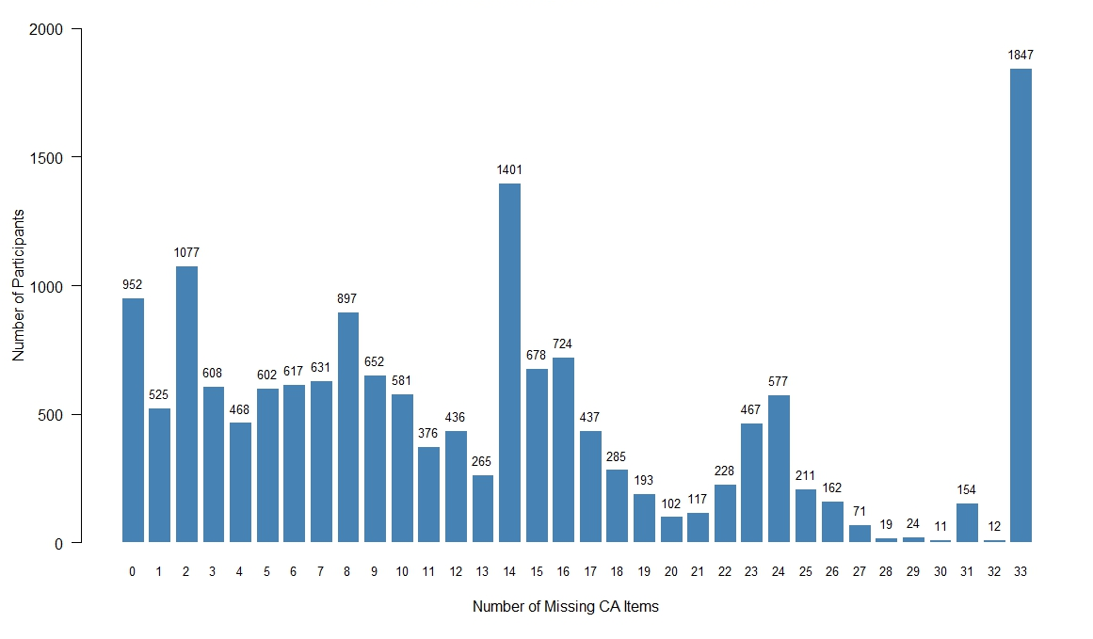

Supplementary Figure 2: Imputation model diagram
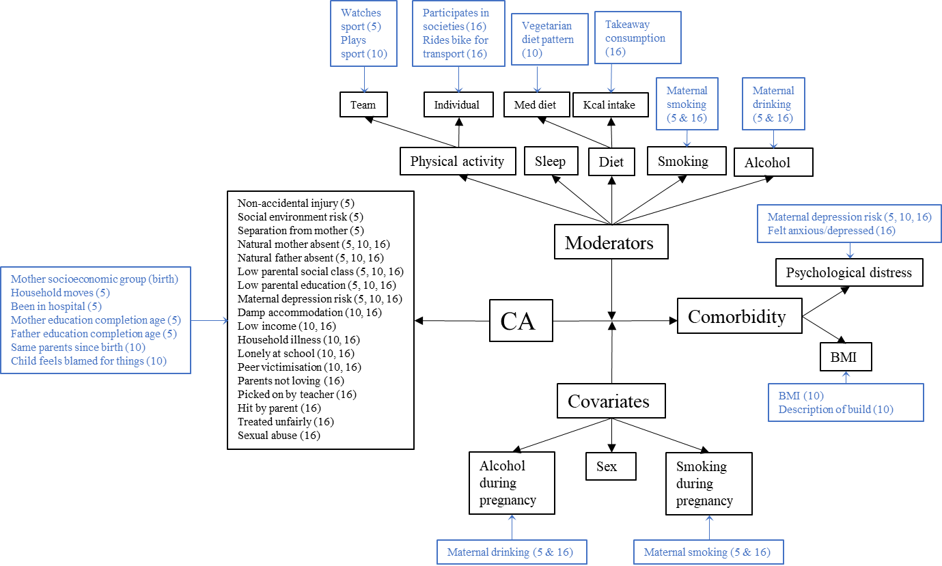

Note: Items in black are items included in the imputation analyses models, whilst items in blue (auxiliary variables) were only included in the imputation model. Auxiliary variables were required to have a correlation of above 0.1 with the respected analysis items. Ages (years) at which auxiliary variables were recorded and included are stated in the diagram.

Supplementary Table 5: Details of missing rates and the specification of imputation methods per parameter

Parameter | Miss % | Method | Predictors
Childhood adversities | 94.2% | 1) PMM (item-level) 2) Passive imputation | CA items, moderators, covariates, outcome, auxiliary
Physical activity | 71.0% | 1) PMM (item-level) 2) Passive imputation | Exposure, covariates, outcomes, auxiliary
Mediterranean diet | 73.9% | 1) PMM (item-level) 2) Passive imputation | Exposure, covariates, outcomes, auxiliary
Energy consumption | 74.4% | PMM | Exposure, covariates, outcomes, auxiliary
Sleep duration | 71.8% | 1) PMM (item-level) 2) Passive imputation | Exposure, covariates, outcomes, auxiliary
Alcohol consumption | 66.3% | PMM | Exposure, covariates, outcomes, auxiliary
Cigarette smoking | 66.5% | PMM | Exposure, covariates, outcomes, auxiliary
Sex | 0.0% | PMM | Exposure, moderators, outcomes, interactions
Maternal drinking | 28.6% | PMM | Exposure, moderators, outcomes, auxiliary, interactions
Maternal smoking | 0.5% | PMM | Exposure, moderators, outcomes, auxiliary, interactions
Psychological distress | 38.5% | 1) PMM (item-level) 2) Passive imputation | Exposure, moderators, covariates, auxiliary, interactions
BMI | 42.7% | 1) PMM (item-level) 2) Passive imputation | Exposure, moderators, covariates, auxiliary, interactions
Comorbidity categories | 43.2% | Passive imputation | N/A
Note: Exposure = childhood adversities, moderators = physical activity, Mediterranean diet, energy consumption, alcohol consumption, cigarette smoking, outcome = comorbidity categories, covariates = sex, maternal drinking, maternal smoking, interactions = exposure*lifestyle factors, CA items = childhood adversity items, auxiliary = auxiliary variables (see Supplementary Figure 2), PMM = predictive mean matching.

 | Controls  (N=1275) | Psychological Distress Only  (N=118) | Obesity Only  (N=130) | Comorbidity Risk  (N=22)
Childhood Adversities
Number of stressors | 4.30 (3.12) | 5.89 (3.38) | 5.46 (2.66) | 7.00 (2.58)
Missing (%) | 838 (65.7%) | 82 (69.5%) | 84 (64.6%) | 18 (81.8%)
Prorated scale | 4.70 (3.24) | 6.41 (3.87) | 5.88 (3.22) | 8.74 (4.24)
Physical Activity
Sessions per week | 6.37 (4.84) | 6.61 (5.47) | 5.98 (4.56) | 4.97 (4.15)
Mediterranean diet
Score | 3.94 (1.86) | 3.77 (1.86) | 3.84 (1.69) | 3.36 (1.50)
Energy Consumption
Daily calorie intake | 2540 (829) | 2550 (950) | 2400 (874) | 2630 (932)
Sleep duration
Hours | 8.75 (1.13) | 8.70 (1.47) | 8.60 (1.27) | 8.25 (1.37)
Cigarette smoking (weekly)
Non-smoker | 1017 (79.8%) | 81 (68.6%) | 99 (76.2%) | 19 (86.4%)
0-10 | 97 (7.6%) | 16 (13.6%) | 13 (10.0%) | 1 (4.5%)
11-40 | 101 (7.9%) | 12 (10.2%) | 12 (9.2%) | 0 (0%)
41+ | 60 (4.7%) | 9 (7.6%) | 6 (4.6%) | 2 (9.1%)
Alcohol consumption (frequency)
Non-drinker | 105 (8.2%) | 12 (10.2%) | 8 (6.2%) | 2 (9.1%)
Special occasions only | 367 (28.8%) | 30 (25.4%) | 41 (31.5%) | 5 (22.7%)
Once a month | 197 (15.5%) | 17 (14.4%) | 24 (18.5%) | 3 (13.6%)
Once a week | 384 (30.1%) | 31 (26.3%) | 33 (25.4%) | 4 (18.2%)
2 or more times a week | 222 (17.4%) | 28 (23.7%) | 24 (18.5%) | 8 (36.4%)
Sex
Male | 499 (39.1%) | 35 (29.7%) | 51 (39.2%) | 7 (31.8%)
Female | 776 (60.9%) | 83 (70.3%) | 79 (60.8%) | 15 (68.2%)
Malaise Inventory
Sum score | 2.30 (2.10) | 10.6 (2.67) | 2.59 (2.02) | 10.0 (2.08)
Body Mass Index
Kg/M² | 23.6 (2.89) | 23.0 (3.27) | 33.4 (3.30) | 36.3 (4.58)
Supplementary Table 6: Sample characteristics with complete outcome, moderator, and covariate data
Note: Continuous (Mean; SD) and categorical (Counts; %) data types from participants with complete outcome, moderator and covariate data, stratified by outcome group. Missing % in childhood adversities displays the number of participants with at least 1 missing childhood adversity item. The prorated scale was calculated in participants with valid responses for at least 80% of all childhood adversity items.

Supplementary Table 7: Results of the multinomial regression model without interactions.
 |  | No interaction model
Outcome | Predictor | Odds Ratio (OR) | Std.Error | P-value | 95% CI (Lower) | 95% CI (Upper)
Psychological  Distress only | Childhood adversities | 1.110 | 0.009 | <0.001 | 1.090 | 1.130
Psychological  Distress only | Sex (Female) | 1.334 | 0.057 | <0.001 | 1.193 | 1.492
Psychological  Distress only | Maternal drinking | 0.944 | 0.059 | 0.333 | 0.839 | 1.062
Psychological  Distress only | Maternal smoking | 1.049 | 0.015 | 0.001 | 1.019 | 1.081
Obesity only | Childhood adversities | 1.045 | 0.009 | <0.001 | 1.028 | 1.063
Obesity only | Sex (Female) | 0.872 | 0.069 | 0.047 | 0.762 | 0.998
Obesity only | Maternal drinking | 1.039 | 0.058 | 0.514 | 0.926 | 1.165
Obesity only | Maternal smoking | 1.067 | 0.017 | <0.001 | 1.033 | 1.102
Comorbidity risk | Childhood adversities | 1.158 | 0.018 | <0.001 | 1.118 | 1.199
Comorbidity risk | Sex (Female) | 1.426 | 0.152 | 0.020 | 1.058 | 1.922
Comorbidity risk | Maternal drinking | 1.016 | 0.123 | 0.896 | 0.797 | 1.295
Comorbidity risk | Maternal smoking | 1.148 | 0.037 | <0.001 | 1.067 | 1.234

Supplementary Table 8: Results of the multinomial regression models without interactions in individuals with complete outcome and covariate data.

 |  | No interaction model – Sensitivity analysis
Outcome | Predictor | Odds Ratio (OR) | Std.Error | P-value | 95% CI (Lower) | 95% CI (Upper)
Psychological  Distress only | Childhood adversities | 1.139 | 0.027 | <0.001 | 1.080 | 1.201
Psychological  Distress only | Sex (Female) | 1.509 | 0.212 | 0.053 | 0.995 | 2.287
Psychological  Distress only | Maternal drinking | 1.161 | 0.050 | 0.003 | 1.052 | 1.281
Psychological  Distress only | Maternal smoking | 0.919 | 0.159 | 0.593 | 0.673 | 1.254
Obesity only | Childhood adversities | 1.106 | 0.026 | <0.001 | 1.050 | 1.165
Obesity only | Sex (Female) | 0.982 | 0.190 | 0.923 | 0.677 | 1.424
Obesity only | Maternal drinking | 1.061 | 0.049 | 0.227 | 0.964 | 1.168
Obesity only | Maternal smoking | 0.816 | 0.147 | 0.167 | 0.611 | 1.089
Comorbidity risk | Childhood adversities | 1.332 | 0.055 | <0.001 | 1.197 | 1.482
Comorbidity risk | Sex (Female) | 1.371 | 0.468 | 0.500 | 0.548 | 3.430
Comorbidity risk | Maternal drinking | 0.950 | 0.119 | 0.665 | 0.753 | 1.199
Comorbidity risk | Maternal smoking | 1.062 | 0.385 | 0.875 | 0.500 | 2.258

Supplementary Table 9: Interaction terms from multinomial logistic regression models.

 |  |  |  | Interaction models
Outcome | Predictor | Odds Ratio (OR) | Std.Error | P-value | Q-value |  | 95% CI (Lower) | 95% CI (Upper)
Psychological  distress | CA:PA | 0.997 | 0.002 | 0.249 | 0.420 |  | 0.993 | 1.002
Psychological  distress | CA:MD | 1.002 | 0.005 | 0.712 | 0.857 |  | 0.992 | 1.012
Psychological  distress | CA:CI | 0.999 | 0.008 | 0.945 | 0.981 |  | 0.984 | 1.015
Psychological  distress | CA:SD | 1.001 | 0.007 | 0.859 | 0.949 |  | 0.987 | 1.016
Psychological  distress | CA:AC | 1.002 | 0.006 | 0.802 | 0.932 |  | 0.989 | 1.014
Psychological  distress | CA:SB | 1.000 | 0.008 | 0.970 | 0.986 |  | 0.984 | 1.016
Obesity only | CA:PA | 0.998 | 0.002 | 0.408 | 0.616 |  | 0.994 | 1.003
Obesity only | CA:MD | 1.002 | 0.005 | 0.641 | 0.808 |  | 0.992 | 1.013
Obesity only | CA:CI | 1.002 | 0.010 | 0.844 | 0.944 |  | 0.983 | 1.021
Obesity only | CA:SD | 1.002 | 0.006 | 0.781 | 0.923 |  | 0.989 | 1.015
Obesity only | CA:AC | 1.003 | 0.007 | 0.669 | 0.831 |  | 0.989 | 1.017
Obesity only | CA:SB | 0.995 | 0.008 | 0.523 | 0.706 |  | 0.978 | 1.011
Comorbidity  risk | CA:PA | 0.994 | 0.006 | 0.275 | 0.460 |  | 0.982 | 1.005
Comorbidity  risk | CA:MD | 1.004 | 0.011 | 0.705 | 0.854 |  | 0.983 | 1.026
Comorbidity  risk | CA:CI | 1.012 | 0.018 | 0.511 | 0.706 |  | 0.976 | 1.050
Comorbidity  risk | CA:SD | 1.000 | 0.013 | 0.995 | 0.995 |  | 0.974 | 1.027
Comorbidity  risk | CA:AC | 1.012 | 0.014 | 0.411 | 0.616 |  | 0.984 | 1.040
Comorbidity  risk | CA:SB | 0.997 | 0.019 | 0.883 |  | 0.949 | 0.960 | 1.036
Note: PA=physical activity, MD=Mediterranean diet, CI=calorie intake (z-score), SD=sleep duration, AC=alcohol consumption, SB=smoking behaviour.

 |  | Interaction models – Sensitivity analyses
Outcome | Predictor | Odds Ratio (OR) | Std.Error | P-value | 95% CI (Lower) | 95% CI (Upper)
Psychological  distress | CA:PA | 1.002 | 0.005 | 0.772 | 0.991 | 1.012
Psychological  distress | CA:MD | 0.994 | 0.015 | 0.704 | 0.965 | 1.024
Psychological  distress | CA:EC | 1.007 | 0.062 | 0.909 | 0.891 | 1.138
Psychological  distress | CA:SD | 1.027 | 0.017 | 0.118 | 0.993 | 1.062
Psychological  distress | CA:AC | 1.013 | 0.020 | 0.518 | 0.974 | 1.054
Psychological  distress | CA:SB | 1.015 | 0.029 | 0.602 | 0.959 | 1.075
Obesity only | CA:PA | 1.003 | 0.005 | 0.514 | 0.993 | 1.014
Obesity only | CA:MD | 1.015 | 0.015 | 0.327 | 0.986 | 1.044
Obesity only | CA:EC | 1.055 | 0.056 | 0.332 | 0.947 | 1.177
Obesity only | CA:SD | 1.013 | 0.018 | 0.451 | 0.979 | 1.049
Obesity only | CA:AC | 1.013 | 0.020 | 0.520 | 0.974 | 1.053
Obesity only | CA:SB | 1.002 | 0.031 | 0.958 | 0.943 | 1.064
Comorbidity  risk | CA:PA | 0.988 | 0.013 | 0.368 | 0.963 | 1.014
Comorbidity  risk | CA:MD | 0.976 | 0.031 | 0.442 | 0.918 | 1.038
Comorbidity  risk | CA:EC | 0.952 | 0.155 | 0.751 | 0.703 | 1.289
Comorbidity  risk | CA:SD | 1.011 | 0.035 | 0.760 | 0.944 | 1.083
Comorbidity  risk | CA:AC | 0.984 | 0.041 | 0.701 | 0.908 | 1.067
Comorbidity  risk | CS:SB | 0.938 | 0.077 | 0.408 | 0.806 | 1.092

Supplementary Table 10: Interaction terms from multinomial regression models applied to individuals with complete outcome, moderator, and covariate data.
Note: PA=physical activity, MD=Mediterranean diet, CI=calorie intake (z-score), SD=sleep duration, AC=alcohol consumption, SB=smoking behaviour.

