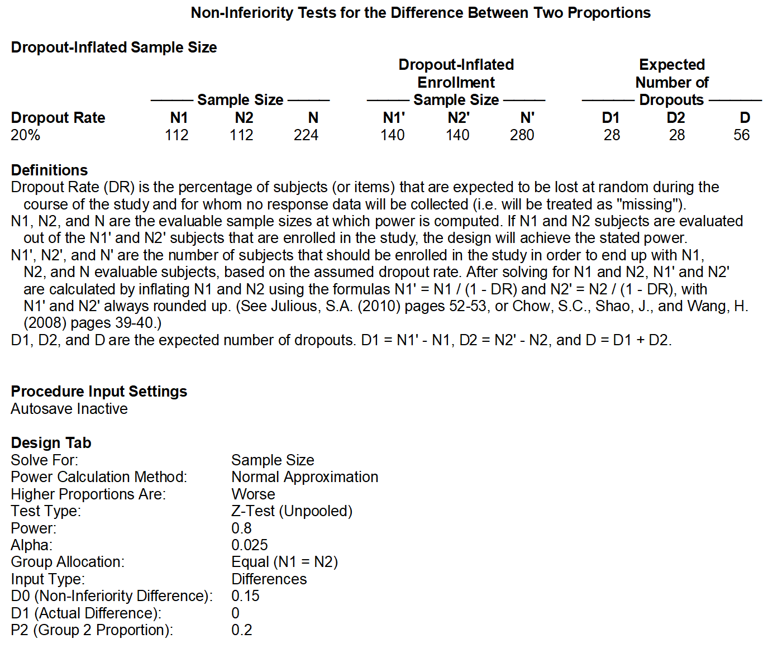
Supplementary Figure 1. Sample size calculated using PASS 11

