Supplementary Material

UV-curable polyurethane-based, halogen-free, CaB₄O₇ nanoparticles decorated, flexible flame-retardant films
Aslı Beyler-Çiğil^{1,2}, Yusuf Samet Aytekin², Özde Ceren Hızal², Ayşen Yılmaz², Okan Esentürk^{2,3,*}

Figure S1. FTIR spectra of UV-curable films

Figure S2. The thermal properties of the UV-curable films

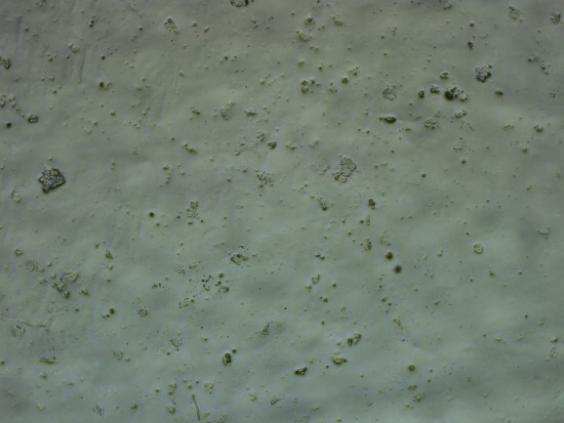  PLU-60PSi | 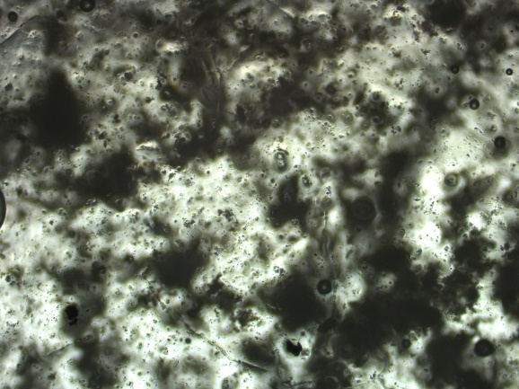  PLU-60PSi-5NP
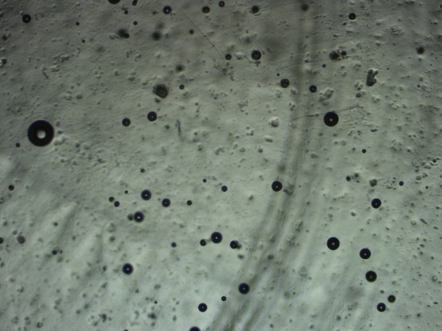  PLU | 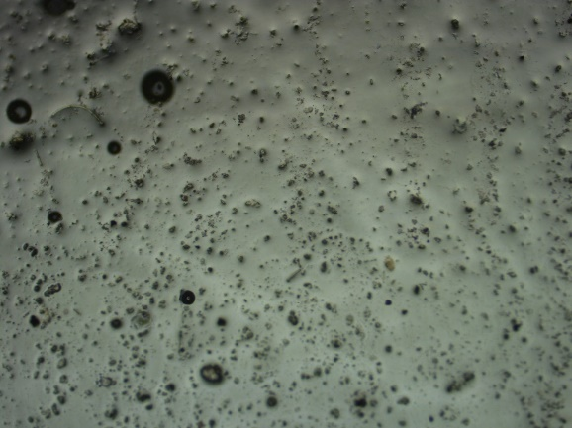  PLU-20PSi
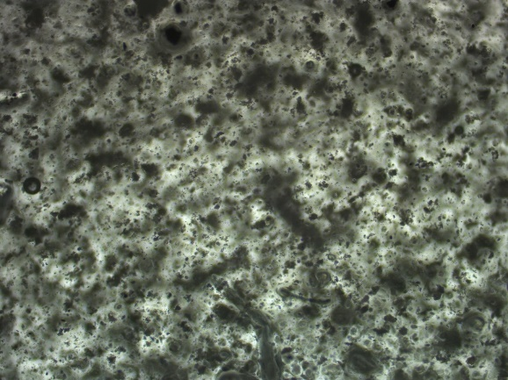  PLU-20PSi-5NP | 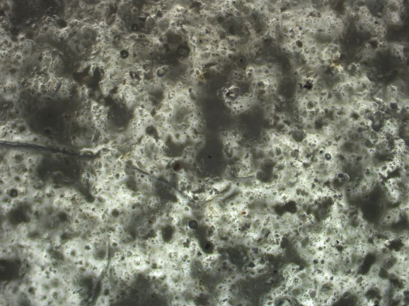  PLU-20PSi-10NP
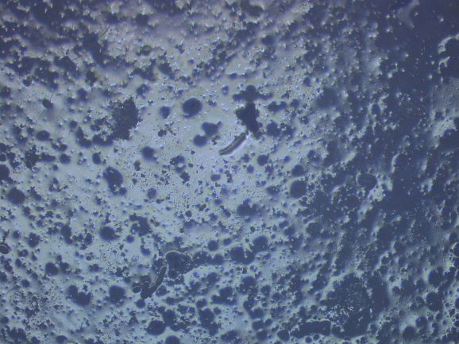  PLU-60Si-10NP | 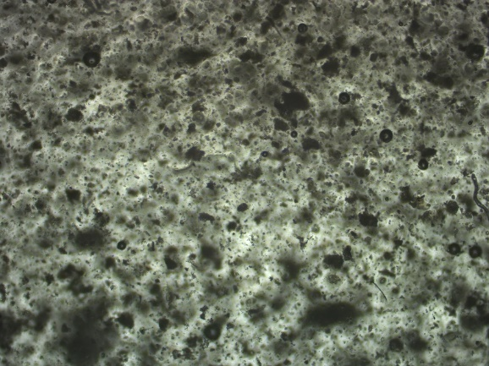  PLU-40PSi-5NP
Figure S3. Images from an optical microscope of UV-curable films

Figure S4. a) Time domain signal profile, b) Fast Fourier transform (FFT) of the time domain signal; for the reference; air (black) and PLU film (red)

