Supplementary Table 1: Unadjusted and adjusted odds ratios of survival
 | Unadjusted odds ratio  (95% CI*) | Adjusted odds ratio  (95% CI) | p value
Age | 0.98 (0.97, 0.99) | 0.98 (0.97, 0.99) | < 0.001
Male | 0.76 (0.57, 1.02) | 0.66 (0.48, 0.91) | < 0.001
Night-time occurrence | 0.87 (0.65, 1.17) | 0.85 (0.62, 1.17) | 0.32
Witnessed cardiac arrest | 1.50 (1.13, 1.99) | 1.40 (1.03, 1.92) | 0.032
Bystander CPR† | 1.24 (0.99, 1.56) | 1.09 (0.86, 1.40) | 0.47
Initial shockable cardiac rhythm | 2.85 (1.05, 3.96) | 2.32 (1.75, 3.10) | < 0.001
Estimated low flow time | 0.98 (0.97, 0.98) | 0.98 (0.97, 0.98) | < 0.001
*CI, confidence interval; †CPR, cardiopulmonary resuscitation.

Supplementary Table 1. Unadjusted and adjusted odds ratios of survival.
This table shows the associations between individual confounders and survival, as indicated by unadjusted and adjusted adds ratios.

Supplementary Table 2. Unadjusted and adjusted odds ratios of favorable neurological outcomes
 | Unadjusted odds ratio  (95% CI*) | Adjusted odds ratio  (95% CI) | p value
Age | 0.98 (0.97, 0.99) | 0.98 (0.97, 0.99) | < 0.001
Male | 0.69 (0.49, 0.99) | 0.61 (0.42, 0.90) | 0.012
Night-time occurrence | 1.02 (0.71, 1.47) | 0.94 (0.63, 1.39) | 0.74
Witnessed cardiac arrest | 1.85 (1.24, 2.76) | 1.49 (0.97, 2.27) | 0.067
Bystander CPR† | 1.95 (1.44, 2.65) | 1.77 (1.28, 2.45) | < 0.001
Initial shockable cardiac rhythm | 2.11 (1.40, 3.20) | 2.39 (1.64, 3.51) | < 0.001
Estimated low-flow time | 0.99 (0.98, 0.99) | 0.99 (0.98, 0.99) | 0.022
*CI, confidence interval; †CPR, cardiopulmonary resuscitation.

Supplementary Table 2. Unadjusted and adjusted odds ratios of favorable neurological outcomes.
This table shows the associations between individual confounders and favorable neurological outcomes, as indicated by unadjusted and adjusted adds ratios.

Supplementary table 3. Unadjusted and adjusted differences in ECMO implementation time
 | Unadjusted odds ratio  (95% CI*) | Adjusted odds ratio  (95% CI) | p value
Night-time occurrence | 6.04 (3.71, 8.37) | 6.02 (3.72, 8.32) | < 0.001
Ultrasound guided cannulation | -0.058 (-2.12, 2.01) | -3.54 (-5.46, -1.62) | < 0.001
Location of ECMO† implementation: ER‡ | -2.34 (-4.19, -0.49) | 1.08 (-1.05, 3.22) | 0.32
*CI, confidence interval; †ECMO, extracorporeal membrane oxygenation; ‡ER, emergency room

Supplementary table 3. Unadjusted and adjusted differences in ECMO implementation time.
This table shows the associations between individual confounders and ECMO implementation time, as indicated by unadjusted and adjusted differences.

Supplementary table 4. Unadjusted and adjusted differences in estimated low flow time
 | Unadjusted difference  (95% CI*) | Adjusted difference  (95% CI) | p value
Night-time occurrence | 6.28 (3.70, 8.87) | 6.14 (3.57, 8.72) | < 0.001
Ultrasound guided cannulation | 0.26 (-2.03, 2.56) | 8.17 (5.21, 11.13) | 0.037
Location of ECMO† implementation: ER‡ | -1.08 (0.99, 1.06) | -2.29 (-4.44, -0.14) | 0.037
*CI, confidence interval; †ECMO, extracorporeal membrane oxygenation; ‡ER, emergency room

Supplementary table 4. Unadjusted and adjusted differences in estimated low flow time.
This table shows the associations between individual confounders and estimated low flow time, as indicated by unadjusted and adjusted differences.

Supplementary table 5. Unadjusted and adjusted odds ratios of complications
 | Unadjusted odds ratio  (95% CI*) | Adjusted odds ratio  (95% CI) | P value
Night-time occurrence | 1.35 (1.00, 1.81) | 1.42 (1.04, 1.96) | 0.030
Ultrasound guided cannulation | 1.21 (0.93, 1.58) | 1.34 (1.01, 1.96) | 0.043
Location of ECMO† implementation: ER‡ | 0.81 (0.63, 1.03) | 0.73 (0.56, 0.96) | 0.024
*CI, confidence interval; †ECMO, extracorporeal membrane oxygenation; ‡ER, emergency room

Supplementary table 5. Unadjusted and adjusted odds ratios of complications.
This table shows the associations between individual confounders and complications related to ECMO cannulation, as indicated by unadjusted and adjusted adds ratios.

Supplementary table 6. Outcomes in each year.
 | Survival to hospital discharge  , n(%) | Favorable neurological outcome  , n(%) | Complications  , n(%) | Total  , n(%)
2013 | 51 (23.9) | 28 (13.1) | 38 (17.6) | 213
2014 | 53 (22.9) | 25 (10.8) | 48 (20.8) | 231
2015 | 63 (26.4) | 30 (12.6) | 52 (21.8) | 239
2016 | 95 (30.5) | 51 (16.4) | 69 (22.2) | 311
2017 | 86 (27.4) | 43 (13.7) | 68 (21.7) | 314
2018 | 99 (29.6) | 54 (16.2) | 71 (21.3) | 334

Supplementary table 6. Outcomes in each year.
This table shows the relationships between the number of patients according to the year of admission, along with the outcomes. As a result, the number of patients increased with the year.

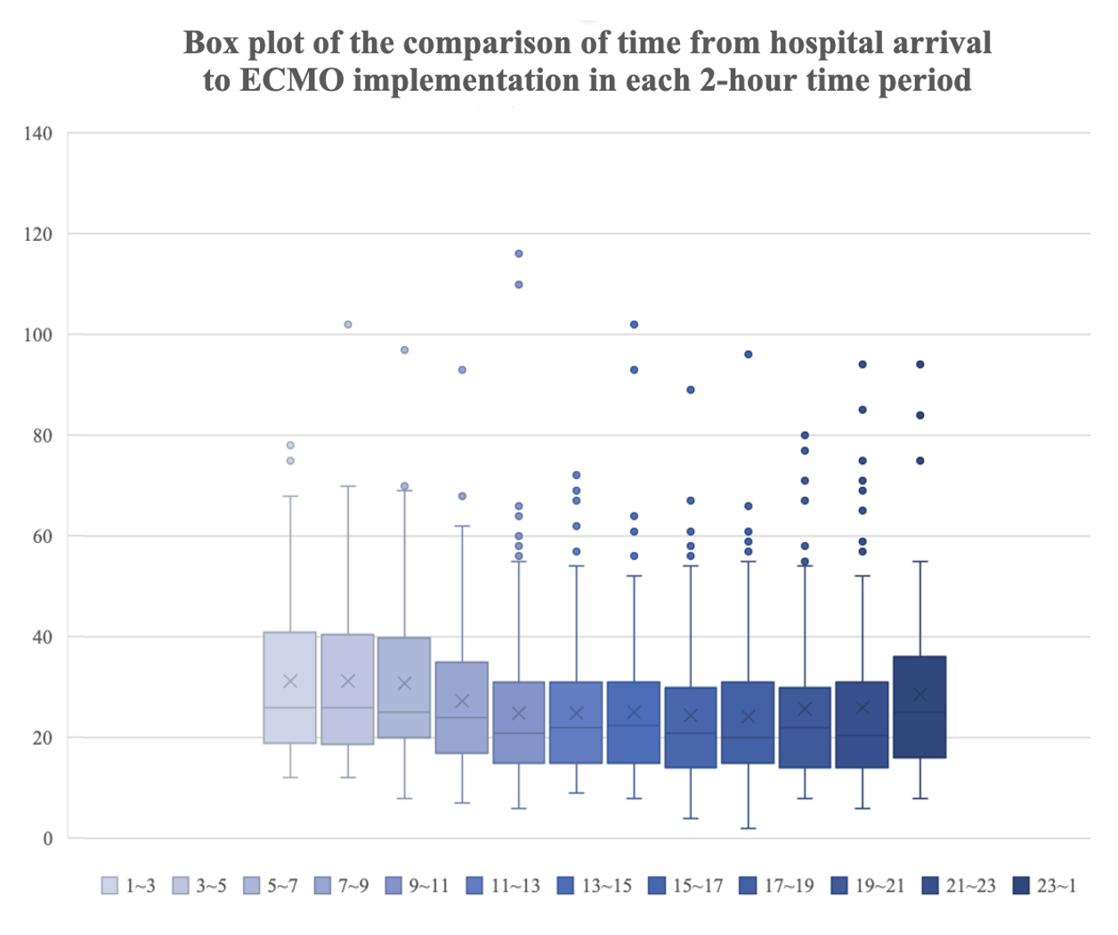

Supplementary figure 1. Box plot showing the comparison of time from hospital arrival to ECMO implementation in each 2-hour time period.
The x-axis shows the 2-hour time period, and the y-axis indicates the time from hospital arrival to ECMO implementation (min). ECMO, extracorporeal membrane oxygenation.

