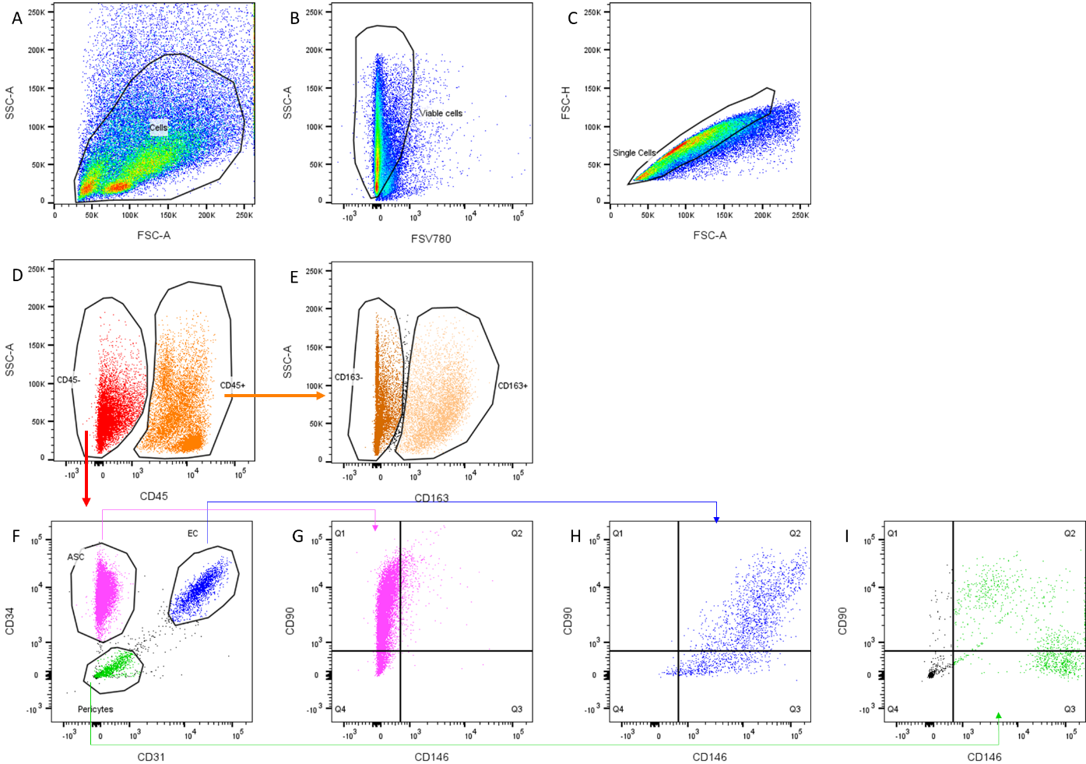
Supplementary data 2 -Gating strategy stromal vascular fraction cells. (A) Forward scatter versus side scatter, (B) viable cells determined with FVS780 exclusion dye, (C) singlet cells selection. (D) immune (CD45+) and non immune (CD45-) cells were identified, (E) among CD45+ cells, resident and M2 macrophages were identified with CD163+ staining. (F) among CD45- cells, 3 populations were identified as ASC (CD31- CD34+) (G), endothelial cells (CD31+ CD34+) (H) and (G) pericytes (CD146+) (I).

