Supplementary information
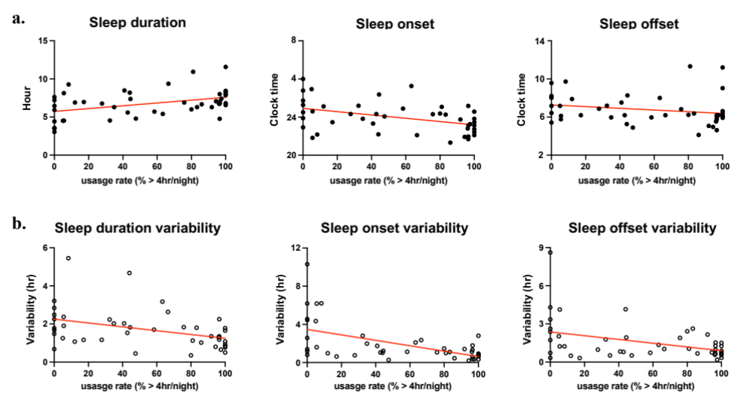
Figure S1. Correlations between CPAP adherence and sleep-wake rhythms and their variability
Correlation between CPAP usage rate and sleep-wake rhythm parameters; sleep duration, sleep onset, and sleep offset (a), and their variabilities (b). r; Spearman's rank correlation coefficient.

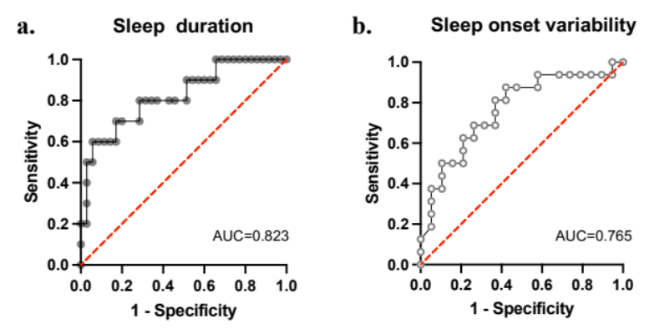
Figure S2. ROC curves for sleep-wake rhythm to predict CPAP withdrawal and poor adherence
The ROC curve for sleep duration showed that the cut-off value for predicting CPAP withdrawal was 4.8 hr, with a sensitivity and specificity of 60.0 % and 94.3 %, respectively (a). The ROC curve for sleep onset variability for predicting CPAP poor adherence showed that a cut-off value of 9.5 hr, with a sensitivity of 87.5 % and a specificity of 57.9 % (b).

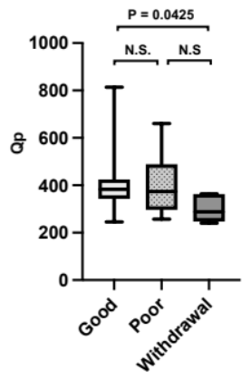
Figure S3. Regularity and/or amplitude of behavior rhythms
The maximum Qp level in behavior rhythm showed significant differences among the 3 groups (P=0.0370). The withdrawal group showed a lower Qp level compared to the good adherence group, indicating lower regularity and/or amplitude (P=0.0425). Median (IQR); Kruskal-Wallis post-hoc with Dunn‘s multiple comparisons test.

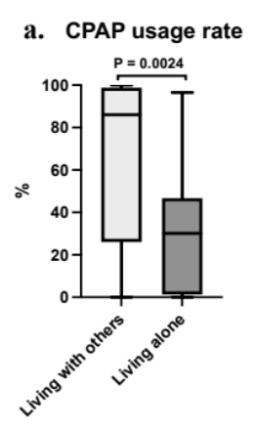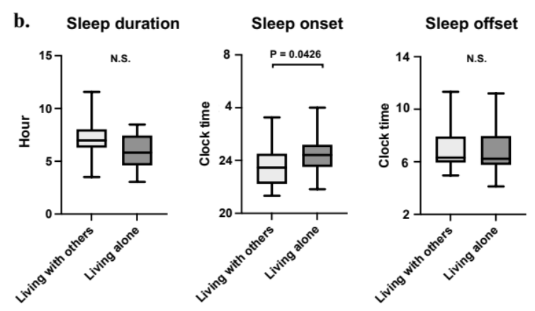
Figure S4. Lifestyle and CPAP adherence, sleep-wake rhythm
Patients living alone showed poorer CPAP adherence (a) with later sleep onset (b) compared to those living with others (P=0.0024, 0.0426, respectively). Median (IQR); Mann Whitney test.

