Additional information

Supplementary Information
Fig S I Study design
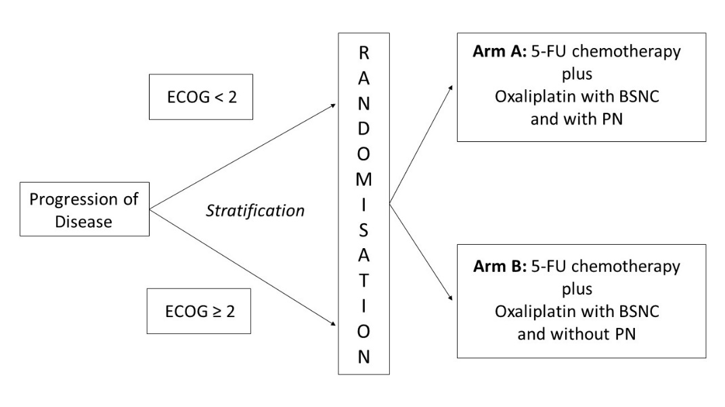

Tab S I stopping criteria of both arms were met if two of the following three criteria were present:
Weight loss | > 2 % within the last seven days or caloric intake ≤ 500 kcal expected within the next five days
Bio impedance analysis (BIA) phase angle and body cell mass (BCM) | with a deterioration > 10 % (in both parameters) compared to baseline assessment
PINI-index | > 10 (only in patients with no sign of acute inflammation).

Fig S II QLQ C30 correlation between change in protein intake (g/kg BW) and change in social functioning
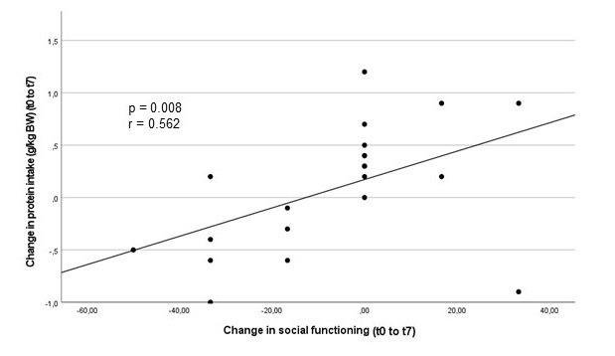

Fig S III QLQ C30 correlation between change in caloric intake and change in role functioning

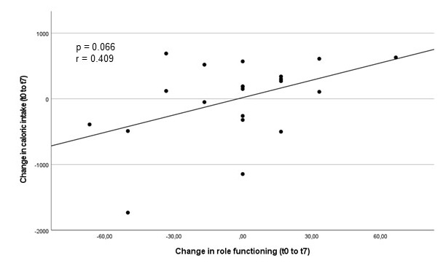
Fig S IV QLQ PAN26 correlations between change in protein intake (g/kg BW) and 1) change in planning of activities 2) change in digestive symptoms 3) change in satisfaction with health care 4) change in troubled with side-effects
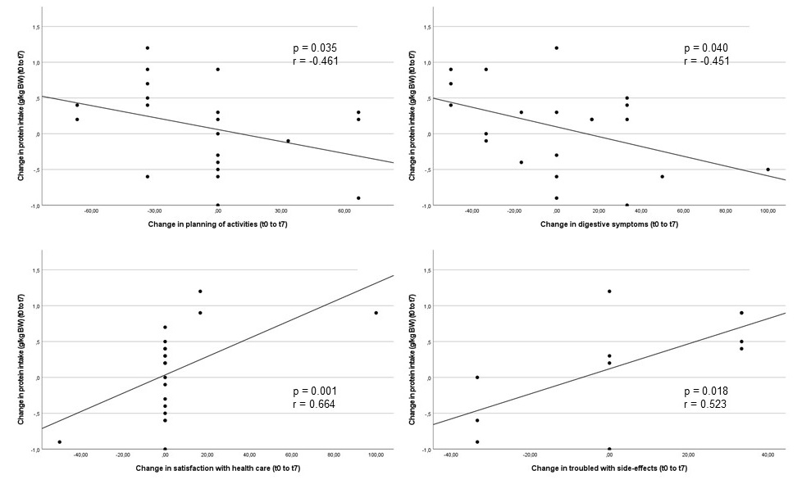
Fig S V QLQ PAN26 correlations between change in caloric intake and 1) change in planning of activities 2) change in flatulence
