Appendix1 Measured value in Steller sealion (mm)
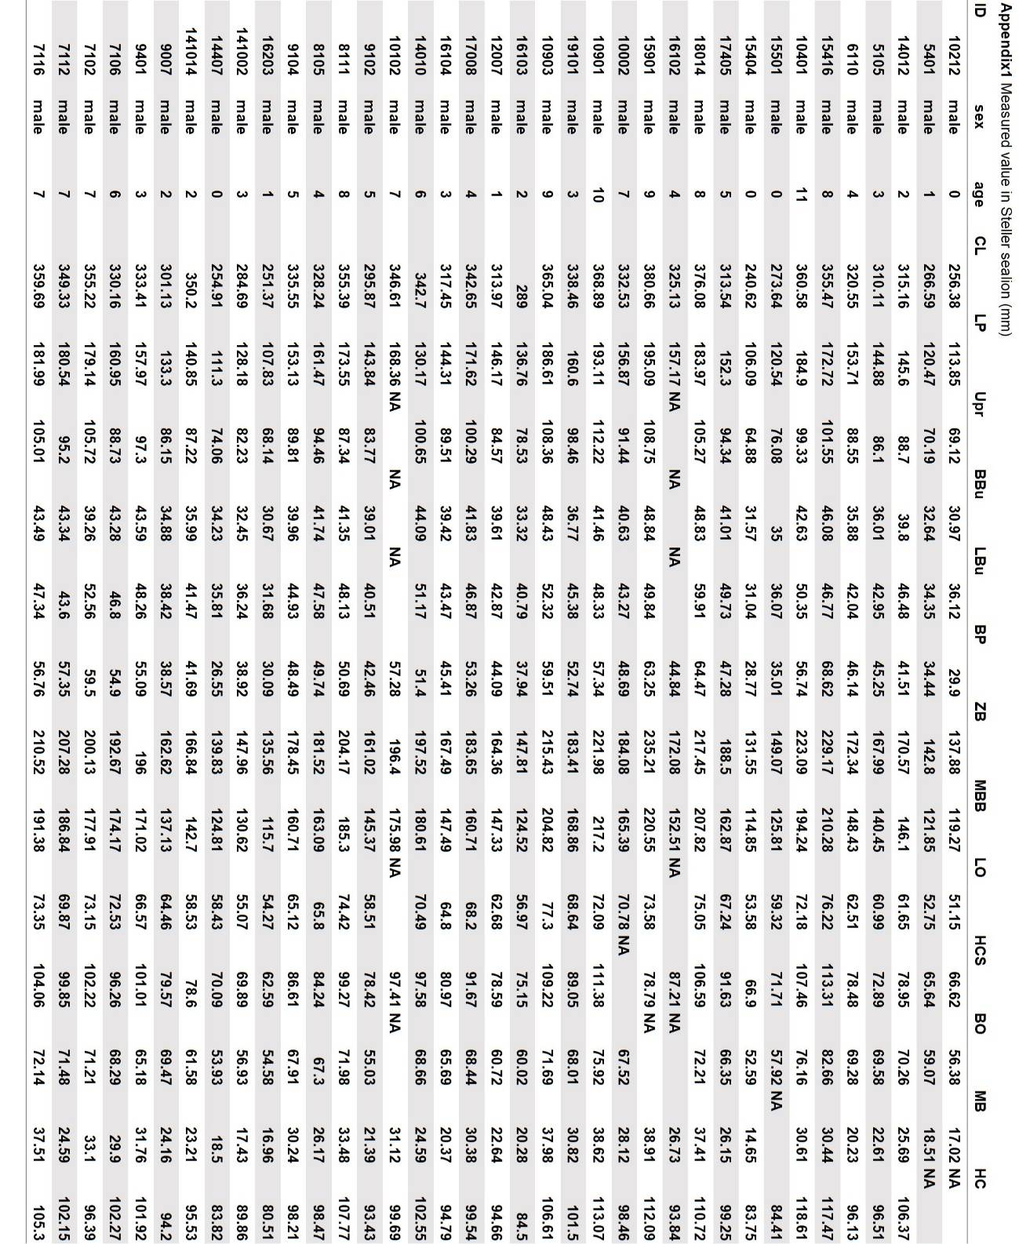

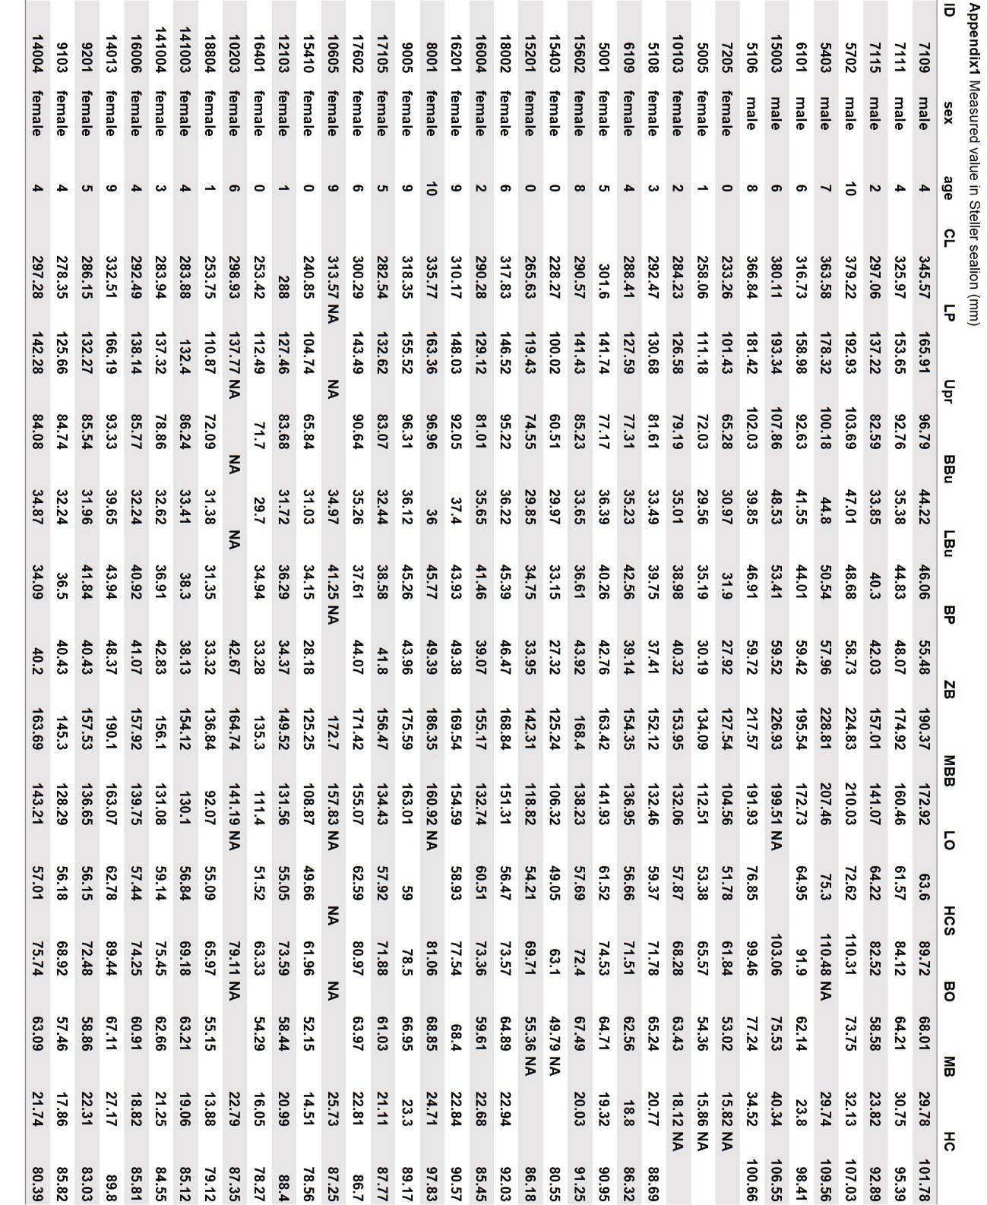

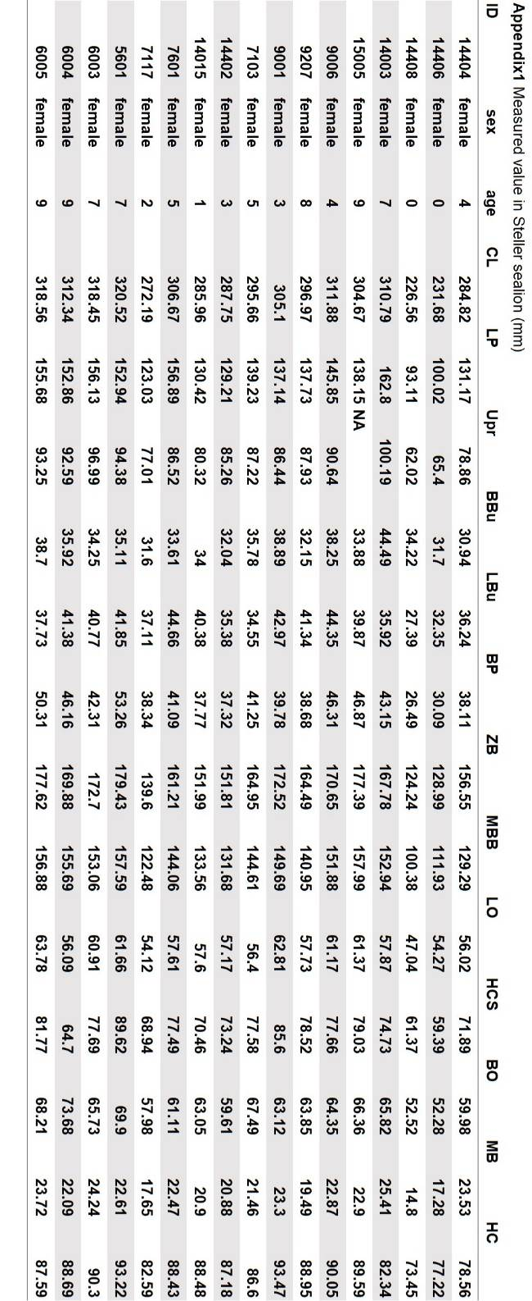
Appendix2 Measured value in Brown bear (mm)
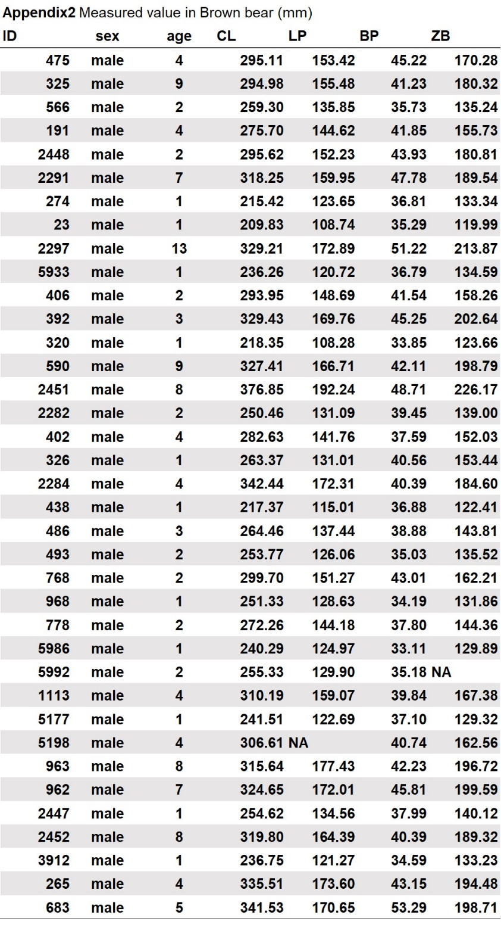
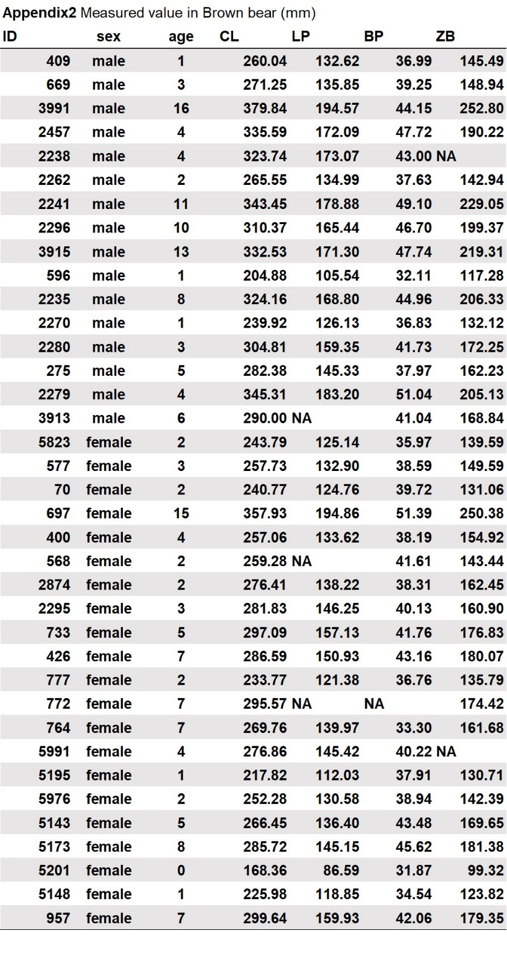

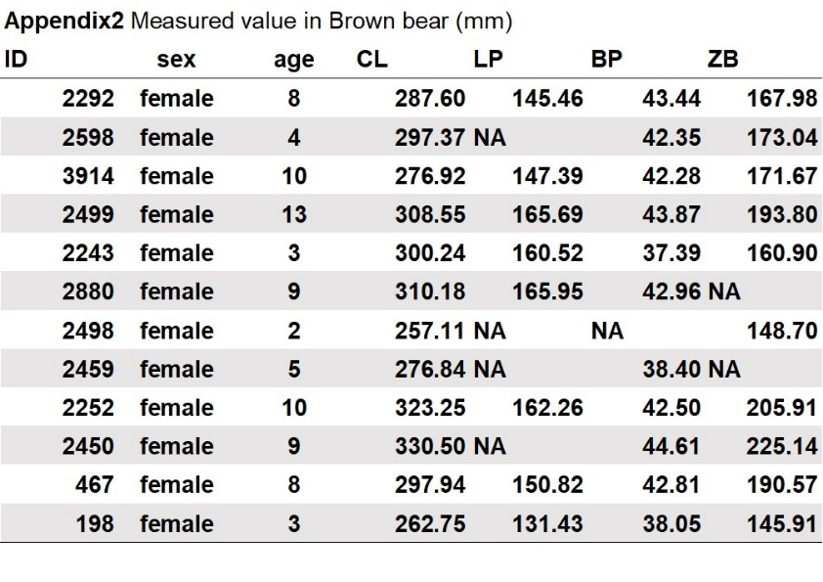

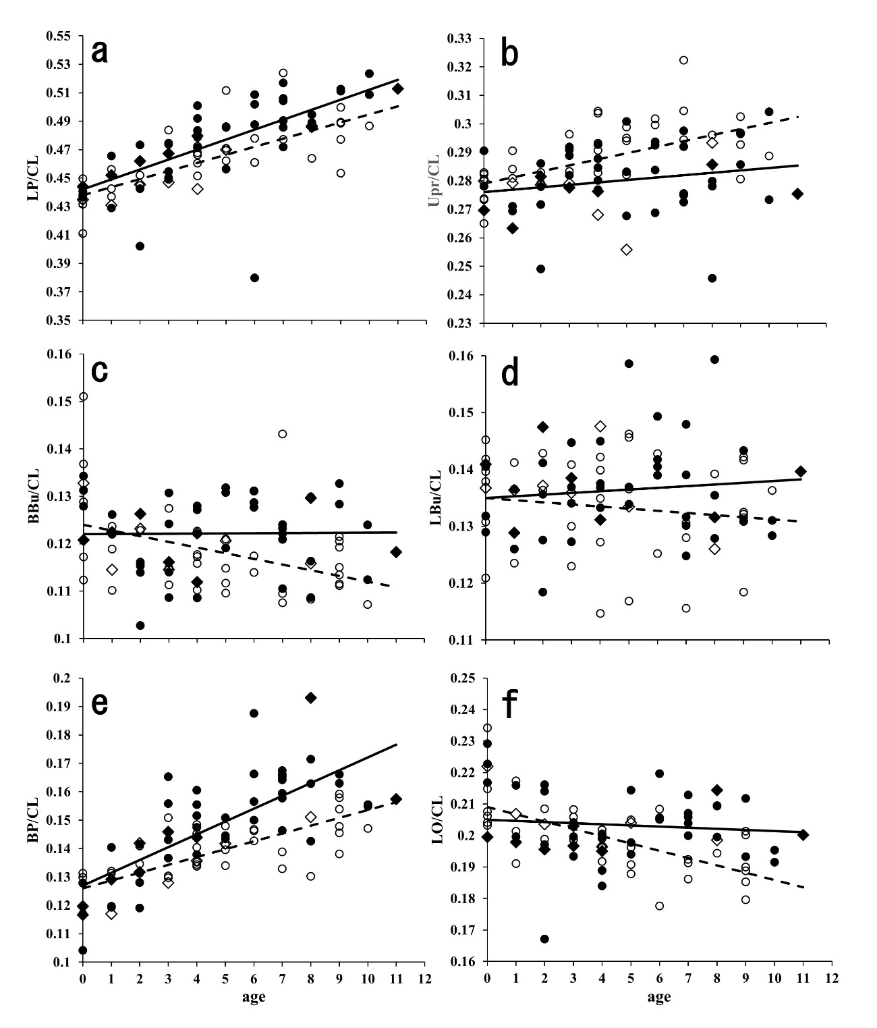
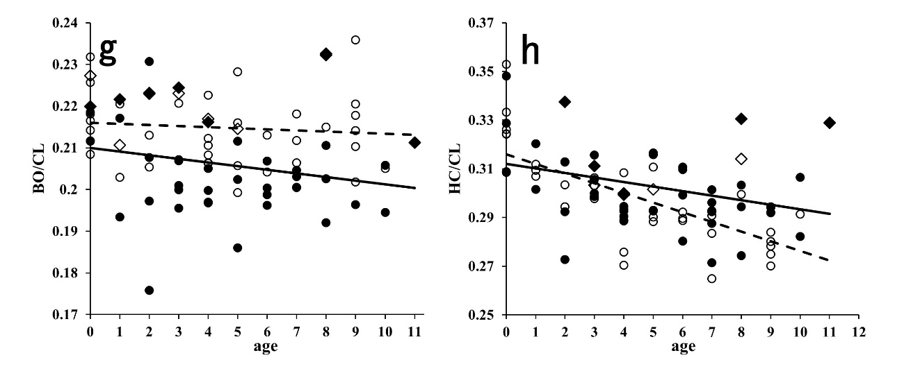

Appendix 3 Changes in measurements relative to cranial length with age in Steller sea lions. a: length of palate, b: length of upper postcanine row c: breadth of auditory bulla, d: length of auditory bulla, e: length of orbit, f: breadth of orbit, g: height of cranium. 〇: female (age-estimated individuals), ●: male (age-estimated individuals), ◇: female (branding-marked individuals), ◆: male (branding-marked) individuals). Solid and dotted lines indicate linear regression curves for males and females, respectively.
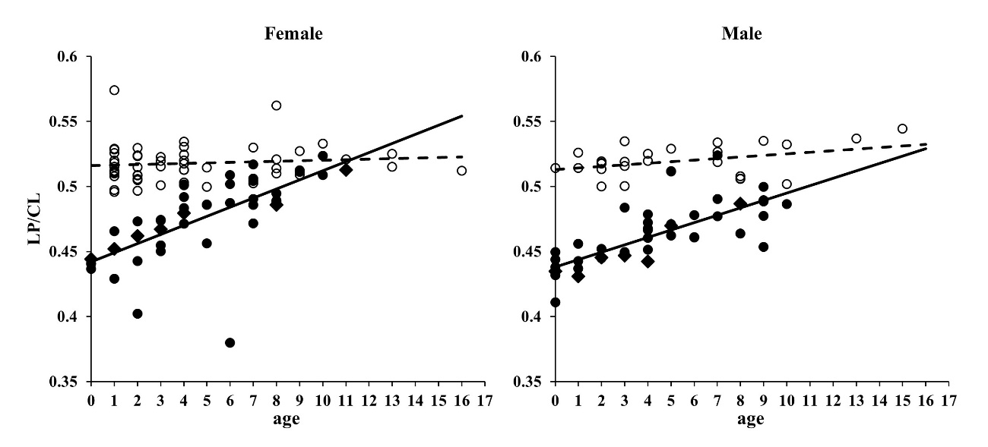

Appendix 4 Changes in measurements relative to cranial length with age. length of palate. ●: Steller sea lion (age-estimated individuals), 〇: Brown bear, ◆: Steller sea lion (branding-marked individuals). Solid and dotted lines indicate linear regression curves for the Steller sea lion and brown bear, respectively.

