Effect of Tb³⁺ and Ce³⁺ co-doping on the structural stability and photoluminescence properties of hexagonal boron nitride phosphors
Lunshuai Nie ª, Kai Jia ª, Hongguang Guo ^{b}, Jiaqin He ª, Zhehui Weng ^{b}, Yizhou Li ^{b}, Haidong Ju ^{b, c, d,} *
ª College of Physics Science and Technology, Kunming University, Kunming 650214, China
^{b} School of Chemistry and Chemical Engineering, Kunming University, Kunming 650214, China
^{c} Yunnan Key Laboratory of Metal-Organic Molecular Materials and Device , Kunming University, Kunming 650214, China
^{d} Yunnan Engineering Technology Research Center for Plastic Films, Kunming University, Kunming 650214, China

Supporting Information

Fig. S1. X-ray diffraction spectra of h-BN doped with various Tb³⁺ concentrations

Fig. S2. X-ray diffraction spectra of h-BN doped with various Ce³⁺ concentrations

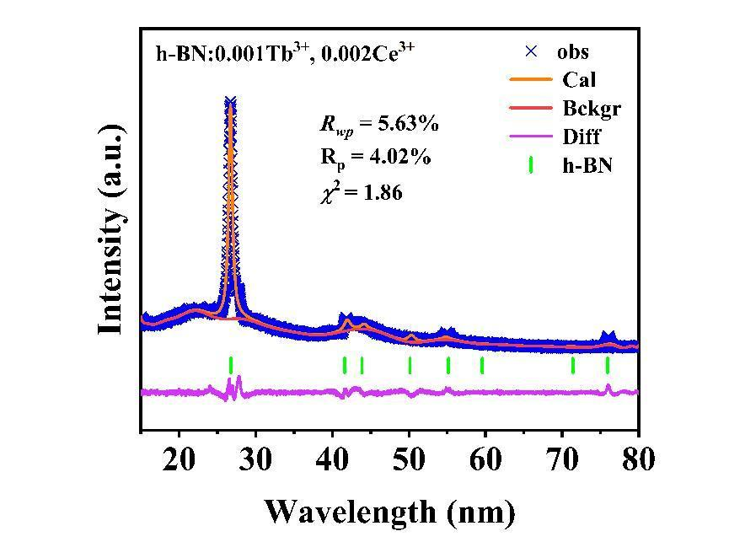
Fig.S3. Structural refinement diffraction spectrum of h-BN:0.001Tb³⁺, 0.002Ce³⁺ sample
Fig. S4. Emission spectra of h-BN substrate, h-BN:Tb³⁺ and h-BN:Tb³⁺, Ce³⁺ samples
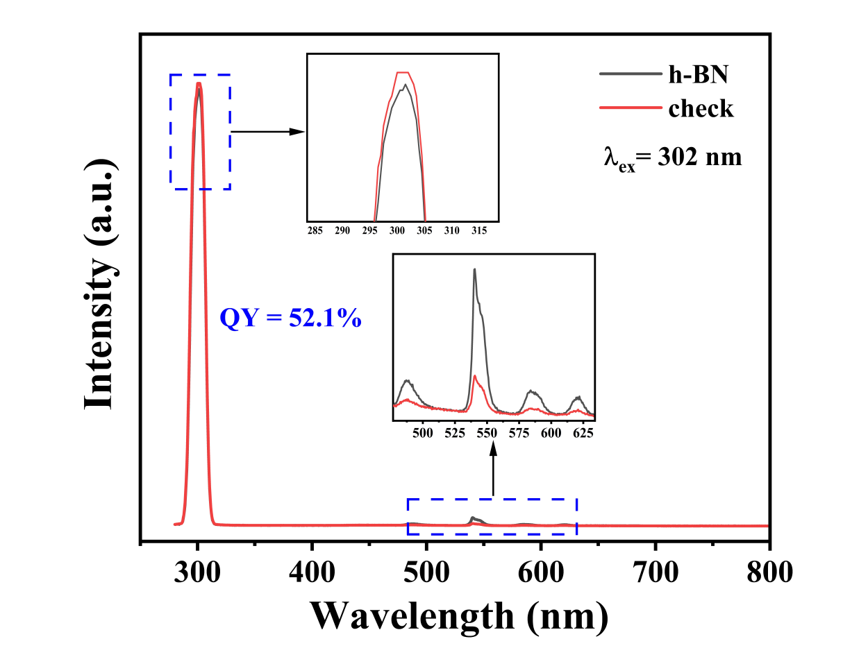
Fig. S5. Photoluminescence quantum yield spectrum of h-BN:0.025Tb³⁺, 0.050Ce³⁺ phosphor

Corresponding author. Tel.: +86 871 65098621. E-mail addresses: hdju1977@outlook.com (H. Ju).

