Supplementary Materials

Mi Jin Kim^{*a}, Hyunil Shin^{* a}, Hwan Seong Choi ª, Nam Sook Kim ª, Ji Hyun Lee ª, Jang Duck Choi ª
ªCenter for Advanced Analysis, Division of Advanced Analysis, National Institute of Food and Drug Safety Evaluation, Ministry of Food and Drug Safety, Osong Health Technology Administration Complex, 187 Osongsaengmyeong2-ro, Osongeup, Heungdeok-gu, Cheongju-si, Chungcheongbuk-do 363-700, Republic of Korea
* Corresponding author: Jang Deok Choi; email address: cjd5388@korea.kr

* These authors contributed equally to this article.

(a) | 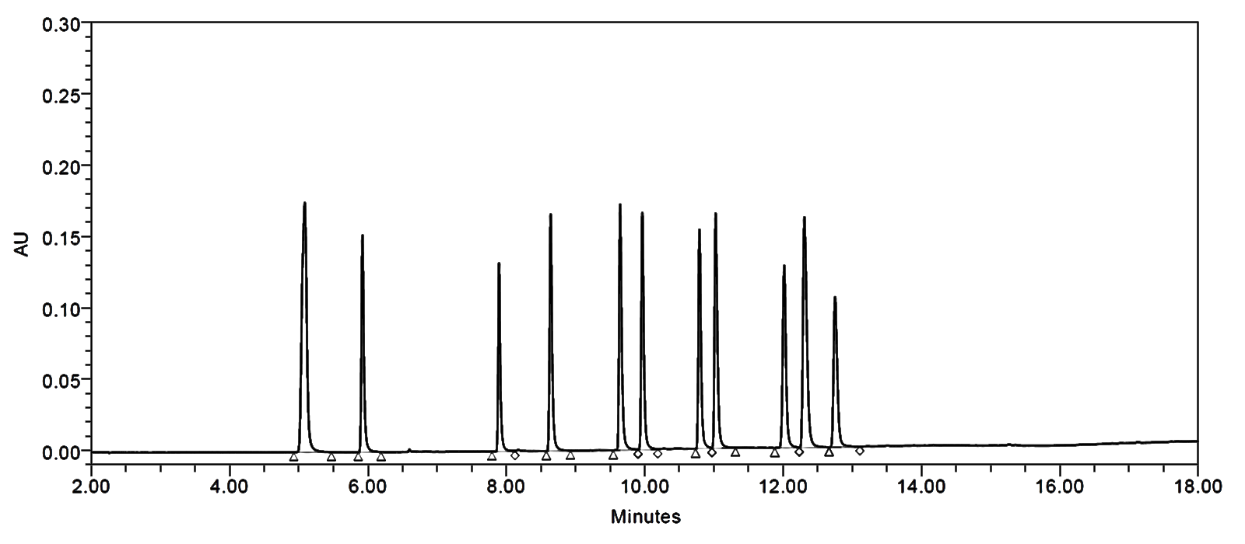  BEH C₁₈ Column
(b) | 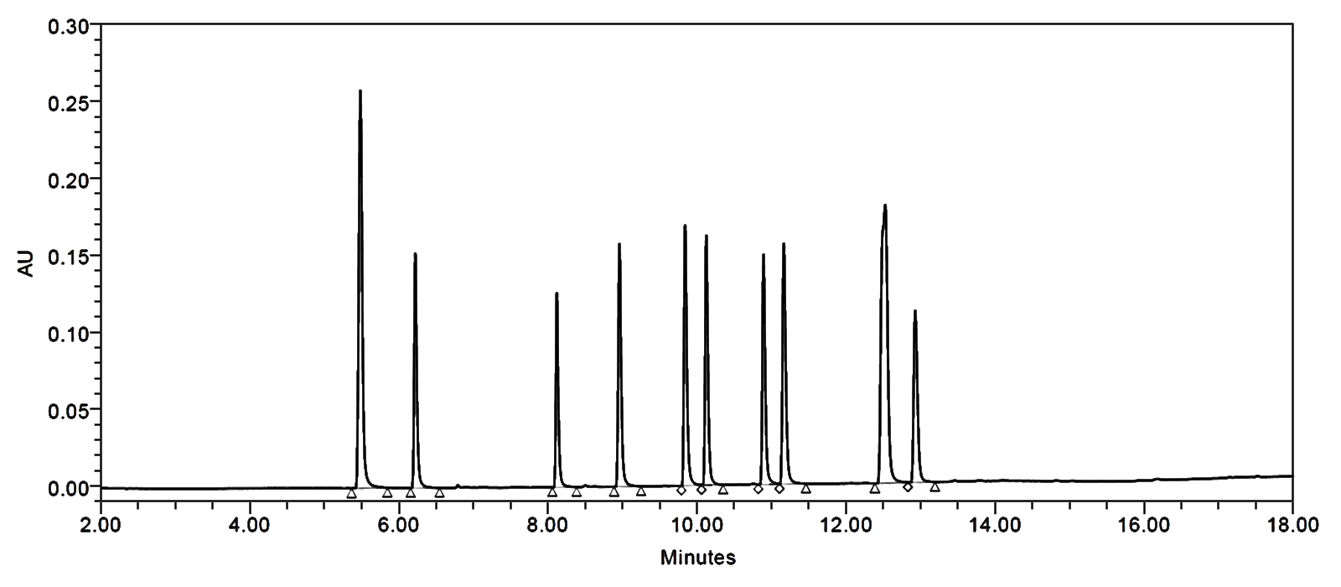  HSS C₁₈ Column
Figure S1. Chromatograms for the comparison of two columns.

(a) | A: 0.5 mM Sodium 1-hexanesulfonate (0.1% H₃PO₄, pH 2.11]  B: 90% ACN
(b) | 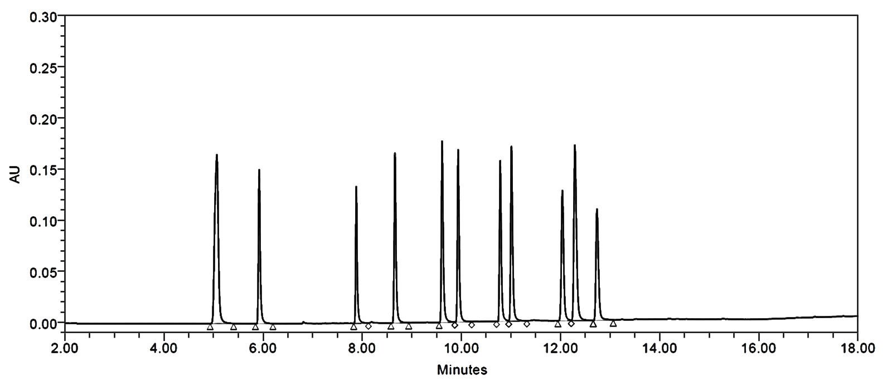  A: 0.5 mM Sodium 1-hexanesulfonate (0.2% H₃PO₄, pH 1.93]  B: 90% ACN
(c) | 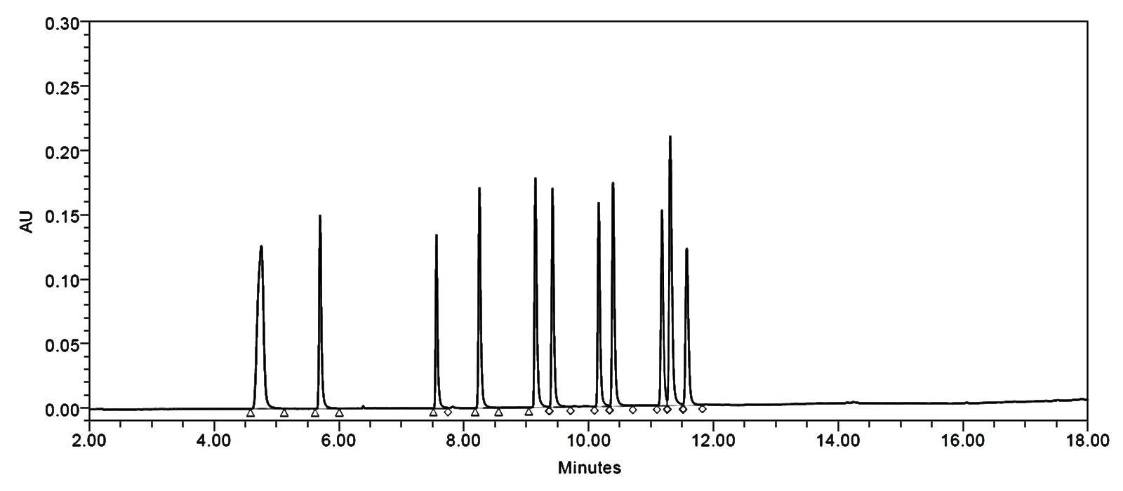  A: 0.5 mM Sodium 1-hexanesulfonate (0.1% H₃PO₄, pH 2.11]  B: 100% ACN
Figure S2. Chromatograms for the comparison of mobile phases.

(a) | 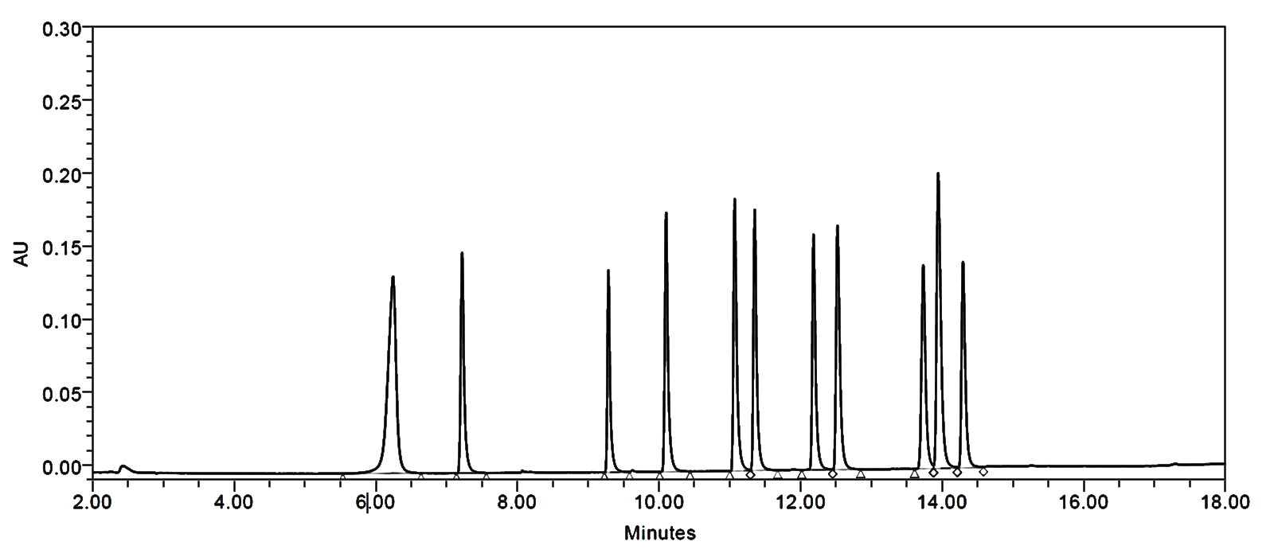
(b) | Flow rate: 0.20 ml/min  Flow rate: 0.15 ml/min
(c) | 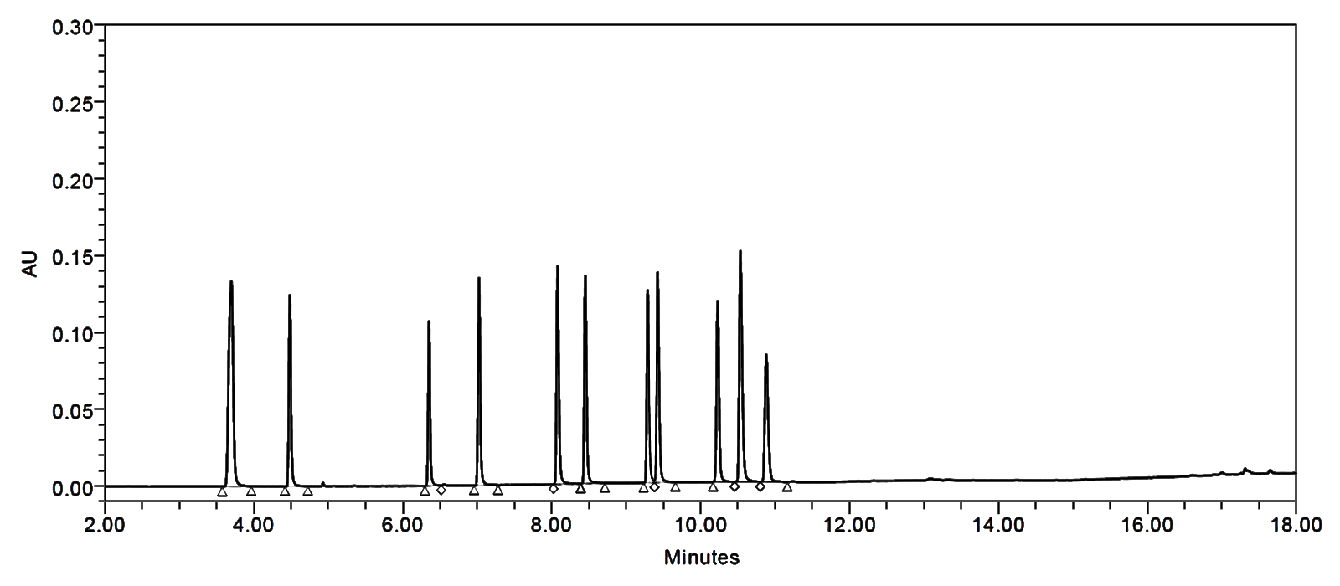  Flow rate: 0.30 ml/min

Figure S3. Chromatograms for the comparison of three flow rate.

(a) | 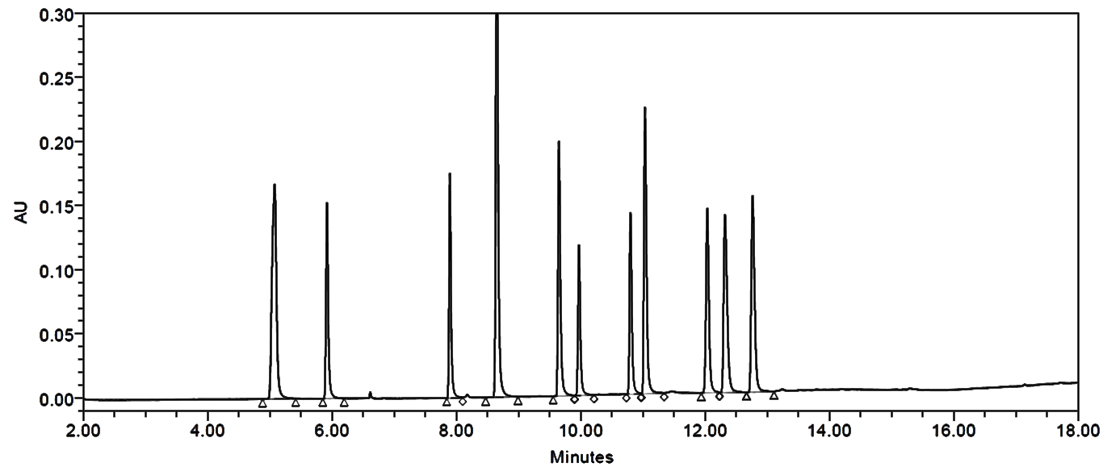  Wavelength: 200nm
(b) | Wavelength: 205nm
(c) | 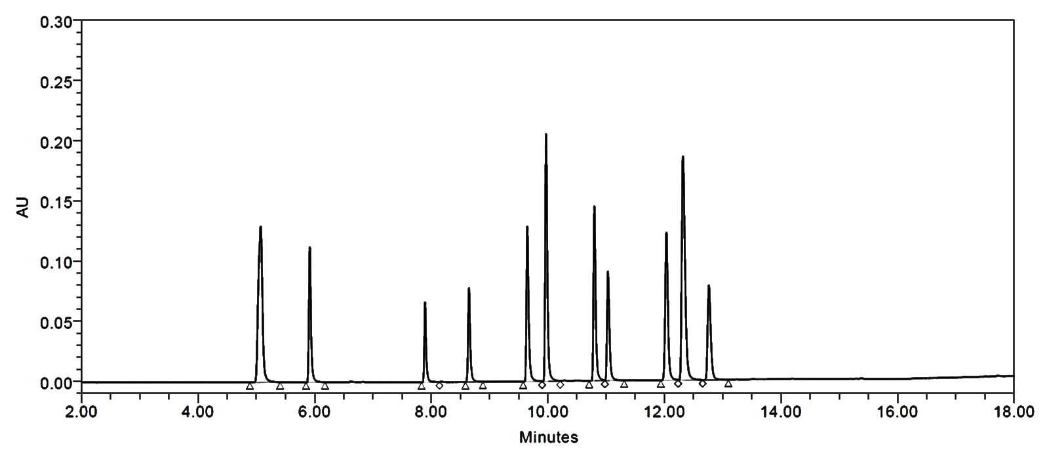  Wavelength: 210nm

Figure S4. Chromatograms for the comparison of different wavelength.

(a) | 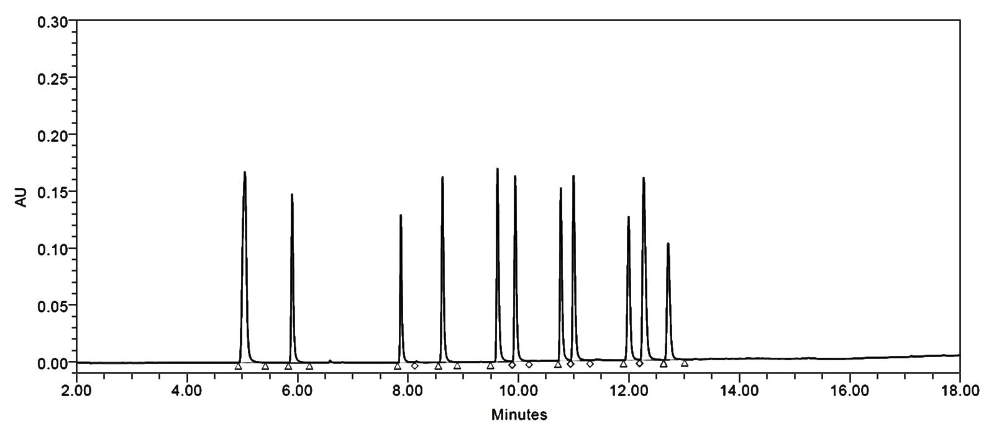  Column Temp: 35℃
(b) | 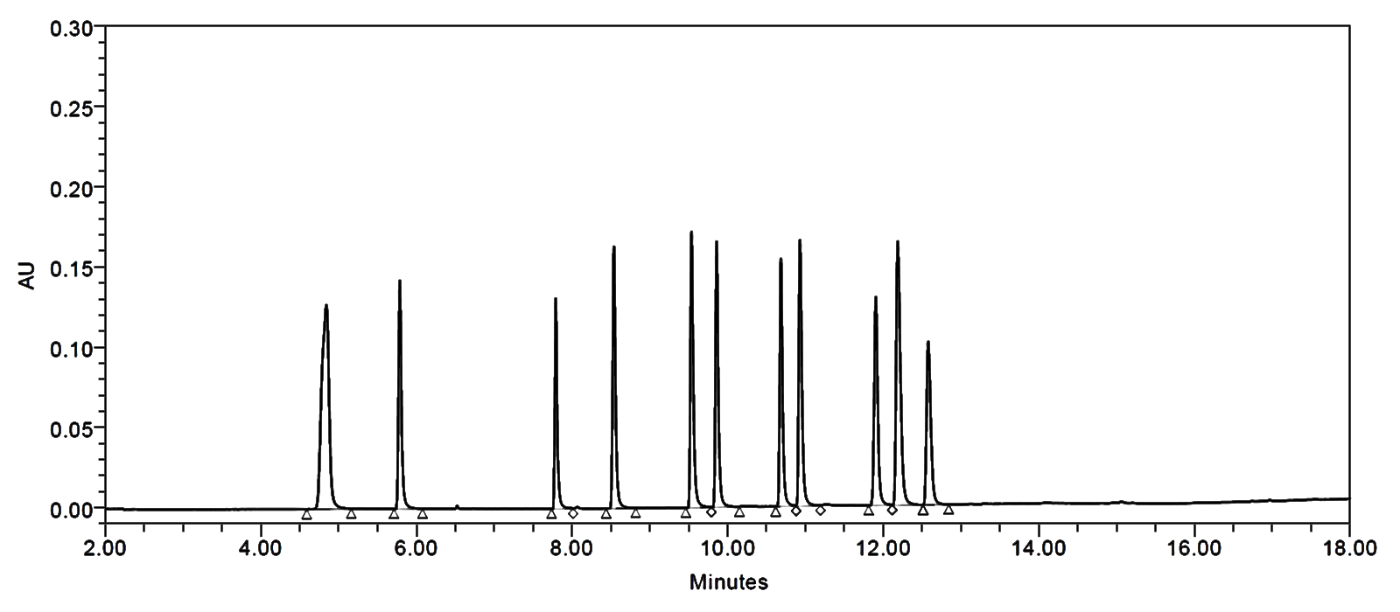  Column Temp: 40℃
Figure S5. Chromatograms for the comparison of two column temperatures.

(a) | 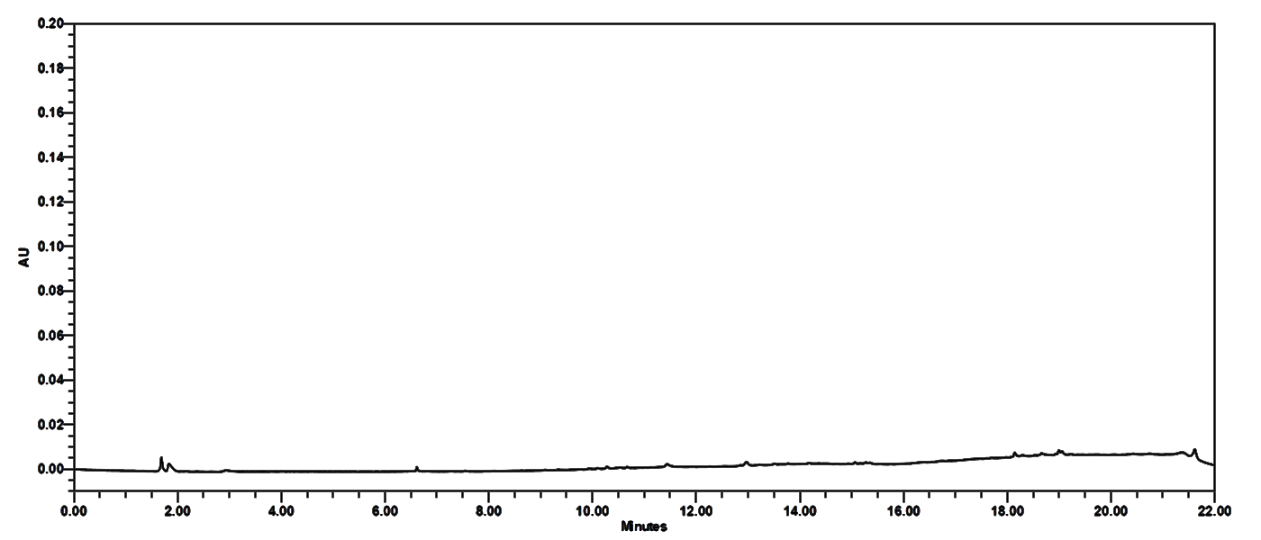
(b) | 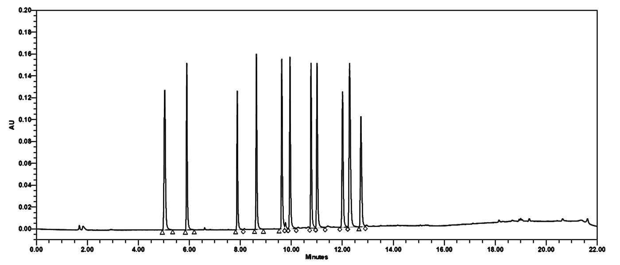
(c) | 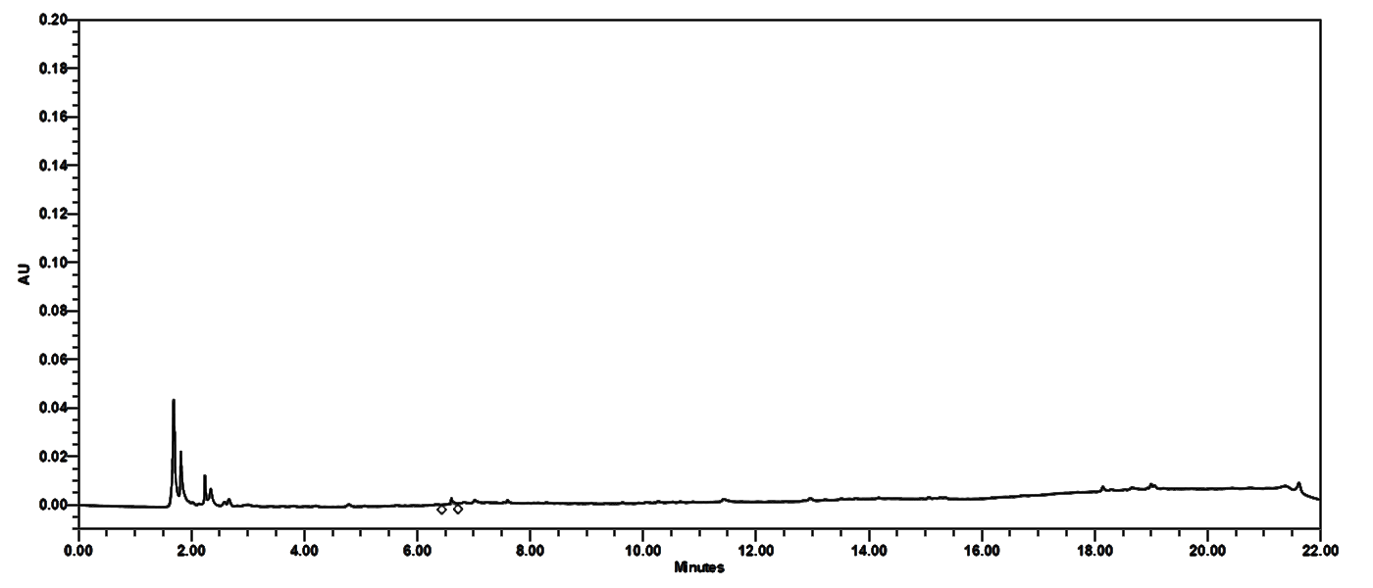
(d) | 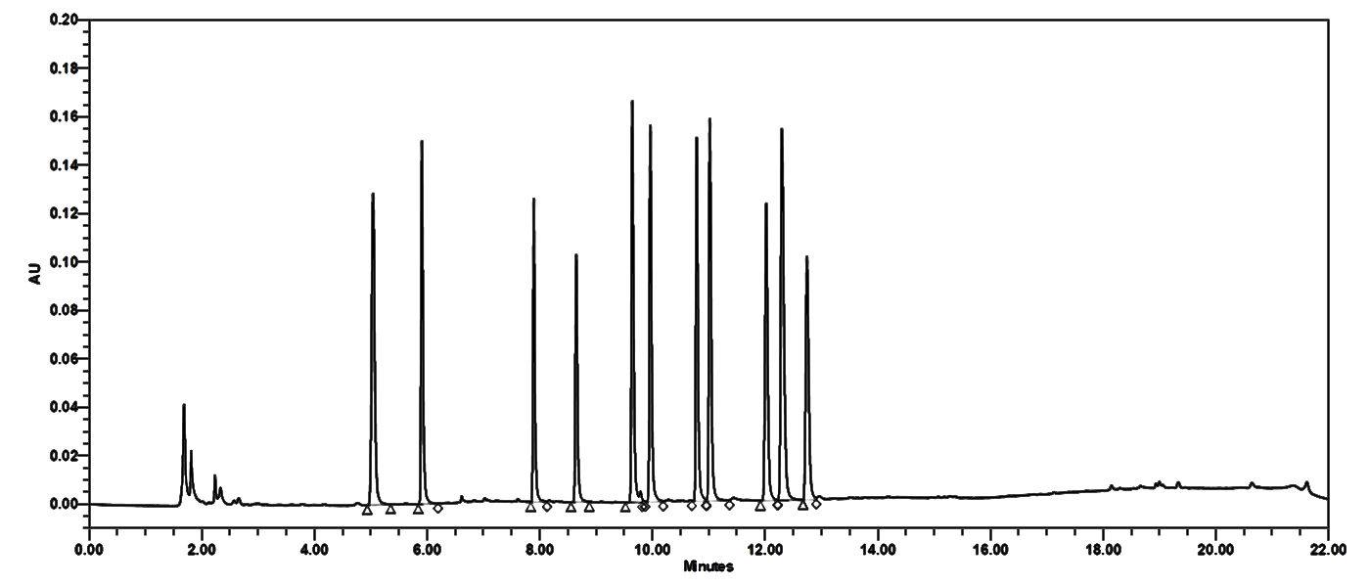
Figure S6. Chromatograms of 11 respiratory related pharmaceutical compounds: (a) solid blank sample, (b) solid blank sample spiked with 11 respiratory related compounds, (c) liquid blank sample, (d) liquid blank sample spiked with 11 respiratory related compounds.

Table S1. The recovery of 11 respiratory related compounds in solid and liquid blank sample (n=3)
No. | Analytes | Recovery (extracted 70% Methanol)
No. | Analytes | Solid blank sample |  | Liquid blank sample
No. | Analytes | Mean(%) | ± SD | Mean(%) | ± SD
1 | Theobromine | 99.3 | 0.25 | 97.47 | 0.89
2 | Theophylline | 102.97 | 0.42 | 98.51 | 0.9
3 | Dropropizine | 97.39 | 1.09 | 96.11 | 0.66
4 | Guaifenesin | 98.49 | 0.58 | 95.84 | 0.77
5 | Tramazoline | 97.33 | 1.34 | 90.25 | 2.61
6 | Noscapine | 96.54 | 0.85 | 97.17 | 0.08
7 | Olopatadine | 99.31 | 0.53 | 96.94 | 0.56
8 | Oxymetazoline | 97.44 | 0.43 | 91.51 | 0.22
9 | Dexamethasone | 98.74 | 0.63 | 98.65 | 0.32
10 | Azelastine | 97.49 | 0.99 | 92.7 | 0.81
11 | Fexofenadine | 98.73 | 0.88 | 98 | 1.1

Table S2. Determinated limit of detection(LOD) and limit of quantitation(LOQ) of 11 respiratory related pharmaceutical compounds in solid and liquid blank sample by UPLC-PDA
No | Compounds | LOD (μg/mL) |  | LOQ (μg/mL)
No | Compounds | Solid | Liquid | Solid | Liquid
1 | Theobromine | 0.40 | 0.40 | 1.20 | 1.20
2 | Theophylline | 0.30 | 0.30 | 0.90 | 0.90
3 | Dropropizine | 0.40 | 0.40 | 1.20 | 1.20
4 | Guaifenesin | 0.60 | 0.40 | 1.80 | 1.20
5 | Tramazoline | 0.40 | 0.40 | 1.20 | 1.20
6 | Noscapine | 0.40 | 0.40 | 1.20 | 1.20
7 | Olopatadine | 0.40 | 0.40 | 1.20 | 1.20
`8 | Oxymetazoline | 0.40 | 0.40 | 1.20 | 1.20
9 | Dexamethasone | 3.00 | 3.00 | 9.0 | 9.00
10 | Azelsatine | 0.60 | 0.60 | 1.80 | 1.80
11 | Fexofenadine | 0.80 | 0.80 | 2.40 | 2.40

No | Compounds | Solid blank samples |  |  | Liquid blank samples
No | Compounds | Calibration curve | Linear range  (μg/mL) | R² |  | Calibration curve | Linear range  (μg/mL) | R²
1 | Theobromine | y=42003.4x-2626.9 | 1.20-48.00 | 1.0000 |  | y=41365x+2273.7 | 1.20-48.00 | 1.0000
2 | Theophylline | y=40901.1x-2227 | 0.90-36.00 | 1.0000 |  | y=40802.8x+4458.3 | 0.90-36.00 | 1.0000
3 | Dropropizine | y=22509.2x-1611.4 | 1.20-48.00 | 1.0000 |  | y=21946.4x+604.5 | 1.20-48.00 | 1.0000
4 | Guaifenesin | y=20637x+976.1 | 1.80-72.00 | 0.9999 |  | y=20231.2x+1083.8 | 1.80-72.00 | 1.0000
5 | Tramazoline | y=35414.9x+1703.6 | 1.20-48.00 | 0.9999 |  | y=34975.9x+3848.1 | 1.20-48.00 | 1.0000
6 | Noscapine | y=34155.1x-924.7 | 1.20-48.00 | 1.0000 |  | y=33491.2x+2936 | 1.20-48.00 | 1.0000
7 | Olopatadine | y=32996.5x-1533.8 | 1.20-48.00 | 1.0000 |  | y=32193.7x+5682.2 | 1.20-48.00 | 1.0000
8 | Oxymetazoline | y=36473.7x-3146.6 | 1.20-48.00 | 1.0000 |  | y=35539.4x-550.2 | 1.20-48.00 | 1.0000
9 | Dexamethasone | y=4482x+1229.8 | 9.00-360.00 | 1.0000 |  | y=4363.9x+4171.7 | 9.00-360.00 | 1.0000
10 | Azelastine | y=32735.3x-5912.1 | 1.80-72.00 | 1.0000 |  | y=31797.3x-298.7 | 1.80-72.00 | 1.0000
11 | Fexofenadine | y=19314.4x-3200 | 2.40-96.00 | 1.0000 |  | y=18967x+2072.1 | 2.40-96.00 | 1.0000
Table S3. Linearity at different six concentrations for 11 respiratory related pharmaceutical compounds spiked in solid and liquid blank samples by UPLC-PDA (n=3)

Table S4. Result of recoveries of 11 respiratory related pharmaceutical compounds spiked in solid and liquid samples (n=3)
No. | Compound | Solid samples |  |  |  |  |  | Liquid samples
No. | Compound | Low(LOQ) |  | Medium(20LOQ) |  | High(40LOQ) |  | Low(LOQ) |  | Medium(20LOQ) |  | High(40LOQ)
No. | Compound | Mean  (%) | ± SD | Mean  (%) | ± SD | Mean  (%) | ± SD | Mean  (%) | ± SD | Mean  (%) | ± SD | Mean  (%) | ± SD
1 | Theobromine | 88.82 | 0.63 | 94.47 | 0.61 | 96.56 | 1.22 | 91.85 | 2.23 | 99.05 | 0.72 | 98.29 | 1.74
2 | Theophylline | 90.67 | 0.92 | 95.70 | 0.63 | 97.78 | 1.14 | 90.50 | 1.18 | 99.74 | 1.01 | 98.66 | 1.79
3 | Dropropizine | 91.17 | 0.47 | 94.78 | 0.30 | 96.71 | 1.56 | 86.18 | 1.77 | 97.94 | 1.63 | 95.91 | 1.59
4 | Guaifenesin | 89.54 | 0.72 | 94.03 | 0.45 | 95.92 | 1.40 | 87.24 | 2.18 | 97.42 | 0.62 | 96.52 | 1.57
5 | Tramazoline | 90.56 | 3.54 | 92.65 | 0.54 | 95.14 | 1.37 | 91.96 | 1.64 | 98.72 | 0.72 | 96.20 | 1.84
6 | Noscapine | 89.02 | 1.12 | 91.59 | 0.98 | 93.20 | 0.82 | 88.08 | 1.02 | 94.87 | 0.85 | 95.44 | 1.70
7 | Olopatadine | 92.25 | 0.21 | 94.64 | 0.34 | 96.50 | 1.54 | 91.78 | 0.51 | 97.89 | 1.03 | 96.60 | 1.58
8 | Oxymetazoline | 91.35 | 1.16 | 95.20 | 0.45 | 97.14 | 1.74 | 89.42 | 0.59 | 97.50 | 0.59 | 96.44 | 1.68
9 | Dexamethasone | 89.06 | 1.41 | 93.76 | 0.72 | 95.96 | 1.15 | 87.40 | 0.95 | 96.73 | 0.55 | 96.08 | 1.24
10 | Azelastine | 97.49 | 2.04 | 91.68 | 1.09 | 93.70 | 1.7 | 93.33 | 2.02 | 99.54 | 0.88 | 98.33 | 1.69
11 | Fexofenadine | 94.54 | 0.96 | 99.03 | 1.35 | 101.30 | 0.79 | 87.14 | 1.91 | 98.35 | 0.62 | 97.25 | 1.91

Table S5. Intra- and Inter-day precision and accuracy of 11 respiratory related pharmaceutical compounds spiked in solid and liquid blank samples analyzed by UPLC-PDA (n=3)
No. | Compounds | Solid samples |  |  |  |  | Liquid samples
No. | Compounds | Conc.  (μg/mL) | Intra-day |  | Inter-day |  | Conc.  (μg/mL) | Intra-day |  | Inter-day
No. | Compounds | Conc.  (μg/mL) | Accuracy  (%) | Precision  (RSD%) | Accuracy  (%) | Precision  (RSD%) | Conc.  (μg/mL) | Accuracy  (%) | Precision  (RSD%) | Accuracy  (%) | Precision  (RSD%)
1 | Theobromine | 1.20 | 99.48 | 8.09 | 108.51 | 7.28 | 1.20 | 101.12 | 2.31 | 99.71 | 1.63
1 | Theobromine | 24.00 | 100.95 | 0.36 | 100.16 | 0.68 | 24.00 | 99.59 | 0.37 | 99.24 | 0.36
1 | Theobromine | 48.00 | 101.16 | 0.79 | 100.29 | 0.75 | 48.00 | 99.36 | 0.43 | 98.98 | 0.36
2 | Theophylline | 0.90 | 99.09 | 7.99 | 108.51 | 7.60 | 0.90 | 100.81 | 4.27 | 100.07 | 1.50
2 | Theophylline | 18.00 | 100.93 | 0.36 | 100.10 | 0.72 | 18.00 | 99.81 | 0.62 | 99.49 | 0.35
2 | Theophylline | 36.00 | 101.17 | 0.76 | 100.28 | 0.77 | 36.00 | 99.23 | 0.52 | 98.99 | 0.33
3 | Dropropizine | 1.20 | 97.68 | 7.57 | 107.96 | 8.36 | 1.20 | 94.35 | 6.27 | 95.03 | 0.69
3 | Dropropizine | 24.00 | 101.06 | 0.39 | 100.05 | 0.91 | 24.00 | 100.67 | 1.07 | 99.91 | 0.76
3 | Dropropizine | 48.00 | 101.3 | 0.86 | 100.23 | 1.00 | 48.00 | 100.17 | 1.03 | 99.36 | 0.78
4 | Guaifenesin | 1.80 | 91.53 | 8.63 | 101.37 | 8.51 | 1.80 | 94.48 | 4.29 | 94.29 | 2.14
4 | Guaifenesin | 36.00 | 101.59 | 0.33 | 100.69 | 0.80 | 36.00 | 100.97 | 0.47 | 100.31 | 0.64
4 | Guaifenesin | 72.00 | 100.95 | 0.80 | 99.95 | 0.89 | 72.00 | 100.08 | 0.50 | 99.42 | 0.62
5 | Tramazoline | 1.20 | 103.68 | 7.63 | 105.24 | 1.51 | 1.20 | 93.64 | 2.15 | 93.97 | 0.30
5 | Tramazoline | 24.00 | 102.73 | 1.24 | 101.69 | 1.36 | 24.00 | 100.91 | 0.48 | 100.12 | 1.62
5 | Tramazoline | 48.00 | 101.59 | 1.98 | 100.26 | 1.14 | 48.00 | 101.53 | 1.45 | 99.80 | 1.82
6 | Noscapine | 1.20 | 94.55 | 7.74 | 104.68 | 8.58 | 1.20 | 100.43 | 0.61 | 98.37 | 1.84
6 | Noscapine | 24.00 | 101.39 | 0.19 | 100.35 | 0.90 | 24.00 | 100.62 | 0.72 | 100.13 | 0.46
6 | Noscapine | 48.00 | 101.58 | 0.74 | 100.46 | 0.97 | 48.00 | 99.77 | 0.74 | 99.30 | 0.51
7 | Olopatadine | 1.20 | 100.74 | 8.08 | 109.51 | 7.07 | 1.20 | 102.03 | 1.27 | 100.34 | 1.58
7 | Olopatadine | 24.00 | 100.87 | 0.35 | 99.98 | 0.78 | 24.00 | 100.80 | 0.91 | 99.81 | 1.17
7 | Olopatadine | 48.00 | 101.24 | 0.80 | 100.25 | 0.85 | 48.00 | 99.88 | 0.92 | 99.00 | 0.97
8 | Oxymetazoline | 1.20 | 103.62 | 8.45 | 109.09 | 4.58 | 1.20 | 104.43 | 2.31 | 102.04 | 2.58
8 | Oxymetazoline | 24.00 | 101.06 | 0.29 | 100.04 | 0.88 | 24.00 | 102.01 | 0.26 | 101.04 | 1.13
8 | Oxymetazoline | 48.00 | 101.43 | 0.72 | 100.30 | 0.98 | 48.00 | 100.47 | 0.59 | 99.72 | 0.72
9 | Dexamethasone | 9.00 | 93.75 | 8.68 | 101.32 | 6.50 | 9.00 | 93.32 | 1.35 | 92.04 | 2.30
9 | Dexamethasone | 180.00 | 101.34 | 0.31 | 100.74 | 0.59 | 180.00 | 100.75 | 0.30 | 100.63 | 0.46
9 | Dexamethasone | 360.00 | 100.97 | 0.85 | 100.14 | 0.77 | 360.00 | 99.51 | 0.33 | 99.39 | 0.47
10 | Azelastine | 1.80 | 107.21 | 9.26 | 108.46 | 4.34 | 1.80 | 99.73 | 0.44 | 99.42 | 1.22
10 | Azelastine | 36.00 | 101.59 | 0.04 | 99.93 | 1.45 | 36.00 | 98.95 | 0.72 | 98.78 | 0.61
10 | Azelastine | 72.00 | 102.30 | 0.43 | 100.66 | 1.41 | 72.00 | 98.79 | 0.67 | 98.73 | 0.60
11 | Fexofenadine | 2.40 | 97.02 | 7.63 | 105.10 | 7.74 | 2.40 | 94.53 | 1.55 | 95.90 | 2.09
11 | Fexofenadine | 48.00 | 100.78 | 0.33 | 99.83 | 0.83 | 48.00 | 99.54 | 0.19 | 99.25 | 0.39
11 | Fexofenadine | 96.00 | 101.26 | 0.83 | 100.22 | 0.91 | 96.00 | 99.26 | 0.25 | 99.00 | 0.36

Table S6. Results of matrix effect of 11 respiratory related pharmaceutical compounds spiked in solid and liquid blank samples by UPLC-PDA (n=3)
No | Compounds | Solid samples |  |  |  | Liquid samples
No | Compounds | Linear range*  (μg/mL) | STD slop** | SPL slop** | Matrix effect (%) | Linear range* (μg/mL) | STD slop** | SPL slop** | Matrix  effect (%)
1 | Theobromine | 1.20-48.00 | 42888.9 | 42003.5 | 97.94 | 1.20-48.00 | 41642.5 | 41365 | 99.33
2 | Theophylline | 0.90-36.00 | 41897.8 | 40901.1 | 97.62 | 0.90-36.00 | 40761.2 | 40802.8 | 100.10
3 | Dropropizine | 1.20-48.00 | 22718.2 | 22509.2 | 99.08 | 1.20-48.00 | 22581.6 | 21946.4 | 97.19
4 | Guaifenesin | 1.80-72.00 | 20987.4 | 20637 | 98.33 | 1.20-48.00 | 20582.3 | 20231.2 | 98.29
5 | Tramazoline | 1.20-48.00 | 36407.3 | 35414.9 | 97.27 | 1.20-48.00 | 35754.4 | 34975.9 | 97.82
6 | Noscapine | 1.20-48.00 | 35198.7 | 34155.1 | 97.04 | 1.20-48.00 | 34867.3 | 33491.2 | 96.05
7 | Olopatadine | 1.20-48.00 | 33094.4 | 32996.5 | 99.70 | 1.20-48.00 | 32541.8 | 32193.7 | 98.93
8 | Oxymetazoline | 1.20-48.00 | 36936.4 | 36473.7 | 98.75 | 1.20-48.00 | 36403.6 | 35539.4 | 97.63
9 | Dexamethasone | 9.00-360.00 | 4528.4 | 4482 | 98.98 | 9.00-360.00 | 4489.1 | 4363.9 | 97.21
10 | Azelastine | 1.80-72.00 | 32519.2 | 32735.3 | 100.66 | 1.80-72.00 | 31981.8 | 31797.3 | 99.42
11 | Fexofenadine | 2.40-96.00 | 19125.3 | 19314.4 | 100.99 | 2.40-96.00 | 19253.9 | 18967 | 98.51
* Linear range: 1, 2.5, 5, 10, 20, 40 times of LOQ (6 concentration points)
** Slop: Slope of calibration curve (STD: standard, SPL: sample)

Table S7. Results of Stability of 11 respiratory related pharmaceutical compounds by UPLC-PDA (n=3)
No. | Compounds |  | RSD (%)
No. |  |  | 0h* | 24h | 48h
1 | Theobromine | Low** | 1.51 | 2.21 | 0.69
1 | Theobromine | Medium*** | 0.43 | 1.45 | 1.31
1 | Theobromine | High**** | 1.80 | 1.25 | 2.68
2 | Theophylline | Low | 1.44 | 1.63 | 2.06
2 | Theophylline | Medium | 0.30 | 1.20 | 1.41
2 | Theophylline | High | 1.85 | 1.04 | 2.75
3 | Dropropizine | Low | 0.55 | 0.90 | 0.87
3 | Dropropizine | Medium | 0.31 | 1.35 | 1.22
3 | Dropropizine | High | 1.87 | 1.05 | 3.10
4 | Guaifenesin | Low | 1.65 | 1.01 | 1.38
4 | Guaifenesin | Medium | 0.39 | 1.29 | 1.20
4 | Guaifenesin | High | 1.80 | 0.97 | 2.82
5 | Tramazoline | Low | 1.39 | 0.82 | 2.73
5 | Tramazoline | Medium | 0.29 | 1.28 | 1.27
5 | Tramazoline | High | 1.91 | 1.07 | 3.23
6 | Noscapine | Low | 4.88 | 3.76 | 4.97
6 | Noscapine | Medium | 0.31 | 1.26 | 1.47
6 | Noscapine | High | 1.72 | 0.76 | 1.98
7 | Olopatadine | Low | 2.39 | 2.64 | 1.92
7 | Olopatadine | Medium | 0.14 | 1.30 | 1.52
7 | Olopatadine | High | 1.83 | 1.16 | 2.91
8 | Oxymetazoline | Low | 1.36 | 1.48 | 1.11
8 | Oxymetazoline | Medium | 0.24 | 1.39 | 1.90
8 | Oxymetazoline | High | 1.70 | 1.44 | 3.10
9 | Dexamethasone | Low | 0.34 | 0.63 | 1.00
9 | Dexamethasone | Medium | 0.32 | 1.23 | 1.22
9 | Dexamethasone | High | 1.80 | 0.76 | 2.36
10 | Azelastine | Low | 0.40 | 1.38 | 0.23
10 | Azelastine | Medium | 0.44 | 1.31 | 1.27
10 | Azelastine | High | 1.89 | 0.93 | 2.84
11 | Fexofenadine | Low | 0.86 | 0.92 | 0.63
11 | Fexofenadine | Medium | 0.32 | 1.00 | 1.33
11 | Fexofenadine | High | 1.95 | 0.93 | 2.53

