Appendix: Inactivated Influenza Vaccines or Live Attenuated Influenza Vaccines? Parental Vaccine Hesitancy and Influenza Vaccine Type Preferences during COVID-19 Pandemic

Supplementary Table 1. Major measures in the surveys
Study measures | Items | Response
Intended SIV type | If you can freely choose between a needle-injected vaccine and a nasal-spray vaccine, which type of flu vaccine will you choose for your child? | Nasal-spray LAIV  Needle-injection IIV  Neither
Actual received SIV type | What did your child receive for SIV in the last season? | Nasal-spray LAIV  Needle-injection IIV  Neither
Vaccine-hesitant attitudes | I dislike giving my child any vaccine excepting for the compulsory ones | 1-5 ª
 | I worry that too many vaccinations for my child may weaken his/her immunity | 1-5 ª
 | I worry about the safety of influenza vaccine for my child | 1-5 ª
 | I favor my child to get immunity from natural methods over that from vaccination. | 1-5 ª
Reasons for choosing one type of SIV over the other | Compared to IIV, LAIV’s safety is… | 1-5 ^{b}
 | Compared to IIV, LAIV’s side effect is… | 1-5 ^{b}
 | Compared to IIV, LAIV’s discomfort is… | 1-5 ^{b}
 | Compared to IIV, fear caused by the LAIV is… | 1-5 ^{b}
 | Compared to IIV, LAIV’s convenience is… | 1-5 ^{b}
Demographics | What is your gender? | Female  Male
 | What is your age group? | 18-24  25-34  35-44  45-54  55 or above
 | What is your educational attainment level? | Primary or below  Secondary  Tertiary or above
 | What is your household monthly income? | <30,000  30,000-59,999  60,000 or above
ª Participants’ responses were rated on a five-point scale from 1 “Strongly disagree” to 5 “Strongly agree”.
^{b} Participants responses were rated on a five-point scale from 1 “Much lower” to 5 “Much higher”.
Supplementary Table 2. Demographics of parents who participated in the in-depth interviews in 2020 and 2021 (N = 48)
ID | Gender | Age group (year) | Received SIV type in previous season ª | Educational attainment | Household monthly Income (HKD)
Interviews conducted from June to July 2020 (N=20)
PR01 | Female | 45-54 | NA | Secondary | 20,000 - 40,000
PR02 | Female | 35-44 | LAIV | Secondary | 20,000 - 40,000
PR03 | Female | 35-44 | LAIV | Secondary | 20,000 - 40,000
PR05 | Female | 25-34 | LAIV | Secondary | <20,000
PR06 | Female | 35-44 | LAIV | Tertiary or above | 20,000 - 40,000
PR07 | Female | 35-44 | LAIV | Tertiary or above | 40,000 - 60,000
PR08 | Female | 35-44 | NA | Secondary | < 20,000
PR09 | Female | 35-44 | LAIV | Secondary | < 20,000
PR10 | Male | 55 or above | IIV | Secondary | < 20,000
PR11 | Female | 35-44 | IIV | Tertiary or above | 20,000 - 40,000
PR12 | Female | 45-54 | NA | Secondary | 20,000 - 40,000
PR13 | Female | 45-54 | LAIV | Tertiary or above | 40,000 - 60,000
PR14 | Female | 25-34 | NA | Secondary | 20,000 - 40,000
PR15 | Male | 35-44 | IIV | Tertiary or above | < 20,000
PR16 | Female | 35-44 | NA | Secondary | 20,000 - 40,000
PR17 | Female | 35-44 | NA | Tertiary or above | ≥ 60,000
PR18 | Female | 25-34 | IIV | Secondary | 40,000 - 60,000
PR19 | Female | 35-44 | IIV | Tertiary or above | 20,000 - 40,000
PR20 | Female | 35-44 | NA | Tertiary or above | 40,000 - 60,000
PR21 | Female | 35-44 | IIV | Secondary | 20,000 - 40,000
Interviews conducted from June to July 2021 (N=28) ^{b}
PS01 | Female | 35-44 | IIV | Secondary | 20,000 - 40,000
PS02 | Female | 35-44 | LAIV | Secondary | 20,000 - 40,000
PS03 | Female | 35-44 | LAIV | Secondary | Refused to answer
PS04 | Female | 35-44 | IIV | Tertiary or above | ≥ 60,000
PS05 | Male | 35-44 | LAIV | Tertiary or above | ≥ 60,000
PS06 | Female | 35-44 | NA | Tertiary or above | 20,000 - 40,000
PS07 | Female | 25-34 | LAIV | Secondary | 20,000 - 40,000
PS08 | Female | 35-44 | IIV | Secondary | 20,000 - 40,000
PS10 | Female | 35-44 | LAIV | Tertiary or above | < 20,000
PS11 | Female | 35-44 | LAIV | Tertiary or above | 20,000 - 40,000
PS12 | Female | 35-44 | LAIV | Tertiary or above | 40,000 - 60,000
PS13 | Female | 45-54 | LAIV | Tertiary or above | 20,000 - 40,000
PS14 | Female | 35-44 | NA | Tertiary or above | ≥ 60,000
PS15 | Female | 35-44 | NA | Tertiary or above | 40,000 - 60,000
PS16 | Female | 35-44 | NA | Secondary | 20,000 - 40,000
PS17 | Female | 25-34 | IIV | Tertiary or above | < 20,000
PS18 | Female | 35-44 | NA | Tertiary or above | ≥ 60,000
PS19 | Female | 35-44 | NA | Secondary | 40,000 - 60,000
PS20 | Female | 35-44 | IIV | Secondary | < 20,000
PS21 | Female | 45-54 | IIV | Secondary | < 20,000
PS22 | Female | 35-44 | IIV | Tertiary or above | ≥ 60,000
PS23 | Female | 45-54 | LAIV | Tertiary or above | 40,000 - 60,000
PS24 | Female | 35-44 | IIV | Tertiary or above | 20,000 - 40,000
PS25 | Female | 25-34 | IIV | Tertiary or above | 20,000 - 40,000
PS26 | Female | 35-44 | IIV | Secondary | 20,000 - 40,000
PS27 | Female | 35-44 | IIV | Secondary | 20,000 - 40,000
PS28 | Female | 35-44 | IIV | Secondary | < 20,000
PS29 | Female | 35-44 | IIV | Tertiary or above | 40,000 - 60,000
ª Participants from the 2020 sample reported their youngest eligible child’s received SIV type in the 2019/20 season, while participants from the 2021 sample reported their youngest eligible child’s received SIV type in the 2020/21 season. LAIV: Live Attenuated Influenza Vaccine. IIV: Inactivated Influenza Vaccine. NA: Received neither type.
^{b} Participants were drawn from different samples.
Supplementary Table 3. Joint display of quantitative and qualitative results amongst parents who were identified as “SIV acceptor”
QUAN  (Compared with IIV, … of LAIV is…) | QUAL | Interpretation
Low Vaccine Hesitancy
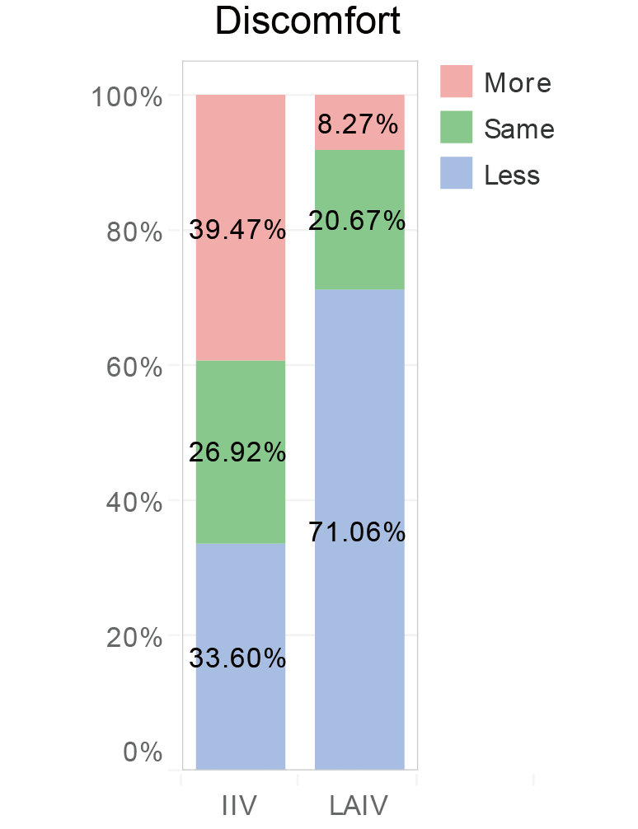 | Parent preferred IIV:  “I never learn about LAIV in details…Will the kid feel more uncomfortable? Because, you know, if something in your nose, it will make you feel so sneezy…Anyway, I dislike such feeling.” (PS26)  Parent preferred LAIV:  “I prefer LAIV, because injection will cause pain in children.” (PS23) | Parents who preferred IIV over LAIV reporting greater discomfort in taking a LAIV. Our qualitative interviews found that parents were not familiar with LAIV, thereby they imagining sneezy feeling when being sprayed by a LAIV. However, parents who preferred LAIV over IIV were more likely to report less discomfort in vaccination (71.1%), this may be mainly attributed to less pain in vaccinating with LAIV compared to the injection-based IIV, according to the interviewees.
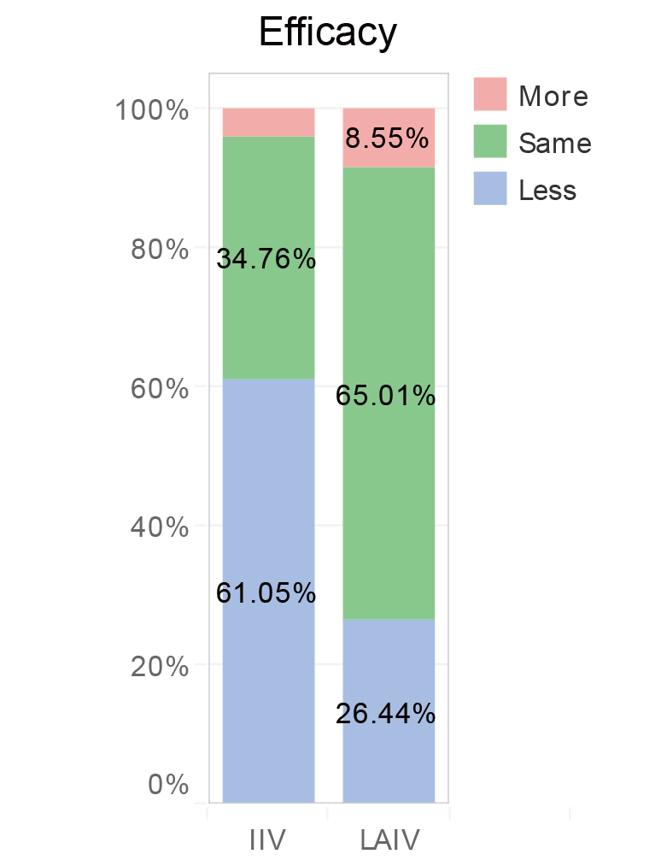 | Parent preferred IIV:  “I think it may hurt when you insert the needle into child’s body, but it can make sure all the vaccine goes into the body. But as for nasal spray…I don’t know, just base on my imagination because I never see the process with my own eyes, the vaccine will be sprayed to anywhere during child’s struggling process.” (PR19)  Parent preferred LAIV:  “The LAIV is a relatively new technology, but injecting with IIV will cause greater pain. When I made the decision, I just told myself, no harm to give a try on LAIV. Then I tried it in the first year, and I think it’s quite okay. My son didn’t get sick, so the vaccine should have entered into his body. That is to say, the LAIV is effective.” | 61.1% of parents who preferred IIV over LAIV believed that LAIV was less effective than the IIV. The qualitative part provided detailed explanation, suggesting that such misbelief was mainly based on parents’ hypothetical imagination that nasal spray is difficult to be fully taken by the children, thereby limiting its effectiveness. On the other hand, parents who preferred LAIV over IIV did not have such misperception, majority of them believed that LAIV was equally effective as IIV. The qualitative interviews found that parents’ initial concern regarding the effectiveness of LAIV were addressed by their actual vaccination experience with the LAIV.
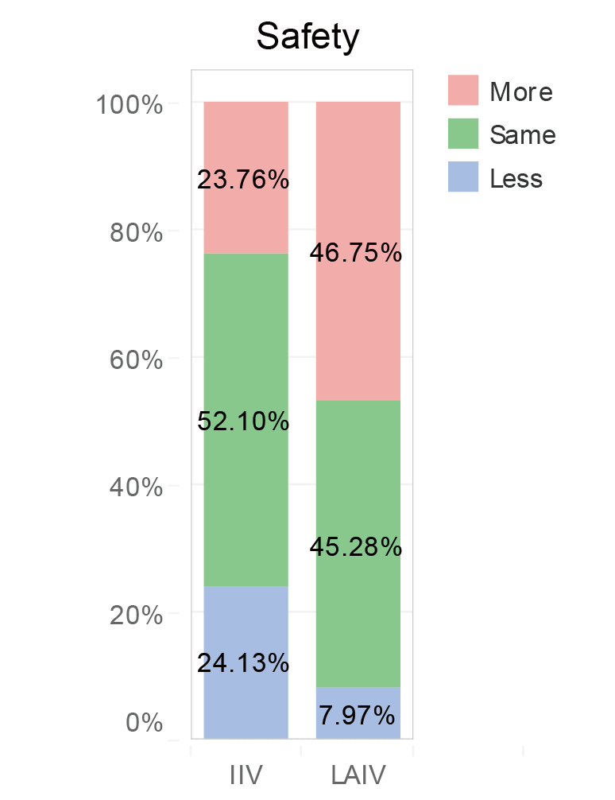 | Parent preferred IIV:  “Because I know LAIV is using lived virus, but the IIV is using dead virus…So I think, taking the IIV will have less side effects.” (PS24)  Parent preferred LAIV:  “I think the LAIV is really good, because after my eldest daughter had the injection, the injection site will hurt for two or three days. But my youngest girl was vaccinated with LAIV, it was just sprayed into her nose and caused mild pain immediately, afterwards she had no other feelings. So, I think the nasal spray seems better.” | There were 24.1% of parents who preferred IIV over LAIV believed that LAIV was less safe compared to the IIV. In our interviews, misunderstanding on live-attenuated influenza vaccine (LAIV) were found in parents who preferred IIV. They misbelieved that live-attenuated influenza vaccine contains lived virus, thereby were less safe for children to take. Parents who preferred LAIV over IIV were more likely to report more or similar safety (~45%) for taking LAIV compared to taking IIV. Most parents mentioned that LAIV had fewer side effects due to lower chance of experiencing pain in the injection site.
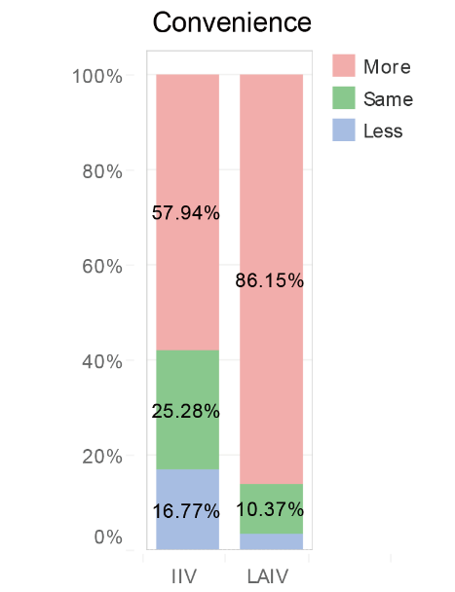 | Parent preferred LAIV:  “When child was vaccinated with needle, his/her emotions will come out, and then the fear will spread to others...This will interrupt the whole process and hinder others from taking the vaccine. So, I think it might be better for children if they can be vaccinated with nasal spray, and the vaccination process will be much smoother…” (PS25) | Parents believed that LAIV was more convenient to be implemented compared to IIV, no matter what their preferred SIV type was. Such positive belief was significantly greater in parents who in favor of LAIV. The perceived convenience can be reflected in parents’ statements that nasal spray causes little pain and fear, thereby is easier to manage children’s emotions during the SIVP implementation process.
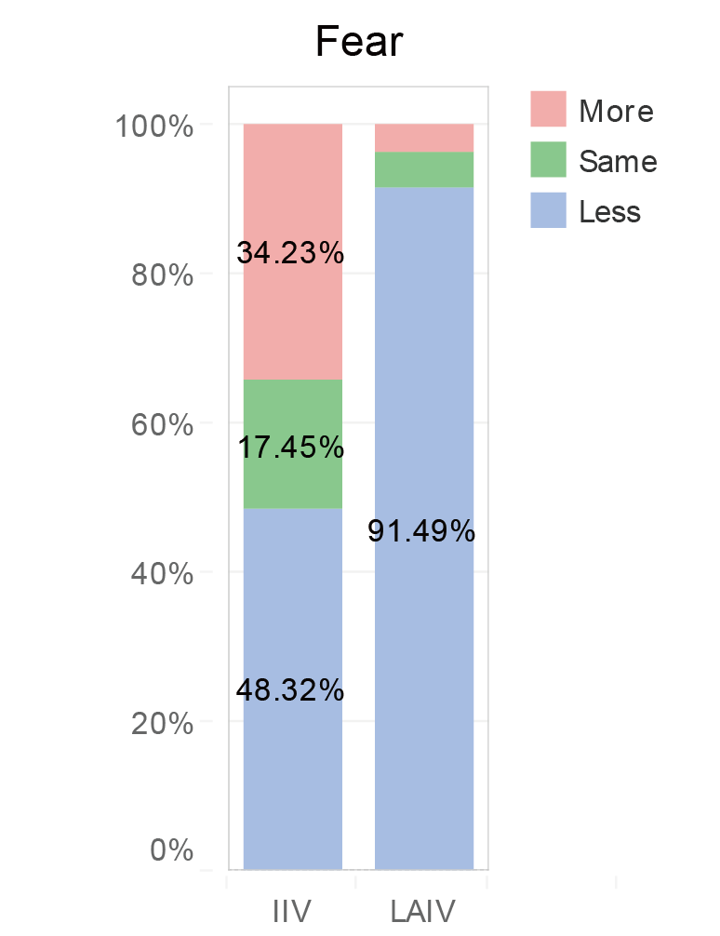 | Parent preferred IIV:  “My daughter prefers getting injection, maybe she is more afraid of being suddenly sprayed something into her nose…” (PR02)  Parent preferred LAIV:  “LAIV is better, children will not fear so much about the needles…I will continue to join the SIVP if my child feel less resistant about taking a vaccine.” (PS05) | 34.2% of parents who preferred IIV over LAIV reported that LAIV will cause greater fear in children. This is mainly because they were not familiar with the administration mode via nasal spray. However, 91.5% of parents who preferred LAIV over IIV believed that LAIV will cause less fear in children. Most parents mentioned that needle fear was the main barrier for children accepting the vaccination. Taking a needle-freed LAIV can enhance children’s acceptability, subsequently, it can also encourage continued participation in the SIVP.

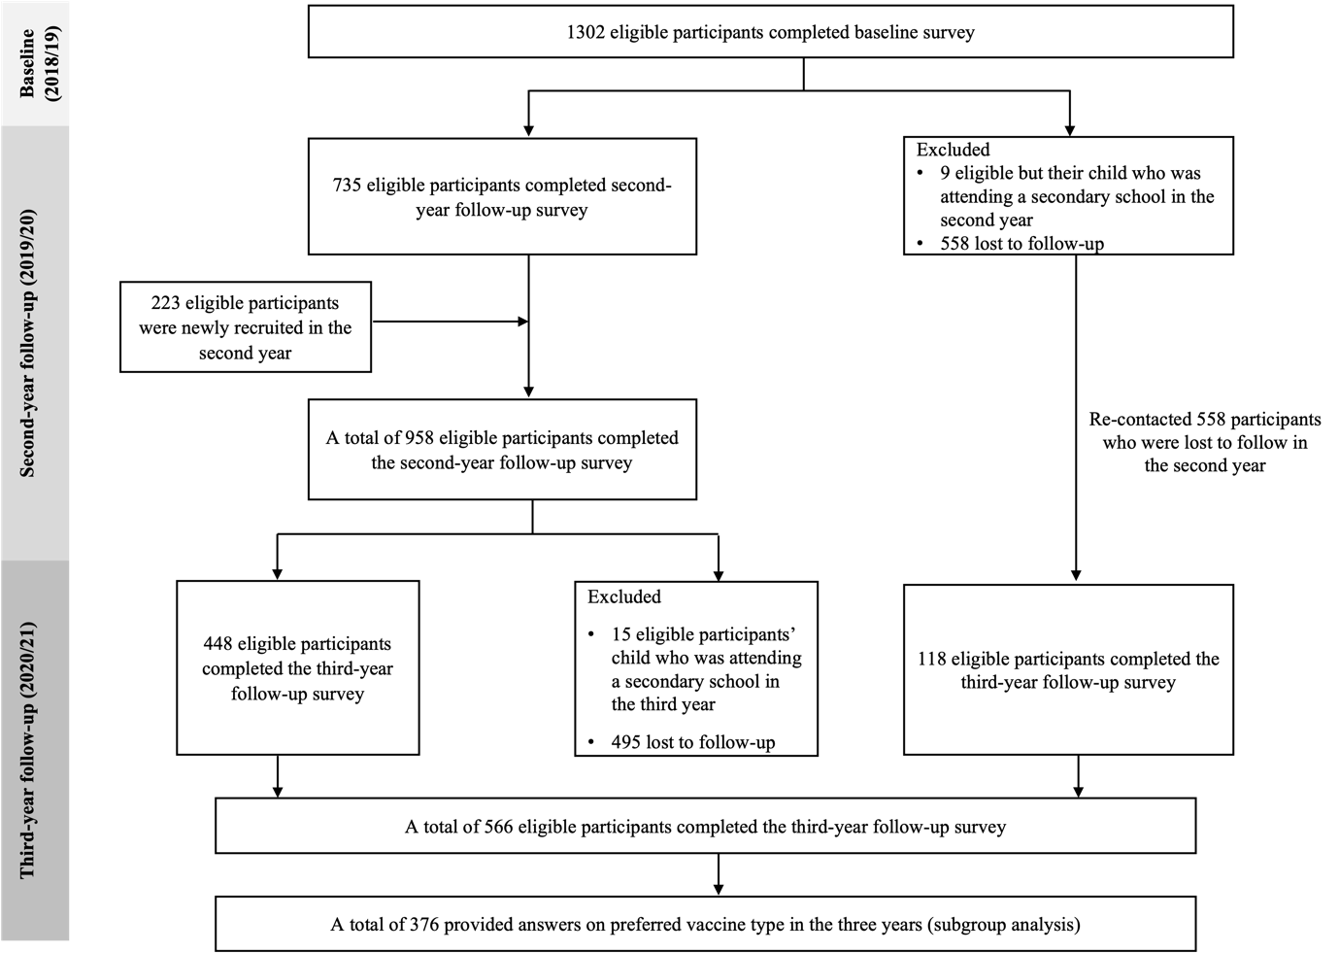
Supplementary Figure 1. Participants recruitment procedures over the three year

