Expression of Jr4CLs gene under drought stress
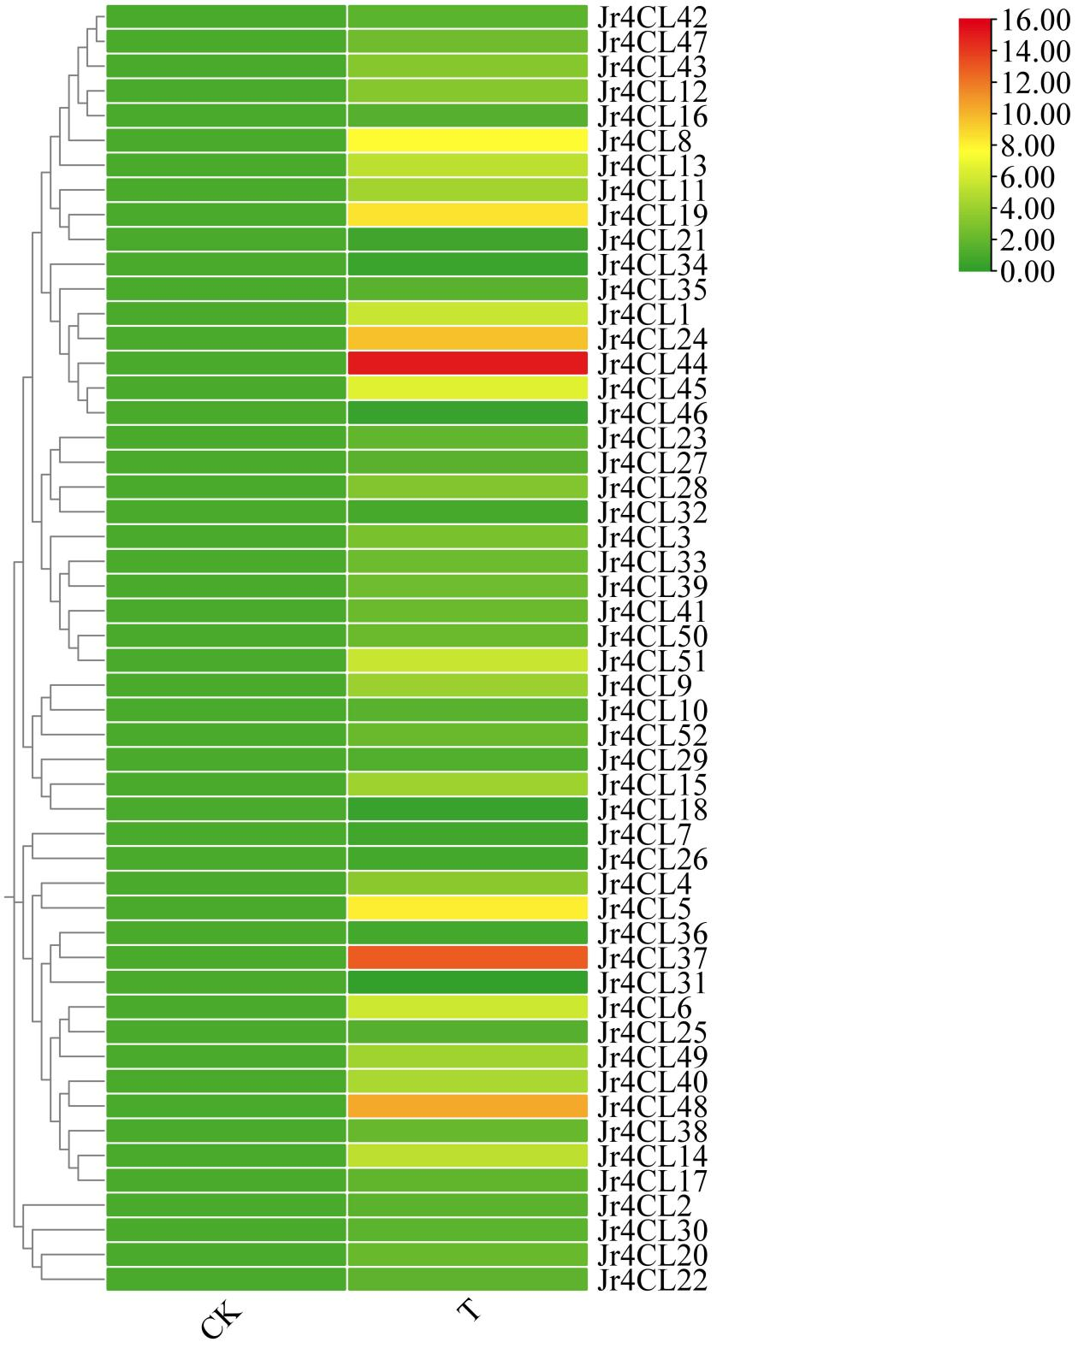
Supplementary Figure.S1 Heat map of Jr4CLs family under drought stress

Bioinformatics analysis of Jr4CL44 gene
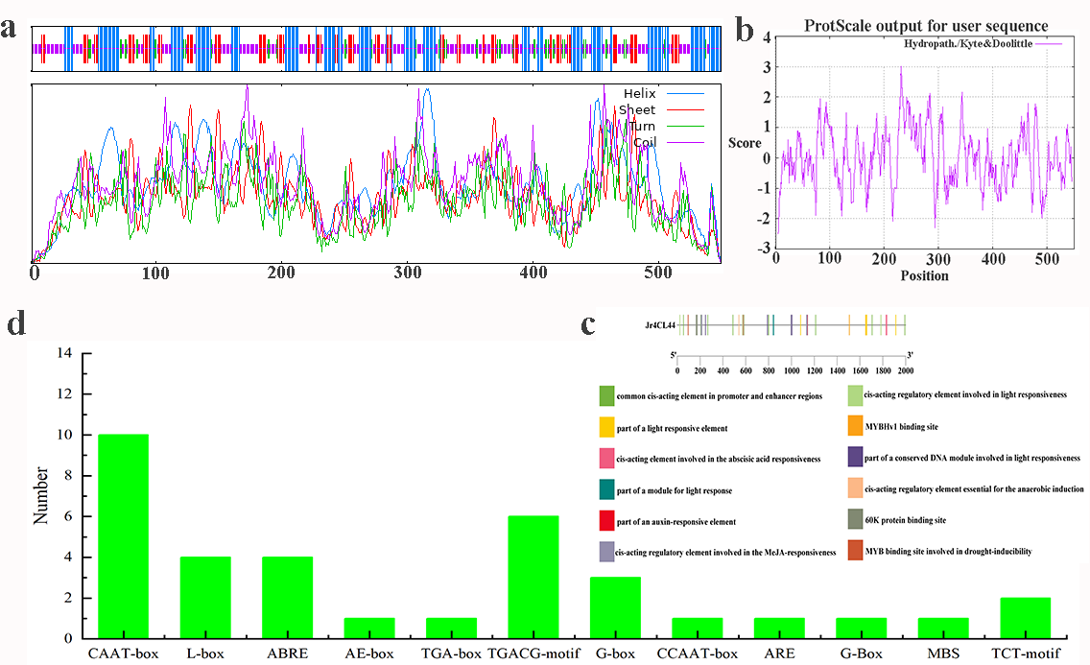
Supplementary Figure.S2 Bioinformatics analysis of Jr4CL44

Cloning of Jr4CL44 gene and identification of transgenic Arabidopsis
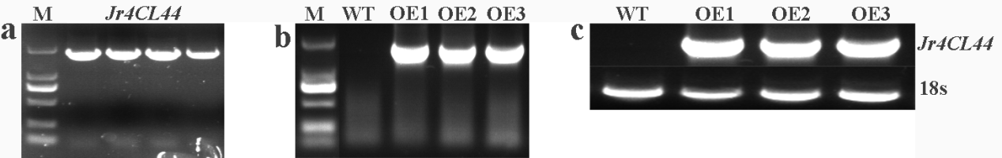
Supplementary Figure.S3 Cloning of Jr4CL44 and identification of transgenic Arabidopsis

