Table 1. Overview of materials (timber from large-diameter logs).
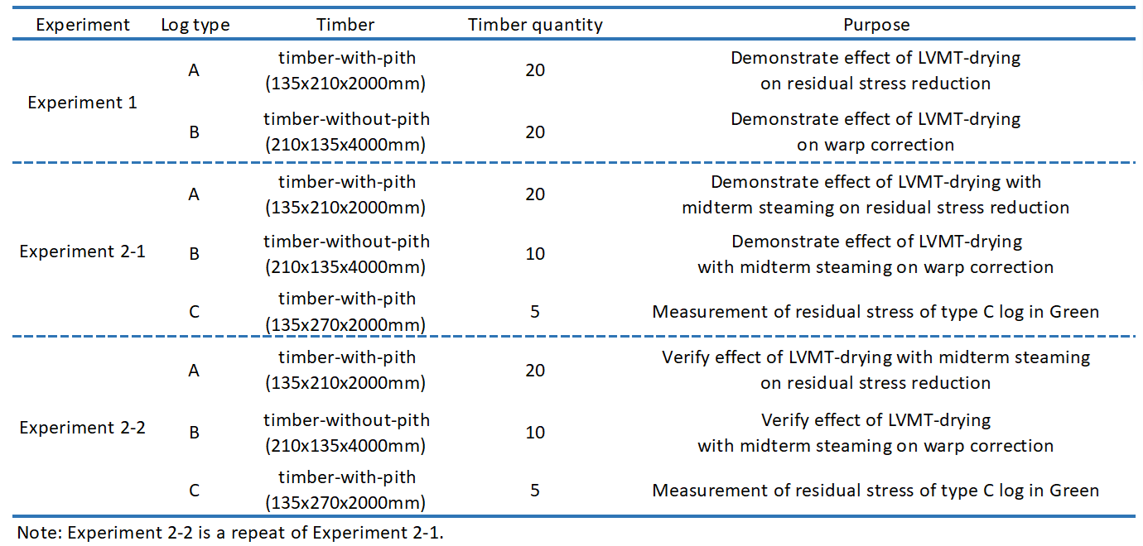

Table 2 LVMT-dying schedule in Experiment 1
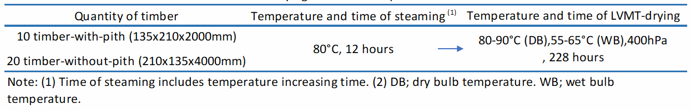

Table 3 Improved LVMT-dying schedule in Experiment 2-1 and 2-2
