Supplementary Information

Ångstrom-scale gold particles loaded with alendronate via alpha-lipoic acid alleviate bone loss in osteoporotic mice

Weihang Gao¹, MD; Jiao Jiao Li², MD; Jingyu Shi³, MD; Hongbing Lan⁴, MD; Yuanyuan Guo³, PhD; Dehao Fu¹, MD

¹ Department of Orthopaedics, Shanghai Sixth People's Hospital Affiliated to Shanghai Jiao Tong University School of Medicine, Shanghai, 200233, P. R. China.
² School of Biomedical Engineering, Faculty of Engineering and IT, University of Technology Sydney, Sydney, NSW 2007, Australia
³ Department of Pharmacy, Liyuan Hospital, Tongji Medical College, Huazhong University of Science and Technology, Wuhan, China.
⁴ Tongji School of Pharmacy, Huazhong University of Science and Technology, Wuhan, China

Corresponding Authors
Dehao Fu − Department of Orthopaedics, Shanghai Sixth People's Hospital Affiliated to Shanghai Jiao Tong University School of Medicine, Shanghai, 200233, P. R. China; orcid.org/0000-0002-9295-1692; Email: fudehao@sjtu.edu.cn
Yuanyuan Guo − Department of Pharmacy, Liyuan Hospital, Tongji Medical College, Huazhong University of Science and Technology, Wuhan, China. Email: yuanyuanguo@hust.edu.cn

Fig. S1 UV/vis spectra of citrate (black line) and lipoic acid stabilized (red line) gold nanoparticles. The spectra were obtained in ultrapure water.

Fig. S2 Transmission FTIR spectra of citrate (black line) stabilized gold nanoparticles exchanged by lipoic acid (red line).

Fig. S3 DLS spectra of the as-prepared gold nanoparticles in water solution.

Fig. S4 The TEM image and core size distribution of the synthesized gold nanoparticles (scale bar=50 nm).

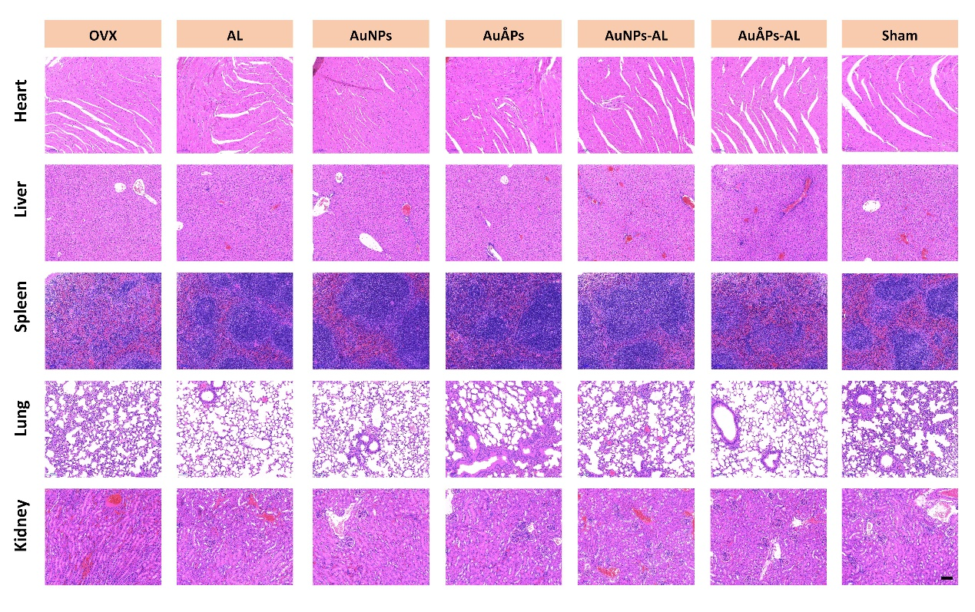
Fig. S5 Histological evaluation of the heart, liver, spleen, lung, and kidney of mice in OVX, AL, AuNPs, AuÅPs, AuNPs-AL, AuÅPs-AL and sham groups (scale bar=100 μm).

