Supplementary materials
Table S1. Primers used in this study.
Experiments | Genes | Primer (5'→3′)
RT-qPCR | XM_022901835.1 (DzMYB2) | Forward | GTCCCTTGGTCAGAATACATC
RT-qPCR | XM_022901835.1 (DzMYB2) | Reverse | TTGCTGGTACATGAGATTGG
RT-qPCR | XM_022887057.1 (DzMYB3) | Forward | GAAGCTGCTCAGGATGTAA
RT-qPCR | XM_022887057.1 (DzMYB3) | Reverse | CACCTTTCTTGAACTGGGATTT
RT-qPCR | DzEF1α (reference gene) | Forward | GAAACCTTCTCTGCGTACC
RT-qPCR | DzEF1α (reference gene) | Reverse | CTCCACACTCTTGATGACAC
Transient expression | DzMYB2-pDONOR207 | Forward | AAAAAGCAGGCTATGGGAAGGGCTCCTTGTT
Transient expression | DzMYB2-pDONOR207 | Reverse | AGAAAGCTGGGTTCAGATCAGTAATGATTCAGCAAAA
Transient expression | DzMYB3-pDONOR207 | Forward | AAAAAGCAGGCTATGGGAAGGTCTCCTTGC
Transient expression | DzMYB3-pDONOR207 | Reverse | AGAAAGCTGGGTTCTCATTTCATTTCCAAACTTCTA
Dual-luciferase assay | DzMYB2-pGreenII-62-SK (BamHI, HindIII) | Forward | TAGAACTAGTGGATCATGGCTGTAACAAGCACATCAAAC
Dual-luciferase assay | DzMYB2-pGreenII-62-SK (BamHI, HindIII) | Reverse | CGGTATCGATAAGCTTTTACTCAATCTTGCTCACCCCAAC
Dual-luciferase assay | DzMYB3-pGreenII-62-SK (BamHI, HindIII) | Forward | TAGAACTAGTGGATCATGGCTGTAACAAGCACATCAAAC
Dual-luciferase assay | DzMYB3-pGreenII-62-SK (BamHI, HindIII) | Reverse | CGGTATCGATAAGCTTTTACTCAATCTTGCTCACCCCAAC
Dual-luciferase assay | pPAL-pGreenII-0800-Luc (HindIII) | Forward | CGGTATCGATAAGCTTATACCACCAACCCCTATG
Dual-luciferase assay | pPAL-pGreenII-0800-Luc (HindIII) | Reverse | ATTCGATATCAAGCTGTTAAAACAGAAATGATCAAAATGA
Dual-luciferase assay | p4CL-pGreenII-0800-Luc (HindIII) | Forward | CGGTATCGATAAGCTACGACCTCCAAGGCAATTAC
Dual-luciferase assay | p4CL-pGreenII-0800-Luc (HindIII) | Reverse | ATTCGATATCAAGCTGGAATTGGAAATGTAAGGTGGT
Dual-luciferase assay | pCHI-pGreenII-0800-Luc (HindIII) | Forward | CGGTATCGATAAGCTCATTCATACGATACAATGATAGCG
Dual-luciferase assay | pCHI-pGreenII-0800-Luc (HindIII) | Reverse | ATTCGATATCAAGCTTTTCTGACAGATCAACTCTTTCTT
Dual-luciferase assay | pCHS-pGreenII-0800-Luc (HindIII) | Forward | CGGTATCGATAAGCTCTGCTTAGATTACATAAATGGACG
Dual-luciferase assay | pCHS-pGreenII-0800-Luc (HindIII) | Reverse | ATTCGATATCAAGCTGAATCTCTTCTGTTAGGTACATG
Dual-luciferase assay | pF3H-pGreenII-0800-Luc (HindIII) | Forward | CGGTATCGATAAGCTAAGTGGCTTGTTCGAAGCATGG
Dual-luciferase assay | pF3H-pGreenII-0800-Luc (HindIII) | Reverse | ATTCGATATCAAGCTGTGTTGGCCATAAGGTCGAGAG
Dual-luciferase assay | pDFR-pGreenII-0800-Luc (HindIII) | Forward | CGGTATCGATAAGCTGTTCGACACCAACACCATTG
Dual-luciferase assay | pDFR-pGreenII-0800-Luc (HindIII) | Reverse | ATTCGATATCAAGCTGCCGGAGCACCAAGAGTA
Dual-luciferase assay | pUFGT-pGreenII-0800-Luc (HindIII) | Forward | CGGTATCGATAAGCTGTGCAACAATGTACTTATATCGTT
Dual-luciferase assay | pUFGT-pGreenII-0800-Luc (HindIII) | Reverse | ATTCGATATCAAGCTTGGAACAGAAAAGTTATCGAACA
Y2H | DzMYB1-pGBKT7 (EcoRI, BamHI) | Forward | CATGGAGGCCGAATTCATGGCTGTAACAAGCACATCAAAC
Y2H | DzMYB1-pGBKT7 (EcoRI, BamHI) | Reverse | GCAGGTCGACGGATCCTTACTCAATCTTGCTCACCCCAAC
Y2H | DzbHLH1-pGBKT7 (EcoRI, BamHI) | Forward | CATGGAGGCCGAATTCATGGCTGTGCCGCCTAG
Y2H | DzbHLH1-pGBKT7 (EcoRI, BamHI) | Reverse | GCAGGTCGACGGATCCTTAGAATTGAGGTATTACTTGATATAT
Y2H | DzMYB2-pGADT7 (SmaI) | Forward | TGGCCATTATGGCCCATGGGAAGGGCTCCTTGTT
Y2H | DzMYB2-pGADT7 (SmaI) | Reverse | GACATGTTTTTTCCCTCAGATCAGTAATGATTCAGCAAAA
Y2H | DzMYB3-pGADT7 (SmaI) | Forward | TGGCCATTATGGCCCATGGGAAGGTCTCCTTGC
Y2H | DzMYB3-pGADT7 (SmaI) | Reverse | GACATGTTTTTTCCCTCTCATTTCATTTCCAAACTTC

Fig. S1. a Heat map depicting the expression levels of DzMYBs at five distinct stages (immature1; IM1, immature2; IM2, mature; M, midripe; MR, and ripe; R) based on gene expression values (RPKM) sourced from the Monthong transcriptome data. b Heat map illustrating tissue-specific expression in root, stem, leaf, and fruit pulp tissues of DzMYBs in the Musang King cultivar at the ripe stage obtained from MaGenDB. This heatmap was generated using MetaboAnalyst 5.0 with the Euclidean distance method. The data underwent sum-normalization, log-transformation, and auto-scaling. The expression levels of each gene are depicted using a color gradient from red (high) to blue (low).

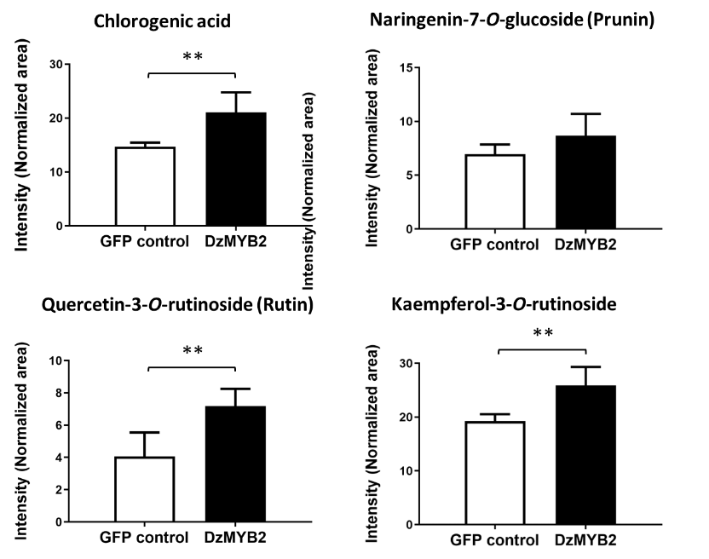

Fig. S2. The intensity of phenolic compounds in transient protein expression in tomato fruit compared to GFP control. The intensity was normalized with the peak area of puerarin used as an internal standard. An asterisk above the bars indicates a significant difference between samples (student’s t-test, **: P < 0.05).

Table S2. Phenolic compounds detected in plants infiltrated with either DzMYB2 or DzMYB3.
Compound | Molecular formula | RT | Adduct | m/z | Error (ppm) | Mass fragment
tomato
Rutin (quercetin-3-O-rutinoside) | C₂₇H₃₀O₁₆ | 12.04 | [M+H]+ | 611.1572 | 5.6728 | 465.1998, 303.4058, 219.0535
Prunin (naringenin-7-O-glucoside) | C₂₁H₂₂O₁₀ | 14.42 | [M+H]+ | 435.1230 | 11.9169 | 273.0742, 153.0168, 119.0467
Kaempferol-3-O-rutinoside | C₂₇H₃₀O₁₅ | 13.28 | [M+H]+ | 595.1606 | 8.6622 | 449.1037, 287.0513
Chlorogenic acid | C₁₆H₁₈O₉ | 10.66 | [M+H]+ | 355.0997 | 7.5082 | 163.0365, 145.0259, 135.0415, 117.0328
Nicotiana benthamiana
Chlorogenic acid | C₁₆H₁₈O₉ | 10.97 | [M+H]+ | 355.1035 | -3.2234 | 163.0399, 145.0291, 135.0446, 117.0338
Kaempferol-3-O-rutinoside | C₂₇H₃₀O₁₅ | 14.35 | [M-H]- | 593.1526 | -2.3667 | 285.2415
Prunin (naringenin-7-O-glucoside) | C₂₁H₂₂O₁₀ | 15.22 | [M-H]- | 433.1153 | -2.9473 | 271.0604, 151.0026, 119.0498
Feruloylquinic acid | C₁₇H₂₀O₉ | 12.19 | [M-H]- | 367.1052 | -4.7832 | 191.055, 134.0367

