Supplementary Information for

Cell restriction factors, and not receptor compatibility, block Jamaican fruit bat (Artibeus jamaicensis) susceptibility to mucosal inoculation with SARS-CoV-2 Delta variant
Julia R. Port#¹, Jade C. Riopelle¹, Sarah van Tol¹, Arthur Wickenhagen¹, Eric Bohrnsen², Daniel E. Sturdevant², Rebecca Rosenke², Jamie Lovaglio³, Justin Lack², Sarah L. Anzick², Kathleen Cordova³, Kwe Claude Yinda¹, Patrick W. Hanley³, Tony Schountz⁴, Lon V. Kendall⁴, Carl I. Shaia³, Greg Saturday³, Craig Martens², Benjamin Schwarz², Vincent J. Munster¹
- Laboratory of Virology, Division of Intramural Research, National Institute of Allergy and Infectious Diseases, National Institutes of Health, Hamilton, MT, USA
- Research Technologies Branch, Division of Intramural Research, National Institute of Allergy and Infectious Diseases, National Institutes of Health, Hamilton, MT, USA
- Rocky Mountain Veterinary Branch, Division of Intramural Research, National Institute of Allergy and Infectious Diseases, National Institutes of Health, Hamilton, MT, USA
- Department of Microbiology, Immunology, and Pathology, Colorado State University, Fort Collins, CO, USA

# Corresponding author: julia.port@nih.gov

Author Contributions:
JRP designed the studies.
JRP, JCR, SvT, EB, JL, KC, KCY, PWH performed the experiments.
JRP, JCR, SvT, AW, DES, RR, JL, SA, KCY, CIS, GS, CM, BS analyzed results.
JRP, JCR, VJM wrote the manuscript.
All co-authors reviewed the manuscript.
Competing Interest Statement: No competing interests to disclose.
Keywords: bats, SARS-CoV-2, Artibeus jamaicensis, infection

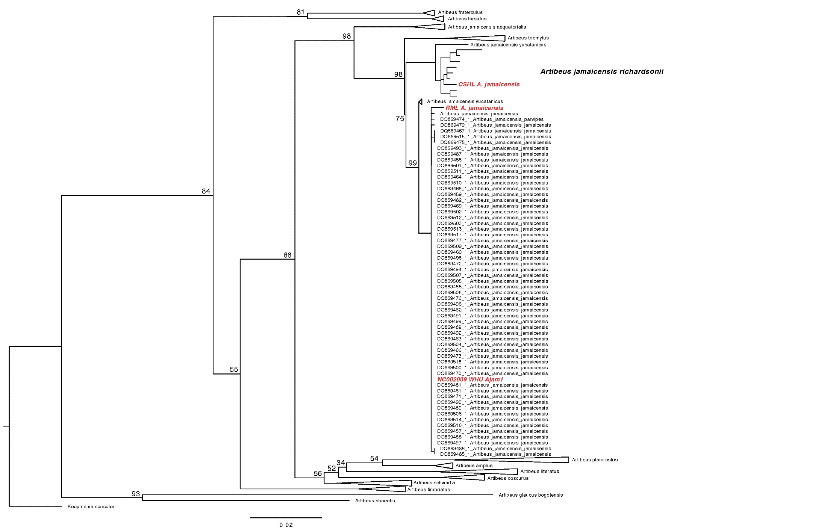Figure S1. Maximum likelihood phylogeny based on complete sequences of the Jamaican fruit bat mtDNA cytochrome b gene. Uninformative monophyletic nodes are collapsed to simplify the phylogeny, and all uncollapsed nodes are labelled with the bootstrap percentages.

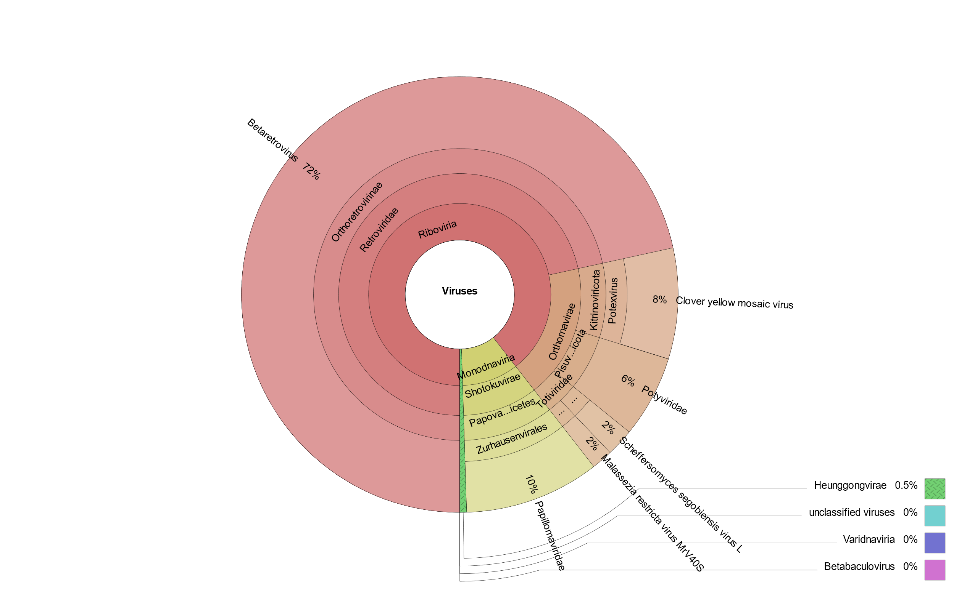 Figure S2. Krona chart showing the virome of the captive Jamaican fruit bat colony.

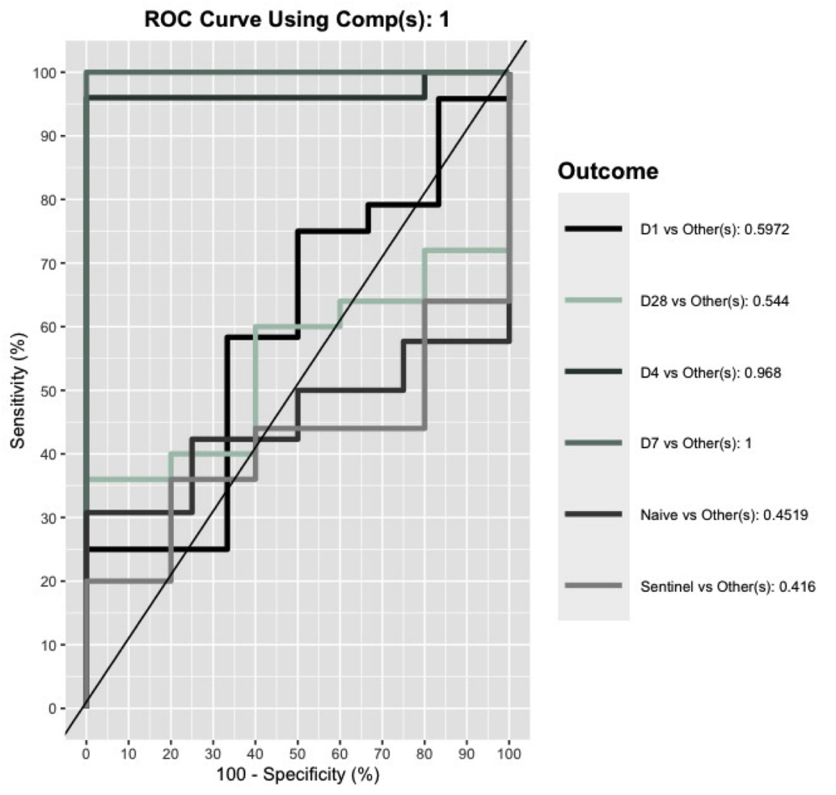
Figure S3. Validation of sparse partial least squares-discriminant analysis of Jamaican fruit bat intestinal metabolome composition after inoculation with SARS-CoV-2 Delta variant. Receiver operating characteristic (ROC) curve for sPLSDA of time and inoculation status (N = 6 (1 DPI) / 5 (4, 7, 28 DPI, sentinels) / 4 (naïve animals)). Lines colored by group. Legend also shows the calculated area under the ROC curve (AUROC) for each predictor.

Figure S4. Gene expression pathway up-or downregulation in Jamaican fruit bats after inoculation with SARS-CoV-2 Delta. Gene expression changes in blood, lungs, and nasal turbinates collected on day 1 and 4 after infection. Tissues collected from uninfected bats on day 28 served as comparison. Ingenuity Pathway Analysis of differentially expressed genes (DEGs) showing the top 20 pathways per comparison. Canonical pathways with a negative z-score are shown in blue, positive z-score in purple and pathways with an undefined or z-score = 0 are shown in grey. Significance threshold (p=0.05) is shown with a dotted orange line in each bar chart.

Table S1: Virome pipelines
Metavirs Pipeline
Megahit
# CAT viral contigs | 10
largest contig (bp) | 3,647
# Kraken2 viral contigs | 210
largest Kraken2 contig (bp) | 11,071
Metaspades
# CAT viral contigs | 17
largest contig (bp) | 3,944
# Kraken2 viral contigs | 321
largest Kraken2 contig (bp) | 5,311
# raw reads | 2,345,827,700

Table S2: Caging schematic
 |  |  |  | until D1 | D1 -
Animal ID | Sex | Necropsy | Group | Cage # | Cage #
1 | Female | 1 | D1 | 1 | 1
2 | Female | 1 | D1 | 1 | 1
3 | Female | 1 | D1 | 1 | 1
7 | Female | 4 | D4 | 1 | 1
8 | Female | 4 | D4 | 1 | 1
12 | Female | 7 | D7 | 2 | 2
13 | Female | 7 | D7 | 2 | 2
14 | Female | 7 | D7 | 2 | 2
17 | Female | 28 | D28 | 2 | 3
18 | Female | 28 | D28 | 2 | 3
19 | Female | 28 | D28 | 2 | 3
26 | Female | 28 | sent | 3 | 3
27 | Female | 28 | sent | 3 | 3
28 | Female | 28 | sent | 3 | 3
22 | Female | 28 | control | 7 | 7
23 | Female | 28 | control | 7 | 7
4 | Female | 1 | D1 | 4 | 4
5 | Female | 1 | D1 | 4 | 4
6 | Female | 4 | D4 | 4 | 4
10 | Female | 4 | D4 | 4 | 4
15 | Female | 7 | D7 | 4 | 4
6 | Male | 1 | D1 | 5 | 5
11 | Male | 4 | D4 | 5 | 5
16 | Male | 7 | D7 | 5 | 5
20 | Male | 28 | D28 | 5 | 6
21 | Male | 28 | D28 | 5 | 6
29 | Male | 28 | sent | 6 | 6
30 | Male | 28 | sent | 6 | 6
24 | Male | 28 | control | 8 | 8
25 | Male | 28 | control | 8 | 8

Table S3: Serological status. Serological status was determined by A/G protein ELISA against the SARS-CoV-2 receptor binding domain. Virus neutralization (VN) titer was determined through neutralization of infectious virus.
Animal ID | Bat 1 | Bat 2 | Bat 3 | Bat 4 | Bat 5 | Bat 6 |  | Bat 7 | Bat 8 | Bat 9 | Bat 10 | Bat 11 |  | Bat 12 | Bat 13 | Bat 14 | Bat 15 | Bat 16 |  | Bat 17 | Bat 18 | Bat 19 | Bat 20 | Bat 21 |  | Bat 26 | Bat 27 | Bat 28 | Bat 29 | Bat 30 |  | Bat 22 | Bat 23 | Bat 24 | Bat 25
Group | D1 |  |  |  |  |  | D4 |  |  |  |  |  | D7 |  |  |  |  |  | D28 |  |  |  |  |  | Sentinel |  |  |  |  |  | Control
Serological status | Negative | Negative | Negative | Negative | Negative | Negative |  | Negative | Negative | Negative | Negative | Negative |  | Negative | Negative | Negative | Negative | Negative |  | Negative | Negative | Negative | Negative | Negative |  | Negative | Negative | Negative | Negative | Negative |  | Negative | Negative | Negative | Negative
VN titer | 0 | 0 | 0 | 0 | 0 | 0 |  | 0 | 0 | 0 | 0 | 0 |  | 0 | 0 | 0 | 0 | 0 |  | 0 | 0 | 0 | 0 | 0 |  | 0 | 0 | 0 | 0 | 0 |  | 0 | 0 | 0 | 0

Table S4: Pathological assessment. Histopathology was assessed by a board-certified pathologist. Lung score = interstitial infiltrate, liver = vascular change – glycogen type, kidney = interstitial fibrosis, lower GI = lymphoid patches: lymphocytolysis, bladder = submucosal lymphocytic infiltrate; 0 = no lesions, 1 =Minimal (1-10%), 2 = Mild (11-25%), 3 = Moderate (26-50%), 4 = Marked (51-75%), 5 = Severe (76-100%).
Bat ID |  | Bat 1 | Bat 2 |  | Bat 3 |  | Bat 7 |  | Bat 8 |  | Bat 22 |  | Bat 23 |  | Bat 4 |  | Bat 5 |  | Bat 9 |  | Bat 10 |  | Bat 6 |  | Bat 11 |  | Bat 24 |  | Bat 25
Group |  | d1 | d1 |  | d1 |  | d4 |  | d4 |  | uninf |  | uninf |  | d1 |  | d1 |  | d4 |  | d4 |  | d1 |  | d4 |  | uninf |  | uninf
Score
Lung |  | 1 | 1 |  | 0 |  | 0 |  | 0 |  | 0 |  | 0 |  | 0 |  | 0 |  | 1 |  | 0 |  | 0 |  | np |  | 0 |  | 0
Trachea |  | 0 | np |  | 0 |  | 0 |  | 0 |  | 0 |  | 0 |  | 0 |  | 0 |  | np |  | np |  | 0 |  | np |  | 0 |  | 0
Brain |  | 0 | 0 |  | 0 |  | 0 |  | 0 |  | 0 |  | 0 |  | 0 |  | 0 |  | 0 |  | 0 |  | 0 |  | np |  | 0 |  | 0
Skull |  | 0 | 0 |  | 0 |  | 0 |  | 0 |  | 0 |  | 0 |  | 0 |  | 0 |  | 0 |  | 0 |  | 0 |  | np |  | 0 |  | 0
Liver |  | 4 | 3 |  | 3 |  | 3 |  | 3 |  | 3 |  | 4 |  | 3 |  | 3 |  | 3 |  | 3 |  | 3 |  | np |  | 3 |  | 3
Spleen |  | 0 | 0 |  | 0 |  | 0 |  | 0 |  | 0 |  | 0 |  | 0 |  | 0 |  | 0 |  | 0 |  | 0 |  | np |  | 0 |  | 0
Kidney |  | 0 | 0 |  | 0 |  | 0 |  | 0 |  | 0 |  | 0 |  | 0 |  | 0 |  | 0 |  | 0 |  | 0 |  | np |  | 0 |  | 1
Upper GI |  | 0 | 0 |  | 0 |  | 0 |  | 0 |  | 0 |  | 0 |  | 0 |  | 0 |  | 0 |  | 0 |  | 0 |  | np |  | 0 |  | 0
Lower GI |  | 0 | 0 |  | 0 |  | 0 |  | 0 |  | 0 |  | 0 |  | 0 |  | 0 |  | 2 |  | 0 |  | 0 |  | np |  | 3 |  | 3
Bladder |  | 0 | 0 |  | np |  | 0 |  | np |  | np |  | 1 |  | 0 |  | np |  | 0 |  | 0 |  | 0 |  | np |  | 0 |  | 0
Heart |  | 0 | 0 |  | 0 |  | 0 |  | 0 |  | 0 |  | 0 |  | 0 |  | 0 |  | 0 |  | 0 |  | 0 |  |  |  | 0 |  | 0
Radiograph lung score D0 |  | 0 | 0 |  | 0 |  | 0 |  | 0 |  | np |  | np |  | 0 |  | 0 |  | 0 |  | 0 |  | 0 |  | 0 |  | np |  | np
Radiograph lung score D1 and D4 |  | 0 | 0 |  | 0 |  | 0 |  | 0 |  | np |  | np |  | 1 |  | 0 |  | 0 |  | 0 |  | 0 |  | 0 |  | np |  | np
SARS-CoV-2 IHC
Lung |  | 0 | 0 |  | 0 |  | np |  | np |  | np |  | np |  | 0 |  | 0 |  | np |  | np |  | np |  | np |  | np |  | 0
Trachea |  | 0 | np |  | 0 |  | np |  | np |  | np |  | np |  | 0 |  | 0 |  | np |  | np |  | np |  | np |  | np |  | 0
Brain |  | 0 | 0 |  | 0 |  | np |  | np |  | np |  | np |  | 0 |  | 0 |  | np |  | np |  | np |  | np |  | np |  | 0
Skull |  | 0 | 0 |  | 0 |  | np |  | np |  | np |  | np |  | 0 |  | 0 |  | np |  | np |  | np |  | np |  | np |  | 0
Liver |  | 0 | 0 |  | 0 |  | np |  | np |  | np |  | np |  | 0 |  | 0 |  | np |  | np |  | np |  | np |  | np |  | 0
Spleen |  | 0 | 0 |  | 0 |  | np |  | np |  | np |  | np |  | 0 |  | 0 |  | np |  | np |  | np |  | np |  | np |  | 0
Kidney |  | 0 | 0 |  | 0 |  | np |  | np |  | np |  | np |  | 0 |  | 0 |  | np |  | np |  | np |  | np |  | np |  | 0
Upper GI |  | 0 | 0 |  | 0 |  | np |  | np |  | np |  | np |  | 0 |  | 0 |  | np |  | np |  | np |  | np |  | np |  | 0
Lower GI |  | 0 | 0 |  | 0 |  | np |  | np |  | np |  | np |  | 0 |  | 0 |  | np |  | np |  | np |  | np |  | np |  | 0
Urinary bladder |  | np | 0 |  | 0 |  | np |  | np |  | np |  | np |  | np |  | np |  | np |  | np |  | np |  | np |  | np |  | np
Ovary |  | 0 | 0 |  | 0 |  | np |  | np |  | np |  | np |  | np |  | np |  | np |  | np |  | np |  | np |  | np |  | np
Testicle |  | np | np |  | np |  | np |  | np |  | np |  | np |  | np |  | np |  | np |  | np |  | np |  | np |  | np |  | 0
Heart |  | 0 | 0 |  | 0 |  | np |  | np |  | np |  | np |  | 0 |  | 0 |  | np |  | np |  | np |  | np |  | np |  | 0
Table S5: qRT measurements of tissues and swabs. UD = undetermined, BQL = below detection limit of 10 copies/reaction. NT = nasal turbinates.
Animal ID | Bat 1 | Bat 2 | Bat 3 | Bat 4 | Bat 5 | Bat 6 | Bat 7 | Bat 8 | Bat 9 | Bat 10 | Bat 11 | Bat 12 | Bat 13 | Bat 14 | Bat 15 | Bat 16 | Bat 17 |  | Bat 18 | Bat 19 | Bat 20 | Bat 21 | Bat 26 |  | Bat 27 | Bat 28 | Bat 29 | Bat 30 | Bat 22 |  | Bat 23 | Bat 24 | Bat 25
Group | D1 |  |  |  |  |  | D4 |  |  |  |  | D7 |  |  |  |  |  | D28 |  |  |  |  |  | Sentinel |  |  |  |  |  | Control
Oral Swab D0 | UD | UD | UD | UD | UD | UD | UD | UD | UD | UD | BQL | UD | UD | UD | UD | UD | BQL |  | UD | UD | UD | UD | UD |  | UD | UD | UD | UD | UD |  | UD | UD | UD
Rectal Swab D0 | UD | UD | UD | UD | UD | UD | UD | UD | UD | UD | UD | UD | UD | BQL | UD | UD | UD |  | UD | BQL | UD | BQL | UD |  | UD | UD | UD | UD | UD |  | UD | UD | UD
Oral Swab D1 | UD | UD | UD | UD | UD | UD | UD | UD | UD | UD | UD | UD | BQL | UD | UD | UD | UD |  | UD | UD | UD | UD | UD |  | UD | UD | UD | UD | UD |  | UD | UD | UD
Rectal Swab D1 | UD | UD | UD | UD | UD | UD | UD | UD | UD | UD | UD | UD | UD | UD | UD | UD | UD |  | UD | UD | UD | UD | UD |  | UD | UD | UD | UD | UD |  | UD | UD | UD
Oral Swab D2 |  |  |  |  |  |  | UD | UD | UD | UD | UD | UD | UD | UD | BQL | UD | UD |  | UD | UD | UD | UD | UD |  | UD | UD | UD | UD | UD |  | UD | UD | UD
Rectal Swab D2 |  |  |  |  |  |  | UD | UD | UD | UD | UD | UD | UD | UD | UD | UD | UD |  | UD | UD | UD | UD | UD |  | UD | UD | UD | UD | UD |  | UD | UD | UD
Oral Swab D3 |  |  |  |  |  |  | UD | UD | UD | UD | UD | UD | UD | UD | UD | UD | UD |  | UD | UD | UD | UD | UD |  | UD | UD | UD | UD | UD |  | UD | UD | UD
Rectal Swab D3 |  |  |  |  |  |  | UD | UD | UD | UD | UD | UD | UD | UD | UD | UD | UD |  | UD | UD | UD | UD | UD |  | UD | UD | UD | UD | UD |  | UD | UD | UD
Oral Swab D4 |  |  |  |  |  |  | UD | UD | UD | UD | UD | UD | UD | UD | UD | UD | UD |  | UD | UD | UD | UD | UD |  | UD | UD | UD | UD | UD |  | UD | UD | UD
Rectal Swab D4 |  |  |  |  |  |  | UD | UD | UD | UD | UD | UD | UD | UD | UD | UD | UD |  | UD | UD | UD | UD | UD |  | UD | UD | UD | UD | UD |  | UD | UD | UD
Oral Swab D7 |  |  |  |  |  |  |  |  |  |  |  | UD | UD | UD | UD | UD | UD |  | UD | UD | UD | UD | UD |  | UD | UD | UD | UD | UD |  | UD | UD | UD
Rectal Swab D7 |  |  |  |  |  |  |  |  |  |  |  | UD | UD | UD | UD | UD | UD |  | UD | UD | UD | UD | UD |  | UD | UD | UD | UD | UD |  | UD | UD | UD
Bladder | UD | UD | UD | UD | UD | UD | UD | UD | UD | UD | UD | UD | UD | UD | UD | UD
Brain | UD | UD | UD | UD | UD | UD | UD | UD | UD | UD | UD | UD | UD | UD | UD | UD
Intestine | UD | UD | UD | UD | UD | UD | UD | UD | UD | UD | UD | UD | UD | UD | UD | UD
Kidney | UD | UD | UD | UD | UD | UD | UD | UD | UD | UD | UD | UD | UD | UD | UD | UD
Liver | UD | UD | UD | UD | UD | UD | UD | UD | UD | UD | UD | UD | UD | UD | UD | UD
Lung | UD | 8E+06 | 1.783 | UD | UD | UD | UD | UD | UD | UD | UD | UD | UD | UD | UD | UD
NT | UD | UD | UD | UD | UD | UD | UD | UD | UD | UD | UD | UD | UD | UD | UD | UD

Table S6: Number of up- or down regulated genes in Jamaican fruit bats after inoculation with Delta.
 | Blood |  |  | Lungs |  |  | Nasal Turbinates
Expression | Day 1 vs Controls | Day 4 vs Controls | Day 1 vs Day 4 | Day 1 vs Controls | Day 4 vs Controls | Day 1 vs Day 4 | Day 1 vs Controls | Day 4 vs Controls | Day 1 vs Day 4
Upregulated | 839 | 358 | 22 | 62 | 12 | 11 | 60 | 11 | 79
Downregulated | 1079 | 545 | 124 | 61 | 10 | 3 | 180 | 57 | 69
Unchanged | 19870 | 20885 | 21642 | 21665 | 21766 | 21774 | 21548 | 21720 | 21640

