Supplementary M&M Table XX.
William Stacy – E. L. Niño Lab – Independence Project 2020
Almond Grading and Sampling Protocol
Below is a basic protocol for sampling a crack out of almonds to determine their characteristics. There will be information at the end of this protocol that will be used to aid in simplifying sample parameters and quantifying qualitative characteristics. Pictures will also be included as a reference for the variety being examined to establish a standard for characteristics like color or dimension definitions. Be sure to fill out all parameters on the data sheet (tree and/or row #, name, date, variety, etc.) and be sure to write any notes at the end of the data sheet. Use the protocol and data sheets for parameter variables and definitions. All mass will be in grams and all dimensions in millimeters. One will need a computer, electronic calipers with USB connection, scale that can weigh up to at least 100 grams, and a pen and paper for notes. Inshell refers to shell and kernel together and kernel refers to just the kernel.
- Select the bags to be sampled
  - There should be one bag for the uncaged tree and one for the caged tree
    - These are not going to be mixed but it assures that pairs of trees get done at the same time

- Randomly select 100 whole in-shells to be used as crack out samples.

- Shell Dimensions and Mass
  - Width (edge to edge)
  - Length
  - Thickness (face to face)
  - Mass

- Shell Quality:
  - Suture
  - Texture
  - Hardness

- Kernel Screening Size and Mass
  - Size = # of kernels per 1 ounce
    - Take 3 sets of size sampling w/o replacement (use a kernel only once for sampling)
  - Mass of each kernel
    - If twins are present weigh each separately

- Kernel Dimensions and Qualities
  - Width (edge to edge)
  - Length
  - Thickness (face to face)
  - Shape
  - Color
  - Smoothness
  - Defects

- Yield (For Whole Tree)
  - Inshells
  - Kernels
  - Shell

Reference Pictures (Independence Variety)
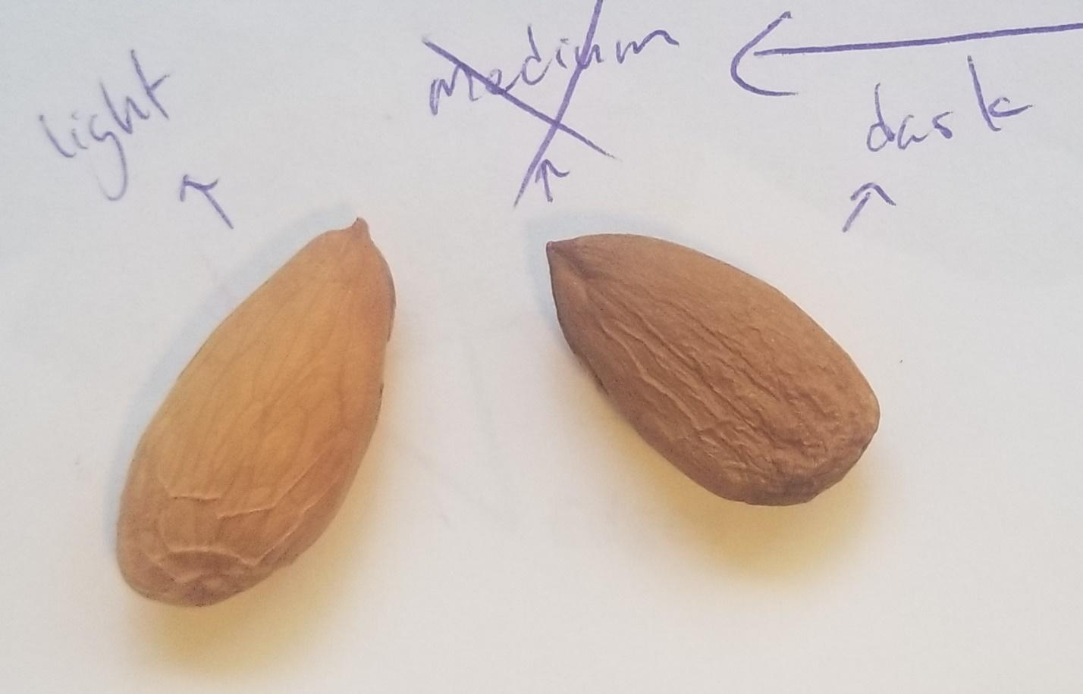

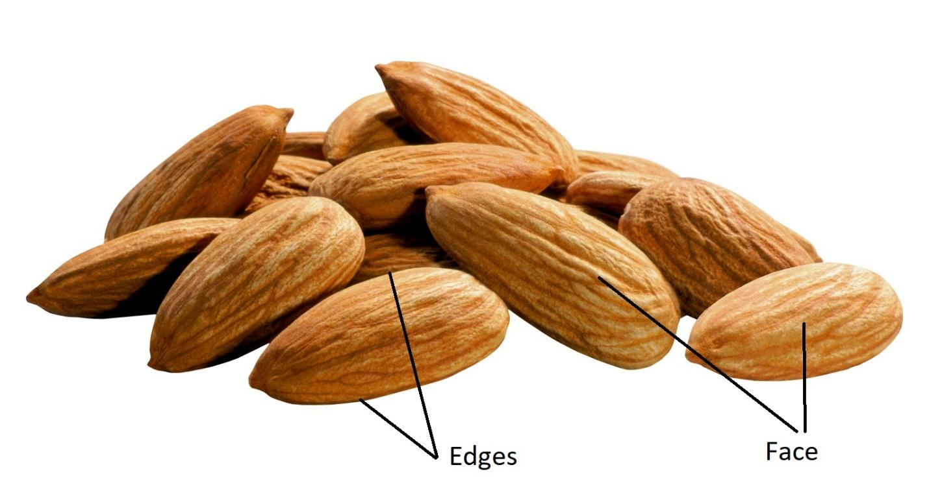

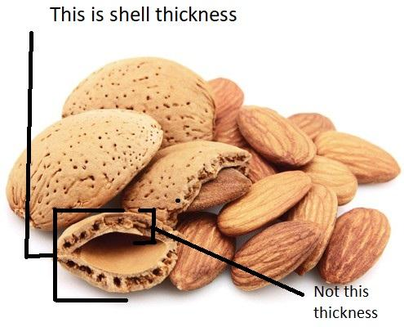

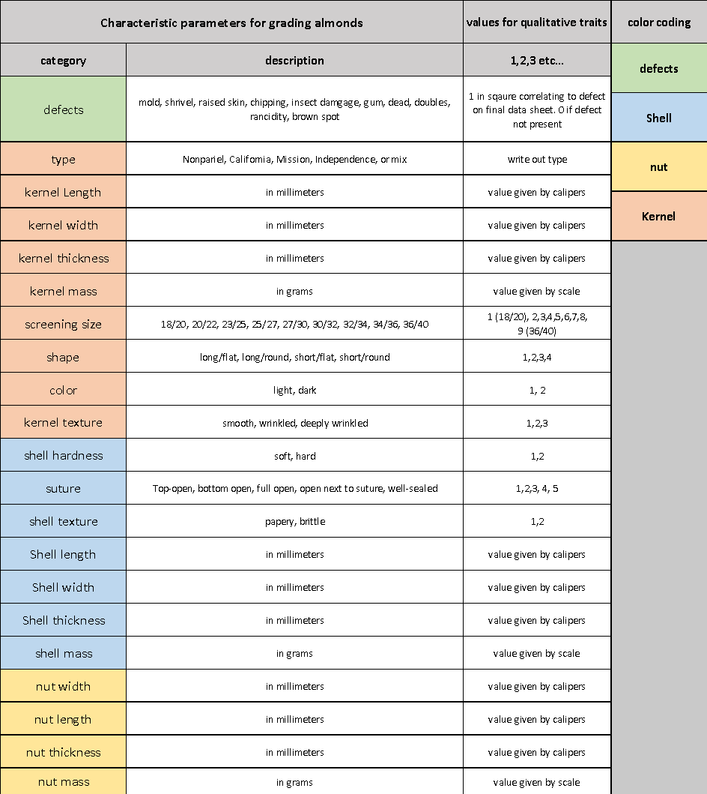
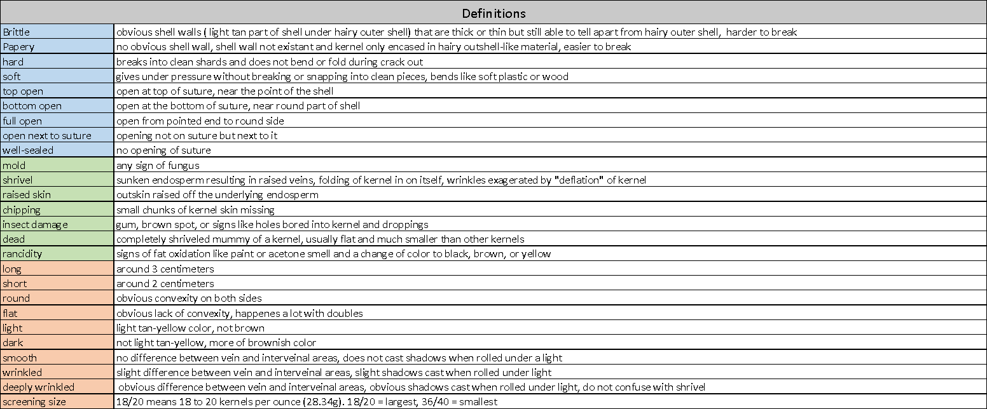
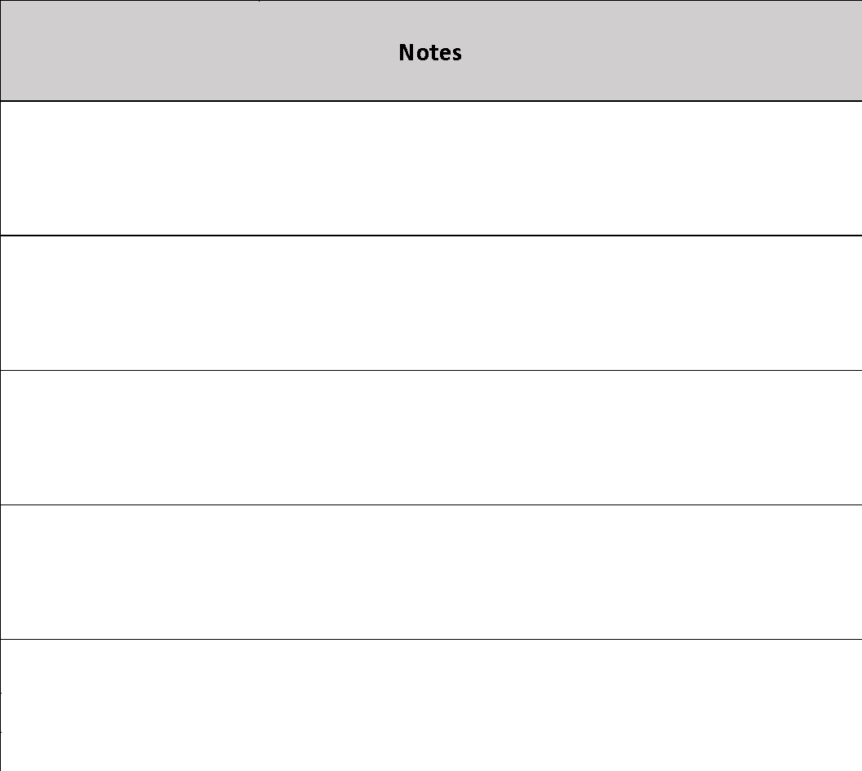
Citations
- Used for almond and grading information

  - https://ucanr.edu/datastoreFiles/608-7.pdf
  - https://www.almonds.com/sites/default/files/content/attachments/standards_grades_pdf_technical_kit.pdf
  - http://www.chiconut.com/page/california-almonds.php
  - http://www.chiconut.com/page/_files/Almond-Varieties.pdf
  - https://www.almonds.com/sites/default/files/content/attachments/guide_to_california_almonds_technical_poster.pdf
  - http://thealmonddoctor.com/2012/06/30/independence-almond-some-observations/
  - https://www.davewilson.com/commercial-orchards/featured-products/independence-almond
  - https://www.davewilson.com/product-information-commercial/product/independence-almond
  - http://www.nuragro.com/almonds.aspx
  - https://www.ams.usda.gov/sites/default/files/media/Almond_Inspection_Instructions%5B1%5D.pdf
  - https://centralvalleyfarmscout.blogspot.com/2013/10/almond-crack-out-today-helps-growers.html
  - https://ucanr.edu/datastoreFiles/608-15.pdf

