Appendix:

Modified CEMS Tool: Modified Children’s Emotional Management Scale
(Accounts for mask use, does not utilize smile or frown)

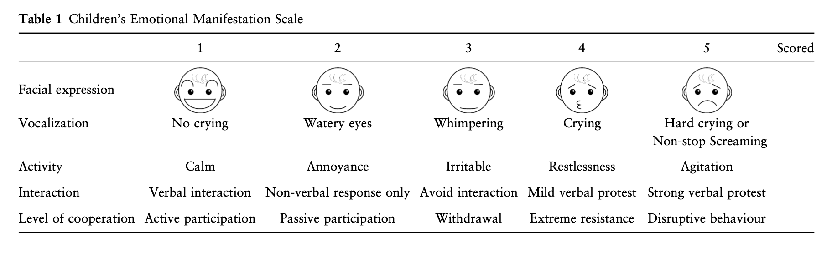
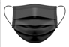
1 2.5 2.5 4 4

Survey Tool:
