Side Effects Caused by BNT162b2 Vaccine (Pfizer/BioNTech) with IgG Antibody and Serovariants among Iraqi Population
Ayad M. Ali^{1*}, Peshnyar M, Atta², Kameran M. Ali³, Kochar I Mahmood⁴, Hassan M Rostam⁵
Supplementary Table 1. Demographic characteristics for the study population (N = 502)
Characteristics | Vaccines(Pfizer/BioNTech) |  |  |  | Pv
Characteristics | First dose |  | Second Dose |  | Pv
Characteristics | n | % | n | %
Age | 60  277  165 | 12  55  33 | 60  277  165 | 12  55  33 | 0.0168
20-39
40-59
≥ 60
Sex | 262  240 | 52  48 | 262  240 | 52  48 | ns
male
female
Clinical Parameters | 182  153  135  116 | 36  30  27  23 | 489  232  122  84 | 97  46  24  17 | <0.0001  <0.0001  0.3995  0.3957
IgG
CRP
WBC
D-Dimer
Side Effects | 226  202  203  42  56  21 | 45  40  40  8  11  6 | 330  268  205  250  287  238 | 66  53  41  50  57  47 | <0.0001
Injection site pain
Headache
Fever
Myalgia
Nausea
Fatigue
Comorbidities:  Comorbidities  Hypertension  Diabetes  Thyroid disease  Cardiovascular disease  Cancer  healthy | 244  146  129  67  33  40  258 | 29  26  13  7  8 | 48.6  146  129  67  33  40  51.4 | 29  26  13  7  8 | <0.0001
Data presented as number (n) and percentage (%). Significant at P ≤ 0.05.

Fig 1. Gender distribution of post-vaccinated participants (morbid and healthy)

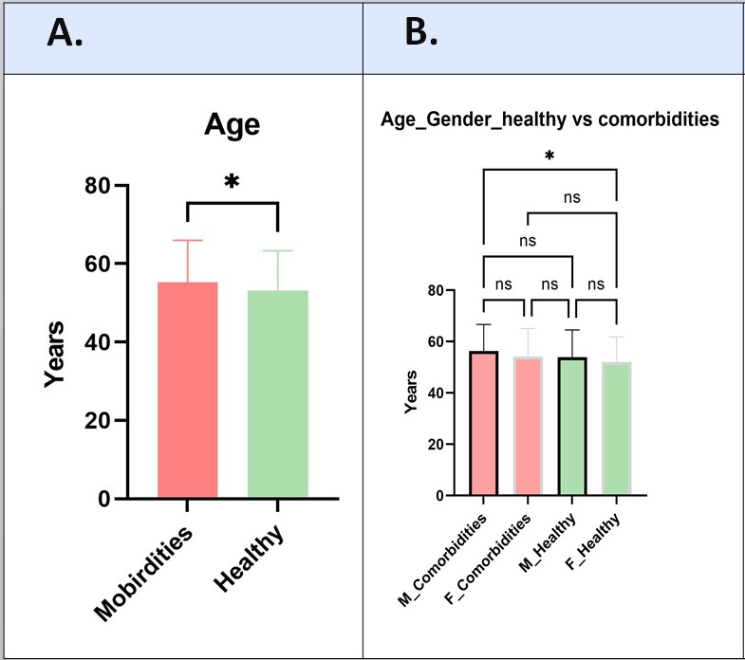
Fig. 2. A. Age distribution of enrolled participants. B. age and gender distribution in both groups: healthy vs comorbidities.

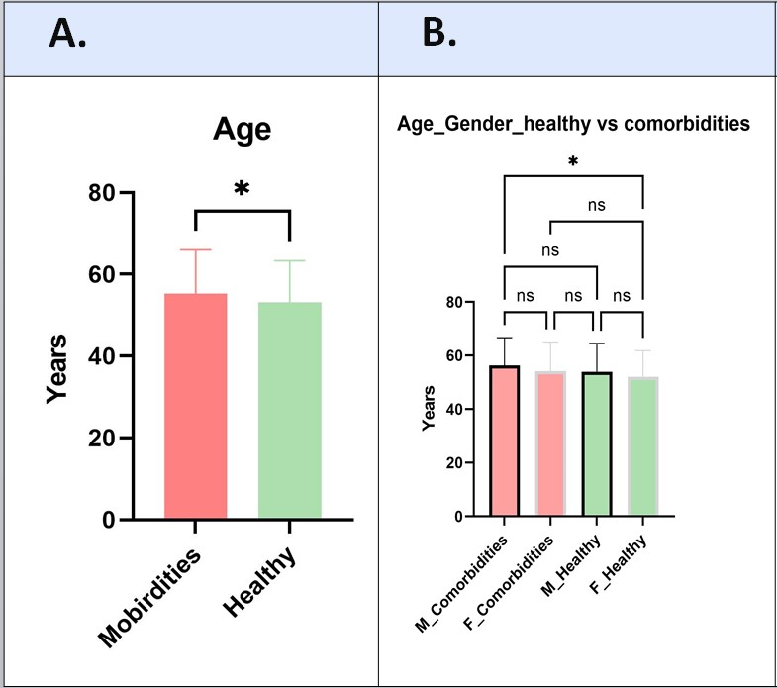
Fig. 3. A. Incedence of IgG generation in D1 and D2 vaccination, B. IgG antibody distribution in both groups: healthy vs morbid.
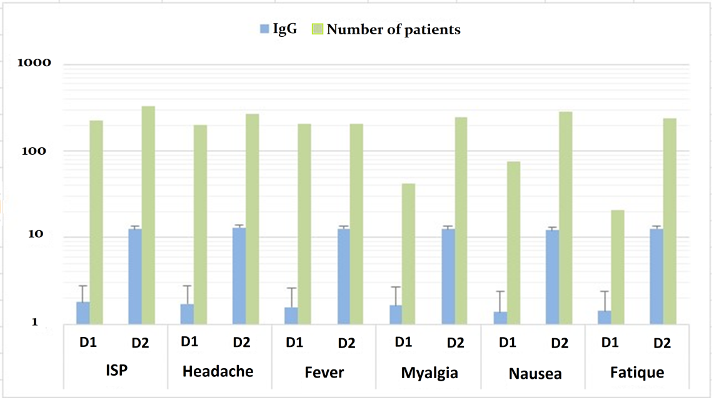
Fig. 4. Prevalence of COVID-19 vaccination side effects with IgG generation and number of patients

