Supplementary Text, Tables and Figures
Supplementary materials
Supplementary data 1. Form for site description.

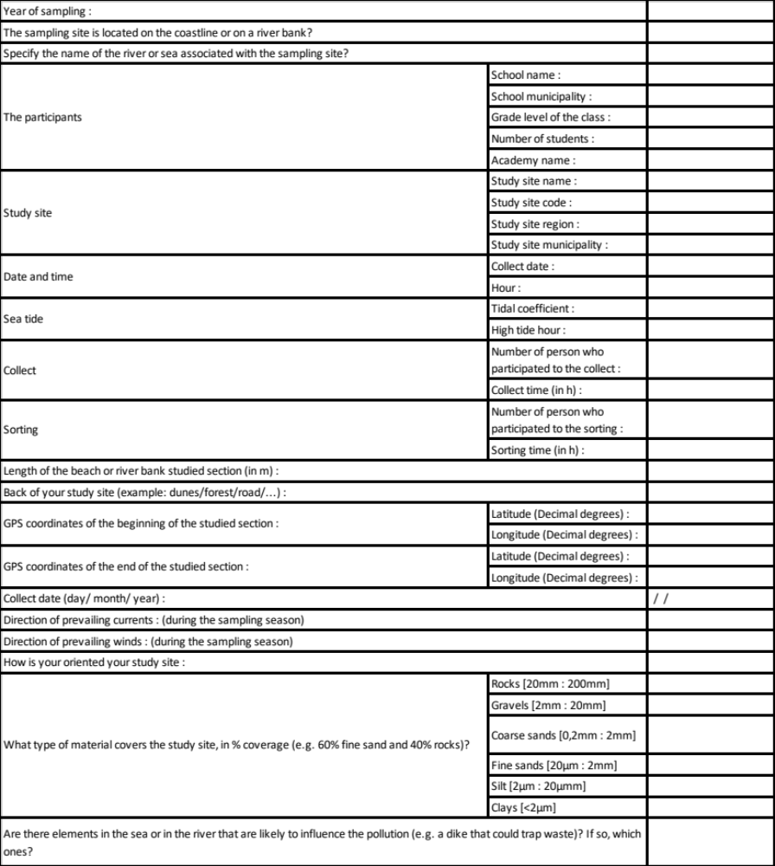

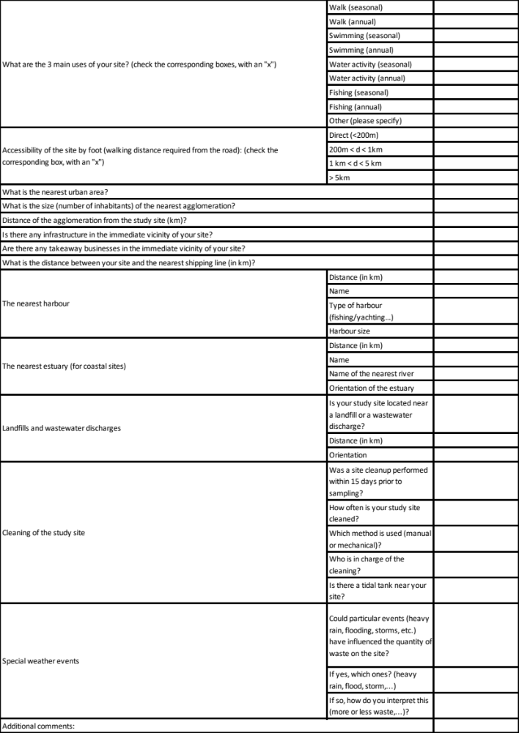
Supplementary data 2. Table for macrolitters, meso- and microplastics referencing.
Macrolitters
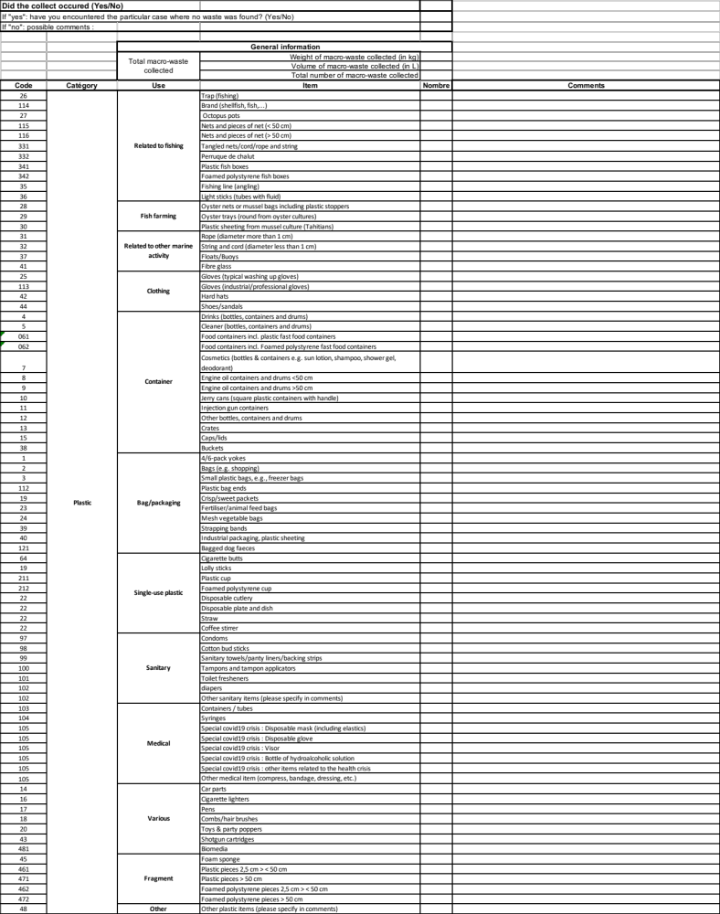
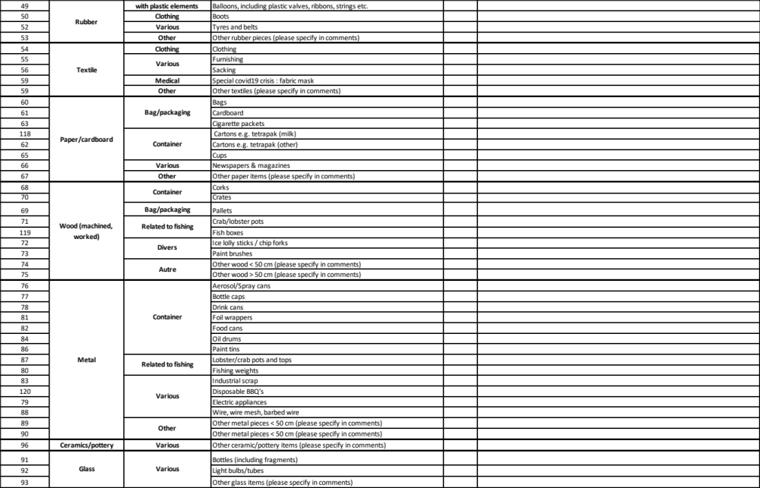
Mesoplastics
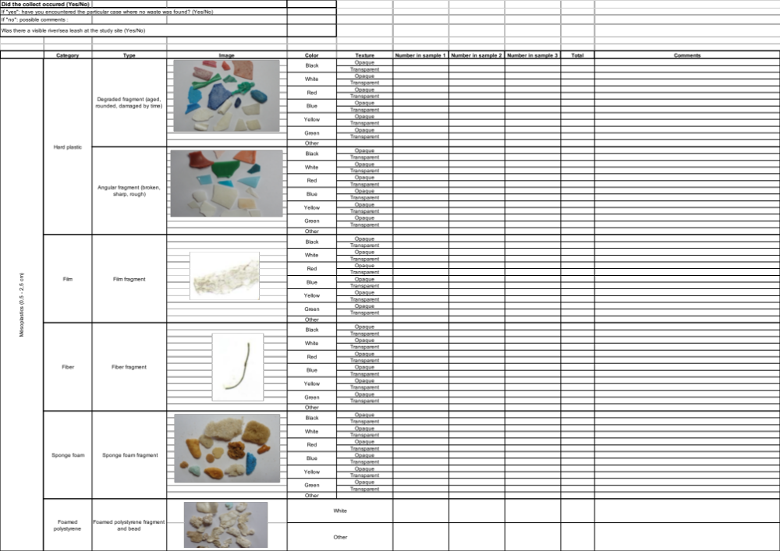
Microplastics

