Supplementary Figures
Supplementary Figure S1. Lack of sex differences in fatty allograft associated PNFs.
Supplementary Figure S2. (A) Unchanged miRNAs in fatty allograft associated PNFs. (B) miRNAs not influenced by grades of hepatic steatosis in tissue of fatty allograft associated PNFs.
A
B1
B2
B3
B4
B5
B6
B7
B8
B9
B10
Supplementary Figure S3. Unresponsive miRNAs in liver tissue following organ storage and reperfusion injury.
A
B
C
D
E
F
G
H
I
J
K

Supplementary Figure S4. Unresponsive miRNAs in blood samples of OLT patients and reperfusion injury following liver resection.
A
B
C
D
E
F
G
H

Supplementary Figure S5. Regulation of PNF associated miRNAs in plasma. (A) The effects of warm ischemia following liver surgery. (B) The effects of cold ischemia and reperfusion injury following OLT (day 1-3).
A1
A2
A3
B2
B1

Supplementary Figure S6. miRNAs not influenced by grades of hepatic steatosis in plasma samples of successfully performed OLTs and liver resection cases. The patients are grouped into mild-moderate and marked steatosis, and we compared the regulation of miRNAs by considering the expression of day 0 and 1, as well as day 1 and 3.
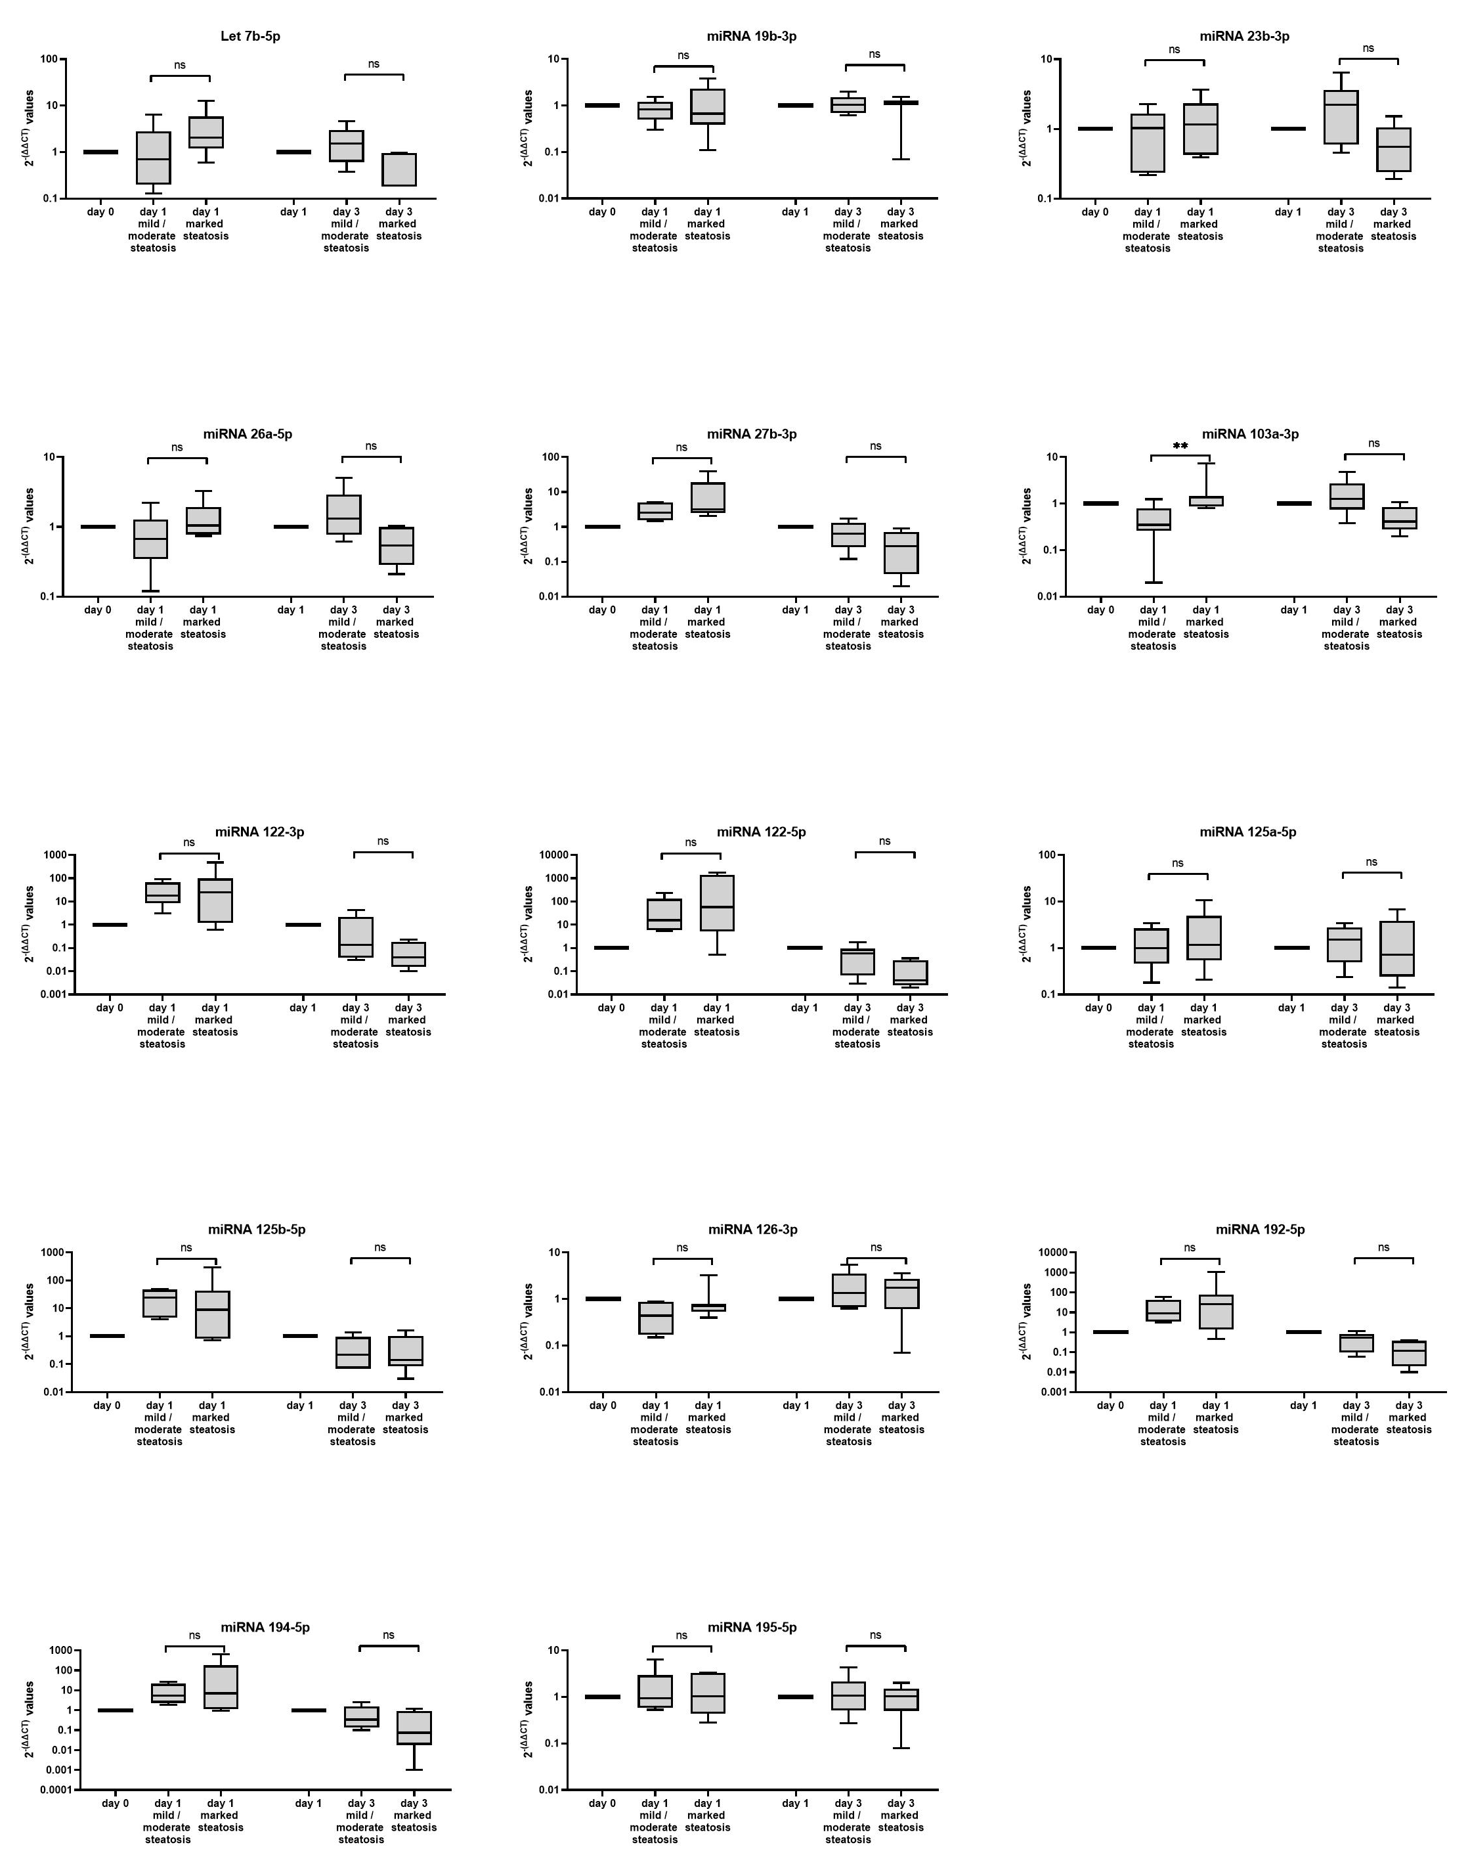
A
B
C
D
E
F
G
H
I
J
K
L
M
N

