Supporting information

Preclinical characterisation of gallium-68 labeled ferrichrome siderophore stereoisomers for PET imaging applications.
Kristyna Krasulova¹, Barbora Neuzilova¹, Katerina Dvorakova Bendova¹, Zbynek Novy^{1,2}, Miroslav Popper¹, Marian Hajduch^{1,2,3} and Milos Petrik^{1,2}

¹Institute of Molecular and Translational Medicine, Faculty of Medicine and Dentistry, Palacky University, Hnevotinska 5, Olomouc, 779 00, Czech Republic
²Czech Advanced Technology and Research Institute, Palacky University, Krizkovskeho 511/8, Olomouc, 779 00, Czech Republic
³University Hospital Olomouc, I.P. Pavlova 6, Olomouc, 779 00, Czech Republic.

Corresponding authors:
Kristyna Krasulova
Institute of Molecular and Translational Medicine, Hnevotinska 5, CZ-77900 Olomouc, Czech Republic
Tel: +420585632138; Fax: +420585632180; Email: kristyna.krasulova@upol.cz
https://orcid.org/0000-0002-8303-6847

Milos Petrik
Institute of Molecular and Translational Medicine, Hnevotinska 5, CZ-77900 Olomouc, Czech Republic
Tel: +420585632126; Fax: +420585632180; Email: milos.petrik@upol.cz
https://orcid.org/0000-0003-1334-5916

Content

1. Figure S1: ⁶⁸Ga-labeling of [⁶⁸Ga]Ga-FRH and [⁶⁸Ga]Ga-FRH S3
2. Figure S2: In vivo stability tests S4

1. Figure S1: ⁶⁸Ga-labeling of [⁶⁸Ga]Ga-FR and [⁶⁸Ga]Ga-FRH

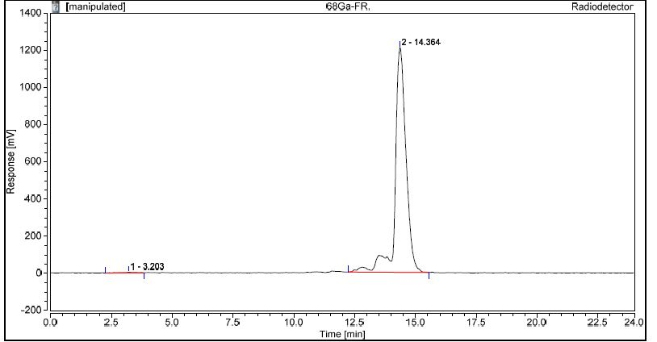
Figure S1A: Example of radiochromatogram of [⁶⁸Ga]Ga-FR.
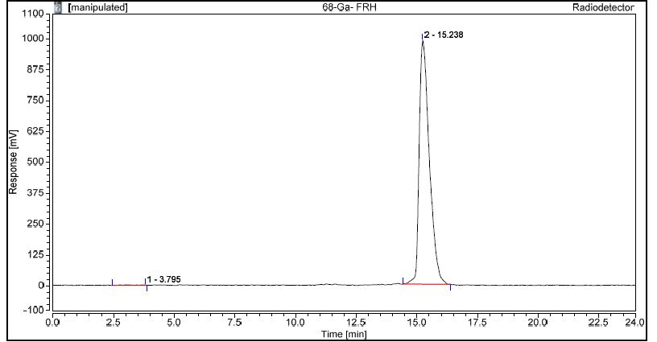
Figure S1B: Example of radiochromatogram of [⁶⁸Ga]Ga-FRH.

2. Figure S2: In vivo stability tests

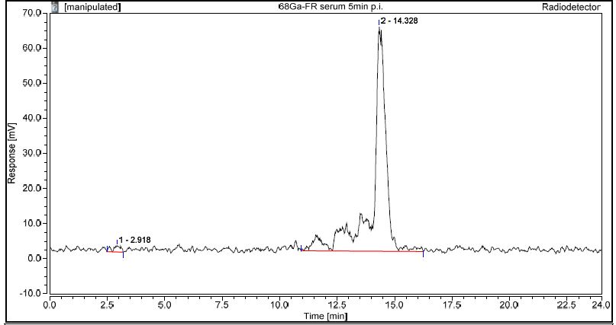
Figure S2A: Radiochromatogram of [⁶⁸Ga]Ga-FR stability in blood, 5 min after injection.
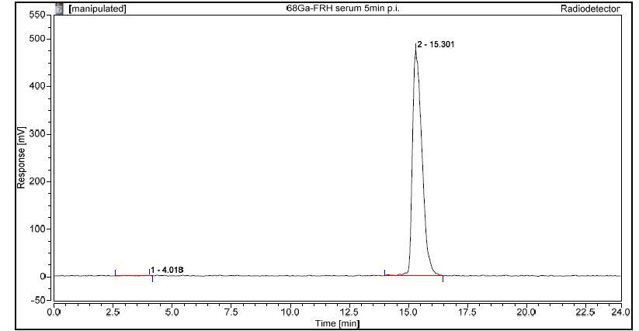
Figure S2B: Radiochromatogram of [⁶⁸Ga]Ga-FRH stability in blood, 5 min after injection.
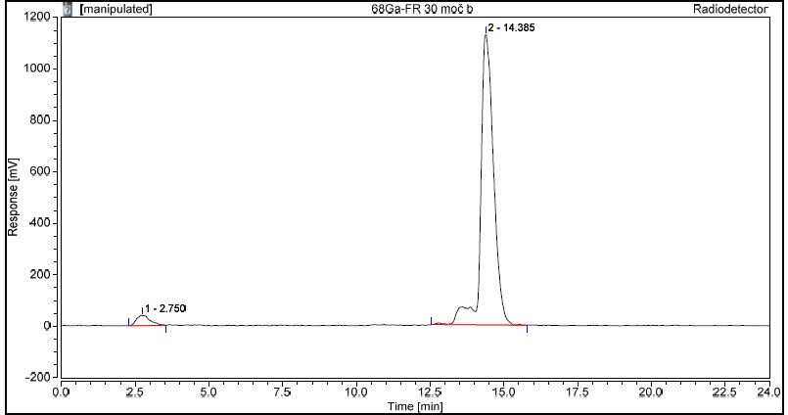
Figure S2C: Radiochromatogram of [⁶⁸Ga]Ga-FR stability in urine, 30 min after injection.
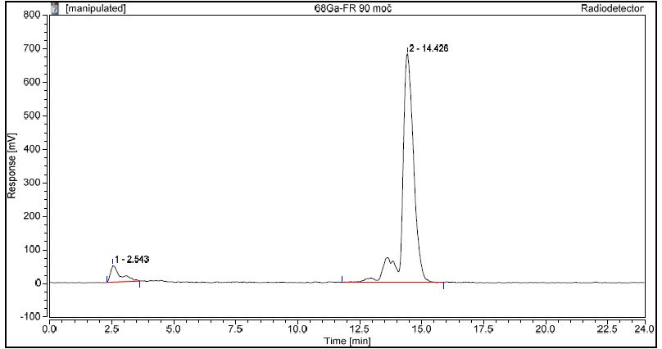
Figure S2D: Radiochromatogram of [⁶⁸Ga]Ga-FR stability in urine, 90 min after injection.
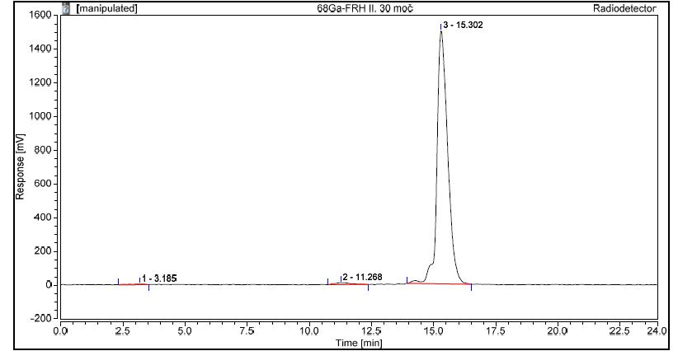
Figure S2E: Radiochromatogram of [⁶⁸Ga]Ga-FRH stability in urine, 30 min after injection.
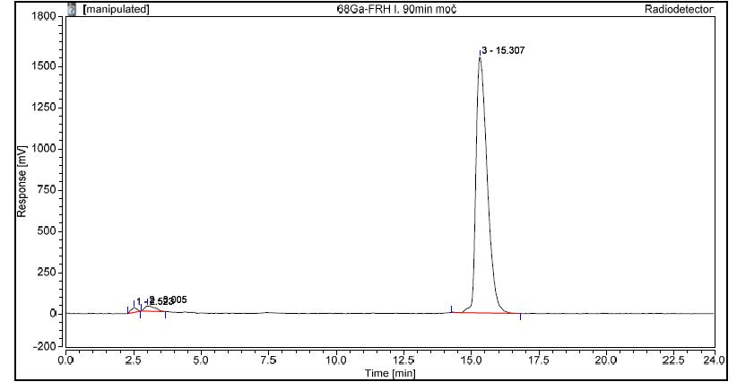
Figure S2F: Radiochromatogram of [⁶⁸Ga]Ga-FRH stability in urine, 90 min after injection.

