Supplementary Material 4: Differences between Former Users and Never Users

RATIONALE
The potential impacts of the reduced-exposure message include reducing the perceived risks of JUUL and increasing the behavioral intentions to use JUUL. Such behavioral changes are likely to benefit AWS by facilitating complete switching, but are likely to be harmful for both adults who formerly used (Former Users) and adults who never used tobacco products (Never Users). The main analyses combined the the Former and Never Users into a Nonuser group. These supplementary analyses compare the results from Former and Never Users, supporting the appropriateness of combining these two study groups into one Nonuser group.

RESULTS
The definition of each group is listed in Table 1 of the manuscript. Apart from the previous history of tobacco use, both Former Users and Never Users had to have not used any tobacco in the past 6 months and not currently use any tobacco products to be defined as Nonusers.
Supplementary Figure 1 summarizes the risk ratings and perceived risk differences of Former and Never Users. Relative risk ratings for Smoking and JUUL were highly comparable between Former and Never Users in the Message group and Former and Never Users in the Control group (all ps>.05). Exposure to the message significantly increased the PRD between smoking and JUUL use in both Former and Never Users, but the extent of the increase was not significantly different between Former and Never Users (p>.05).
Similarly, average ratings of specific diseases and addiction did not show significant differences between Former and Never Users in the Message group, or between Former and Never Users in the Control group (all ps>.05). Compared to Former Users, Never Users perceived a significantly higher likelihood of harming others with JUUL. However, the extent to which the message decreased the absolute risk ratings were similar between Former and Never Users on all three (all ps>.05).

CONCLUSION
Within both the Message or Control condition, Former and Never Users had similar risk perceptions of Smoking and JUUL. Exposure to the message decreased the risk ratings of JUUL, both relative and absolute, and the extent of the effects was not significantly different between Former and Never Users.
These results suggest that Former and Never Users are highly comparable in their risk perceptions of smoking and JUUL use, and in the effect of the reduced-exposure message. Based on these similarities, along with the shared potential negative impact use of JUUL may have on these subpopulations, Former and Never Users were merged into one group of Nonusers for the manuscript.

Supplementary Figure 1. Risk Rating for Smoking and JUUL use among Former and Never Users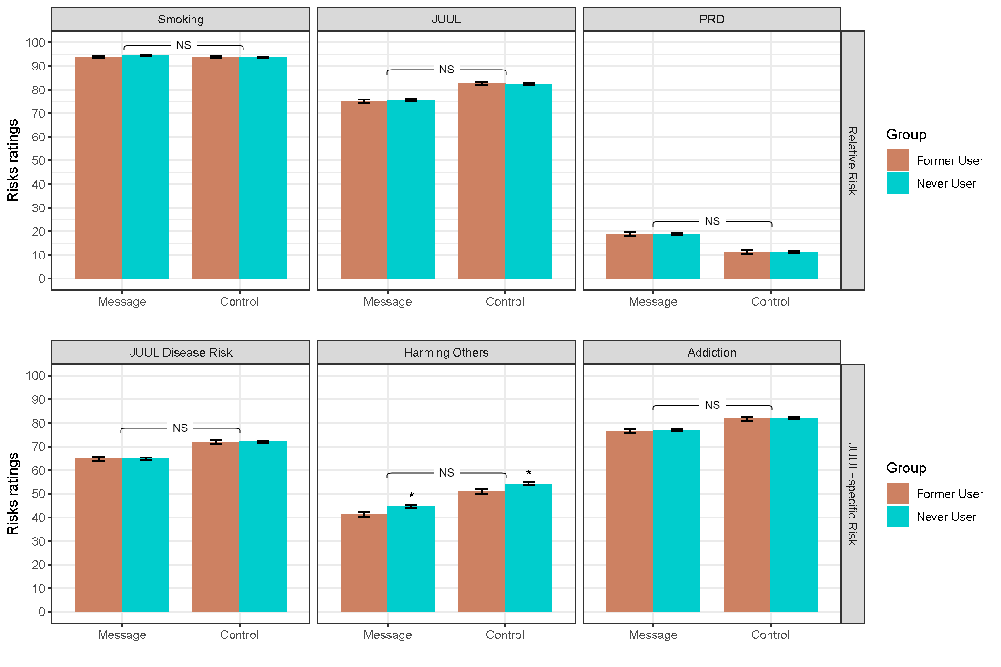
PRD: Perceived Risk Differential between Smoking and JUUL; NS: not significant
Note: Asterisk (*) indicates statistically significant (p<.05) differences between Former and Never Users within the Message (t=-2.60; df=1547; p=0.009) and Control (t=-2.51; df=1531; p=0.012) groups. Brackets represent interaction effects between Message/Control and Former/Never Users.

