Exploring the Structural, Electronic, and Hydrogen Storage Properties of hexagonal Boron Nitride and Carbon Nanotubes: Insights from Single-Walled to Doped Double-Walled Configurations

Mahmoud A. S. Sakr^{1*}, Hazem Abdelsalam^{2,3*}, Nahed H. Teleb^{2,4}, Omar H. Abd-Elkader⁵, Qinfang Zhang^{1*}
¹Center of Basic Science (CBS), Misr University for Science and Technology (MUST), 6th October City, Egypt
²School of Materials Science and Engineering, Yancheng Institute of Technology, Yancheng 224051, PR China
³Theoretical Physics Department, National Research Centre, El-Buhouth Str., 12622, Dokki, Giza, Egypt
⁴Electron Microscope and Thin Films Department, National Research Centre, El-Buhouth Str., 12622, Dokki, Giza, Egypt
⁵Department of Physics and Astronomy, College of Science, King Saud University, P.O. Box 2455, Riyadh 11451, Saudi Arabia

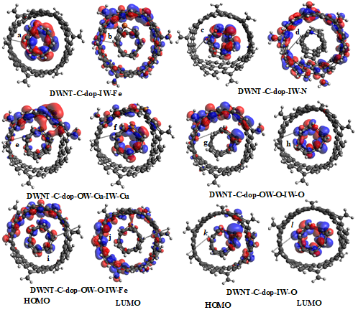
Figure S1. HOMO/LUMO MOs representations for DWNT-C-dop-IW-Fe, DWNT-C-dop-IW-N, DWNT-C-dop-OW-Cu-IW-Cu, DWNT-C-dop-OW-O-IW-O, DWNT-C-dop-OW-O-IW-Fe and DWNT-C-dop-IW-O (a-l).

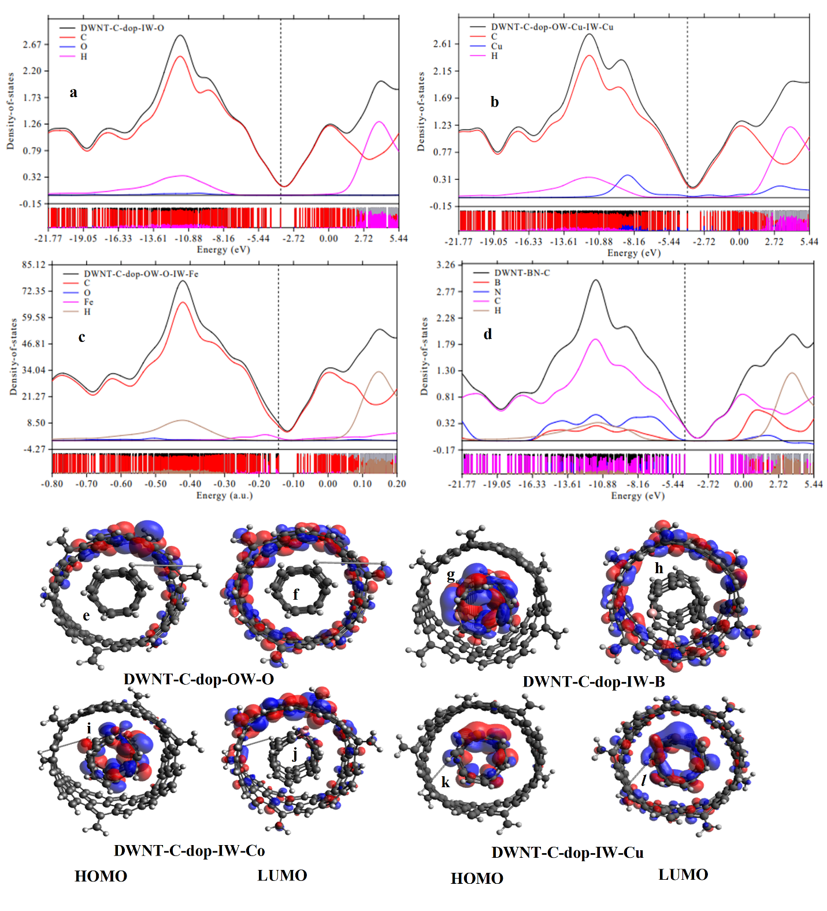
Figure S2. The partial density of states of DWNT-C-dop-IW-O, DWNT-C-dop-OW-Cu-IW-Cu, DWNT-C-dop-OW-O-IW-Fe, and DWNT-BN-C (a-d). HOMO/LUMO MOs representations for DWNT-C-dop-OW-O, DWNT-C-dop-IW-B, DWNT-C-dop-IW-Co, and DWNT-C-dop-IW-Cu (e-l).

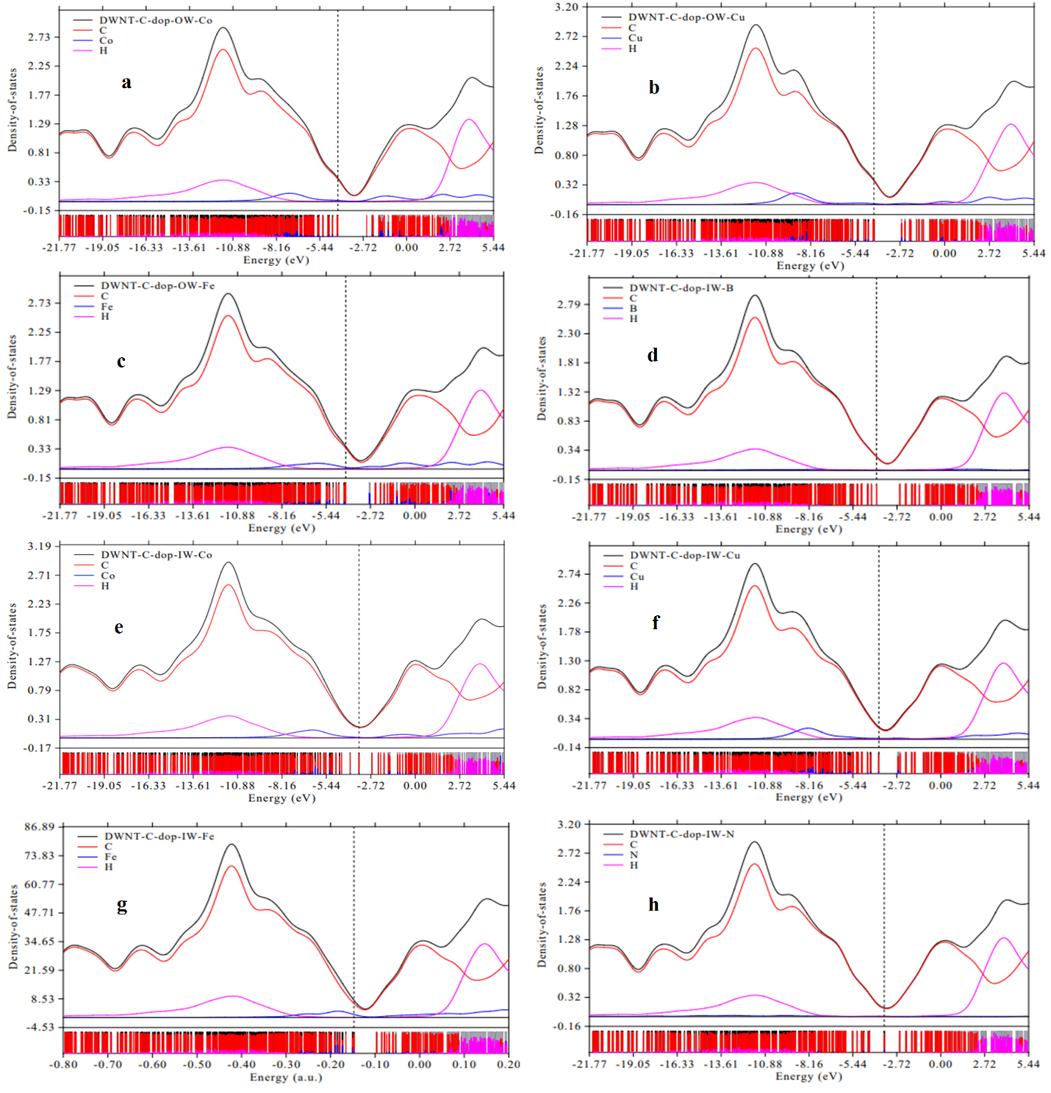
Figure S3 The partial density of states of DWNT-C-dop-OW-Co, DWNT-C-dop-OW-Cu, DWNT-C-dop-OW-Fe, DWNT-C-dop-IW-B, DWNT-C-dop-IW-Co, DWNT-C-dop-IW-Cu, DWNT-C-dop-IW-Fe, DWNT-C-dop-IW-N (a-h).

