Jacopo Garlasco, MD; Angelo D’Ambrosio, MD; Costanza Vicentini, MD; Francesca Quattrocolo, MD; Carla Maria Zotti, M.Sc.
Risk factors for healthcare-associated infections and antimicrobial use: indicators from a national dataset

SUPPLEMENTARY MATERIAL

Table of contents

Supplementary Figure A1. Directed acyclic graph (DAG) showing the causal model framework built for each outcome (HAI prevalence and proportion of antibiotics prescribed with no specified reason) against each of the determinants...............................................................................................2

Supplementary Table A1. Geographical characterisation of the hospitals included in the PPS-2 surveillance 2

Supplementary Table A2. Coefficients of the confounder and interaction terms of the respective models built with HAI incidence as outcome 3

Supplementary Table A3. Sensitivity analysis, showing the effect of different variables on HAI prevalence in multivariable models, adjusted for geographic region, hospital type and size (number of beds), considering the proxy variable “number of blood tests per 100 beds” as a confounder instead of an interactor 4
Supplementary Table A4. Sensitivity analysis, showing the effect of different variables on HAI prevalence in multivariable models, adjusted for geographic region, hospital type and size (number of beds), without accounting for the variable “number of blood tests per 100 beds” 5

Supplementary Table A5. Coefficients of the confounder terms of the respective models built with the percentage of antibiotics prescribed with no specified reason on medical records as outcome 6

Supplementary Figure A1. Directed acyclic graph (DAG) showing the causal model framework built for each outcome (HAI prevalence and proportion of antibiotics prescribed with no specified reason) against each of the determinants. NUTS-1 geographic area was used as adjustment variable, with potential effect on the two confounders (hospital type and number of beds). Causal and confounding relationships are represented by green and purple pathways, respectively.

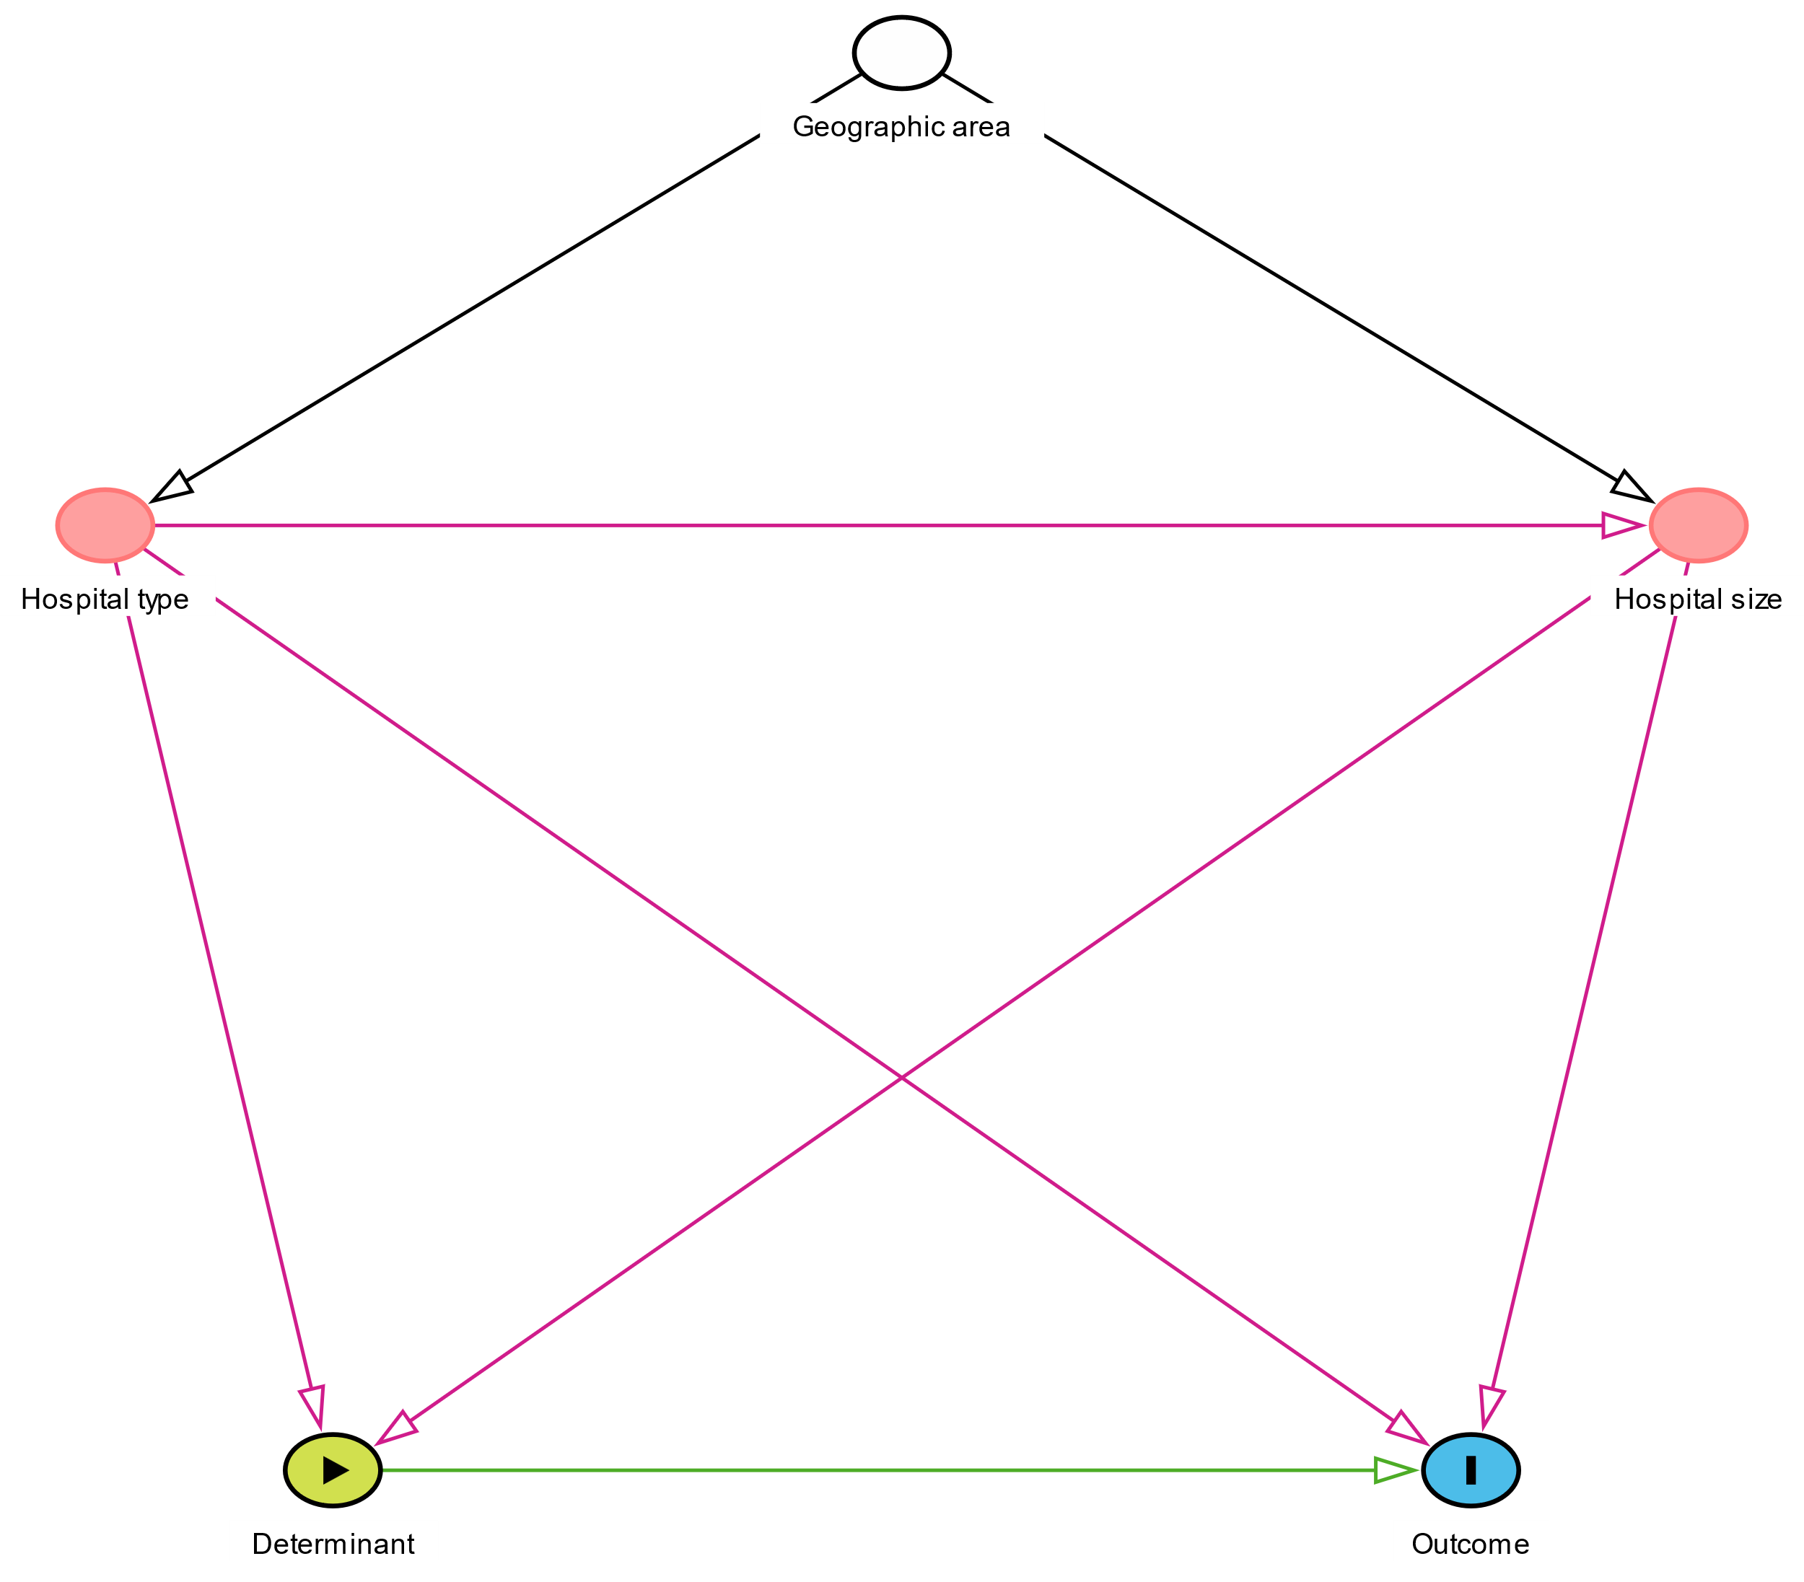

Supplementary Table A1. Geographical characterization of the hospitals included in the PPS-2 surveillance.

NUTS-1 Italian Region | Participating hospitals (%) | Enrolled patients (%)
North-West | 52 (38.5) | 11,512 (37.8)
North-East | 43 (31.9) | 11,511 (37.8)
Centre | 19 (14.1) | 3,994 (13.1)
South & Isles | 21 (15.5) | 3,450 (11.3)
Total (Italy) | 135 (100) | 30,467 (100)

Supplementary Table A2. Coefficients of the confounder and interaction terms of the respective models built with HAI incidence as outcome. Determinants’ coefficients are reported in Table II of the main manuscript (coefficients from main models only are reported).

Model determinant | Proportion of single-bed rooms |  | Number of airborne-infection isolation rooms per 100 beds |  | Alcohol-based hand rub consumption |  | Proportion of HCW carrying portable AHR dispenser |  | Number of IPC nurses (FTE)  per 100 beds |  | Number of IPC physicians (FTE)  per 100 beds |  | Number of antibiotic consultants (FTE) per 100 beds |  | Routinely provided IPC plan
Variable | OR [95% CI] | p-value | OR [95% CI] | p-value | OR [95% CI] | p-value | OR [95% CI] | p-value | OR [95% CI] | p-value | OR [95% CI] | p-value | OR [95% CI] | p-value | OR [95% CI] | p-value
Geographic area
(ref = North-East)
North-West | 0.893 [0.767 - 1.039] | 0.143 | 0.882 [0.758 - 1.026] | 0.103 | 0.911 [0.782 - 1.062] | 0.233 | 0.871 [0.747 - 1.016] | 0.080 | 0.894 [0.767 - 1.041] | 0.148 | 0.892 [0.765 - 1.041] | 0.146 | 0.908 [0.779 - 1.057] | 0.213 | 0.888 [0.763 - 1.033] | 0.123
Centre | 0.873 [0.720 - 1.059] | 0.169 | 0.858 [0.706 - 1.042] | 0.122 | 0.855 [0.705 - 1.037] | 0.112 | 0.866 [0.707 - 1.060] | 0.163 | 0.851 [0.702 - 1.031] | 0.099 | 0.866 [0.714 - 1.050] | 0.143 | 0.850 [0.699 - 1.033] | 0.103 | 0.732 [0.597 - 0.897] | 0.003
South & Isles | 0.590 [0.479 - 0.727] | <0.001 | 0.602 [0.488 - 0.742] | <0.001 | 0.595 [0.483 - 0.734] | <0.001 | 0.595 [0.480 - 0.737] | <0.001 | 0.597 [0.484 - 0.735] | <0.001 | 0.614 [0.498 - 0.756] | <0.001 | 0.594 [0.480 - 0.734] | <0.001 | 0.554 [0.447 - 0.686] | <0.001
Hospital type
(ref = territory hospitals)
Hub hospitals | 1.192 [1.024 - 1.388] | 0.023 | 1.229 [1.052 - 1.435] | 0.009 | 1.244 [1.071 - 1.444] | 0.004 | 1.240 [1.062 - 1.446] | 0.006 | 1.193 [1.029 - 1.384] | 0.020 | 1.180 [1.018 - 1.368] | 0.028 | 1.209 [1.038 - 1.407] | 0.014 | 1.201 [1.028 - 1.404] | 0.021
Research centres | 2.249 [1.838 - 2.751] | <0.001 | 2.214 [1.817 - 2.697] | <0.001 | 2.142 [1.759 - 2.608] | <0.001 | 2.203 [1.781 - 2.726] | <0.001 | 2.146 [1.766 - 2.608] | <0.001 | 2.138 [1.759 - 2.598] | <0.001 | 2.143 [1.755 - 2.616] | <0.001 | 2.101 [1.723 - 2.562] | <0.001
Others | 1.253 [0.582 - 2.698] | 0.565 | 1.116 [0.522 - 2.388] | 0.777 | 1.180 [0.402 - 3.465] | 0.763 | 1.232 [0.566 - 2.682] | 0.599 | 1.034 [0.483 - 2.215] | 0.932 | 1.065 [0.498 - 2.278] | 0.871 | 3.613 [0.85 - 15.349] | 0.082 | 1.251 [0.582 - 2.689] | 0.567
Hospital size (+100 beds) | 1.020 [1.000 - 1.040] | 0.053 | 1.012 [0.993 - 1.031] | 0.224 | 1.014 [0.995 - 1.033] | 0.153 | 1.010 [0.991 - 1.030] | 0.290 | 1.013 [0.994 - 1.032] | 0.183 | 1.018 [0.999 - 1.037] | 0.059 | 1.014 [0.995 - 1.034] | 0.142 | 1.014 [0.994 - 1.034] | 0.176
Interaction term | 1.027 [0.997 - 1.059] | 0.082 | 1.193 [0.887 - 1.603] | 0.244 | 1.045 [0.709 - 1.540] | 0.826 | 1.007 [0.997 - 1.016] | 0.181 | 0.999 [0.987 - 1.011] | 0.862 | 0.997 [0.987 - 1.007] | 0.603 | 1.014 [0.989 - 1.040] | 0.277 | 1.008 [1.002 - 1.015] | 0.012
Model determinant | Routinely provided IPC report |  | ≥ 1 HAI surveillance performed |  | Number of performed HAI surveillances |  | ≥ 1 HAI preventive measure |  | Number of HAI preventive measures |  | Antibiotic stewardship performed |  | Number of antibiotic stewardship measures |  | Post-prescription review procedures
Variable | OR [95% CI] | p-value | OR [95% CI] | p-value | OR [95% CI] | p-value | OR [95% CI] | p-value | OR [95% CI] | p-value | OR [95% CI] | p-value | OR [95% CI] | p-value | OR [95% CI] | p-value
Geographic area
(ref = North-East)
North-West | 0.867 [0.744 - 1.010] | 0.068 | 0.889 [0.764 - 1.035] | 0.130 | 0.907 [0.781 - 1.055] | 0.206 | 0.972 [0.833 - 1.133] | 0.714 | 0.886 [0.761 - 1.032] | 0.119 | 0.892 [0.767 - 1.038] | 0.140 | 0.876 [0.753 - 1.019] | 0.086 | 0.897 [0.759 - 1.061] | 0.205
Centre | 0.804 [0.652 - 0.991] | 0.041 | 0.879 [0.725 - 1.067] | 0.192 | 0.904 [0.745 - 1.096] | 0.304 | 0.812 [0.664 - 0.993] | 0.043 | 0.870 [0.717 - 1.056] | 0.160 | 0.710 [0.573 - 0.880] | 0.002 | 0.867 [0.710 - 1.059] | 0.162 | 0.886 [0.714 - 1.098] | 0.269
South & Isles | 0.543 [0.436 - 0.677] | <0.001 | 0.614 [0.499 - 0.756] | <0.001 | 0.634 [0.515 - 0.780] | <0.001 | 0.621 [0.504 - 0.765] | <0.001 | 0.630 [0.510 - 0.777] | <0.001 | 0.546 [0.441 - 0.676] | <0.001 | 0.608 [0.494 - 0.750] | <0.001 | 0.608 [0.482 - 0.765] | <0.001
Hospital type
(ref = territory hospitals)
Hub hospitals | 1.214 [1.037 - 1.421] | 0.016 | 1.218 [1.046 - 1.418] | 0.011 | 1.240 [1.067 - 1.440] | 0.005 | 1.205 [1.035 - 1.403] | 0.016 | 1.249 [1.071 - 1.456] | 0.004 | 1.221 [1.050 - 1.421] | 0.010 | 1.265 [1.089 - 1.469] | 0.002 | 1.252 [1.045 - 1.500] | 0.015
Research centres | 2.001 [1.628 - 2.460] | <0.001 | 2.129 [1.750 - 2.590] | <0.001 | 2.307 [1.889 - 2.818] | <0.001 | 1.768 [1.443 - 2.165] | <0.001 | 2.054 [1.688 - 2.500] | <0.001 | 2.108 [1.728 - 2.570] | <0.001 | 2.159 [1.777 - 2.624] | <0.001 | 2.245 [1.824 - 2.764] | <0.001
Others | 1.301 [0.604 - 2.804] | 0.502 | 1.103 [0.514 - 2.366] | 0.802 | 1.202 [0.561 - 2.580] | 0.636 | 1.143 [0.533 - 2.452] | 0.731 | 1.144 [0.532 - 2.457] | 0.731 | 1.190 [0.554 - 2.555] | 0.656 | 1.230 [0.572 - 2.641] | 0.596 | 1.066 [0.495 - 2.297] | 0.870
Hospital size (+100 beds) | 1.010 [0.990 - 1.029] | 0.334 | 1.008 [0.989 - 1.028] | 0.421 | 1.013 [0.995 - 1.032] | 0.162 | 1.020 [1.000 - 1.040] | 0.049 | 1.008 [0.989 - 1.027] | 0.409 | 1.005 [0.986 - 1.025] | 0.588 | 1.007 [0.988 - 1.027] | 0.468 | 0.998 [0.976 - 1.021] | 0.888
Interaction term | 1.013 [1.006 - 1.020] | <0.001 | 1.004 [0.998 - 1.011] | 0.170 | 1.002 [1.000 - 1.004] | 0.022 | 1.008 [1.002 - 1.014] | 0.011 | 1.000 [1.000 - 1.001] | <0.001 | 1.008 [1.002 - 1.015] | 0.009 | 1.002 [1.001 - 1.003] | <0.001 | 1.019 [1.006 - 1.031] | 0.003

Supplementary Table A3. Sensitivity analysis, showing the effect of different variables on HAI prevalence in multivariable models, adjusted for geographic region, hospital type and size (number of beds), considering the proxy variable “number of blood tests per 100 beds” as a confounder instead of an interactor.

Variable | OR [95% CI] | p-value
Proportion of single-bed rooms | 0.929 [0.900 - 0.959] (for every +5%) | <0.001
Number of airborne-infection isolation rooms per 100 beds | 1.014 [0.976 - 1.054] (+1 per 100 beds) | 0.479
Alcohol-based hand rub consumption [L/100 beds] | 0.998 [0.982 - 1.014] (+1 L/100 beds) | 0.824
Proportion of HCW carrying portable AHR dispenser | 0.946 [0.841 - 1.064] (>25% vs <25%) | 0.357
Number of IPC nurses (FTE) per 100 beds | 0.926 [0.853 - 1.006] (+1 per 100 beds) | 0.068
Number of IPC physicians (FTE) per 100 beds | 1.017 [0.957 - 1.081] (+1 per 100 beds) | 0.586
Number of antibiotic consultants (FTE) per 100 beds | 0.799 [0.616 - 1.036] (+1 per 100 beds) | 0.090
Routinely provided IPC plan | 0.670 [0.576 - 0.780] | <0.001
Routinely provided IPC report | 0.809 [0.699 - 0.936] | 0.004
≥ 1 HAI surveillance performed | 1.279 [1.025 - 1.598] | 0.030
Nr of performed HAI surveillances | 1.055 [1.013 - 1.097] | 0.009
≥ 1 HAI prevention measure | 0.300 [0.208 - 0.431] | <0.001
Nr of HAI prevention measures | 0.998 [0.993 - 1.003] | 0.370
Antibiotic stewardship performed | 0.768 [0.661 - 0.892] | 0.001
Nr of antibiotic stewardship measures | 1.004 [0.988 - 1.019] | 0.647
Post-prescription review procedures | 1.014 [0.890 - 1.157] | 0.830

Supplementary Table A4. Sensitivity analysis, showing the effect of different variables on HAI prevalence in multivariable models, adjusted for geographic region, hospital type and size (number of beds), without accounting for the variable “number of blood tests per 100 beds”.

Variable | OR (95% CI) | p-value
Proportion of single-bed rooms | 0.930 [0.901 - 0.960] (for every +5%) | <0.001
Number of airborne-infection isolation rooms per 100 beds | 1.017 [0.979 - 1.056] (+1 per 100 beds) | 0.390
Alcohol-based hand rub consumption [L/100 beds] | 0.998 [0.982 - 1.015] (+1 L/100 beds) | 0.841
Proportion of HCW carrying portable AHR dispenser | 0.943 [0.838 - 1.062] (>25% vs <25%) | 0.334
Number of IPC nurses (FTE) per 100 beds | 0.918 [0.845 - 0.997] (+1 per 100 beds) | 0.043
Number of IPC physicians (FTE) per 100 beds | 1.015 [0.955 - 1.078] (+1 per 100 beds) | 0.641
Number of antibiotic consultants (FTE) per 100 beds | 0.795 [0.614 - 1.030] (+1 per 100 beds) | 0.082
Routinely provided IPC plan | 0.669 [0.575 - 0.778] | <0.001
Routinely provided IPC report | 0.799 [0.692 - 0.924] | 0.002
≥ 1 HAI surveillance performed | 1.292 [1.035 - 1.612] | 0.024
Nr of performed HAI surveillances | 1.056 [1.015 - 1.099] | 0.007
≥ 1 HAI prevention measure | 0.316 [0.221 - 0.454] | <0.001
Nr of HAI prevention measures | 0.998 [0.992 - 1.003] | 0.343
Antibiotic stewardship performed | 0.772 [0.664 - 0.897] | 0.001
Nr of antibiotic stewardship measures | 1.004 [0.988 - 1.019] | 0.646
Post-prescription review procedures | 1.020 [0.895 - 1.164] | 0.763

Supplementary Table A5. Coefficients of the confounder terms of the respective models built with the percentage of antibiotics prescribed with no specified reason on medical records as outcome. Determinants’ coefficients are reported in Table III of the main manuscript.

Model determinant | Number of IPC nurses (FTE)  per 100 beds |  | Number of IPC physicians (FTE) per 100 beds |  | Number of antibiotic consultants (FTE) per 100 beds |  | Routinely provided IPC plan |  |  | Routinely provided IPC report |  |  | Antibiotic stewardship performed |  |  | Number of antibiotic stewardship measures |  | Post-prescription review procedures
Variable | OR [95% CI] | p-value | OR [95% CI] | p-value | OR [95% CI] | p-value |  | OR [95% CI] | p-value |  | OR [95% CI] | p-value |  | OR [95% CI] | p-value | OR [95% CI] | p-value |  | OR [95% CI] | p-value
Geographic area
(ref = North-East)
North-West | 0.965 [0.870 - 1.071] | 0.508 | 0.933 [0.841 - 1.035] | 0.192 | 0.968 [0.871 - 1.076] | 0.547 |  | 0.936 [0.845 - 1.038] | 0.209 |  | 0.976 [0.880 - 1.083] | 0.645 |  | 0.857 [0.775 - 0.948] | 0.003 | 0.854 [0.772 - 0.946] | 0.002 |  | 0.851 [0.761 - 0.951] | 0.005
Centre | 2.225 [1.958 - 2.528] | <0.001 | 2.308 [2.032 - 2.621] | <0.001 | 2.284 [2.011 - 2.594] | <0.001 |  | 1.642 [1.462 - 1.844] | <0.001 |  | 1.630 [1.450 - 1.833] | <0.001 |  | 1.827 [1.618 - 2.063] | <0.001 | 1.709 [1.518 - 1.924] | <0.001 |  | 1.335 [1.173 - 1.519] | <0.001
South & Isles | 2.855 [2.501 - 3.259] | <0.001 | 3.013 [2.640 - 3.438] | <0.001 | 2.976 [2.604 - 3.401] | <0.001 |  | 2.904 [2.544 - 3.316] | <0.001 |  | 2.853 [2.497 - 3.259] | <0.001 |  | 2.909 [2.551 - 3.316] | <0.001 | 2.854 [2.502 - 3.256] | <0.001 |  | 2.687 [2.320 - 3.111] | <0.001
Hospital type
(ref = territory hospitals)
Hub hospitals | 0.521 [0.469 - 0.579] | <0.001 | 0.499 [0.449 - 0.555] | <0.001 | 0.502 [0.452 - 0.559] | <0.001 |  | 0.455 [0.409 - 0.507] | <0.001 |  | 0.463 [0.416 - 0.515] | <0.001 |  | 0.488 [0.440 - 0.541] | <0.001 | 0.489 [0.441 - 0.543] | <0.001 |  | 0.452 [0.402 - 0.507] | <0.001
Research centres | 0.536 [0.455 - 0.631] | <0.001 | 0.529 [0.448 - 0.623] | <0.001 | 0.531 [0.450 - 0.626] | <0.001 |  | 0.560 [0.475 - 0.659] | <0.001 |  | 0.574 [0.487 - 0.676] | <0.001 |  | 0.560 [0.476 - 0.659] | <0.001 | 0.593 [0.505 - 0.696] | <0.001 |  | 0.516 [0.436 - 0.611] | <0.001
Others | 3.706 [2.334 - 5.885] | <0.001 | 4.052 [2.554 - 6.429] | <0.001 | 7.062 [3.933 - 12.682] | <0.001 |  | 3.769 [2.377 - 5.977] | <0.001 |  | 3.730 [2.352 - 5.916] | <0.001 |  | 3.680 [2.321 - 5.835] | <0.001 | 3.937 [2.477 - 6.256] | <0.001 |  | 3.418 [2.152 - 5.431] | <0.001
Hospital size (+100 beds) | 1.076 [1.060 - 1.093] | <0.001 | 1.089 [1.073 - 1.105] | <0.001 | 1.091 [1.075 - 1.108] | <0.001 |  | 1.073 [1.057 - 1.089] | <0.001 |  | 1.067 [1.051 - 1.082] | <0.001 |  | 1.073 [1.057 - 1.088] | <0.001 | 1.070 [1.055 - 1.086] | <0.001 |  | 1.093 [1.076 - 1.111] | <0.001

